HOLA SECONDARY SCHOOL
CHEMISTRY
FORM TWO
YEAR 2012
MID TERM
TERM TWO
1. The diagram below represents a set – up that can be used to prepare and collect oxygen.
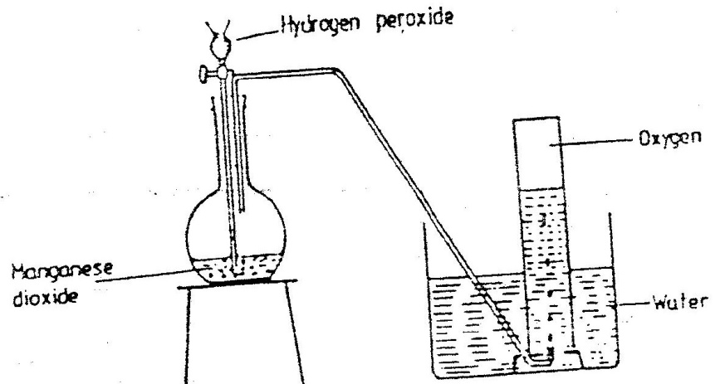

a) Write an equation for the reaction that takes place (1mk)

b) What property of oxygen makes it possible for its collection as indicated by the diagram? (1mk)

c) Explain why it is important not to collect any gas for the first few seconds of the experiment. (1mk)
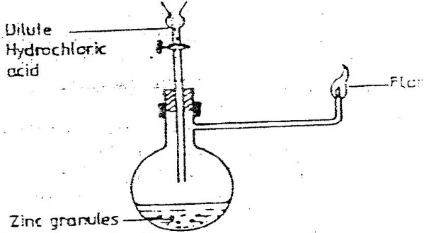
2. Study the diagram below and answer the questions that follow

Write an equation for each of the two reactions that take, place in the experiment represented by the diagram above (2mks)

3. Chlorine and iodine are elements in the same group in the periodic table. Chlorine gas is
yellow while aqueous, iodine; I₂(aq) is brown.
a) What observation would be made if chlorine gas is bubbled through aqueous
sodium iodide? Explain using and ionic equation. (2mks)

b) Under certain conditions chlorine and iodine react to give iodine chloride, ICl₃(s)-
What type of bonding would you expect to exist in iodine trichloride? Explain (1mk)

4. Give the name of each of the processes described below which takes place when
salts are exposed to air for sometime.
i) Anhydrous copper sulphate becomes wet (1mk)

ii) Magnesium chloride forms an aqueous solution (1mk)

iii) Fresh crystals of sodium carbonate, Na₂CO₃. 10H₂O (1mk)

5. The set – up below was used to study some properties of air.
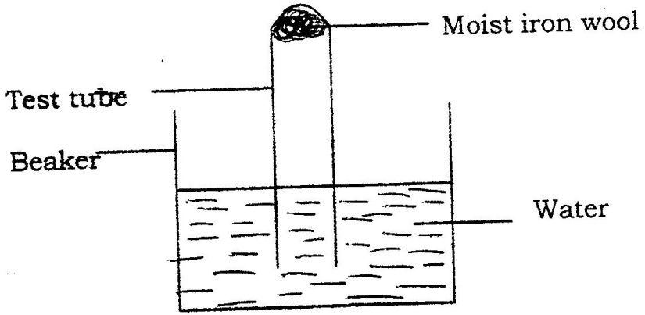

- State and explain two observations that would be made at the end of the experiment. (3mks)

b) When extinguishing a fire caused by burning kerosene, carbon dioxide is used in preference to water .Explain (1mk)

6. An element Y has the electronic configuration 2.8.5
a) Which period of the periodic table does the element belong? (1mk)

- Write a formula of the most stable anion formed when element Y ionizes (1mk)

- Explain the difference between the atomic radius of element Y and its ionic radius.(2mks)

7. Describe how a solid sample of lead (II) Chloride can be prepared using the following reagents, dilute nitric acid, dilute hydrochloric acid and lead carbonate (3mks)
- The diagram below shows the physical state of matter. Study it and answer the questions that follow.

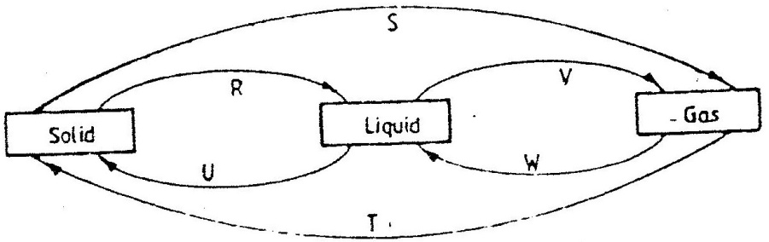

Identify the processes R, V, W and U(2mks)

        - Name one substance which can undergo the process represented by S and T.(1mk)

8. Corrosion is a destructive process in which iron is converted into hydrated iron (III) oxide
State:
a) two conditions necessary for rusting to occur (1mk)

b) One method used to protect iron from rusting (1mk)

C .Explain why it is not advisable to wash vehicles using seawater (1mk)

9. What type of bond is formed when lithium and Fluorine react? Explain
(Atomic numbers: Li = 3 and F = 9) (2mks)

10. Write the formula of sulphide of an element C, whose atomic number is 5. (C is not the actual symbol of the element) (1mk)

- Study the information in the table below and answer the questions that follow. The letters do not represent the symbols of the elements.
Element(C) | Atomic number | Melting point
L  M  N  Q  R | 11  13  14  17  19 | 97.8  660  1440  401  63.7
a) Write the electrons arrangement for the atom formed by elements and M and Q (2mks)
b) Select an element which is
i) The most reactive non – metal (1mk)

    - A poor conductor of electricity (1mk)

      - In which period of the periodic table does elements R below. (1mk)

d) Element R looses its outermost electron more readily than L. Explain (1mk)

e) Using dots(.) and crosses (x) to represent outermost electrons show
bonding in the compound formed elements N and Q. (2mks)

f) Explain why the melting point elements M is higher than that of element . (1mk)

g) Describe how a solid mixture of sulphate of R and lead sulphate can be separated into solid samples. (2mks)

- a) A piece of phosphorus was burnt in excess and the product obtained was shaken with a small amount of hot water to make a solution. Write an equation for the burning of phosphorus in excess air.(1mk)

  - Explain why cooking pots made of aluminium do not corrode when exposed to air.(1mk)

13. Use the scheme below to answer the questions that follow
Carbon Dioxide
Solid H
Solid J
Ca (OH)₂(aq)
Heat
H₂O

(a) Identify the solid (2mks)
H
J
(b) State one commercial use of solid J. (1mk)

- State any two differences between luminous and non – luminous flames. (2mks)

14. Compound Q is a solid with a giant ionic structure. In what form would the compound conduct an electric current. Explain. (2mks)

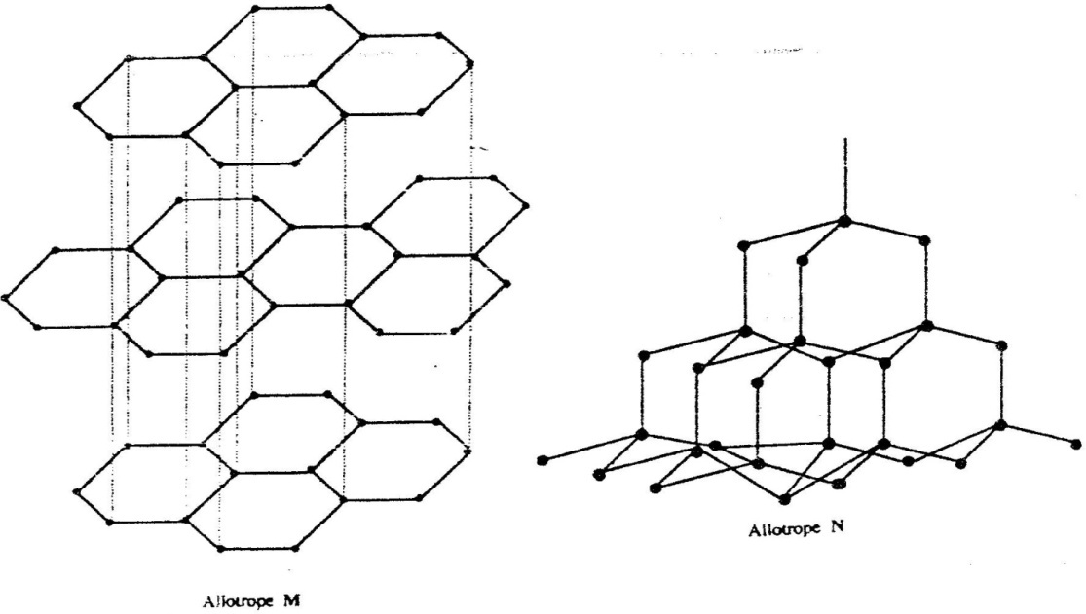
15. (a) The following diagrams show the structures of two allotropes of carbon. Study them and answer the questions that follow

(i) Name allotrope. (2mks)
M
N
(ii) Give one use of N.(1mk)

  - Which allotrope conducts electricity? Explain. (2mks)

16 (a) A student was supplied with a colourless liquid suspected to be water
- Describe one chemical test that could have been used to show that the liquid was water (1mk)

(ii) How could it have been shown that the liquid was pure water? (1mk)

17. How would you obtain a sample of pure iodine from a mixture of iodine and lead sulphate? (2mks)

18. In an experiment, a piece of magnesium ribbon was cleaned with steel wool. 2.4 g of the clean magnesium ribbon was placed in a crucible and completely burnt in oxygen. After cooling, the product weighed 4.0 g
(a) Explain why it was necessary to clean the magnesium ribbon ( 1mk)

(b) What observation was made in the crucible after burning ( 1 mk)

(c) Why was there an increase in mass? ( 1 mk)

(d) Write the equation for the reaction which took place in the crucible ( 1mk)

(e) The product in the crucible was shaken with water and filtered. Explain the observation which was made when blue and red litmus papers were dropped into the filtrate.
( 3 mks)
19. The graph below shows a curve obtained when water at 20oC was heated for 15 minutes.
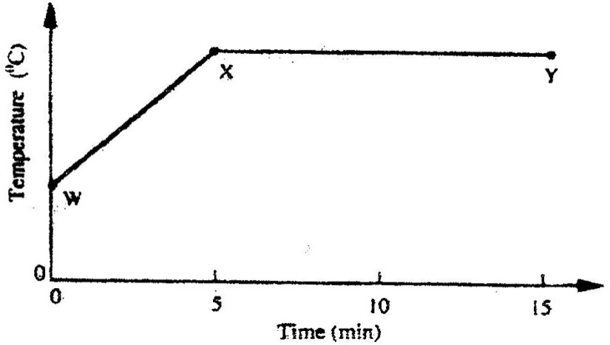

a) What happens to the water molecules between points W and x? (1mk)

  - In which part of the curve does a change of state occur? (1mk)

c) Explain why the temperature does not rise between points X and Y. (1mk)

