SUNSHINE SECONDARY SCHOOL

KIDATO CHA KWANZA
KISWAHILI
MUHULA WA PILI 2014
MUDA: 2 HRS

JINA:………………………………………………………NAMBARI YA USAJILI:…………

DARASA: …………………..TAREHE:……………….

MADA | ALAMA
UFAHAMU | 15
SARUFI | 40
FASIHI SIMULIZI | 10

UFAHAMU
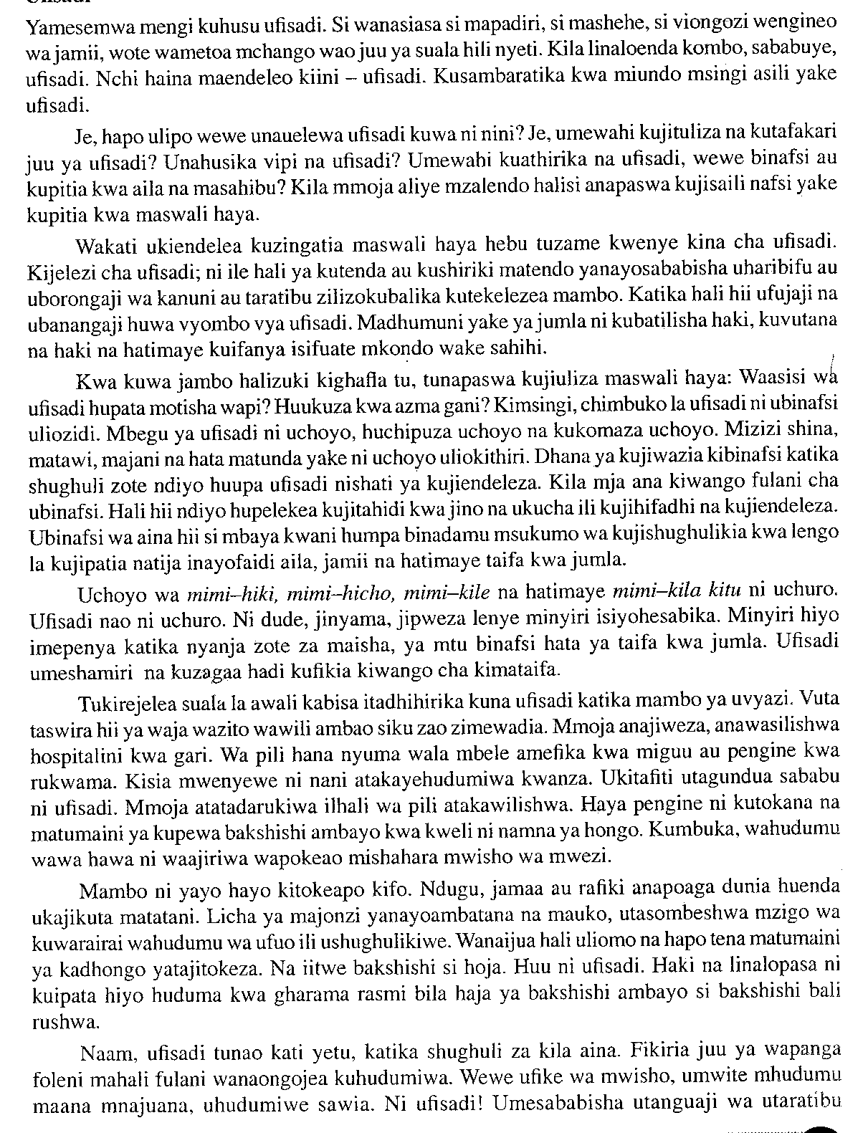
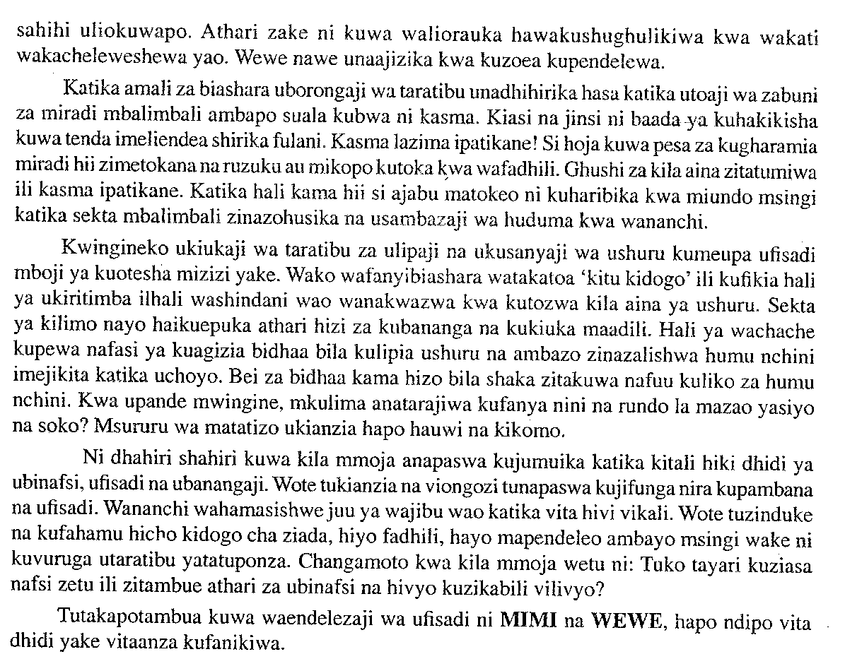
- Ipe taarifa hii kichwa mwafaka. (al 1)
…………………………………………………………………………………………………..
…………………………………………………………………………………………………..
- Eleza maana ya ufisadi. (al 2)
…………………………………………………………………………………………………..
…………………………………………………………………………………………………..
…………………………………………………………………………………………………..
…………………………………………………………………………………………………..
- Eleza chimbuko la ufisadi. (al 2)
…………………………………………………………………………………………………..
…………………………………………………………………………………………………..
…………………………………………………………………………………………………..
…………………………………………………………………………………………………..
…………………………………………………………………………………………………..
…………………………………………………………………………………………………..
- Kwa nini mwandishi anafananisha ufisadi na uchuro, jinyama au jipweza? (al 2)
…………………………………………………………………………………………………..
…………………………………………………………………………………………………..
…………………………………………………………………………………………………..
…………………………………………………………………………………………………..
- Taja maneno ambayo ufisadi hutekelezwa. (al 5)
…………………………………………………………………………………………………..
…………………………………………………………………………………………………..
…………………………………………………………………………………………………..
…………………………………………………………………………………………………..
…………………………………………………………………………………………………..
…………………………………………………………………………………………………..
- Eleza njia moja ya kukomesha ufisadi. (al 2)
…………………………………………………………………………………………………..
…………………………………………………………………………………………………..
- Taja maneno mawili yenye maana sawa na ufisadi. (al 1)
…………………………………………………………………………………………………..
…………………………………………………………………………………………………..

SAFURI (ALAMA 40)

Maagizo: Jibu maswali yote.

- Lugha ni nini? (al 2)
…………………………………………………………………………………………………..
…………………………………………………………………………………………………..
- Eleza sifa mbili za lugha. (al 2)
…………………………………………………………………………………………………..
…………………………………………………………………………………………………..
…………………………………………………………………………………………………..
- Fafanua umuhimu wa lugha. (al 2)
…………………………………………………………………………………………………..
…………………………………………………………………………………………………..
…………………………………………………………………………………………………..
…………………………………………………………………………………………………..
- Eleza tofauti kati ya irabu na konsonanti. (al 2)
…………………………………………………………………………………………………..
…………………………………………………………………………………………………..
…………………………………………………………………………………………………..
- Tofautisha sauti zifuatazo. (al 2)
- /a/ na /o/……………..…………………………………………………………………..
…………………………………………………………………………………………………..
…………………………………………………………………………………………………..
- /j/ na /k/ …………………………………………………………………………………………..
…………………………………………………………………………………………………..
…………………………………………………………………………………………………..
- Taja vikwamizo viwili vya midomo meno. (al 2)
…………………………………………………………………………………………………..
…………………………………………………………………………………………………..
- Unda maneno kutokana na muundo wa silabi zifuatazo. (al 2)
K I……………………………………………………………………………………………..
K K I…………………………………………………………………………………………..
- Ainisha vipashio vya lugha huku ukitoa mifano. (al 2)

…………………………………………………………………………………………………..
…………………………………………………………………………………………………..
…………………………………………………………………………………………………..
…………………………………………………………………………………………………..
…………………………………………………………………………………………………..
…………………………………………………………………………………………………..
…………………………………………………………………………………………………..
- Kiambishi ni nini? (al 2)
…………………………………………………………………………………………………..
…………………………………………………………………………………………………..
…………………………………………………………………………………………………..

- Ainisha viambishi awali na tamati katika vitenzi vifuatavyo. (al 2)
- Tuliyempiga ……………………………………………………………………………
…………………………………………………………………………………………
………………………………………………………………………………………….
- Ulivyoniletea……………………………………………………………………………
…………………………………………………………………………………………..
…………………………………………………………………………………………..
- Bainisha viambishi katika maneno yafuatayo. (al 3)
Waliyempiga
…………………………………………………………………………………………………..
…………………………………………………………………………………………………..
…………………………………………………………………………………………………..
…………………………………………………………………………………………………..
…………………………………………………………………………………………………..
- Tofautisha kiimbo na shadda. (al 2)
…………………………………………………………………………………………………..
…………………………………………………………………………………………………..
…………………………………………………………………………………………………..
…………………………………………………………………………………………………..
…………………………………………………………………………………………………..
- Bainsiha matumizi mawili ya kiimbo. (al 2)
…………………………………………………………………………………………………..
…………………………………………………………………………………………………..
…………………………………………………………………………………………………..
…………………………………………………………………………………………………..
- Tofautisha maneno yafuatayo kwa kutia shadda. (al 2)
- Ala……..………………………………………………………………………………..
A la………….…………………………………………………………………………..
- Walakini………………………………………………………………………………..
Walakini………………………………………………………………………………..
- Tia shadda katika sentensi zifuatazo. (al 2)
(i) Kitabu cha mwanafunzi ki mezani.
(ii) Wanafunzi wamo darasani.
- Tofautisha sentensi zifuatazo kwa kutia shadda. (al 1)
Wacheza kandanda.
Wacheza kandanda.
…………………………………………………………………………………………………..
…………………………………………………………………………………………………..
- Akifisha sentensi ifuatayo. (al 2)
wageni kutoka afrika kusini walikaribishwa na rais moi.
…………………………………………………………………………………………………..
…………………………………………………………………………………………………..
…………………………………………………………………………………………………..
- Tunga sentensi kuonyesha tofauti ya vitate hivi. (al 2)
Papa
Baba
…………………………………………………………………………………………………..
…………………………………………………………………………………………………..
- Tunga sentensi katika wakati timilifu katika nafsi ya kwanza umoja. (al 2)
…………………………………………………………………………………………………..
…………………………………………………………………………………………………..
- Nyambua vitenzi vifuatavyo. (al 2)

Kitenzi | Kutendea | Kutendewa
Piga
Lima

- Kamilisha methali ifuatayo. (al 1)
Akumegeaye tonge…
…………………………………………………………………………………………………..
…………………………………………………………………………………………………..
…………………………………………………………………………………………………..

FASIHI SIMULIZI (ALAMA 10)
- Fasihi ni nini? (al 2)
…………………………………………………………………………………………………..
…………………………………………………………………………………………………..
…………………………………………………………………………………………………..
- Taja makundi mawili ya fasihi simulizi? (al 2)
…………………………………………………………………………………………………..
…………………………………………………………………………………………………..
…………………………………………………………………………………………………..
- Eleza tofauti zozote tatu za Fasihi Simulizi na Fasihi Andishi. (al 6)

…………………………………………………………………………………………………..
…………………………………………………………………………………………………..
…………………………………………………………………………………………………..
…………………………………………………………………………………………………..
…………………………………………………………………………………………………..
…………………………………………………………………………………………………..
…………………………………………………………………………………………………..
…………………………………………………………………………………………………..
…………………………………………………………………………………………………..
…………………………………………………………………………………………………..
…………………………………………………………………………………………………..
…………………………………………………………………………………………………..

