FORM 1
PHYSICS
MID TERM EXAM - JUNE 2016
2 hours

NAME:……………………………………………………CLASS:………………ADM No: ………

INSTRUCTIONS TO CANDIDATES

1. Write your name, class and set in the spaces provided above.
2. This paper consists of three sections A, B and C
3. Answer all the questions in section A, B and C in the spaces provided.
4. all working must be clearly shown.
5. Mathematical tables and silent electronic calculators may be used.

Take g = 10Nkg⁻¹

FOR EXAMINER’S USE ONLY

SECTION |  | MAXIMUM SCORE | CANDIDATES SCORE
A |  | 45
B |  | 15
C |  | 20
 | TOTAL SCORE | 80

SECTION A
1. a) Distinguish between basic physical quantity and derived quantity 2mks

b) The figure below represents an arrangement a student used to determine the diameter of a Ksh 10 coin

ruler
3 4 cm

coin Set square

(i) What is the diameter of the coin? [1 mks]

(ii) Determine the area of one face of the coin SI units [3 mks]

2) a) Define volume and state it’ SI units 2mks

b) Some liquid is poured into a burette so that it reads 14cm³. 50 drops were run each of volume 0.1cm³.
(i) What is the volume of the 50 drops (2mks)

(ii) Find the new reading of the burette when the 50 drops are run out (2mks)

(iii) The burette reading is at 15cm³ then 20 such drops were added into the burette.
I. Find the new reading (2mks)

II . At what height has the liquid risen in the burette if the cross-section area is 5cm²(2mks)

III. Express the above height in metres (1mk)

(c) A metal box has a 6cm square base and contains water to a height of 7cm
(i) What is the volume of water (1mk)

(ii) A stone is lowered into the water so as to be completely submerged and water rises to a height of 9cm. What is the volume of the stone in centimeters? (2mks)

(iii) If the mass of the stone was 600g, find its density in SI units (2mks)

(3) a) Define density and state the SI units ( 2mks )

b) An empty density bottle has a mass of 23.5g. When completely filled with water
its mass is 39.0g. What will be its mass if it is completely filled with an acid of density 1.25g/cm³? (Take the density of water to be 1.0gcm⁻³) (3mks)

c) 1600 cm³ of fresh water of density l g/cm³ are mixed with 1400cm³ of seawater of density 1.25g/cm³. Determine the density of the mixture 3mks

d) During an experiment to determine the density of Copper metal, a student collected the
following data,

- mass of empty density bottle = 30 g
- mass of density bottle and copper turnings = 210g
- mass of density battle, copper turnings and water = 225g
- mass of density bottle filled with water only = 80 g
Use the data to calculate the;

i) Mass of copper turnings (1 Mk)

ii) Volume of water used in filling up the air spaces in the density bottle. (2 mks)

iii) Volume of density bottle 2mks

iv) Volume of copper turnings 1mk

v) Density of copper 2mks

4) a)Define mass 1mks

b) A boy was heard saying that the mass of an object on a certain planet is a sixth that on the earth. State with a reason whether he is corrector not 2mks

c) An object weighs 980N on the earth’s surface
(i) What is its mass (take g=10N/kg) (2mks)

(ii) If the same object weighs 360N on another, find the gravitation constant of that planet (2mks)

SECTION B

1.a) Define a force and state its SI units ( 2 mks )

b) Name two types of forces which can act between objects without contact 2mks

c) Give a reason why the weight of a body varies from place to place 2mks

2.a) What is surface tension (2mk)

b) State two ways you would increase the surface tension of water. (1mks)

3. Distinguish between a scalar and a vector quantity 2mks

4.A drop of water was placed on two glass surfaces; one smeared with wax while the other left clean. The result was as shown below;
Smeared with wax Water drops clean glass

Explain the difference in the shapes of the drops. (4mks)

SECTION C

1.a) Define pressure (1mks)

b) Explain the following observations
i) Mountain climbers suffer from nose bleeding in high altitudes (1marks)

ii)Why are water dams thicker at the base than at the top? (1marks)

2. Calculate the pressure exerted by a box of 1kg resting on a surface of area 0.1mm² (2mks)

3. Figure below shows a manometer used to measure gas pressure.

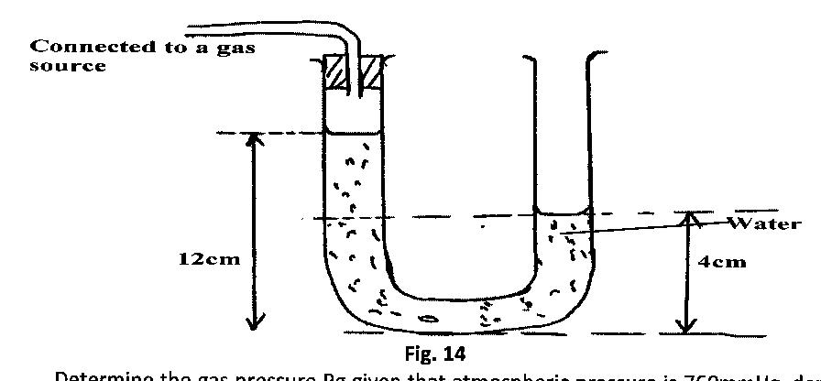
a) Determine the gas pressure Pg given that atmospheric pressure is 105000pa and density of
water is l000kgm⁻³ (3mks )

6. Mercury barometer reads 760mm at sea level and 700mm at the top of a mountain. If the density of mercury is 13600kgm⁻³, and the average density of air is 1.25kgm⁻³, calculate the height of the mountain. (3mks)

7.A block of density 2.5g/cm³ has dimensions 40cm x 15cm x 10cm.
- determine the volume of the block in m³(2marks)

- mass in SI unit(2marks)

- the weight of the block(1marks)

- maximum pressure it can exerts on the ground in pascals(2mks)

- Minimum pressure it can exerts on the ground in Pascals(2mks)

