SUNSHINE SCHOOL

FORM 2
CHEMISTRY
END TERM EXAM – OCT. 2015
TIME: 2 HOURS

NAME: …………………………………………..…CLASS:……..ADM NO ………………

INSTRUCTIONS
- Write your name and admission number on the spaces provided.
- Answer your questions in spaces provided.
- All working must be shown clearly.
- Silent electronic calculators may be used.

  - (a) Give the names of the following apparatus and state their uses. (2 mks)
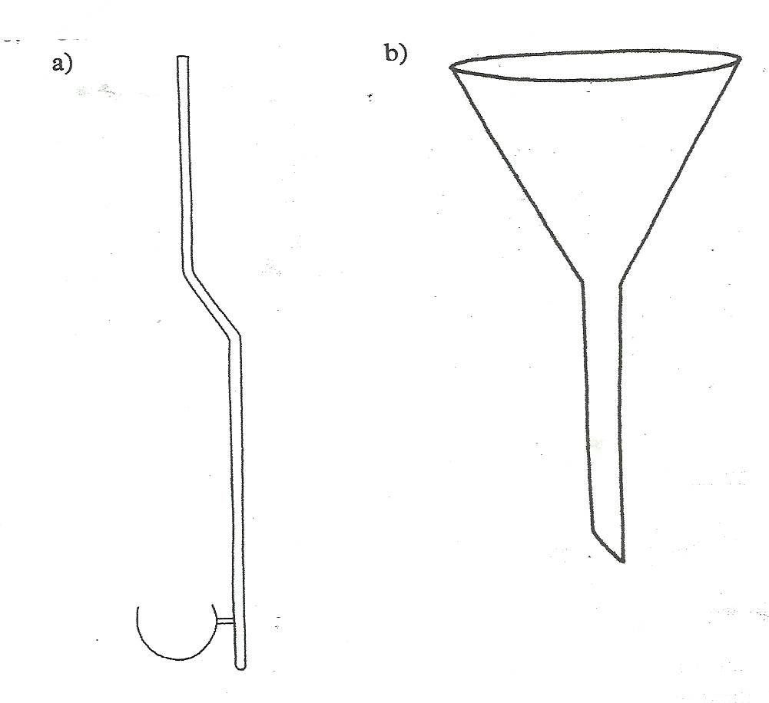
…………………………………………………………………………………………………
…………………………………………………………………………………………………
…………………………………………………………………………………………………
…………………………………………………………………………………………………
(b) The diagram below shows a non-luminous flame.
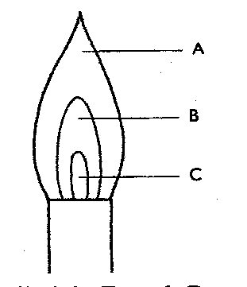
- Name the parts labelled: (3 mks)
A………………………………………………………………………………………
B………………………………………………………………………………………
C………………………………………………………………………………………
- Which part is the hottest? Explain. (1 mk)
…………………………………………………………………………………………………
………………………………………………………………………………………………….
…………………………………………………………………………………………………
…………………………………………………………………………………………………
  - Six solutions were tested with universal indicator and their pH values recorded.

Solution | pH value
A | 11.0
B | 2.0
C | 6.0
D | 7.0
E | 12.0
F | 3.0

- Classify the solutions according to the table below. (5 mks)
Weakest base
Strongest base
Weakest acid
Strongest acid
Neutral substance

  - (a) Describe how the following reagents can be used to prepare lead (II) sulphate: solid
sodium sulphate, distilled water, lead (II) carbonate and dilute nitric (V) acid. (4 mks)

…………………………………………………………………………………………………
…………………………………………………………………………………………………
…………………………………………………………………………………………………
…………………………………………………………………………………………………
…………………………………………………………………………………………………
…………………………………………………………………………………………………
…………………………………………………………………………………………………
…………………………………………………………………………………………………
…………………………………………………………………………………………………
…………………………………………………………………………………………………
…………………………………………………………………………………………………
…………………………………………………………………………………………………
- The flow chart below shows the effect of heat on salt H.
Solid H
Carbon (IV) oxide
Solid J
Ca(OH)_{2 (aq)}

Heat
H₂O

- Identify: (2 mks)

Solid H…………………………………………………………………………….
Solid J………………………………………………………………………………
- State one commercial use of solid J. (1 mk)

…………………………………………………………………………………………………
…………………………………………………………………………………………………
- State and explain the observation made when carbon (IV) oxide is bubbled through Ca(OH)_{2(aq)} for a short time. (1 mk)

…………………………………………………………………………………………………
…………………………………………………………………………………………………
…………………………………………………………………………………………………
…………………………………………………………………………………………………
  - The grid below represents part of the periodic table. Study it and answer the questions that follow
W |  |  |  | I |  |  | L | U
X | F |  | R | J | G |  | Q
Y
Z

- Name the chemical families to which the following elements belong (2mks)
a) W and X --------------------------------------------------------------------------------------------
b) L and Q --------------------------------------------------------------------------------------------

ii) Write the formula of the compound formed when F reacts with Q. (1mk)
…………………………………………………………………………………………………
…………………………………………………………………………………………………
- Compare the atomic radius of R and G. Explain (2mks)
…………………………………………………………………………………………………
…………………………………………………………………………………………………
…………………………………………………………………………………………………
…………………………………………………………………………………………………
- Compare the reactivity of L and Q. Explain. (2mks)
…………………………………………………………………………………………………
…………………………………………………………………………………………………
…………………………………………………………………………………………………
…………………………………………………………………………………………………
- F reacts with air to form two compounds. Write down two equations to show the formation of the compounds. (2mks)
…………………………………………………………………………………………………
…………………………………………………………………………………………………
…………………………………………………………………………………………………
…………………………………………………………………………………………………
vi) State one use of element U. (1mk)
…………………………………………………………………………………………………
…………………………………………………………………………………………………
b) Using dot and cross diagram show bonding in
i) R and Oxygen (1mk)

- Molecule of Q (1mk)

- Carbon (II) oxide (1mk)

  - (a) Differentiate between simple and fractional distillation. (1 mk)
…………………………………………………………………………………………………
…………………………………………………………………………………………………
…………………………………………………………………………………………………
…………………………………………………………………………………………………
…………………………………………………………………………………………………
(b) Given fresh green leaves of hibiscus flower, chromatogram paper, dropper, mortar and
pestle. Describe how you can separate the components of chlorophyll in leaves.
(3 mks)

…………………………………………………………………………………………………
…………………………………………………………………………………………………
…………………………………………………………………………………………………
…………………………………………………………………………………………………
…………………………………………………………………………………………………
…………………………………………………………………………………………………
…………………………………………………………………………………………………
- State two applications of chromatography. (2 mks)
…………………………………………………………………………………………………
…………………………………………………………………………………………………
…………………………………………………………………………………………………
…………………………………………………………………………………………………
  - The diagram below shows a heating curve.
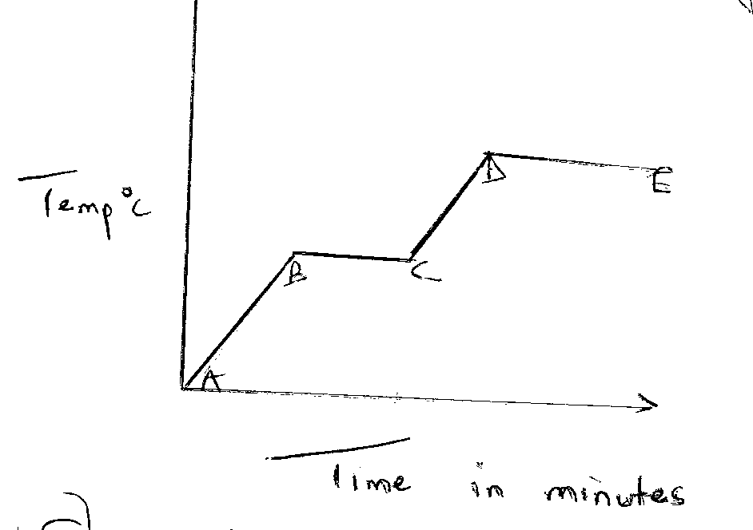
State what happens at BC and DE. (2 mks)
…………………………………………………………………………………………………
…………………………………………………………………………………………………
…………………………………………………………………………………………………
…………………………………………………………………………………………………
  - Classify the changes below as permanent or temporary chagnes;
- CuCO₃ CuO_{(s)} + CO_{2(g)} (1 mk)

- Iodine Iodine (1 mk)
(crystals) (purple vapour)

- Give one reason for categorizing each of the change above. (1 mk)
…………………………………………………………………………………………………
…………………………………………………………………………………………………
…………………………………………………………………………………………………
…………………………………………………………………………………………………

  - Use the following scheme to answer the questions that follow:
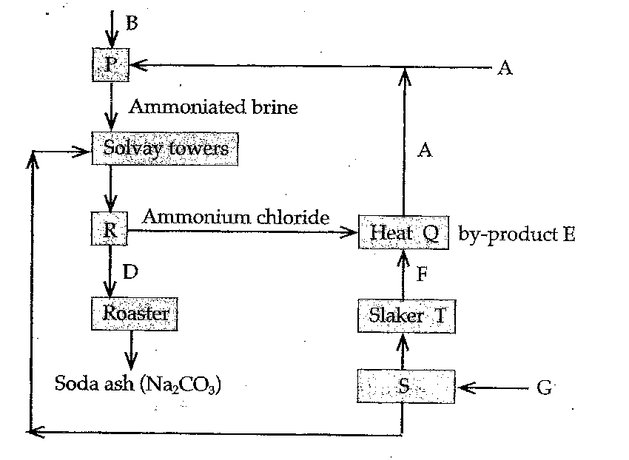
(a) Name the raw materials A, B and G. (3 mks)
A……………………………………………………………………………………
B……………………………………………………………………………………………
G……………………………………………………………………………………………
(b) Write equations for the reactions taking place at Q, S and T. (3 mks)
Q:…………………………………………………………………………………………
S:…………………………………………………………………………………………
T:…………………………………………………………………………………………
(c) Name two recycled substances and show the chemical equations for the reactions
leading to their production. (4 mks)

…………………………………………………………………………………………………
…………………………………………………………………………………………………
…………………………………………………………………………………………………
…………………………………………………………………………………………………
…………………………………………………………………………………………………
…………………………………………………………………………………………………
…………………………………………………………………………………………………
- Name by-product E. (1 mk)
…………………………………………………………………………………………………
- Name substance D. (1 mk)
…………………………………………………………………………………………………
- Name the physical processes in chamber: (3 mks)
Chamber R…………………………………………………………………………………
Chamber T…………………………………………………………………………………
Chamber S…………………………………………………………………………………
- Give the use of baffles found inside the solvay towers. (1 mk)
…………………………………………………………………………………………………
…………………………………………………………………………………………………
- Outline two commercial uses of sodium carbonate. (2 mks)
…………………………………………………………………………………………………
…………………………………………………………………………………………………
  - Study the diagram below and answer the questions that follow.
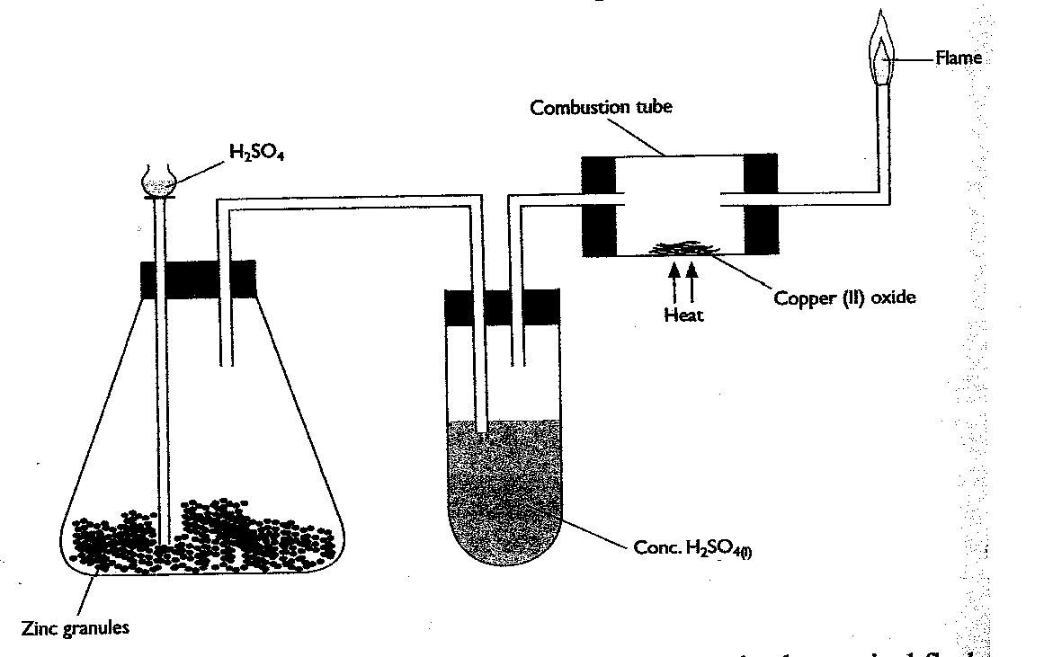

- Write a balanced equation for the reaction taking place at:
(i) conical flask (1 mk)
…………………………………………………………………………………………………
…………………………………………………………………………………………………
(ii) the combustion tube (1 mk)
…………………………………………………………………………………………………
…………………………………………………………………………………………………
- State the use of the concentrated sulphuric (VI) acid. (1 mk)
…………………………………………………………………………………………………
- State the product formed at the flame and one chemical test for this product on cooling.
(2 mks)

…………………………………………………………………………………………………
…………………………………………………………………………………………………
  - Study the flow chart below and answer the questions that follow.
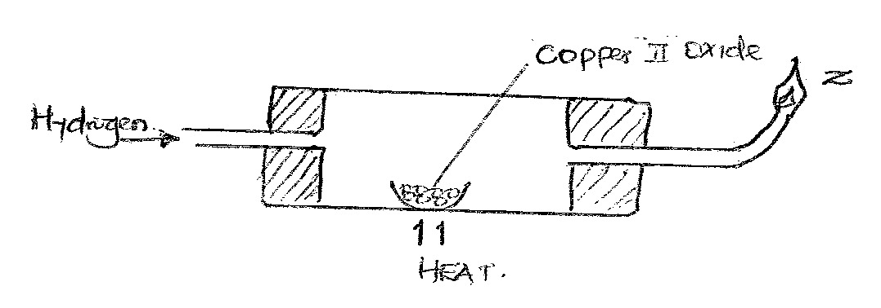
- State the observation made in the combustion tube. (1 mk)
…………………………………………………………………………………………………
…………………………………………………………………………………………………
…………………………………………………………………………………………………
…………………………………………………………………………………………………
- State a precaution taken before the gas is burnt at Z. (1 mk)
…………………………………………………………………………………………………
…………………………………………………………………………………………………
- Write a balanced chemical equation for the reaction at: (2 mks)
(i) Z
…………………………………………………………………………………………………
…………………………………………………………………………………………………
(ii) The combustion tube
…………………………………………………………………………………………………
…………………………………………………………………………………………………
  - The diagram below shows fractional distillation of liquid air.
AIR

Filters

Concentrated sodium
Hydroxide solution

-25⁰C

Compression
200 atm
-200⁰C

Fractional distillation

-196⁰C -186⁰C -183⁰C
A B C

- Explain why air is passed through concentrated sodium hydroxide. (1 mk)

………………………………………………………………………………………………
………………………………………………………………………………………………
………………………………………………………………………………………………
- Write an equation to show what would happen if calcium hydroxide was used to place of sodium hydroxide. (1 mk)

………………………………………………………………………………………………
………………………………………………………………………………………………
………………………………………………………………………………………………

- Identity the gases A, B and C. (3 mks)
A……………………………………………………………………………………………
B…………………….………………………………………………………………………
C…………………………………….………………………………………………………

  - The table below outlines some properties of substances U, V, W, X, Y. Use it to answer the questions that follow.

 | M.P | B.P | Electrical Conductivity
 |  |  | Solid | Liquid
U | 1083 | 2995 | Good | Good
V | 801 | 1413 | Poor | Good
W | 5 | 80 | Poor | Poor
X | -115 | -84 | Poor | Poor
Y | 3550 | 4927 | Poor | Poor

- Which substance is likely to be: (1 mk)
(i) a liquid at room temperature ……………………………………………………..

- Which substance is likely to have the following structure: (4 mks)
(i) simple molecular structure ………………………………………………………..
(ii) giant atomic structure……………………………………………………………..
(iii) giant ionic structure……………………………………………………………….
(iv) giant metallic structure……………………………………………………………

