SUNSHINE SCHOOL

FORM 2
PHYSICS THEORY
END TERM EXAM – OCT. 2015
TIME: 2 HOURS

NAME:………………………………………………………….CLASS:……..ADM NO:….…

INSTRUCTIONS

- Write your name, class and admission number.
- This paper consists of two section A and B.
- Attempt al the questions in both sections.

FOR EXAMINERS USE ONLY

SECTION | QUESTION | MAX SCORE | CANDIDATE’S SCORE
A | 1 – 10 | 25
B | 11 – 15 | 55
 | TOTAL | 80

SECTION A (25 MARKS)

- Define force and state it SI units. (2 mks)
…………………………………………………………………………………………………..
…………………………………………………………………………………………………..
…………………………………………………………………………………………………..
- The figure below shows the level of water before and after a stone was immersed into the measuring cylinder. If the mass of the stone is 200g. Determine its density. (3 mks)
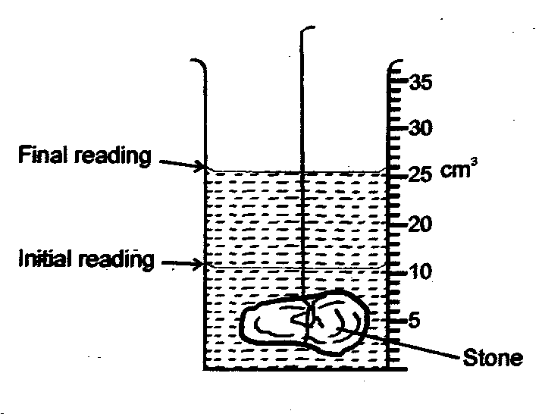

…………………………………………………………………………………………………..
…………………………………………………………………………………………………..
…………………………………………………………………………………………………..
…………………………………………………………………………………………………..
…………………………………………………………………………………………………..
…………………………………………………………………………………………………..
- State the role of the following in the Brownian motion experiment. (3 mks)
- Smoke particles
…………………………………………………………………………………………………..
…………………………………………………………………………………………………..
- Lens
…………………………………………………………………………………………………..
…………………………………………………………………………………………………..
- Microscope
…………………………………………………………………………………………………..
…………………………………………………………………………………………………..
- The figure below shows a wave travelling from a point A to B at a speed of 40 cm/s and takes 0.14s. Determine the wavelength of the wave. (3 mks)

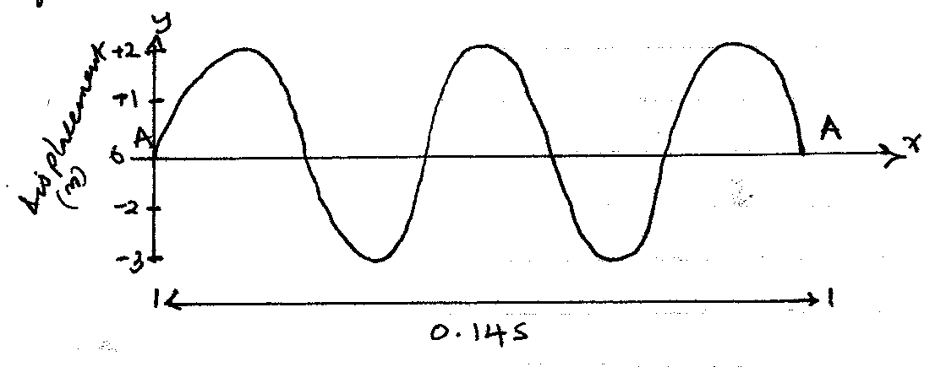
…………………………………………………………………………………………………..
…………………………………………………………………………………………………..
…………………………………………………………………………………………………..
…………………………………………………………………………………………………..
…………………………………………………………………………………………………..
…………………………………………………………………………………………………..
- Name the type of mirror used in the following: (2 mks)
- Car head lights
…………………………………………………………………………………………………..
- Underground car parking area.
…………………………………………………………………………………………………..
- State three properties of a good thermometer liquid. (3 mks)

…………………………………………………………………………………………………..
…………………………………………………………………………………………………..
…………………………………………………………………………………………………..
…………………………………………………………………………………………………..
- State two uses a gold leaf electroscope. (2 mks)

…………………………………………………………………………………………………..
…………………………………………………………………………………………………..
…………………………………………………………………………………………………..
…………………………………………………………………………………………………..
- A liquid of density 1.2 g/cm³ and volume 50 cm³ is mixed with another liquid of mass 40g and density 1.6 g/cm³. Determine the density of the mixture. (2 mks)

…………………………………………………………………………………………………..
…………………………………………………………………………………………………..
…………………………………………………………………………………………………..
…………………………………………………………………………………………………..
…………………………………………………………………………………………………..
- (a) Give one advantage of lead acid accumulator over alkaline accumulator. (1 mks)
…………………………………………………………………………………………………..
…………………………………………………………………………………………………..
(b) Explain any two defects of a simple cell. (2 mks)
…………………………………………………………………………………………………..
…………………………………………………………………………………………………..
…………………………………………………………………………………………………..
…………………………………………………………………………………………………..
…………………………………………………………………………………………………..
- An oil drop of radius 7 mm spreads on the surface of water to form a patch of radius 70 mm. Determine the diameter of an oil molecule. (2 mks)

…………………………………………………………………………………………………..
…………………………………………………………………………………………………..
…………………………………………………………………………………………………..
…………………………………………………………………………………………………..
…………………………………………………………………………………………………..
…………………………………………………………………………………………………..

SECTION B (55 MARKS)

- (a) The figure below shows a u-tube manometer in which liquid X of density 1.6 g/cm³
balances liquid Y. Determine the density of liquid Y. (3 mks)

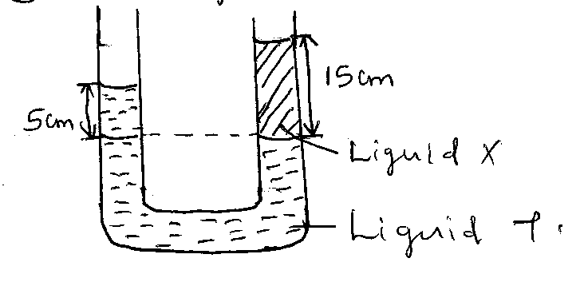
…………………………………………………………………………………………………..
…………………………………………………………………………………………………..
…………………………………………………………………………………………………..
…………………………………………………………………………………………………..
…………………………………………………………………………………………………..
…………………………………………………………………………………………………..
(b) The area of piston l is 20 cm² and that of piston 2 is 100 cm² in the hydraulic machine shown below. A mass of 2 kg is placed on top of piston l. Determine the value of mass P. (4 mks)
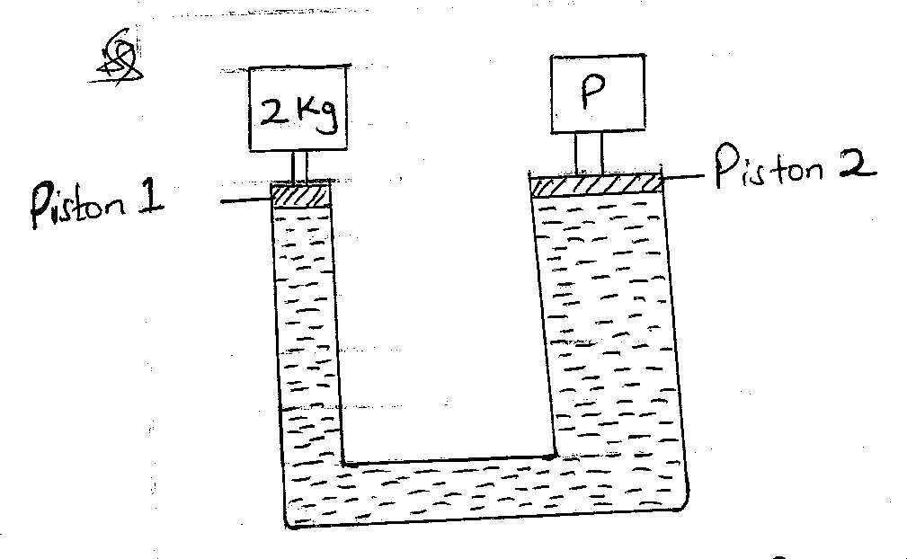

…………………………………………………………………………………………………..
…………………………………………………………………………………………………..
…………………………………………………………………………………………………..
…………………………………………………………………………………………………..
…………………………………………………………………………………………………..
…………………………………………………………………………………………………..
…………………………………………………………………………………………………..
(c) (i) State Bernoulli’s effect. (1 mk)

…………………………………………………………………………………………………..
…………………………………………………………………………………………………..
(ii) The rate of flow of blood in an aorta of cross-sectional area 0.8 cm² is 40 cm³S⁻¹. Calculate the velocity of the blood in the aorta. (3 mks)

…………………………………………………………………………………………………..
…………………………………………………………………………………………………..
…………………………………………………………………………………………………..
…………………………………………………………………………………………………..
…………………………………………………………………………………………………..
…………………………………………………………………………………………………..
- (a) A spiral spring produces an extension of 6mm when a force 0.3N is applied to it.
Calculate the spring constant for a system when two such springs are in series. (3 mks)

…………………………………………………………………………………………………..
…………………………………………………………………………………………………..
…………………………………………………………………………………………………..
…………………………………………………………………………………………………..
…………………………………………………………………………………………………..
…………………………………………………………………………………………………..
(b) (i) Define velocity. (1 mk)
…………………………………………………………………………………………………..
…………………………………………………………………………………………………..
(ii) A stone is projected vertically upwards at a velocity of 40 m/s. Determine:

- The maximum height reached. (2 mks)
…………………………………………………………………………………………………..
…………………………………………………………………………………………………..
…………………………………………………………………………………………………..
…………………………………………………………………………………………………..
…………………………………………………………………………………………………..
…………………………………………………………………………………………………..
- The time taken to reach maximum height. (2 mks)
…………………………………………………………………………………………………..
…………………………………………………………………………………………………..
…………………………………………………………………………………………………..
…………………………………………………………………………………………………..
- The time of flight of stone. (1 mk)
…………………………………………………………………………………………………..
…………………………………………………………………………………………………..
…………………………………………………………………………………………………..
- The velocity of return to the point of projection. (1 mk)
…………………………………………………………………………………………………..
…………………………………………………………………………………………………..
…………………………………………………………………………………………………..

- Sketch the displacement-time graph for the motion above. (1 mk)

- (a) Complete the diagram below to show how the image of the object is formed on the screen
of the pinhole camera. (2 mks)

(b) State two adjustments required by the camera to take a permanent picture. (2 mks)

…………………………………………………………………………………………………..
…………………………………………………………………………………………………..
…………………………………………………………………………………………………..
…………………………………………………………………………………………………..
- State two effects observed when the hole of the camera is enlarged. (2 mks)

…………………………………………………………………………………………………..
…………………………………………………………………………………………………..
…………………………………………………………………………………………………..
…………………………………………………………………………………………………..
- State the disadvantage of using a pinhole camera to take pictures. (2 mks)

…………………………………………………………………………………………………..
…………………………………………………………………………………………………..
…………………………………………………………………………………………………..
…………………………………………………………………………………………………..
- An object of height 8 cm is placed 10 cm away form a pinhole camera. The screen is 14 cm from the pinhole. Determine the height of image formed. (3 mks)

…………………………………………………………………………………………………..
…………………………………………………………………………………………………..
…………………………………………………………………………………………………..
…………………………………………………………………………………………………..
…………………………………………………………………………………………………..
…………………………………………………………………………………………………..
- (a) State the principle of moments. (1 mk)

…………………………………………………………………………………………………..
…………………………………………………………………………………………………..
(b) State one factor determining turning effect of a force. (1 mk)

…………………………………………………………………………………………………..
…………………………………………………………………………………………………..
- A uniform metre rule is balanced at the 20 cm when a load of 1.2N is hung at the zero weight. Determine the:
- Mass and weight of the metre rule. (5 mks)

…………………………………………………………………………………………………..
…………………………………………………………………………………………………..
…………………………………………………………………………………………………..
…………………………………………………………………………………………………..
…………………………………………………………………………………………………..
…………………………………………………………………………………………………..
…………………………………………………………………………………………………..
…………………………………………………………………………………………………..
- Reaction at the pivot. (3 mks)
…………………………………………………………………………………………………..
…………………………………………………………………………………………………..
…………………………………………………………………………………………………..
…………………………………………………………………………………………………..
…………………………………………………………………………………………………..
- Explain why it isn’t safe for a double decker bus to carry standing passengers on the upper decker. (1 mk)

…………………………………………………………………………………………………..
…………………………………………………………………………………………………..
- (a) Draw the magnetic field pattern around the following. (2 mks)

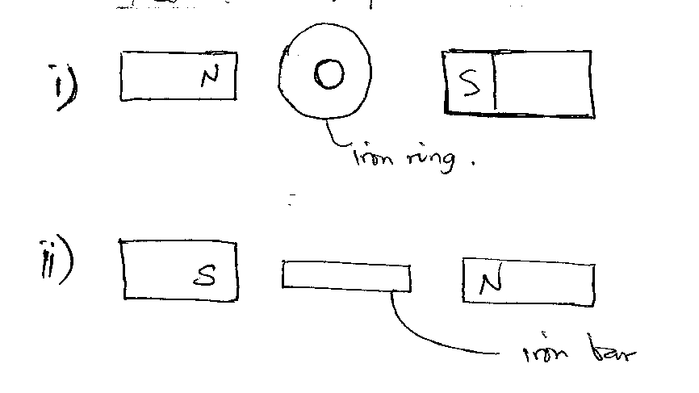

(b) Explain using a diagram how keepers help to retain magnetism in stored magnets. (3 mks)

…………………………………………………………………………………………………..
…………………………………………………………………………………………………..
…………………………………………………………………………………………………..
…………………………………………………………………………………………………..
(c) Explain why a student can magnetize an iron rod by hammering it in a north-side direction with respect to earth. (2 mks)

…………………………………………………………………………………………………..
…………………………………………………………………………………………………..
…………………………………………………………………………………………………..
…………………………………………………………………………………………………..
- The diagram below shows a wire carrying current placed in a magnetic field.

- Draw the magnetic field pattern around the conductor and indicate the direction of force. (2 mks)

- Explain how the force in (i) above is produced. (2 mks)

…………………………………………………………………………………………………..
…………………………………………………………………………………………………..
…………………………………………………………………………………………………..
…………………………………………………………………………………………………..
…………………………………………………………………………………………………..

END

