HOLA SECONDARY SCHOOL
BIOLOGY FORM TWO TERM ONE 2013
TIME: 1 HOUR 30 MINUTES
NAME: CLASS: ADM NO:
- The diagram below represents a transverse section of a young stem
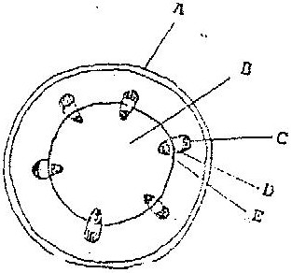

  - Name the parts labeled A and B ( 2 mks)

  - State the functions of the parts labeled C, D and E ( 3 mks)

c. List three differences between the section shown above and one that would be obtained from the root of the same plant (3 mks)

2. (a) state the role of light in the process of photosynthesis ( 1 mk)
(b) Name one end product of dark reaction in photosynthesis (1 Mk)

- The diagram below represents then pathways of water from the soil into the plant.

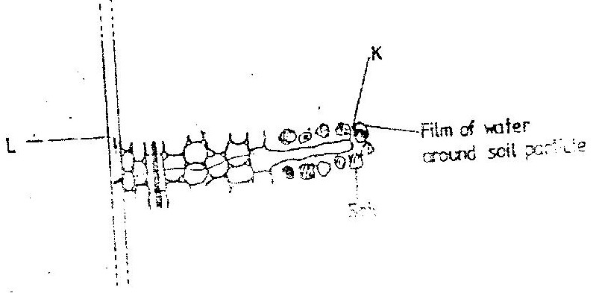

- Name the structures labeled K and L. ( 2 mks)

- Explain how water from the soil reaches the structure labeled L. (5 mks)

- Name the process by which mineral salts enter into the plant ( 1 mk)

- State the functions of the following cell organelles (2 MKS )
  - Golgi apparatus

  - Ribosomes

- state four ways in which xylem vessels are adapted to their function (4 mks )

- Name a disease caused by lack of each of the following in human diet. ( 2 mks )
Vitamin D
Iodine

7. State one use for each of the following apparatus in the study of living organisms.(2 mks)
(a) Pooter
(b) Pitfall trap

8. The diagram represents part of the human digestive system.
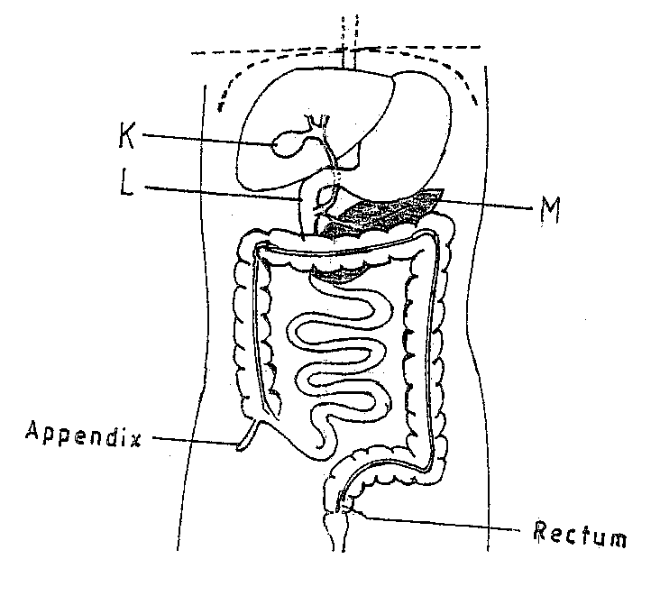
- Name the organs labeled L and M.(2 mks)
L

M
- (i) Name the substance produced by organ K (1 mk)

(ii) state two roles of the substance name in b (i) above. (2 mk)

9. The number of stomata on the lower and upper surface of two leaves from plant X and Y were counted under the field of view of a light microscope. The results were as shown in the table below.

Leaf | Number of stomata
 | Upper surface | Lower surface
X | 4 | 12
Y | 20 | 23

- Which of the leaves would be expected to have a lower rate of transpiration?(1 mk)

- Given a reason for your answer in (a) above. (1 MK)

- The set-up below illustrates a procedure that was carried out in the laboratory with a leaf plucked from a green plant that had been growing in sunlight.

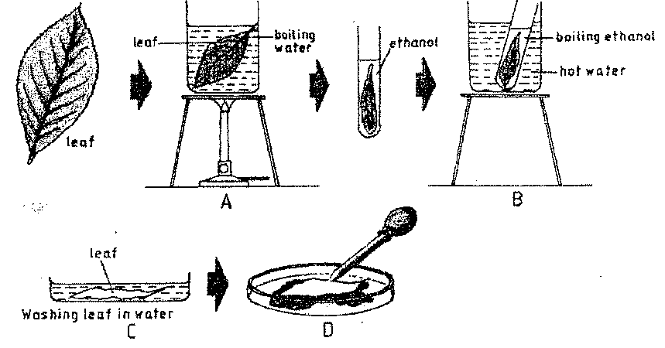

(i) What was the purpose of the above procedure? (1 mark)
(ii) Give reasons for carrying out steps A, B and C in this procedure. (3 marks)

(iii) Name the reagent that was used at the step labeled D. (1 mark)
(iv) State the expected result on the leaf after adding the reagent named in (iii) above.
- mark
- (a) The type of circulatory system found in members of the class insecta is………………….. (1 mk)

(b) Name the blood vessel that transports blood from: (2mks)
(i) Small intestines to the liver
(ii) Lungs to the heart

- The diagram below represents part of phloem tissue.

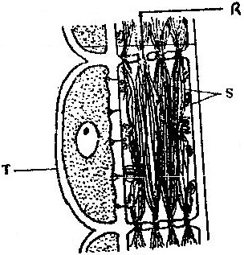

a) Name the structures labeled R and S and the cell labeled T. (3 mks)
R-
S-
Cell labeled T
b) State the function of the structure labeled S (1 mk)
c) Explain why xylem is a mechanical tissue (1 mk)

- The diagram below shows a vertical section through a mammalian heart.
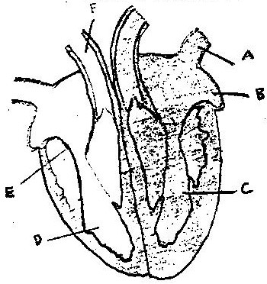

a) Name the parts labeled A,B,E and F (4mk)

b) Use arrows to show the direction in which blood flows in the heart.
(2mks)
c) Give a reason why the wall of chamber C is thicker than
chamber D (2mks)

14. a) What is diffusion (2mks)

b) how do the following factors affect the rate of diffusion?
i) Diffusion gradient (1mk)

ii) Surface area volume ratio (1mk)

iii) Temperature (1mk)

c) Outliner three roles of active transport in the human body (3mks)

- The diagram below represents a cell.
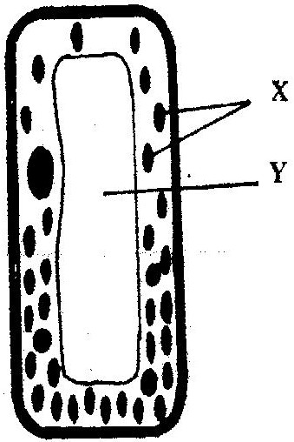

(a) Name the parts labeled X and Y (2mk)
X ……………………………………..
Y ……………………………………..
(b) Suggest why the structures labelled X would be more on one side
than the other. (1mks

