HOLA SECONDARY SCHOOL

MID TERM EXAMINATION
YEAR 2013
GEOGRAPHY
FORM THREE
PAPER 1
TIME: 2 HOURS 45 MINUTES

NAME_____________________________________CLASS_________ADM/NO.___________

1. (a) (i) Give the two dates in a year during which the number of hours of
darkness is equal in both the north and south poles.

(ii) Why do the lengths of days and nights vary from one part of the earth to another?

(b) The diagram below shows the revolution of the earth around the sun. Use it to answer the questions that follow
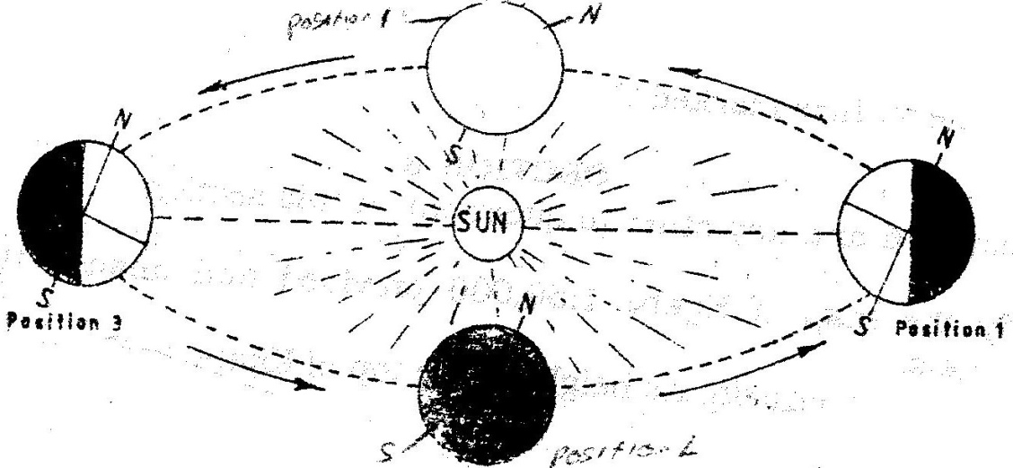

(i) If the earth takes 366 days to make a complete revolution during a leap year, how long will it take to move from position 1 to position 4?

(ii) What season is experienced in the southern hemisphere when the earth is in Position 1?
2. (a) State two conditions that are necessary for the formation of fog.

(b) The diagram below shows some types of clouds. Use it to answer the questions that follow.
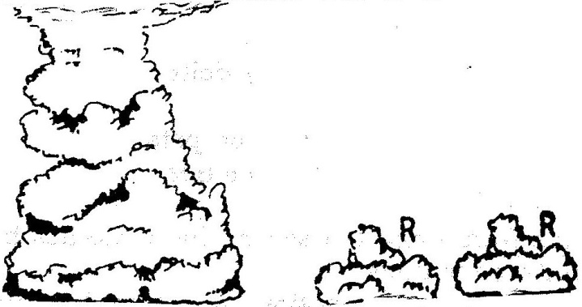

(i) Name the clouds marked R

(ii) Give two weather conditions associated with cumulonimbus clouds

3. (a) What is mechanical weathering?
(b) How is an exfoliation dome formed?

4. (a) State three climatic conditions experienced in the Sahara desert

(b)State three ways in which plants adapt to hot desert conditions

5 (a)
(i) What is a rock?
(ii) Describe three ways through which sedimentary rocks are formed
  - Mechanically formed
  - Organically formed
  - Chemically formed
- Describe two process through which sedimentary rocks changer into metamorphic rocks
- Give an example of each of the following types of igneous rocks
- Plutonic rocks
- Hypabyssal rocks
- Volcanic rocks

(e) Suppose you were to carry out a field study of rocks within the vicinity of your
school
(i) Name three secondary sources of information you would use to prepare for the field study
(ii) State four activities you would carry during the filed study
(iii) State three problems you are likely to experience during the field study

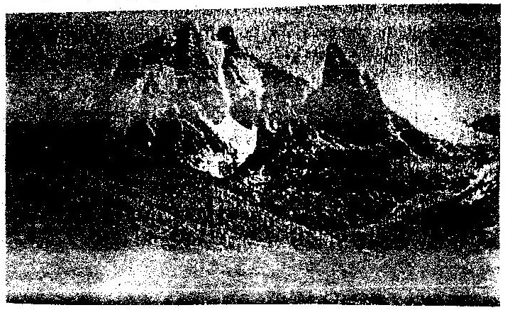
6. Study the photograph below and use it to answer questions (a)

(a) (i) Name the type of photograph shown
(ii) Draw a rectangle measuring 15cm to 10cm to represent the area of
photograph
(iii) On the rectangle draw a sketch of the photograph and label three physical
features

7) a) the tables below represent rainfall and temperature of stations X and Y.
Use them to answer questions (a) and (b)
MONTHS | J | F | M | A | M | J | J | A | S | O | N | D
TEMPERATURE IN ^{0c} | 30 | 31 | 31 | 31 | 30 | 29 | 29 | 28 | 28 | 29 | 29 | 30
RAINFALL IN MM | 250 | 250 | 325 | 300 | 213 | 25 | 25 | 25 | 100 | 275 | 380 | 200

MONTHS | J | F | M | A | M | J | J | A | S | O | N | O
TEMPERATURE IN ⁰C | 21 | 20 | 20 | 17 | 15 | 13 | 12 | 13 | 15 | 16 | 18 | 20
RAINFALL IN MM | 12 | 12 | 15 | 50 | 90 | 110 | 87 | 87 | 50 | 35 | 20 | 15

a) (i) for each of the two stations calculate the mean annual temperature.
X -
Y -
(ii) Calculate the annual rainfall for station Y
(iii) On the graph paper provided, draw a bar graph to represent rainfall for station x. Use vertical scale of 1cm to represent 50mm
b) Describe the climatic characteristics of station Y.
c) (i) Describe how conventional rainfall in the lake region of Kenya

8(a) i) A part from the Rift Valley name two other relief features that
were formed as result of faulting. (2mks)
ii) With the aid of a well labeled diagram, describe how a Rift Valley is formed by tensional forces. (8mks)
b) Explain four effects of faulting (8mks)
c) Students are planning to carry out a field study of an area affected by faulting
i) State four reasons why it is important for the students to have a pre-visit of the area (4mks)
ii) One of the ways they would use to collect data is through direct observation. Give three disadvantages of direct observation in the study of such an area.

