NAME……………………………………………………………………………………… ADM NO……………………….
DATE…………………………………
231/3
BIOLOGY
Paper3
(Practical)
2017
1¾ hrs.

HOLA SECONDARY SCHOOL
Form 4
BIOLOGY
Paper3
(Practical)
February 217
1¾ hrs

Instructions
- Write your name and admission number in the spaces provided at the top of this page.
- Sign and write the date of examination in the spaces provided above.
- Answer ALL the questions.
- You are required to spend the first 15 minutes of the 1¾ hours allowed for this paper reading the whole paper carefully before commencing your work.
- Answers MUST be written in the spaces provided in this question paper.
- Additional pages MUST NOT be inserted.
- This paper consists of five (5) printed pages.
- Check the question paper to ascertain that all the pages are printed as indicated and that no questions are missing.
For Examiner’s Use Only
Question | Maximum Score | Candidate’s Score
1 | 09
2 | 16
3 | 15
Total Score | 40
- You are provided with solution S, Iodine solution (Solution A), Benedict’s solution (solution B), Sodium Hydroxide Solution (NaOH) (Solution C) and Copper Sulphate solution (Solution D). Carry out the tests as indicated in the table below. (9 mks)

Test | Procedure | Observations | Conclusion

- Study the specimens provided below.
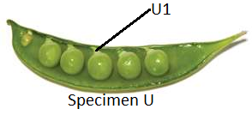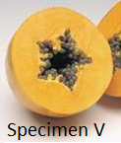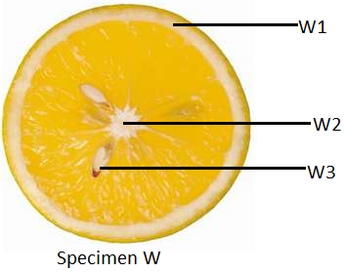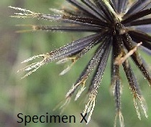
- Name the parts labeled U1, W1, W2 and W3. (4 mks)
U1
…………………………………………………………………………………………………………………………………………………..…
W1
…………………………………………………………………………………………………………………………………………………..…
W2
……………………………………………………………………………………………………………………………………………………..
W3
...........................................................................................................................................................
- (i) Suggest the mode of dispersal of the specimen labeled U. (1 mk)
……………………………………………………………………………………………………………………………………………………..
(ii) Give a reason for your answer in (b) (i) above. (1 mk)
……………………………………………………………………………………………………………………………………………………
- (i) Suggest the mode of dispersal of the specimen labeled X. (1 mk)
……………………………………………………………………………………………………………………………………………………
(ii) Give a reason for your answer in (c) (i) above. (1 mk)
……………………………………………………………………………………………………………………………………………………..
- On the specimen V, label the mesocarp and placenta. (2 mks)

- State two advantages of dispersal in plants. (2 mks)
…………………………………………………………………………………………………………………………………………………..…
……………………………………………………………………………………………………………………………………………………..
- State the type of placentation of specimen U, V and W. (3 mks)
U
…………………………………………………………………………………………………………………………………………………..…
V
…………………………………………………………………………………………………………………………………………………..…
W
………………………………………………………………………………………………………………………………………………….....
- What is parthenocarpy? Give an example of a fruit that shows parthenocarpy (2 mks)
…………………………………………………………………………………………………………………………………………………..…
……………………………………………………………………………………………………………………………………………………..
3.You are provided with the specimens below.
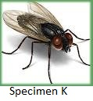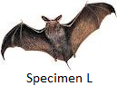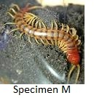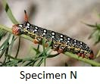
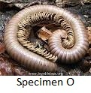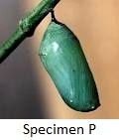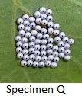
- Giving reasons, state the classes in which specimens K, L and M belong. (6 mks)
Specimen K
……………………………………………………………………………………………………………………………………………………
Reason
……………………………………………………………………………………………………………………………………………………

Specimen L
……………………………………………………………………………………………………………………………………………………
Reason
……………………………………………………………………………………………………………………………………………………
Specimen M
……………………………………………………………………………………………………………………………………………………
Reason
……………………………………………………………………………………………………………………………………………………
- Specimen N, P and Q represent life stages of insects. Identify the specimens. (3 mks)
N
…………………………………………………………………………………………………………………………………………………..…
P
…………………………………………………………………………………………………………………………………………………..…
Q
……………………………………………………………………………………………………………………………………………………..
- Give two reasons why specimen N represents a very important life stage in insects. (2 mks)
…………………………………………………………………………………………………………………………………………………..…
……………………………………………………………………………………………………………………………………………………..
- Give one way in which specimen M differs from specimen O. (1 mk)
……………………………………………………………………………………………………………………………………………………..
- Give the name of the life cycle represented by N, P and Q (1mks)

- Give one way in which specimen K is a health hazard. (1 mk)
……………………………………………………………………………………………………………………………………………………..

