HOLA SECONDARY SCHOOL
Mid-Term Examinations- February 2017
PHYSICS FORM ONE
TIME: 1 ½ HOURS

Name ……………………………..………...…………. Adm. No …………………

Class ………………………………………………... Date ………………..........

INSTRUCTIONS:
• Write your name, class and admission number in spaces provided above
• Answer ALL the questions in the spaces provided
• Mathematical tables and electronic calculators may be used
• All working must be clearly shown where necessary.
.
- The initial level of water in a burette was 20.3 cm³. 20 drops each of volume 0.02 cm³ were let out into a beaker placed below the burette. Determine the final level of water. (2 marks)

………………………………………………………………………………………………………………………………………………………………………………………………………………………………………………………………………………………………………………………………………
- An object is thrown vertically upwards. Name two forces that acts on the object. (2 marks)
…………………………………………………………………………………………………………………………………………………………………………………………………………………………
- Give two factors that lower the surface tension of water. (2 marks)
…………………………………………………………………………………………………………………………………………………………………………………………………………………………
- Explain why in a vacuum flask the walls enclosing the vacuum are silvered on the inside.
(2 marks)
………………………………………………………………………………………………………………………………………………………………………………………………………………………………………………………………………………………………………………………………………

- State two disadvantages of anomalous expansion of water. (2 marks)
…………………………………………………………………………………………………………………………………………………………………………………………………………………………
- A building standing 100m from a pinhole camera produces on the screen of the camera an image 5 cm high 10 cm behind the pinhole. Determine the actual height of the building. ( 3 marks)

………………………………………………………………………………………………………………………………………………………………………………………………………………………………………………………………………………………………………………………………………

- Two identical spheres A and B each standing on an insulated base are in contact. A negatively charged rod is brought near sphere A as shown below
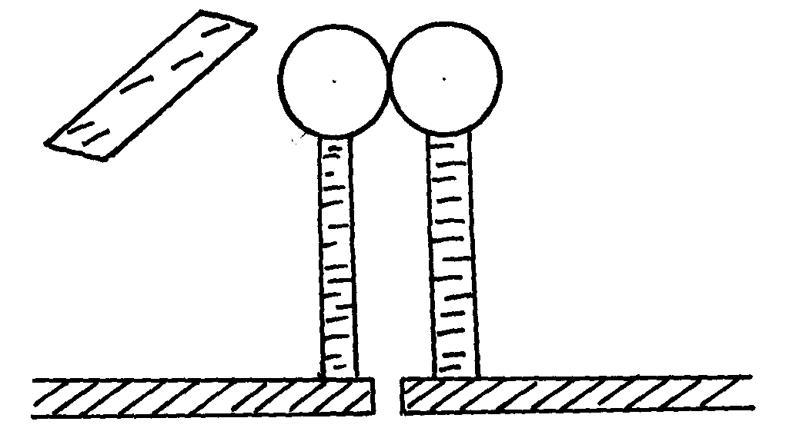
A
B

In what way will A differ from B if separated while the rod is near? (2 marks)
…………………………………………………………………………………………………………………………………………………………………………………………………………………………
- A glass rod can be charged positively by rubbing it with silk. Explain what happens when the glass rod is being charged. (2 marks)

………………………………………………………………………………………………………………………………………………………………………………………………………………………………………………………………………………………………………………………………………
- Explain how you can charge an electroscope positively by the method of induction. (3 marks)
…………………………………………………………………………………………………………………………………………………………………………………………………………………………………………………………………………………………………………………………………………………………………………………………………………………………………………………………………………………………………………………………………………………………………

- a) Define the term electric current (1 mark)
…………………………………………………………………………………………………………………………………………………………………………………………………………………………
b) Calculate the quantity of charge that passes in a circuit for 3 minutes when a current of 2A is flowing. (2 marks)
………………………………………………………………………………………………………………………………………………………………………………………………………………………………………………………………………………………………………………………………………
- Give two reasons why domestic light bulbs are connected in parallel. (2 marks)
…………………………………………………………………………………………………………………………………………………………………………………………………………………………

- A block measuring 20cm x 10cm x 5cm rests on a flat surface. The block has a weight of 30N. Determine the maximum pressure it exerts on the surface. (3 marks)
………………………………………………………………………………………………………………………………………………………………………………………………………………………………………………………………………………………………………………………………………
- Explain why feet feel colder in the morning when a person stands on a cemented floor than when a wooden floor. (2 marks)
………………………………………………………………………………………………………………………………………………………………………………………………………………………………………………………………………………………………………………………………………
- What is Brownian motion? (1 mark)
…………………………………………………………………………………………………………………………………………………………………………………………………………………………

- What property of light is suggested by the formation of shadows? (1 mark)
…………………………………………………………………………………………………………………………………………………………………………………………………………………………
- Differentiate between the images formed by plane mirrors and that formed by a pinhole camera.
(2 marks)
…………………………………………………………………………………………………………………………………………………………………………………………………………………………
- State and explain the effect of enlarging the size of hole in a pinhole camera on the image formed.
(2 marks)
………………………………………………………………………………………………………………………………………………………………………………………………………………………………………………………………………………………………………………………………………
- An object O is placed in front of a plane mirror M. Locate the image formed as viewed by the observer’s eye. (2 marks)
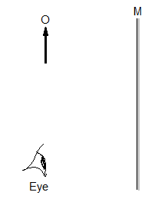
- a) Define the term pressure. (1 mark)
…………………………………………………………………………………………………………………………………………………………………………………………………………………………
b) A boy standing upright exerts a pressure of 13600 Pa on the floor. Given that the total area of contact of shoes and floor is 0.0368m², determine the pressure he would exert on the floor if he stood on one foot. (3 marks)
……………………………………………………………………………………………………………………………………………………………………………………………………………………………………………………………………………………………………………………………………………………………………………………………………………………………………………………
- State two factors that affect pressure in liquids. (2 marks)
…………………………………………………………………………………………………………………………………………………………………………………………………………………………
- A force of 10 N is applied on the small piston of a hydraulic lift of cross-sectional area 0.01 m² in order to compress a cotton bale placed on a large piston of area 10 m². Determine the force produced to compress the bale. (3 marks)
……………………………………………………………………………………………………………………………………………………………………………………………………………………………………………………………………………………………………………………………………………..........................................................................................................................................................
- What is diffusion? (1 mark)
…………………………………………………………………………………………………………………………………………………………………………………………………………………………
- Give a reason why when determining the upper fixed point of a thermometer scale, steam and not water is used. (1 mark)
…………………………………………………………………………………………………………………………………………………………………………………………………………………………

