HOLA SECONDARY SCHOOL

232/3
PHYSICS FORM THREE
Paper 3
PRACTICAL
2 ½ hours
February 2017

Name................................................................................ Class.................... Adm/No.................

INSTRUCTIONS TO CANDIDATES.

- Answer all the questions in the spaces provided in this question paper.
- You are supposed to spend the first 15 minutes of the 2 ½ hours allowed for this paper reading the whole paper carefully before commencing your work.
- Marks are given for a clear record of the observations actually made, their suitability and accuracy, and the use made of them.
- Candidates are advised to record their observations as soon as they are made.
- Mathematical tables and non-programmable electronic calculators may be used.

FOR EXAMINERS USE ONLY.

Question 1
 | a | e | f | g | i | j | k
Maximum score | ½ | 7 | 5 | 2 ½ | 1 | 1 | 3
Candidate’s score
Total
Question 2
 | d | e | f | g | i | j
Maximum score | 4 | 5 | 4 | 3 | 2 | 2
Candidate’s score
Total

Grand Total

This paper consists of 8 printed pages. Candidates should check the question paper to ensure that all pages are printed as indicated and no questions are missing.
QUESTION ONE
You are provided with the following
- A metre rule
- 10 cm long thread
- One 10g mass, two 20g mass and one 50g mass
- A knife edge wooden block
- Vernier callipers (to be shared)

- Balance the metre rule on the knife edge and adjust it until it balances horizontally. Record the position of the centre of gravity, G.

G = .................................................... cm (½ mark)
- Arrange the apparatus as shown in figure 1 below.

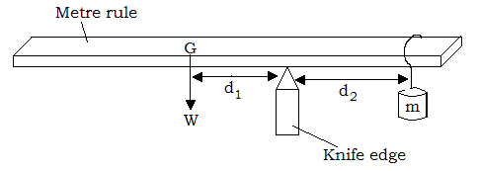
Figure 1
- Hung a mass m of 20g at 1cm mark, adjust the knife edge until the rule balances horizontally again at a new mark.
- Record length d₁ and the corresponding length d₂.
- Repeat the procedure for the different masses and complete the table.

m (g) | d₁(cm) | d₂(cm) | d₁/d₂ | md₂ (gcm)
(7 marks)
- Plot a graph of md₂ against d₁. (5 marks)

- Determine the slope S of the graph. (2 marks)
............................................................................................................................................................................................................................................................................................................................................................................................................................................................................................................................................................................................................................
- What quantity does S represent? (½ mark)
.......................................................................................................................................................
- Use the graph to find the weight W of the rule. (g = 10N/kg) (1 mark)
..............................................................................................................................................................................................................................................................................................................
- Use the vernier callipers to measure the thickness t and width b of the metre rule.

t =.................................................. cm (½ mark)

b = ................................................. cm (½ mark)
- Determine the quantity P given that;
$P= \frac{S}{100cm x t x b}$ (2 marks)
.....................................................................................................................................................................................................................................................................................................................................................................................................................................................................
- What does P represent? (1 mark)
.......................................................................................................................................................

QUESTION TWO
PART A
You are provided with the following
- A metre rule
- A spring balance
- A mass of 100g with a hook
- Stand
- Knife edge support
Proceed as follows
- Suspend the spring balance from a clamp and support the rule from the spring at the 95cm mark.
- Support the other end of the rule with a knife edge at the 10 cm mark so that the rule is horizontal
- Suspend the 100g mass at a distance d =10cm from the knife edge as shown and take the readings of the spring balance, F. Record the results in the table.
- Adjust the distance d to 20cm, 30cm e.t.c and each time recording the readings of the balance to complete the table.

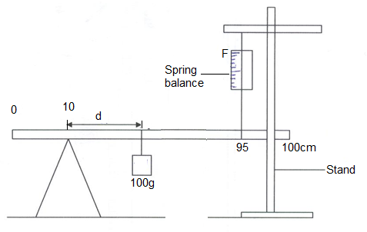
Figure 2

Distance (d) (cm) | 10 | 20 | 30 | 40 | 50 | 60 | 70 | 80
Force (N)
(4 marks)

- Plot a graph of force (F) against distance (d) (5 marks)

- From the graph determine
(a) The slope (3 marks)
.....................................................................................................................................................................................................................................................................................................................................................................................................................................................................
(b) The value of F when d = 0 (1 mark)
.......................................................................................................................................................

- Given that the equation of the graph is
85F = 2 md + 40k
Determine the values of k and m (3 marks)
.....................................................................................................................................................................................................................................................................................................................................................................................................................................................................

PART B
You are provided with the following apparatus
- Masses 50g, 100g, 150g.
- Metre rule
- Spring balance
Proceed as follows
- Set up the apparatus as shown in the diagram below
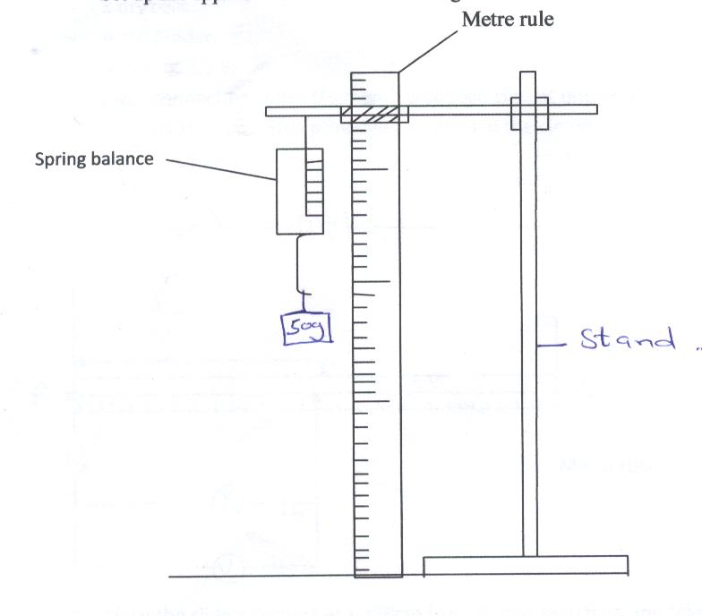
Stand
Figure 3
- Hang 50g mass on the spring balance and note the extension and record your value in the table below. Increase the mass to 100grams and 150 grams noting the extension and recording it in the table.
Mass (g) | F (N) | Extension (m)
50g
100g
150g
(2 marks)
- Use the above values to determine the value of the spring constant (2 marks)
.....................................................................................................................................................................................................................................................................................................................................................................................................................................................................

