CHEMISTRY, FORM 2
TERM I 2016, OPENER EXAM
NAME………………………………………………………..................ADM. NO………………
- A student separated two alkanes, hexane (B.P 69⁰C) and heptane (B.P 98⁰C) using the apparatus shown below.
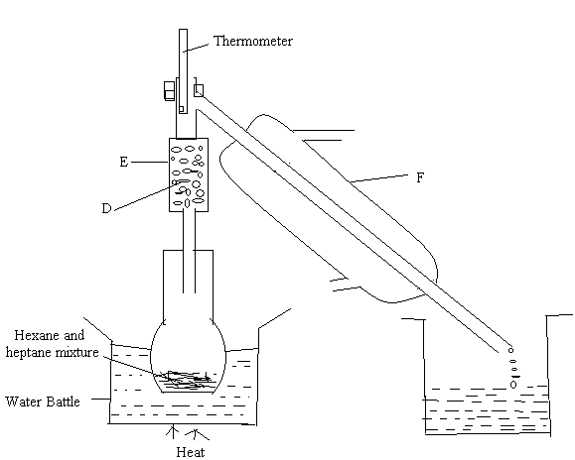
- Name (3mks)
- D

- E

- F

- State the function of each of the apparatus and substances named in (a) above (3mks)

- On the diagram indicate with an arrow ( ) ‘water in’ and ‘water out’ (2mks)
- Which of the two alkanes was collected first. Give a reason (2mks)

- State two industrial application of the above method of separating mixture (2mks)

- Dry hydrogen gas passed over heated copper (II) oxide in the set up below
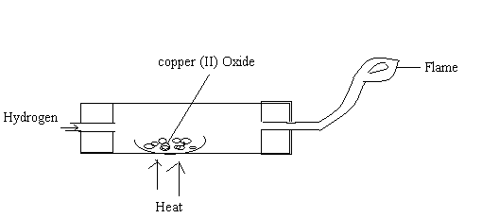
- State two observations made in the experiment (2mks)

- What property of hydrogen was being investigated? (1mks)

- Write a word equation for the reaction that took place in the combustion tube (1mk)

- State two industrial uses of hydrogen gas (2mks)

- Name the suitable method you can use to separate the following mixture in order to obtain the first substance in pure form. (3mks)
- Water and common salt.

- Ammonium chloride and sodium chloride

- Ethanol and water

- The table below shows PH values of solutions labeled A-E
Solution | A | B | C | D | E
PH | 5 | 13 | 2 | 10 | 7

Which solution is likely to be? (3mks)
- Hydrochloric acid

- Sodium chloride

- Sodium hydroxide

- State what students should do in case of a major accident such as fire outbreak in the chemistry laboratory (3mks)

- State any three differences between a mixture and a compound (3mks)

