NAME:………………………………………………………INDEX NO:……………………
SCHOOL:…………………………………………………..DATE: ...................................... SIGN:…………………
231/2
BIOLOGY
PAPER 2
TIME: 2 HOURS
ELERAI PRE – MOCK EXAMINATIONS - 2016
Kenya Certificate of Secondary Education (K.C.S.E)
BIOLOGY PAPER 2
2 HRS

INSTRUCTIONS TO CANDIDATES
- Write your name, index number, school and signature in the spaces provided at the top of the page.
- Answer ALL questions in section A. in Section B answer question 6 (compulsory) and either question 7 or 8 in the spaces provided after question 8.

SECTION | QUESTION | MAX. SCORE | CANDIDATE’S SCORE
A | 1 | 8
 | 2 | 8
 | 3 | 8
 | 4 | 8
 | 5 | 8
B | 6 | 20
 | 7 | 20
 | 8 | 20
TOTAL |  | 80

This paper consists of 7 printed pages. Candidates should check the question paper to ascertain that all pages are printed as indicated and that no questions are missing.
SECTION A
- A bull with coat of red colour was crossed with a cow of white colour coat. The calf produced had a coat of roan colour.
a) Explain briefly the occurrence of a roan coat colour on the calf. (Imk)
…………………………………………………………………………………………………………………………………………………………………………………………………………………………………………………………………………………………………………………………………………………………………………………………………………………………………………………………………………………………………………………………………….
b) The roan coloured calf after attaining maturity was crossed with a bull of red coat colour. Work out the phenotypic ratio of the offspring’s produced. (4mks)
………………………………………………………………………………………………………………………………………………………………………………………………………………………………………………………………………………………………………………………………………………………………………………………………………………………………………………………………………………………………………………………………………………………………………………………………………………………………………………

c) Name one disorder in human beings caused by gene mutation. (Imk)
………………………………………………………………………………………………………………………………………………………………………………………………………………
d) State two causes of continuous variation. (2mks)
………………………………………………………………………………………………………………………………………………………………………………………………………………
- The following is an incomplete summary of a biological process taking place in an organism. Use it to answer the following questions.
Glucose Ethanol + Y + Energy
- Identify and name
(i) the process above. (1mk)
…………………………………………………………………………………..

(ii) The product Y. (1mk)
…………………………………………………………………
- Name the part of the cell in which the above process takes place. (1mk)
……………………………………………………………………..
- What is the biological significance of the above process? (1mk)
………………………………………………………………………………………………………………………………………………………………………………………………………………
- Define the terms
(i)Oxygen debt. 2mks
………………………………………………………………………………………………………………………………………………………………………………………………………………
(ii)Respiratory Quotient. 1mk
………………………………………………………………………………………………………………………………………………………………………………………………………………
- Give one reason why energy produced is in form of ATP molecules. 1mk
………………………………………………………………………………………………………………………………………………………………………………………………………………
- A student carried out an experiment to test the effect of salivary amylase on digestion of bread. She ground equal amounts of bread using a pestle and a mortar and made equal volumes of pastes then put them in test tubes A, B, and C. She added into each test tube 1ml of fresh saliva and treated the set ups as shown below. After 5 minutes, she carried out a test for reducing sugars and used the volumes of the precipitates formed in each test tube as a measure of the amount of starch already digested.
TEST TUBE | CONDITION | VOLUME OF PRECIPITATE
A | Put in a beaker of icy water at temperature of 4ºC | 10 mls
B | Put in a beaker of warm water at temperature of 37ºC | 50 mls
C | Put in a beaker of hot water at temperature of 60ºC | 1ml
- What was the biological significance of grinding the bread into a paste? (2mks)
……………………………………………………………………………………………………………………………………………………………………………………………………
- Account for the results obtained in test tube
A ( 2mks)
………………………………………………………………………………………………………………………………………………………………………………………………………………
B (2mks)
………………………………………………………………………………………………………………………………………………………………………………………………………………………………………………………………………………………………………………………
C (2mks)
………………………………………………………………………………………………………………………………………………………………………………………………………………………………………………………………………………………………………………………
- Use the diagram below to answer the following questions.
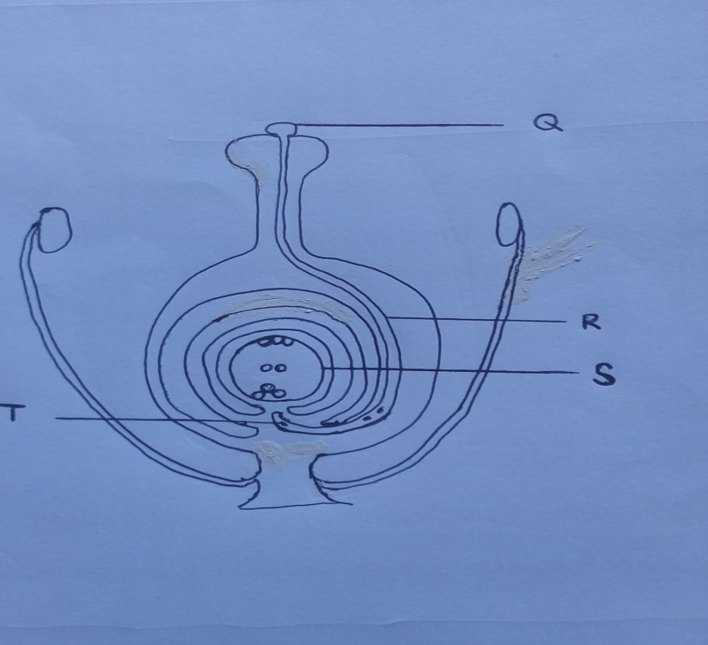
- Label the parts Q and T. 2mks

Q……………………………………………………….

T………………………………………………………..

- Describe briefly the events taking place in structure S once the tip of R penetrates it. 4mks
…………………………………………………………………………………………………………………………………………………………………………………………………………………………………………………………………………………………………………………………………………………………………………………………………………………………………………………………………………………………………………………………
- Write the biological term that describes
- the process in b) above……………………………………………… 1mk
- the phenomenon shown in the diagram that hinders self pollination and fertilization……………………………………………………... 1mk

- Explain briefly the following observations.
(a) A mouse feeds more frequently compared to an elephant within the same ecosystem. 3mks
………………………………………………………………………………………………………………………………………………………………………………………………………………………………………………………………………………………………………………………………………………………………………………………………………………………………………………………………………………………………………………………………………
(b) A Kangaroo rat has a larger medulla than the cortex in its kidneys. (3mks)
……………………………………………………………………………………………………………………………………………………………………………………………………………………………………………………………………………………………………………………………………………………………………………………………………………………………

(c) Some plants shed off their leaves during prolonged drought conditions. ( 2mks)
………………………………………………………………………………………………………………………………………………………………………………………………………………………………………………………………………………………………………………………………………………………………………………………………………………………………
SECTION B (40MKS)
Answer question 6 (compulsory) on the spaces provided and either question 7 or 8 on the space provided after question 8.
- A student carried out an investigation to find out the average diameter of cells of a certain herbaceous plant. She immersed several pieces of the plant tissue in various concentrations of sugar solutions, waited for 10 minutes, observed the cells under a light microscope and determined the average diameters. The volume of distilled water was maintained at a constant while the amount of sugar was varied in every investigation. The following data shows the results that were obtained by the end of the investigation.
Sugar concentration in gms/10 mls | 0.7 | 1.0 | 1.5 | 2.0 | 3.0 | 3.9 | 4.6 | 5.6 | 6.6 | 7.6
Average Diameter of cells in micrometers | 59.5 | 55.5 | 49.0 | 44.0 | 36.0 | 30.0 | 26.0 | 20.0 | 15.0 | 10.0

- Draw a graph of the average diameter of the cells in micrometers against sugar concentration. (6mks)
- (i) Determine the average diameter of the cells if their normal solute concentration is similar to 5.5gms/10mls
………………………………………………………………… 1mk
(ii)If the diameter of the field of view measured 0.5mm in b (i) above, calculate the number of whole cells that were counted across the diameter. 2mks
………………………………………………………………………………………………………………………………………………………………………………………………………………………………………………………………………………………………………………………

- Account for the shape of the graph at
- Concentration between 5.5mg/ 10mls and 7.6mg/10mls 3mks

………………………………………………………………………………………………………………………………………………………………………………………………………………………………………………………………………………………………………………………………………………………………………………………………………………………………
- Concentration between 5.5mg/10mls and 0.7mg/10mls 3mks
………………………………………………………………………………………………………………………………………………………………………………………………………………………………………………………………………………………………………………………………………………………………………………………………………………………………

- Write down five roles of the physiological process involved in the investigation, in plants. 5mks.
………………………………………………………………………………………………………………………………………………………………………………………………………………………………………………………………………………………………………………………………………………………………………………………………………………………………………………………………………………………………………………………………………

- Explain how the various abiotic factors affect plants in an ecosystem. (20 mks)
- (.i) Explain how various environmental factors affect rate of transpiration in plants. (10 mks)
(ii) Describe the process of gaseous exchange in insects. ( 10mks)

