NAME:……………………………………………………… INDEX NO:……………………
SCHOOL:………………………………………………….. DATE: ...................................... SIGN:…………………

231/3
BIOLOGY PRACTICAL
PAPER 3
March/ April 2016
Time: 1 ¾ Hours

ELERAI PRE – MOCK EXAMINATIONS - 2016
Kenya Certificate of Secondary Education (K.C.S.E)
BIOLOGY PAPER 3 (Practical)
1 ¾ HRS

INSTRUCTIONS TO CANDIDATES
- Answer all the questions in the spaces provided.
- You are required to spend the first 15 minutes of 1 ¾ hours allowed for this paper reading the whole paper carefully before commencing your work.
- Candidates may be penalized for recording irrelevant information and for incorrect spelling especially of technical terms.

FOR EXAMINER’S USE ONLY
Question | Max Score | Candidate’s Score
1 | 16
2 | 13
3 | 11
TOTAL | 40

This paper consists of 5 printed pages. Candidates should check the question paper to ensure that all pages are printed as indicated and no questions are missing.

- Use the photographs provided to answer the questions that follow:
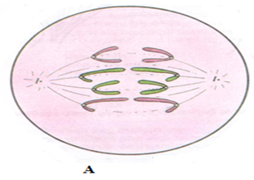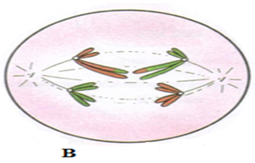
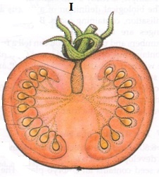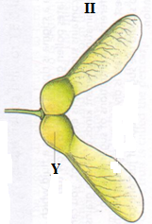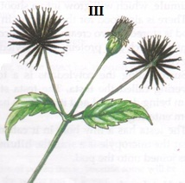

a) (i) Identify the type of cell division represented in the photographs A and B. (2mks)
A ………………………………………………………………………………………………….
B …………………………………………………………………………………………………
(ii) With a reason, name the stage of cell division represented in each case. (4mks)
A …………………………………………………………………………………………………
Reason ………………………………………………………………………………………….......
………………………………………………………………………………………………………
B ……………………………………………………………………………………………………
Reason …………………………………………………………………………………………
………………………………………………………………………………………………
(iii) Name the parts of human body where the process B represented above occur. (2mks)
………………………………………………………………………………………………………………………………………………………………………………………………………………
b) (i) What type of fruit is represented by photograph I? Give two reasons. (3mks)
Type ………………………………………………………………………………………………
Reasons……………………………………………………………………………………………
………………………………………………………………………………………………………
(ii) Name the agent of dispersal for fruits II and III. (2mk)
II ……………………………………………………………………………………………………
III …………………………………………………………………………………………………
(iii) How are the fruits adapted for the mode of dispersal stated in (b)( ii) above? (2mk)
II ……………………………………………………………………………………………………
……………………………………………………………………………………………………..
III …………………………………………………………………………………………………
………………………………………………………………………………………………………
(iv) Identify the type of placentation shown by photograph I. (1mk)
………………………………………………………………………………………………………

- You are provided with the following:
- Solution labelled A
- Benedict’s solution labelled solution B
- Solution C
- 0.1% NaCl solution
- 1.4% / NaCl solution
- Iodine solution labelled solution E
Label three test tubes, P, Q and R. Into each test-tube, place 3ml of the solution C
- Put a drop of solution from P on a white tile and add a drop of iodine (solution E)
Repeat the procedure for each test tube Q and R.
Record your observations in the table below. (3mks)

Test-tube | Observation
P
Q
R

- To test tube Q add 3 drops of 0.1% sodium chloride solution and 2ml of solution A. To test tube R,add three drops of 1.4% sodium chloride solution and 2ml of solution A. Place the test tube P,Q and R in a water bath and maintain at 37⁰C for 30 minutes. Using a drop of the solution from each test tube, repeat the procedure in (a) above and spare the rest for next question. Record your observations in the table below. (3mks)
Test-tube | Observation at the end of experiment
P
Q
R

(c) Put 2cm³ of solution from test tube P in a clean test tube and add 2cm³ of Benedict’s(solution B)shake then heat the mixture to boil in a hot water bath.
Record your final observations in the table below.
Repeat the procedure for solution Q and R. (3mks)

Test-tube | Observation after experiment
P
Q
R

(d) Why was the test tube P included in the experiment? (1mk)
………………………………………………………………………………………………………
- Account for observations made in test tube Q and R at the end of the experiment.
(i) Test tube Q (2mks)
………………………………………………………………………………………………………
………………………………………………………………………………………………………
- Test tube R
………………………………………………………………………………………………………
………………………………………………………………………………………………………
- Suggest the identity of solution A. (1mk)
………………………………………………………………………………………………………
- The photomicrograph below is of a blood smear. Examine it.
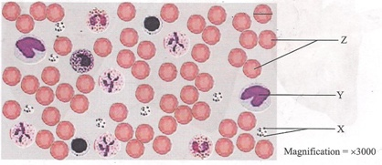
- Identify the blood components labeled X, Y and Z (3mks)
………………………………………………………………………………………………………………………………………………………………………………………………………………………………………………………………………………………………………
- State the functions of X and Y (2mks)
……………………………………………………………………………………………………………………………………………………………………………………………………
- Name the mineral ion and vitamin required in the process brought about by the components labeled X (2mks)
……………………………………………………………………………………………………………………………………………………………………………………………………
- State a feature which is observable in the photograph, that adapts the components labeled Z to their functions (1mk)
……………………………………………………………………………………………………………………………………………………………………………………………………
- (i) Measure the diameter marked by the black line on the cell at the right hand corner of the photomicrograph in centimetres (1mk)
……………………………………………………………………………………………………………………………………………………………………………………………………
(ii) Calculate the actual diameter of the cell in micrometers(um) (2mks)
………………………………………………………………………………………………………………………………………………………………………………………………

