COUNTY LINK GROUP
COMMON EXAMINATION
END OF TERM II FORM 4 -2017
NAME ……………………………………………………… ADM NO…………………………………
SCHOOL …………………………………………………… .SIGN …………………………………...
DATE…………………………………………………………………………………………………….
AGRICULTURE
PAPER 443/1
2HOURS
Instructions
- This paper consist of three sections A, B and c
- Answer all questions in section A and B and any two from section C.
- All answers must be written in the spaces provided in this booklet.
Section | Questions | Maximum score | Candidates
A | 1-15 | 30
B | 16-19 | 20
C |  | 20
 |  | 20
 | Total score | 90

Section A (30marks)
- (a) Define the term Mulching (1mk)

(b) State two types of mulches used (1mk)
(i)
(ii)
- State four ways of improving labour production in a tea plantation (2mks)
(i)
(ii)
(iii)
(iv)
- List four factors that determine seed rates (2mks)
(i)
(ii)
(iii)
(iv)
- Give three factors that determine the depth of cultivation ($1\frac{1}{2} mks)$
(i)
(ii)
(iii)
- State two reasons why weeds are adapted to a wide range of environment (1mk)
(i)
(ii)
- State three reasons that make tissue culture popular $(1\frac{1}{2} mks)$
(i)
(ii)
(iii)
- Give three main methods of land preparation ($1\frac{1}{2} mks)$
(i)
(ii)
(iii)
- Give four examples of product – product relationship in management of agricultural enterprises (2mks)
(i)
(ii)
(iii)
(iv)
- State four functions of Farmers’ co-operative societies (2mks)
(i)
(ii)
(iii)
(iv)
- What role does soil PH contribute inn maintenance of soil fertility (1mk)
(i)
(ii)
- Give two biological methods of weed control (1mk)
(i)
(ii)
- State two factors that encourage damping off disease in cabbage nursery bed (1mk)
(i)
(ii)
- Sate three reasons why proper drying of grains is encouraged ($1\frac{1}{2} mks)$
(i)
(ii)
(iii)
- Name two marking organization for coffee in Kenya (1mks)
(i)
(ii)
- List any three disadvantages of concession or company land tenure system $1\frac{1}{2} mks)$
(i)
(ii)
(iii)
- How do the following environmental factors influencing the effectiveness of a herbicide ?
- Soil (1mk)

- Temperature (1mk)
- Outline four qualities of a good farm manager (2mks)
(i)
(ii)
(iii)
(iv)
- Outline four sites in the firm where agro-forestry may be practiced (2mks)
(i)
(ii)
(iii)
(iv)
- Give four methods of treating agro-forestry seeds before planting (2mks)
(i)
(ii)
(iii)
(iv)
SECTIONS B (20MKS)
- The diagram below shows a method of crop propagation
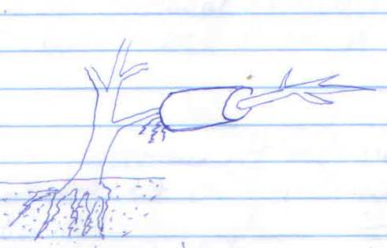
- Identity the method of propagation illustrated above (1mk)

- State three ways of initiating faster root development in plant propagation illustrated above (3mks)

(i)
(ii)
(iii)
- The diagram below, A and B illustrated same field pest. Study them carefully and answer the questions that follow.
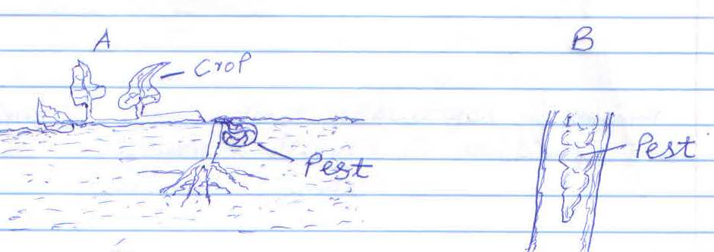

- Identify pests A and B (1mk)

- State two damages caused by pest B to a maize crop (1mks)

- Give two cultural practices carried out to control the pest A

- Below is diagram of a domestic water tank study it and answer the equations that follow
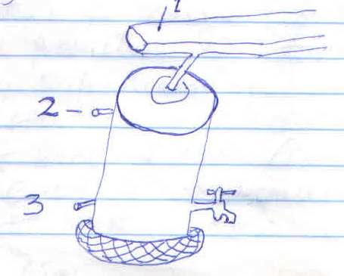
- Name the parts (3mks)
(i)
(ii)
(iii)
(b) Outline the properties of clean water (7mks)
(i)
(ii)
(iii)
(iv)
(v)
(vi)
(vii)
- Sate three advantages of using polythene leaves in raising seedlings (3mks)
(i)
(ii)
(iii)

Section C
- (a) Describe six benefits of sub- surface irrigation (6mks)
(b) Describe five methods of land acquisition for agriculture in Kenya. (5mks)
(c ) Describe the production of matoes under the following sub- headings
- Nursery establishment and maintenance (6mks)
- Control of bacterial with (3mks)
- (a) Describe the causes of crop disease (6mks)
(b) (i) Describe the water control in irrigated Rice (4mks)
(ii) Explain the selection and preparation of beans for planting (3mks)
(c ) Explain the various out by a farmer to maintain soil fertility on his (7mks)
- (a) Discuss six negative effects of liberalization of agricultural market to farming in Kenya (6mks)
(b) Explain how farmers overcome risks and uncertainties in farm business (7mks)
(c ) Explain how the advancement in technology has contributed into the meaning of agriculture in Kenya to day (7mks)

