COUNTY LINK GROUP
COMMON EXAMINATION
END OF TERM II FORM 4 -2017

NAME ……………………………………………………… ADM NO…………………………………
SCHOOL …………………………………………………… .SIGN …………………………………...
DATE…………………………………………………………………………………………………….
231/1
BIOLOGY PAPER 1
JULY 2017
2 HOURS

Instructions to candidates:
- Answer all the questions in this questions paper
- All answers must be written in the spaces provide
- Candidates should answer the questions in English
For examiners use only
Questions number | Maximum score | Candidates score
1-26 | 80

- State the role of the following in the collection of biological specimens (2mks)
- Pitfall trap

- Pooter

- Name the end products of the light stage of photosynthesis (2mks)

- Below is a diagram of a cell organelle
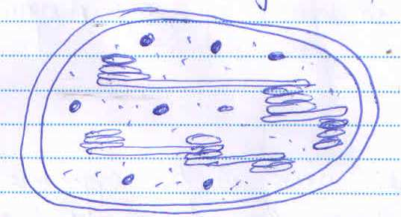

- Identify the organelle (1mk)

- Name the organic compound found in part labeled A (1mks)

- A certain metabolic process takes place in the part labeled B. Name the process and products formed (2mks)

- Process

- Product(s )

- State two adaptations of xylem vessels (2mks)

- State two disadvantages of sexual reproduction in animals (2mks)

- (a) Name two areas in a plant where meristematic tissues are found (2mks)

(b) State two characteristics of meristematic cells (2mks)

- Give the scientific name of the organisms that cause the following diseases in human (2mks)
- Tuberculosis

- Cholera

- An experiment was carried out to investigate the effect of different concentrations of sodium chloride on human red blood cells. Equal amounts of blood were added to equal volumes of the salt but of different concentrations.
There results were shown in the table below
Set up | Sodium chloride  Concentration | Number of red blood cells
 |  | At the start of experiment | At the end of experiment
A | 0.9% | Normal | No change in number
B | 0.3% | Normal | Fewer in number

Account for the results in the set up
- Set up A (2mks)

- Set up B (4mks)

- A students collected a specimen shown below
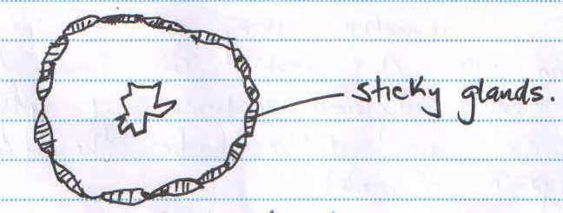
- Name the methods of dispersal. Give a reason far your answer (2mks)

- State two reasons why dispersal of seeds and fruits is important (2mks)

- Differentiate between homologous and analogous structures (2mks)

- (a) A Student counted 30 cells lengthwise across the diameter of the field of views of a microscope. If the diameter of the field of view was 2.5 millimeters. Calculate the average length of one cell in micrometers(2mks)

- In an examination using an electron microscope a certain organ of a rabbit was found to have numerous rough endoplasmic reticular and Golgi bodies what can you deduce to be the functions of the organ? (1mk)

- (a) Name two structures used far gaseous exchange in plants (2mks)

(b) What is meant by each of the following?
(i) Pyramid of biomass (1mk)

- pyramid of number (1mks)

- name the type of skeleton that makes up each of the following animals
- locust (1mk)

- Bird (1mk)

- Name two vestigial structures in human beings (2mks)

- Name the three end products of amoebae respiration in plants (3mks)

- Name three mechanisms that ensures cross pollution takes place in following plants (3mks)

- How the human sperm cell is structurally specialized? (3mks)

- State three factors in seeds that cause seed dormancy (3mks)

- (a) What is meant by the term organic evolution (1mk)

(b)Explain the role of continental drift in evolution (3mks)

- (a) What are sex- linked genes? (1mk)

(b)Name two sex- linked traits in the X-sex chromosome of human beings (2mks)

- What is the probability of a couple with blood group AB getting a child with blood AB. (show your working ) (4mks)

- Hemophilia is due to a sex- linked gene. A hemophilia man marries a woman who is heterozygous for the condition. What percentage of their offspring would be hemophiliacs show your working ( use letter H to represent the dominant gene and letter h of the recessive gene (4mks)

- Distinguish between population and communality (2mks)

- The diagram below shows a pollen tube as it develops down the style
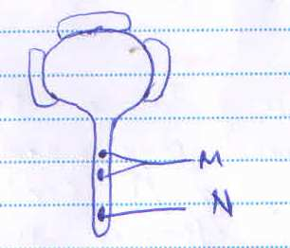
- Name the parts labeled M and N.
M………………………………... (1mk)
N………………………………….(1mk)

- State the function of part M (2mks)
- Name three ways in which HIV/AIDS has been spread (3mks)

- Sate the functions of each of the following hormones (3mks)

- ADH (Anti- Diuretic Hormone)

- Aldosterone

- Glucagon

