COUNTY LINK GROUP
COMMON EXAMINATION
END OF TERM II FORM 4 -2017

NAME ……………………………………………………… ADM NO…………………………………
SCHOOL …………………………………………………… .SIGN …………………………………...
DATE…………………………………………………………………………………………………….

AGRICULTURE
PAPER 443/2
2HOURS

Instructions
- This paper consist of three sections A, B and c
- Answer all questions in section A and B and any two from section C.
- All answers must be written in the spaces provided in this booklet.
Section | Questions | Maximum score | Candidates
A | 1-15 | 30
B | 16-19 | 20
C |  | 20
 |  | 20
 | Total score | 90

Section A (30marks)
- State two importance of tooth clipping in piglets (2mks)

- Name four components of a truss. (2mks)

- Name four light breeds of poultry (2mks)

- State two ways in which each of the following requirements can be achieved in a calf pen (4mks)
- Proper drainage

- Free from draught

- Give four functions of water in poultry (2mks)

- State any four causes of infertility in cattle (2mks)

- State three factors that determine the depth and size of foundation in a farm building ($1\frac{1}{2}mks)$

- State three reasons why wins power is not reliable as a source of farm power $(1\frac{1}{2}mks)$

- State four requirements of artificial brooder (2mks)

- State four reasons for dehorning cattle (2mks)

- State four reasons for seasoning timber (2mks)

- Give two functional differences between pruning saw and a pruning knife (2mks)

- State two factors to consider when formulating livestock ration. (2mks)

- State four predisposing factors of mastitis in dairy cattle. (2mks)

- Outline two causes of bloat in farm animals (1mk)

Section B( 20mks)
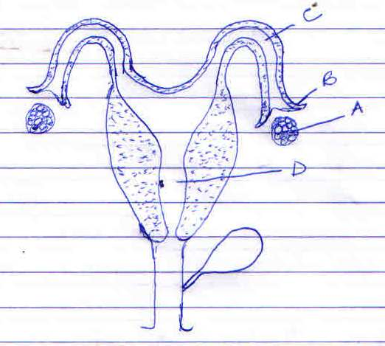
- Study the illustration of the reproduction system of a cow below and answer the questions that follow.

- Label parts A-D (2mks)
a………………………….
b………………………….
c…………………………..
d………………………….
- State the functions of part A, B and C (3mks)
A……………………………………………
B……………………………………………
C……………………………………………

Name two diseases which can be transmitted through natural mating (1mk)

- A pig farmer has maize containing 8%cp and simsim containing 43%DCP. He wants to make 100kg of the feed. Calculate the amount of each feed stuff required using nearsons squire method. (5mks).

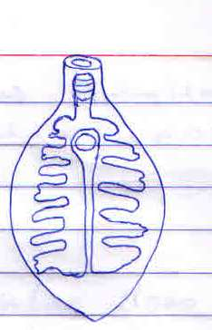
- Below is an illustration of an internal parasite in livestock

- Identify the parasite (1mk)

- Name one final host for the parasite (1mk)

- Name the intermediate host of the parasite (1mk)

- State two measurers used to control the parasite (2mks)

- The diagram below is equipment used in livestock production.

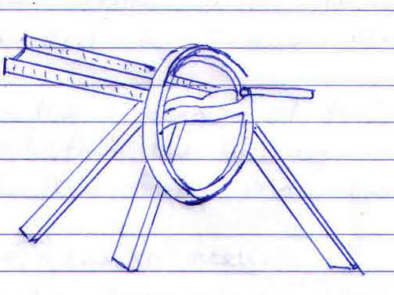

- Identify the equipment (1mk)

- State the use of the equipment above (1mk)

- State two maintenance practices carried out on the equipment (2mks)

- What value does the equipment add in the livestock feeding (1mk)

Section C (40mks)
19 (a) Explain eight factors considered when sitting a produce store (8mks)
(b) Highlight eight uses of a fence can the farm (8mks)
(c) State four factors determining the quality of honey (4mks)
20. (a) Explain seven management practices carried out to ensure maximum harvest of fish (7mks)
(b) Explain the procedure of training a daily calf to feed from the bucket in artificial feeding (5mks)
© Describe the daily maintenance o a tractor (8mks)
21 (a) Outline ten general methods of diseases control giving an example in each case (10mks)
Explain the uses of various hand tools in the construction of Kenya top bar hive. (10mks)

