COUNTY LINK GROUP
COMMON EXAMINATION
END OF TERM II FORM 4 -2017

NAME ……………………………………………………… ADM NO…………………………………
SCHOOL …………………………………………………… .SIGN …………………………………...
DATE…………………………………………………………………………………………………….

231/2
BIOLOGY PAPER 2
JULY 2017
2 HOURS

Instructions to candidates:
- Write your name and index number in the space provided
- Answer all the questions in sections A in the space provided
- In sections B answer questions 6 (compulsory) and either questions 7 or 8 in the space provided after questions 8

- (a) The diagram below shows a part of a nucleic acid strand
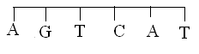

- Identify the nucleic acid strand above (1mk)

- Give a reason for your answer in (a) (i) above (1mk)

(b) A pure breed of red cows and pure breed of white bulls were crossed to give F1 calves which
had a mixture of red and white fur, known as roan. The F1 were selfed.
- Using letter R to represent gene for red colour and W to represent gene for white colour, work out the phenotypic ratio of the F2. (4mks)
- In human couples, the sex of a baby is determined by man. Explain (2mks)

- Study the diagram below and answer the equations that follow
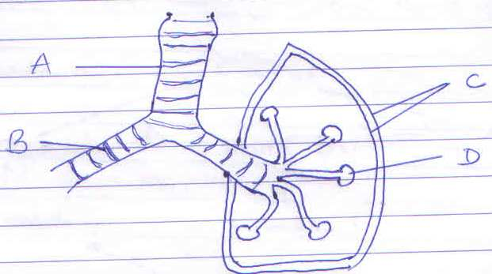

- Name the part labeled A (1mk)

- State the functions of the parts labeled B and C (2mks)
B………………………………….
C…………………………………
- State any three adaptations of the part labeled D to its functions (3mks)

- Name the structures that perform the same function as p[art labeled D in :
- Amoeba (1mk)

- Fish (1mk)

- The flow chart below shows a feeding relationship in an aquatic ecosystem. Study it and answer the questions that follow
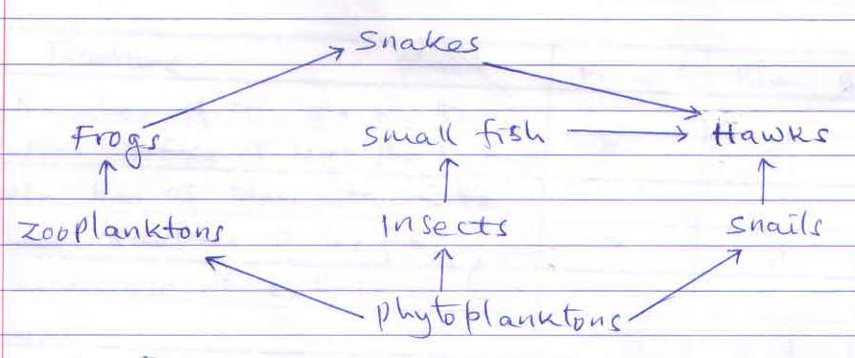

- Name the:
- Producers in the ecosystem (1mk)

- Organisms that occupy the highest trophic level (1mk)

- Write a food chain that ends with hawks as tertiary consumer (1mk)

- If all the small fish died, State two short terms effects on the ecosystems (2mks)

- Oil spills on water bodies lead to death of fish Explain (1mk)

- What is an ecosystem ?

- State one reason why biomass decreases as you move from a lower trophic level to a higher trophic level (1mk)

- The table below shows results of a study of three plants A, B and C growing in different habitats
Feature | Plant A | Plant B | Plant C
Number of stomata on the upper surface of leaf per squire area | 3 | 21 | 9
Number of stomata on lower surface of leaf per squire area | 7 | 0 | 9
Thickness of cuticle of the leaf | 0.5 | 0.2 | 0.3
Surface area of roots | 2100 | 1100 | 1300

- (i) Which of the three leaves would be expected to have lower rate of transpirations? (1mk)

- Give reasons for your answer in (a) (i) above (2mks)

- Explain why waterlogged soils do not support plant growth (3mks)

- State the importance of transpiration to plants. (2mks)

- The diagram below illustrates an experiment to determine the rate of respiration in a small insect.
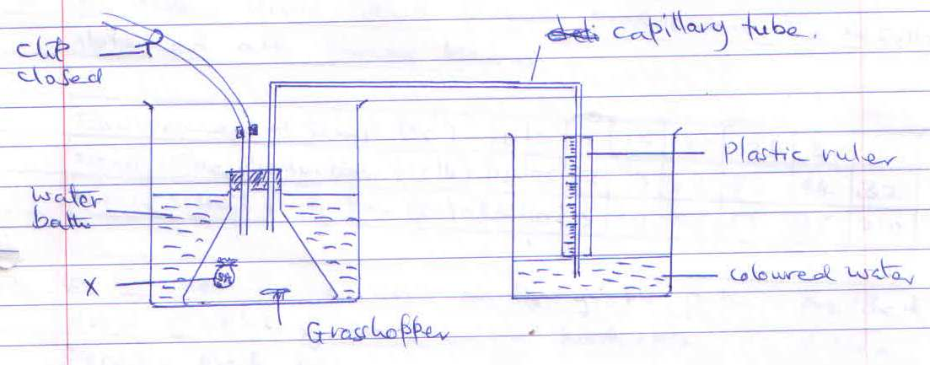
- State the functions of the chemical component labeled X (1mk)

- What changes would you expect to observe in the level of the coloured water in the capillary tube after the experiment has run for 5 minutes (1mk)

- Account for the change you have stated in (b) above (3mks)

- State three industrial applications of anaerobic respirations (3mks)

Section B (40mks)
- A study involving 50 persons was carried out to establish the effect of environmental temperature on mean urine and sweat production. The results obtained are shown below.
Environmental temp ($0_{C}$) | 0 | 5 | 10 | 15 | 20 | 25 | 30 | 35
Mean uraine productions (cc/h) | 120 | 95 | 82 | 73 | 62 | 53 | 44 | 32
Means sweat production (cc/h) | 5 | 10 | 15 | 30 | 35 | 55 | 125 | 210

- On the same axis on the graph paper provided, draw graphs of mean urine production and mean sweat production against environmental temperature (8mks)

- At what temperature was urine production equal to sweat production (2mks)

- Explain the relationship between Sweat and urine production (2mks)

- Explain the changes that occur in the skin when body temperature rises above ${37.8}_{C}^{0}$ (6mks)

- State three adaptations of loop of henle to its functions (3mks)

- Describe the role of hormones in the human menstrual cycle (20mks)
- Describe the uptake and movement of water from the soil to the leaves of a tall plant till transpiration (20mks)

