COUNTY LINK GROUP
COMMON EXAMINATION
END OF TERM II FORM 4 -2017
AGRICULTURE MARKING SCHEME
PAPER 443/2
- Importance of tooth clipping
- Avoid causing injury on teats
- Prevent piglets form injuring each other
- Controls mastitis (2x 1 = 2mks)
- Components of a truss
- Cross tie
- Rafter
- Tie
- Strut (4 x $\frac{1}{2}=2mks)$
- Light breeds of poultry
- Leghorns
- Ancona
- Minoca
- Sykes (4 x $\frac{1}{2}=2mks)$
- (i) Proper drainage
- Saluted floor
- Raised floor (2x1 =2mks)
(ii) Free from draught
- Windward side covered
- Placed in sheltered place (2 x1 $2mks)$
- Functions of water
– regulate body temperature
- Important component of cells
- Froms part of animal products
- Maintain osmotic balance of blood and tissues fluid
- Help in excretion of waste products from the body (4 x $\frac{1}{2}=2mks)$
- Causes of infertility
- Blocked fallopian tube
- Damaged fallopian tube
- Deficiency of essential nutrients e.g vit .E
- Freemartin
- Consensual diseases (4 x $\frac{1}{2}=2mks)$
- Factors determining the depth and size of foundation
- Soil depth
- Soil type
- Function of the building (3 x $\frac{1}{2}=1 \frac{1}{2}mks)$
- Reasons why wind power is not reliable ==
- Direction of flow keeps on changing
- Not evaluable at all times
- Has no constant strength
- Requirements of artificial brooder
- Letter to keep the louse warm
- Ventilation
- Heat to provide desired room temperature
- Dim light to aloe chicks see food
- Round shaped brooder to discourage overcrowding
- Reasons for dehorning cattle
- Prevent cattle from injuring each other
- Make the animal docile and easy to handle
- Prevent destruction of farm structures
- Polled animals occupy small space and therefore easy to transport and feed.
- Pruning saw
- cuts hard branches of coffee
- has teeth
- Pruning knife
- pruning tea with soft branches
- has a smooth cutting edge
(2×1=2mks)
- – percentage of nutrient to be obtained
-Protein content of the feed /value of the nutrients
(2×1=2mks)
- Predisposing factors of mastitis in a cattle dairy
- Age
- Stage of lactation
- Incomplete milking
- Mechanical injuries
- Poor sanitation
- Poor milking techniques (4 x $\frac{1}{2}=2mks)$
- Causes of bloat
- Indigestion
- Blockage of oesophagus
- Pressure exerted on the oesophagus (2 x $\frac{1}{2}=1mk)$
SECTION B
- (i)
A. Ovary
B. Funnel
C. oviduct (4 x $\frac{1}{2}=2mks)$ D. uterus

(ii) Ovary-produce eggs and hormones
Funnel-direct ova into the fallopian tube
Oviduct –fertilization site
-allows passage of ova (3×1=3mks)

(iii)- Brucellosis /contagious abortion
- Trichomoniasis
- Vaginitis
- Orchitis (2×$\frac{1}{2}$ =1mk)
16.
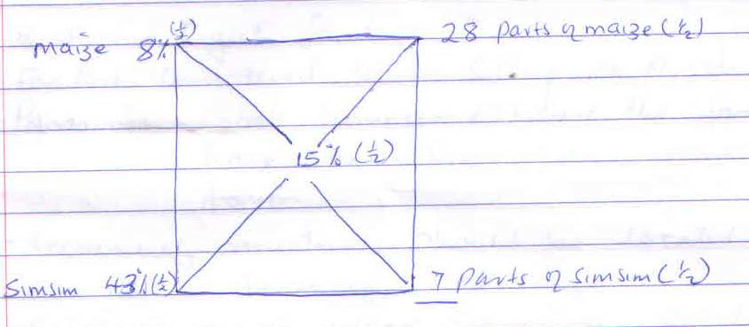
Total parts 28+7=35 ( $\frac{1}{2}mk)$
- Maize $\frac{28}{35}$ ×100 =80kg (1mk)
- Simsim $\frac{7}{35}$×100 =20kg (1mk)
- (i) liver fluke
(ii) cattle/sheep
(iii) Water snail
(iv) - Control intermediate host
-Drain swampy areas
-Burning pastures during dry season
-Not grazing near marshy areas
- Routine drenching of animals (2×1=2mks)

- Chaff cutter
- Cut folder into small pieces
- Greasing the moving parts regularly
-Sharpening the cutting blades
-Cleaning the equipment after days work
iv. Improve form of feed by cutting it into smaller pieces hence increasing digestibility

SECTION C
19. Factors considered when sitting a produce store
-Panorama – locate homestead where the farmer will have full view of all enterprises on the farm.
-Accessibility – structures should be located in easily accessed place
- Relationship with others structures – related structures should be close to one another
-Topography - Gentle sloping areas are the most suitable to reduce cost of leveling
-Soil type- The soil should be firm and well drained
-Direction of prevailing wind – locate homestead on the windward side of the structures with small foul scale
-Security – structures with high risk should be close to form house
-Drainage – locate structures in areas with good drainage to avoid dampness which encourage diseases. Proximity to amenities i.e: should be accessible to electricity and water supply. NB; mark right explanation only. (8mks)
b.-Used to democrate the farm land
-Used to keep off wild animals from the farm
-Used to separate crop field from pasture facilitating mixed farming
-Used to divide pastures field into paddocks facilities rotational grazing
-Control transport of people and animals preventing formation of unnecessary paths
- Help to control spread of parasites and diseases by keeping off wild and stray animals.
- Help isolate sick from healthy animals to prevent diseases.
- Help a farmer to control breeding.
- Provide security to the homestead and farm animals (8×1=8mks)

C .Method of extraction
-Type of flowers from which the nectar was obtained
-Season of the year –Honey formed in dry season seems to be of lower quality
-Maturity age of the honey mature honey is of good quality
-Method of harvesting- honey harvested well has less foreign materials (4×1=4 mks)
20 .(a) - Control of stocking rate
-Harvest at the correct maturity stage
-Avoid water pollution in the ponds it may poison the fish.
-Ensure adequate supply of food in the pod.
-Water in the pond should be kept in motion to facilitate aeration
-Maintain appropriate depth of water
-Control predators and thieves
-Drain and refill pond water with fresh water when necessary (1×7 mks)
(b) Well measured milk is put in a clean bucket
- Insert index figure into the mouth of the calf
- Lower the head calf slowly into the bucket until the calf starts to drink milk
- Withdraw the figure slowly as the calf continues to drink milk from the bucket
- The procedure is repeated until the calf learn to drink from the bucket (1 x5 = 5 mks)
C - Check the engine oil using dip stick and add if necessary
-Check battery electrolyte and add distilled water if low
-Grease al the moving parts using nipples
-check the fan belt and tighten if loose
- Check water level in the radiator and add if low.
- Check sir cleaner and blow off excessive dust
-Check oil filters and replace if dirty
-Check loose nuts and bolts and tighten the loose ones
-Sediments bowl be cleaned if clogged -Check tyre pressure and adjust accordingly (1×8mk)
21. .(a)General method of disease control giving an example in each case
-proper feeding eg; milk fever; bloat
-proper housing eg; pneumonia
- quarantine eg;anthrax, rinderpest, foot and mouth
-Vaccination eg; Anthrax
-Treatment eg; black quarter, pneumonia
- proper breeding eg; brucellosis
- Proper selection eg ; cancer
-Use of prophylactic drugs eg; coccidiosis
- Control of vectors e.g trypanosomiasis, ECF, anaplasmosis
-Slaughtering affected animals e.g Antrax, Newcastle
-Proper disposal of carcass e.g Anthra
-Proper hygiene – Newcastle, contagious abortion
-Isolation -foot and mouth, Newcastle
- Hoof trimming – foot rot ( stating ×$\frac{1}{2}$ and example ×$\frac{1}{2}$ mk)
b. various tools used in the construction of Kenya top bar hive.
-Claw hammer – driving nails in and out of wood.
-Tpe measure- measuring required sizes of timber
-Clamp - for holding tight pieces of wood when cutting / joining
- Handsaw – cutting timber to the required size
-Wood chisel / brace hand drill- boring holes in wood
- Mallet – hitting the chisel
- Pliers –for cutting wire
- Jackplane –for smoothing timber surfaces
- Making / mortise gauge – making point for cutting
- Marking/ mortise gauge – marking points for cutting
- Ball pen – hammer – straightening / shaping metal sheet
- Try –square / combination square –for determining right angels on timber during construction
(10 X 1 =10mks)

