COUNTY LINK GROUP
COMMON EXAMINATION
END OF TERM II FORM 4 -2017
231/2 BIOLOGY MARKING SCHEME
PAPER 2
- (a) (i) Deoxyribonucleic acid; (Rej . DNA)
(ii) It has base thyaline;
(b) (i) 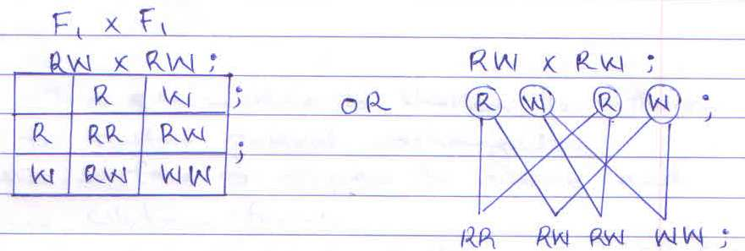

Ratio : - I red : 2 Roan : I white (rej. If phenotype is not stated)

(ii) The man produced two types of sperm cells, one types contain X chromosome and the other contains Y chromosomes, while the woman produces one types of egg cells containing x chromosomes; Fertilization of egg cell by a sperms containing X chromosome gives a female child while fertilization by a sperm containing Y chromosome gives a male child;

- (a) Trachea;
(b) B –Prevents collapsing of the air passage during breathing;
C – Secrets pleural fluid; that lubricate the lungs.
(c) - Has a thin membrane to shorten the diffusion distance for faster gaseous exchange,
- Has moist surface for oxygen to dissolve and diffuse in solution form;
- Are numerous to increase surface are for faster gaseous exchange;
- Are highly vascularised for faster diffusion of respiratory gases; (any first 3)

(d) (i) Cell membrane;
(ii) Gill filament, (rej . gill alone )
- (a) (i) Phytoplanktons
(ii) Hawks;

(b) Phytoplanktons – Insects- small fish – Hawks;

(c) The populations of snakes and snails would decrease (due to increase predation);
- The population of insects would increase (due to lack of predation)
(d) Oil prevent entry of oxygen in the water body leading to suffocation/ oil dogs fish gills; (thus
reducing rate of gaseous exchange )
(e) Natural unit consisting of living organisms and non- living components such as water, soil, air
and light whose interactions lead to a self sustaining system;
(f) Energy is lost through respiration/ undigested food materials/ wastage;

- (a) (i) Leaf A;
(ii) Has fewer numbers of stomata on the upper surface to reduce the rate of transpiration
- Has a thicker cuticle to reduce the rate of transpiration.

(b) Water logged soil has air spaces occupied b water, this reduced amount of oxygen in the soil;
the root do not get enough oxygen needed for respiration, hence active intake of minerals salts
is impaired thus death of plants .
(c) Transpiration cods the plant; creates transpiration pull, a motive force for uptake of water end minerals salts provides a mean of excretion of excess water in fresh water plants. (any two)

- (a) To absorb carbon (iv) oxide produced by the insect;
(b) The level of coloured water in the capillary tube would rise;
(c) The insect respired, taking up oxygen; and realizing carbon (iv) oxide which was absorbed by
the soda lime / substance X; uptate of oxygen and absorptions of carbon (iv) oxide cause a
decrease in air pressure within he flask; hence the rise in the level of coloured water.
(d) - Production of alcoholic drinks;
- Bread baking / raising of dough;
- Processing of dairy products; (eg cheese and yoghurt)

- (b) ${24.5}^{0}C ±{0.5}^{0}C$
(c) As the sweat production increases the urine production reduces; because more water is reabsorbed at the kidney; to minimize dehydration (rej. Reverse)
(d) Superficial blood vessels /arterioles vasodilate; while deeper arterioles vasoconstrict. More
blood flows nearer the skin surface; hence more heat is lost from the blood ; by radiation and
convection. The erector pilli muscles relax making the hair to lie flat on skin surface; less air is
trapped / less insulation; the sweat gland stimulated to produce more sweat; which lead to loss
of latent heat of vaporization hence drop in body temperature (max 6 marks).

(e) – long to increase surface area for reabsoprtion of water;
- Supplied with a dense networks of blood capillaries to enhance reabsorption of water.
- It is U- shaped to bring about counter current multiple effect;

- Follicle stimulating hormone (Fish) : secreted by anterior tube of pituitary gland; just after menstruation cause development of graduation follicle in the ovary; and stimulate ovarian tissues, to secrete hormone estrogen; which initiates healing and repair of andomethium (destroyed during menstruation ) ; high levels of estrogen stimulates pituitary gland ; to discrete luteinizing hormones (LH) ; which stimulates maturation of guaafian follicle; and causes ovulation; it also stimulates corpus luteum; to secrete hormone progesterone; progesterone stimulates thickening and increased supply of blood to the endometrium; in preparation for implantation; if fertilization fails the corpus inteum degenerates; and production of progesterone stops; hence endomentrium sloughs off; and menses occurs; if fertilization takes place the corpus luteum persist; and more progesterone is produced; high levels progesterone inhibits secretion of Fish
(Max. 20mks)

- Water exist as thin film in the soil/ between soil particles; the concentration in the cell sap/ cytoplasm is higher than the surrounding solution in the soil; thus drawing water molecules across the cell wall ; and cell membrane; into the root hair cells; by osmosis; this dilutes the cell sap/ cytoplasm in the root hair cells; making water to move into the adjacent cortex cells by osmosis, water then moves across the endosperm by active transport, into the xylem vessels (of the root); the water is conducted up the stem xylem by root pressure; capillarity ; transpiration pull; adhesion and cohesion forces; water moves as a continues water column upto the leaf xylem; As water vaporizes from mesophyll cells; their cell sap become more concentrated; than the adjacent cells and draws / pulls water from the surrounding cells; which inturn absorbs water from xylem vessels (within the leaves) ; This creates a pull/ suction force/ transpiration pull that pulls a stream of water from xylem vessels in the stem and roots; the transpiration pull maintains continues column of water/ transpiration stream from the roots to leaves; (max. 20mks)

