NAME______________________________________ ADM/NO___________

DATE_______________________________________ FORM______________

C.R.E.
TERM TWO 2017
FORM 1
TIME: 2 HOURS

HOLA SECONDARY SCHOOL
MID TERM EXAMINATIONS
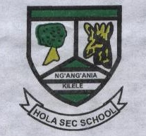

1. Identify six national goals of education. (6mks)

2. Name five poetic books of the bible. (5mks)

3. What are other words used to explain the meaning of sin. (3mks)

4. What were the consequences of sin according to biblical view of creation? (6mks)

5. In African communities what believed to be the causes of evil. (5mks)

6. Define the term faith. (2mks)

7. What were Abrahams act of faith. (5mks)

8. Give five characteristics of a covenant. (5mks)

9. What was the importance of covenant? (5mks)

10. Why is the bible referred to as a library? (6mks)

11. Name atleast 8 versions of the bible. (8mks)

12. Give reasons why CRE is taught in schools today. (7mks)

13. State the events that took place during the night of Passover. (7mks)

