NAME______________________________________ ADM/NO___________

DATE_______________________________________ FORM______________

C.R.E.
TERM TWO 2017
FORM 2
TIME: 2 HOURS

HOLA SECONDARY SCHOOL
MID TERM EXAMINATIONS
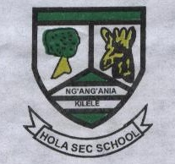

1. What are literary forms used in the bible. (5mks)

2. Describe the process of the bible translation from original languages to local languages. (7mks)

3. What are the similarities in the first and second account of creation? (3mks)

4. Identify the promises that God made to Abraham during the making of the covenant? (8mks)

5. In what ways did Abraham show his faith in God? (6mks)

6. How did God prepare Moses for his mission as a leader. (7mks)

7. Outline the achievements of King David. (6mks)

8. Explain the importance of the temple to the Israelites. (8mks)

9. State atleast 5 forms of idols in modern society. (5mks)

10. What were importances of initiation rites? (6mks)

11. Identify 3 moral values that young people were taught during some rites at passage.

12. What are the roles of ancestors in traditional African communities? (6mks)

