NAME________________________________________________ ADMISSION NUMBER _____________

DATE___________________ CLASS ______________ CANDIDATE’S SIGNATURE_____________

232/1
FORM 4 PHYSICS
PAPER 1 (THEORY)
JUNE 2017
2 HOURS

HOLA SECONDARY SCHOOL
Mid Term Examinations- 2017

INSTRUCTIONS
- Write your name and admission number in the space provided
- Sign and write the date of the examination in the space provided above
- This paper consists of two sections A and B.
- Answer all the questions in the spaces provided.
- All workings must be clearly shown.
- Mathematical tables and silent electronic calculators may be used.

For examiner’s use only

SECTION | QUESTION | TOTAL MARKS | CANDIDATE’S SCORE
A | 1-10 | 25
B | 11 | 13
 | 12 | 07
 | 13 | 05
 | 14 | 08
 | 15 | 13
 | 16 | 09
 |  | 80

TOTAL CANDIDATE’S SCORE

Section A + section B =

This paper consists of 11 printed pages. Candidates should check to ensure that all pages are printed as indicated and no questions are missing

- The load carried by a truck loader was measured to be 65,000 grams. Convert the mass of the load into milligrams and express the answer in standard form. (2 Marks)
………………………………………………………………………………………………………
………………………………………………………………………………………………………
………………………………………………………………………………………………………
………………………………………………………………………………………………………
- A form one student observed that when mercury is put into a glass it does not wet the glass. Explain the observations made by the girl. (2 Marks)
………………………………………………………………………………………………………
………………………………………………………………………………………………………
………………………………………………………………………………………………………
………………………………………………………………………………………………………
- In using the lift pump to raise water from a bore hole. It is observed that practically the height the water is raised cannot be 10m and more. Give two reasons for this observation. (2 Marks)
………………………………………………………………………………………………………
………………………………………………………………………………………………………
………………………………………………………………………………………………………
………………………………………………………………………………………………………
- When a mass of 2kg is hang from a single spring, the spring extends by a distance x. Determine the total extension in the set up below. (2 marks)

2 Kg

………………………………………………………………………………………………………
………………………………………………………………………………………………………
………………………………………………………………………………………………………
………………………………………………………………………………………………………

- The sketch below shows the relationship between the efficiency and the load for a pulley system.

C
Efficiency
1.0
B
A
0.5

Load (N)

Explain the shape of the curve (2 Marks) ………………………………………………………………………………………………………
………………………………………………………………………………………………………………………………………………………………………………………………………………
- State a reason why the efficiency of a machine is always less than 100% (1 Mark)
………………………………………………………………………………………………………
………………………………………………………………………………………………………
6. (i) Explain why bodies in circular motion undergo acceleration even when their speed is constant.
(1 Mark)
………………………………………………………………………………………………………
………………………………………………………………………………………………………
(ii) The figure below shows a container with small holes at the bottom in which wet clothes have been put.

Holes
Container Wet clothes
When the container is whirled in air at high speeds, it is observed that the clothes dry faster. Explain how the rotation of the container causes the clothes to dry faster. (2 Marks)

………………………………………………………………………………………………………
………………………………………………………………………………………………………
………………………………………………………………………………………………………
………………………………………………………………………………………………………

7. The diagram below shows a swinging pendulum.

B
A
C

(i) Which position does the bob have the:
(a) Maximum momentum (1 Mark)
………………………………………………………………………………………………………
(b) Minimum kinetic energy (1 Mark)
………………………………………………………………………………………………………
(ii) What basic physical quantity can be measured using a single pendulum? (1 Mark)
………………………………………………………………………………………………………
8. (a) State the principle of moments (1 Mark)
………………………………………………………………………………………………………
………………………………………………………………………………………………………
………………………………………………………………………………………………………

(b) A uniform 1m wooden bar with uniform cross-sectional area of 2.5cm by 2.5cm is suspended at the 60cm mark and kept balanced by hanging a mass 450g at 100cm mark.

60cm

Determine
(i) The density of the material of the metre rule (2 Marks)
………………………………………………………………………………………………………
………………………………………………………………………………………………………
………………………………………………………………………………………………………
………………………………………………………………………………………………………

(ii) The tension T in the string (1 Mark)
………………………………………………………………………………………………………
………………………………………………………………………………………………………

9. Explain the term sea breeze (3 Marks)
………………………………………………………………………………………………………
………………………………………………………………………………………………………
………………………………………………………………………………………………………
………………………………………………………………………………………………………
10. State two factors which affect the rate of diffusion in gases (2 Marks)
………………………………………………………………………………………………………
………………………………………………………………………………………………………

SECTION B – 55 Marks
Answer all the questions in this section in the spaces provided

11. (a) State two characteristics of perfectly inelastic collisions (2 Marks)
………………………………………………………………………………………………………
………………………………………………………………………………………………………
……………………………………………………………………………………………………...
(b) A body of mass 4.0 kg held at a vertical height of 500cm is released to travel along a frictionless curved path as shown in the figure below.
Mass = 4.0 kg
Mass =6.0 kg

The 4.0kg mass strikes body of mass 6.0kg at rest immediately it reaches the horizontal. The bodies stick together and move in the same direction. Determine the velocity of the bodies immediately after collision. (4 Marks)

………………………………………………………………………………………………………
………………………………………………………………………………………………………
………………………………………………………………………………………………………
…………………………………………………………………………………………………….....

(c) (i) A matatu whose mass is 2500kg is lifted with a jack screw of 10mm pitch. If the handle is 30cm from the screw, find force applied (Neglect frictional force) Take $π=3.14$ (4 Marks)

………………………………………………………………………………………………………
………………………………………………………………………………………………………
………………………………………………………………………………………………………
……………………………………………………………………………………………………

(ii) The figure below shows an inclined plane and a load of mass 15kg pulled by an effort of 100N.
100N
) 30⁰
15kg

Find the efficiency of the machine (3 Marks)

………………………………………………………………………………………………………
………………………………………………………………………………………………………
………………………………………………………………………………………………………
………………………………………………………………………………………………………

12. (a) The diagram below shows a rubber bladder filled with air and fixed to the bottom of a water
container with a string.
Water
Bladder
Air
String
S

Explain why the tension in the string increases when the water is heated (3 Marks)

………………………………………………………………………………………………………
………………………………………………………………………………………………………
………………………………………………………………………………………………………
………………………………………………………………………………………………………
(b) The figure below shows water pump which forces water through a hydraulic system. An air chamber is used to maintain a continuous flow of water during both the upstroke and down stroke of the piston.
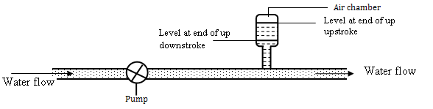

Explain how the continuous flow of water is maintained (2 Marks)
………………………………………………………………………………………………………
……………………………………………………………………………………………………...
………………………………………………………………………………………………………

13. (a) The figure below shows a circuit diagram for a device for controlling the temperature in a room.
S
Brass
Iron
Contact
Copper strip
Heater element

(i) Explain the purpose of the bimetallic strip. (2 Marks)
………………………………………………………………………………………………………
………………………………………………………………………………………………………
………………………………………………………………………………………………………

(ii) Describe how the circuit controls the temperature when the switch S is closed. (3 Marks)
……………………………………………………………………………………………………...
………………………………………………………………………………………………………
………………………………………………………………………………………………………
………………………………………………………………………………………………………
(b) (i) Define the term specific latent heat of vaporization of a substance (1 Mark)
………………………………………………………………………………………………………
………………………………………………………………………………………………………

(ii) An electric kettle rated 2.5kW is used to raise the temperature of 3.0kg of water through 50⁰C.
Calculate the time required to effect this (Specific heat capacity of water is 4200j/kgK) (3 Marks)

………………………………………………………………………………………………………
………………………………………………………………………………………………………
………………………………………………………………………………………………………
…………………………………………………………………………………………………….....

(c) A 12.9 gram sample of unknown metal at 26.5⁰C is placed in a Styrofoam cup containing 50.0 grams of water at 88.6⁰C. The water cools down and the metal warms up until thermal equilibrium is achieved at 87.1⁰C. Assuming all the heat lost by the water is gained by the metal. Determine the specific heat capacity of the unknown metal. (Specific heat capacity of water is 4180 J/kg/K) (4 Marks)

………………………………………………………………………………………………………
………………………………………………………………………………………………………
………………………………………………………………………………………………………
………………………………………………………………………………………………………

14. (a) The graph below represents the relationship between $\frac{1}{Volume}$ and pressure at constant temperature.
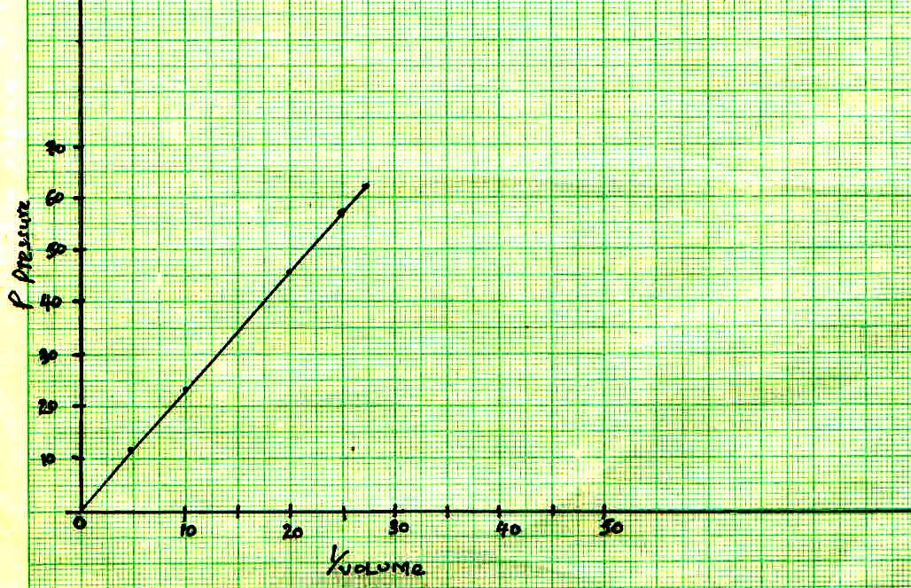
P Pressure

$$\frac{1}{volume}$$

(i) With the aid of a labelled diagram describe the apparatus and arrangements used in getting the results used to plot the graph above. (4 marks)

(ii) From the graph state the law under investigation. (1 mark)
………………………………………………………………………………………………………
………………………………………………………………………………………………………
………………………………………………………………………………………………………

(iii) State and explain how the graph can be used to verify the law stated in (ii) (3 marks)
………………………………………………………………………………………………………
………………………………………………………………………………………………………
………………………………………………………………………………………………………
………………………………………………………………………………………………………
15. (a) State what is meant by streamline flow (1 Mark)
………………………………………………………………………………………………………
………………………………………………………………………………………………………
(b) The figure shows the cross section of an aeroplane wing, with the aeroplane moving in the direction shown by the arrow.

Sketch streamlines to show how air flows past the wing as the aeroplane moves (1 Mark)

(c) The diagram below shows two horizontal pipes, A and B. Tube A contains liquid at rest while tube B contains liquid in motion.
A
B

(a) Liquid at rest (b) Liquid at motion

(i) Sketch graphs for (a) and (b) to show variation in pressure (2 Marks)

(d) A jet of water emerges from a hose pipe of cross-sectional area 5.0 x 10⁻³m² with a velocity of
3.0ms⁻¹. The water strikes a wall at a right angle and comes to rest without rebounding. Determine the mass of water striking the wall per second (Density of water is 1000 kgm⁻³)
(4 marks)
………………………………………………………………………………………………………
………………………………………………………………………………………………………............................................................................................................................................................................................................................................................................................................................

16. (a) Explain how a hydrometer may be used to test whether a car battery is fully charged.(2 Marks)
………………………………………………………………………………………………………
………………………………………………………………………………………………………
………………………………………………………………………………………………………

(b) A submarine made of iron was observed to float in water while a piece of iron rod sinks in water. Explain this observation 2 Marks)

………………………………………………………………………………………………………
………………………………………………………………………………………………………
………………………………………………………………………………………………………
(c) A solid displaces 5.0 cm³ of paraffin when floating and 20cm3 when fully immersed in it. Given that the density of paraffin is 0.8g/cm³. Calculate the density of the solid (4 Marks)

………………………………………………………………………………………………………
………………………………………………………………………………………………………
………………………………………………………………………………………………………
………………………………………………………………………………………………………

(d) Define the term relative density as used in liquids (1 Mark)
………………………………………………………………………………………………………
………………………………………………………………………………………………………

MARKING SCHEME
- 65,000g x 1000
65,00,000mg Either step
6.5 x 107mg (A.O Accept without units)
- The weak adhesive force between mercury and glass makes mercury not wet the glass while strong adhesive force between water and glass makes water wet the glass.
Accept argument interms of cohesive forces.
- – Low atmospheric pressure in places high sea
- Leakages at the valves and pistons of the lift pump
- $\frac{1}{2}$x + x + x = $\frac{5}{2}$x = (2.5x)
- (a) - As the load increases, the effect of friction is less significant.
- As the load increases, the work done in moving parts becomes less significant.
- At maximum efficiency, work output equals work input.
(b) - Friction always opposes movement
- Moving parts use some energy
- (i) Velocity is not constant since its direction changes at very instant.
(ii) - The water is expelled through the holes when the container is rotated at high speed. The clothes keep moving in a circular path because the contact force of the container provides the centripetal force.
- The fibres of the clothes cannot provide sufficient centripetal force to the water in the circular paths; thus the water flies off at a tangent and escapes through the holes. This makes clothes dry faster.
- (i) (a) B
(B) A and C or Any one
(ii) Time
- (a) When a system is in equilibrium the sum of clockwise moments is equal to the sum of anticlockwise moments taken at a point.
(b) (i) Clockwise moment = 0.45 x 40
Anticlockwise moments = 10 x w
10w = 0.45 x 40
w = 1.8
m = 180g
d = $\frac{m}{v}$ = $\frac{180}{2.5 x 0.5 x 100}$
= 1.44g/ cm³
(ii) Sum of upward forces = Sum of downward forces
T = 0.45 + 1.8
T = 2.25N
- – During the day, the land heats up much faster than the sea
- The air just above the land gets heated up and rises because of reduced density
- Cold air above the sea blows towards the land to replace the void being created by warm rising air
- – Density
- Temperature
- (a) – The total mass is the sum of the masses of the individual bodies
- The bodies end up with a common velocity
(b) At the bottom of fall $\frac{1}{2}$mv² = mgh
v = $\sqrt{2gh}$ = $\sqrt{{4kg x 10Nkg}^{-1}x 5M}$
= 14.14ms⁻¹
Momentum before collision = mv
= 4kg x 14.14ms⁻¹ = 56.57 kgms⁻¹
Momentum after collision
= (m + m₁)v₁ = 10kg x v₁
Momentum before collision = momentum after collision
56.57kgms-1 = 10kg x v₁
v₁ = 5.657ms⁻¹

- (i) V.R of screw = $\frac{Circumference of the handle}{Pitch}$
= $\frac{2 x 3.14 x 30 x {10}^{-2}}{0.010}$
= 188.52
Neglecting friction MA = V.R
MA = $\frac{L}{E}$ = $\frac{2500}{E}$
$\frac{25000}{E}$ = $\frac{{2 X 3.14 X 30 X 10}^{-2}}{0.010}$
$E= \frac{25000 X 0.010}{{2 X 3.14 X 30 X 10}^{-2}}$
$=132.$7N
Soln
V.R. $\frac{1}{Sin }$ = $\frac{1}{Sin {30}^{0}}$ = $\frac{1}{0.5}$ = 2
(ii) M.A = $\frac{L}{E}$
= $\frac{150}{100}$ = 1.5
Eff = $\frac{MA}{VR}$ x 100
= $\frac{1.5}{2}$ x 100
= 75%
- (a) Air inside the bladder get a bigger volume. This displaces more water hence greater up thrust. Although the water also expands; the expansion is insignificant compared to that of the air.
(b) Upstroke - The valve opens; pressure forces water flow into the air chamber and air compressed.
Down stroke - Valve closes; compressed air expands hence continuous flow of water.
- (a) (i) To make and break the contact of the circuit. The strip bends and straightens when the metals
contract or expand, at different temperature.
(ii) When the switch is closed current flows through the heater and warms air in the room thus
heating the strip, the strip bends away from the contact. This disconnects the heater, when the strip cools down, it reconnects and the process repeats itself.
(b) (i) Specific latent heat of vaporization is the quantity of heat required to change 1kg of a liquid to
vapour at a constant temperature.
(ii) P x t = MCΔθ
2.5 X 1000T = 3 x 4200 x 50
T = 252 sec
= 4.2min
(c) Solve for Q water
Q water = MCΔT = (509 x (4.18) (-1.5⁰C)
Q water = - 313.5J (- Sign indicates that heat is lost by water)
Q metal = 313.5j (Use + sign since the metal is gaining heat)
Q metal = Mmetal x Cmetal ΔT metal
C metal = 313.5/12.9 x 60.6⁰C
Cmetal = 0.40103 x 10³ (JKg⁻¹k⁻¹)

- a (i) Set the apparatus as shown below.
h
L
Rubber
Scale
Air

Raise or lower the open end and record the corresponding values of pressure (h) of trapped air L (It represents volume)
(ii) The pressure of a fixed mass of gas is inversely proportional to its volume, provided the temperature
is kept constant.
(ii) – Determine corresponding values of pressure and $\frac{1}{Volume}$
- It is noticed that as pressure increases volume is decreasing

Pressure | 12 | 23 | 45
Volume | 0.2 | 0.1 | 0.05

- (a) A flow in which every particle of liquid passing a point follows the path of the preceeding particle.
The velocity of the particles passing a certain point is the same and in one direction.
(b)

- Bottom- the streamlines must be closer
- Top - the streamlines must be spaced
Distance
Pressure
Distance
Pressure
(c) (i) (a)
1 Mark 1 Mark

(d) Volume of water striking wall per second.
= 3.0 ms⁻¹ x 5.0 x 10⁻³m²
= 1.5 x 10⁻² m³s⁻¹
Mass of water/sec
= 1.5 x 10-2m3 x 1.0 x 10³ kgm³s⁻¹
= 15 kgs-1
- (a) Hydrometer has a scale along its wall. A fully charged battery has density 1.30g/cm³ thus it will float at 1.3 mark A battery with no charge has density between 1.18 – 1.15g/cm³. It floats within 1.18 and1.15 means has no charge.

(b) A submarine has a hollow part filled with air and is also large in volume. The large volume
displaces a lot of water making the up thrust large hence the submarine floats A piece of iron displaces small volume of water whose up thrust cannot support it weight hence it sinks.
(c) Weight of solid = weight of solid fluid displaced
Volume of fluid = 5.0 cm³
Mass of fluid = 5 x 0.8 = 4.0g
Weight of fluid = $\frac{4}{1000}$ x 10 = 0.04N
Mass of solid = 4.0g
Volume of solid = 20cm³
Density of solid = $\frac{M}{V}$ = $\frac{4}{20}$ = 0.2g/cm³
(d) Relative density = $\frac{Weight of a substance in air}{Weight the same substance in water}$
or
= $\frac{Mass of substance in air}{Mass of equal volume in water}$
= $\frac{Density of the liquid}{Density of water}$

