NAME______________________________________ ADM/NO___________

DATE_______________________________________ FORM______________

HISTORY
TERM TWO 2017
FORM 2
TIME: 2 HOURS

HOLA SECONDARY SCHOOL
MID TERM EXAMINATIONS
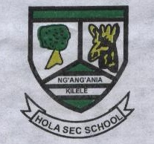

1. Identify five unwritten sources of information. (5mks)

2. State 6 methods used by scientists to date fossils remains and artefacts. (6mks)

3. Identify six crops grown in Egypt. (6mks)

4. What were the impacts of migration of the plain Nilotes in pre-colonial period? (6mks)

5. Identify five early visitors to the East Cost Africa up to 1500. (5mks)

6. Give reason for the coming of missionaries to the East African coast in the 19th Century. (6mks)

7. What is communication? (2mks)

8. What are the disadvantages of fire and smoke as a form of traditional communication? (4mks)

9. What are the disadvantages of animal transport? (4mks)

10. What were the difficulties encountered by traders during Trans-Saharan trade. (6mks)

11. State ways in which slaves were obtained from West Africa. (5mks)

12. Give 8 benefits of domestication of animals. (8mks)

13 What are the remedies for food shortages in Kenya? (7mks)

