NAME:…………………………………………………….INDEX NUMBER:…………………
DATE:……………………
231/1
BIOLOGY
PAPER 1
JULY 2013
TIME: 2 HOURS

SUPA JET MOCK EXAM
Kenya Certificate of Secondary Education
Biology
Paper 1

INSTRUCTIONS TO CANDIDATES

Answer all the questions in the spaces provided in this paper.

FOR EXAMINER’S USE ONLY

Questions | Maximum score | Candidates score
- 40 | 80

- Name the hormone that is responsible for the development of a deep voice in humans.
(1 mark)

…………………………………………………………………………………………………
- The relationship between fungi and algae in a lichen is best described as: (1 mark)
…………………………………………………………………………………………………
- Name the bacteria found in the root nodules of leguminous plants. (1 mark)

………………………………………………………………………………………………………..
- In which part of the cell does each of the following processes take place? (2 marks)
- Glycolysis ………………………………………………………………………………..
- Krebs cycle ………………………………………………………………………………
- Name the structure used for excretion in fresh water protozoa. (1 mark)
………………………………………………………………………………………………………..
- State two mechanisms of excretion in terrestrial green plants. (2 marks)

………………………………………………………………………………………………………..
………………………………………………………………………………………………………..
………………………………………………………………………………………………………..
………………………………………………………………………………………………………..
- Name the gamete cells that are produced by ovaries. (1 marks)

………………………………………………………………………………………………………..
- Name three abiotic factors in a soil ecosystem. (3 marks)

………………………………………………………………………………………………………..
………………………………………………………………………………………………………..
- Define facultative anaerobe. (1 mark)

………………………………………………………………………………………………………..
………………………………………………………………………………………………………..
………………………………………………………………………………………………………..
………………………………………………………………………………………………………..
- What is meant by single circulatory system? (1 marks)

………………………………………………………………………………………………………..
………………………………………………………………………………………………………..
………………………………………………………………………………………………………..

- What is meant by a test cross in genetics? (2 marks)

………………………………………………………………………………………………………..
………………………………………………………………………………………………………..
………………………………………………………………………………………………………..
………………………………………………………………………………………………………..
- Give the scientific name of the bacterium that causes tuberculosis in humans. (1 mark)

………………………………………………………………………………………………………..
………………………………………………………………………………………………………..
- (a) Name two chemicals that undergo no digestion. (2 marks)

………………………………………………………………………………………………………..
………………………………………………………………………………………………………..
(b) Explain why the chemicals names in (a) above undergo no digestion. (1 mark)

………………………………………………………………………………………………………..
………………………………………………………………………………………………………..
- Which part of the ovule forms the following structures after fertilization? (2 marks)
- Zygote……………………………………………………………………………………
- Testa……………………………………………………………………………………..
- The process by which living organisms take oxygen into their bodies and release Carbon(VI) oxide into the environment is called? (1 mark)

………………………………………………………………………………………………………..
- Name three requirements of a plant to carry out photosynthesis . (3 marks)

………………………………………………………………………………………………………..
………………………………………………………………………………………………………..
………………………………………………………………………………………………………..
………………………………………………………………………………………………………..
- The branch of biology that deals with the study of structure of living things that can be seen by the unaided eye when the animal is dissected is called? (1 mark)

………………………………………………………………………………………………………..
- Give one merit of internal fertilization e.g. in humans. (1 mark)

………………………………………………………………………………………………………..
………………………………………………………………………………………………………..
………………………………………………………………………………………………………..
………………………………………………………………………………………………………..

- Give the importance of mosaic leaf arrangement. (1 mark)

………………………………………………………………………………………………………..
- State 3 features that a grasshopper, a crab and a spider have in common. (3 marks)

………………………………………………………………………………………………………..
………………………………………………………………………………………………………..
………………………………………………………………………………………………………..
………………………………………………………………………………………………………..
- Name one plant excretory product that is harnessed and used as a local anesthetic. (1 mark)

………………………………………………………………………………………………………..
- State the importance of each of the following features of the mammalian ileum.
- Highly coiled. (1 mark)

………………………………………………………………………………………………………..
………………………………………………………………………………………………………..
- Long (1 mark)

………………………………………………………………………………………………………..
………………………………………………………………………………………………………..

- State two ways in which food is mechanically digested in a mammal. (2 marks)

………………………………………………………………………………………………………..
………………………………………………………………………………………………………..
………………………………………………………………………………………………………..
………………………………………………………………………………………………………..
- The body cells of an organism contain two copies of 24,000 genes i.e. 48,000 genes in total of these. How many genes would have been inherited from the organism’s female parent? (1 mark)

………………………………………………………………………………………………………..
………………………………………………………………………………………………………..
- Besides direct drinking, name two other sources of water in nutrition of man. (2 marks)

………………………………………………………………………………………………………..
………………………………………………………………………………………………………..
………………………………………………………………………………………………………..
………………………………………………………………………………………………………..
- State the importance of the following features of mammalian lungs.
- Spongy and elastic (1 mark)

………………………………………………………………………………………………………..
………………………………………………………………………………………………………..
- Pleural fluid (1 mark)

………………………………………………………………………………………………………..
………………………………………………………………………………………………………..
- Give the term used to describe the following organelle / features of cells.
- They become visible only when the cells are dividing. (1 mark)

………………………………………………………………………………………………………..
………………………………………………………………………………………………………..
- A term which means “made of many cells”. (1 mark)

………………………………………………………………………………………………………..
………………………………………………………………………………………………………..
- Give 2 reasons why humans (Homo sapiens), unlike garden peas (Pisum sativum), are not convenient subject for genetic studies. (2 marks)

………………………………………………………………………………………………………..
………………………………………………………………………………………………………..
………………………………………………………………………………………………………..
………………………………………………………………………………………………………..
………………………………………………………………………………………………………..
………………………………………………………………………………………………………..
- Identify each of the genetic disorders in man, characterized by the symptoms described in (a) and (b) below.
- Inability to distinguish between blue and green colour and various shades of red.
(1 marks)

………………………………………………………………………………………………………..
- Lack of the protein dystrophin resulting in a progressive weakening of body muscles and inco-ordinated body moement. (1 mark)

………………………………………………………………………………………………………..
- Inscribed on the casing of an objective lens of a light microscope are x5 and 0.14. Specify what 0.14 represents. (1 mark)

………………………………………………………………………………………………………..

- (a) It was found that during germination of pea seeds, 9.00 cm³ of oxygen was used while
9.2 cm³ of carbon (IV) oxide was produced. Calculate the RQ. (3 marks)

………………………………………………………………………………………………………..
………………………………………………………………………………………………………..
………………………………………………………………………………………………………..
………………………………………………………………………………………………………..
………………………………………………………………………………………………………..
………………………………………………………………………………………………………..
(b) Identify the food substance that was metabolised. (1 mark)

………………………………………………………………………………………………………..
- (a) Under what conditions is carboxyhaemoglobin formed in the human body.(1 mark)

………………………………………………………………………………………………………..
………………………………………………………………………………………………………..
(b) Why does accumulation of carboxyhaemoglobin cause death? (2 marks)

………………………………………………………………………………………………………..
………………………………………………………………………………………………………..
………………………………………………………………………………………………………..
- Give 2 functions of each of the following structures in the human reproductive system.
- Epididymis. (2 marks)

………………………………………………………………………………………………………..
………………………………………………………………………………………………………..
………………………………………………………………………………………………………..
………………………………………………………………………………………………………..
- Oviduct (2 marks)

………………………………………………………………………………………………………..
………………………………………………………………………………………………………..
………………………………………………………………………………………………………..
………………………………………………………………………………………………………..
- To estimate the population of Tilapia using the capture recapture method, 60 fish were captured marked and released. In the second capture, out of 72 fish, 10 had been marked. Calculate the estimated population of Tilapia. (Show your working). (3 marks)

………………………………………………………………………………………………………..
………………………………………………………………………………………………………..
………………………………………………………………………………………………………..
- (a) Describe the vestibular apparatus of the ear. (1 mark)
………………………………………………………………………………………………………..
(b) State the role of the vestibular apparatus. (1 mark)
………………………………………………………………………………………………………..
- Name the smallest ear oscicle. (1 mark)
………………………………………………………………………………………………………..
- State two distinguishing features of scapula. (2 marks)

………………………………………………………………………………………………………..
………………………………………………………………………………………………………..
………………………………………………………………………………………………………..
………………………………………………………………………………………………………..
- (a) What is meant by biological control? (1 mark)

………………………………………………………………………………………………………..
………………………………………………………………………………………………………..
………………………………………………………………………………………………………..
(b) Give two examples of biological control. (2 marks)

………………………………………………………………………………………………………..
………………………………………………………………………………………………………..
………………………………………………………………………………………………………..
………………………………………………………………………………………………………..
- The diagram below represents a certain animal.

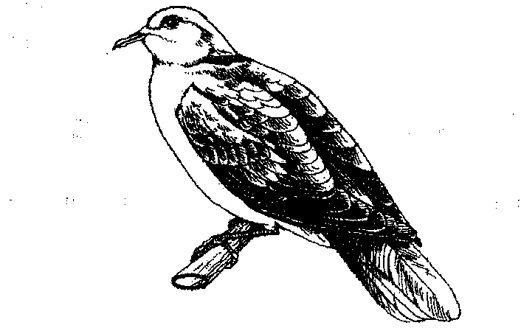

- Name the taxonomic class to which the animal belongs. (1 mark)

…………………………………………………………………………………………….
- Label on the diagram, three features in which are characteristics of organisms in the class named in (a) above. (3 marks)
- The diagram below shows a fruit specimen dispersed by a certain agent. Study the diagram carefully and then answer the questions that follow.

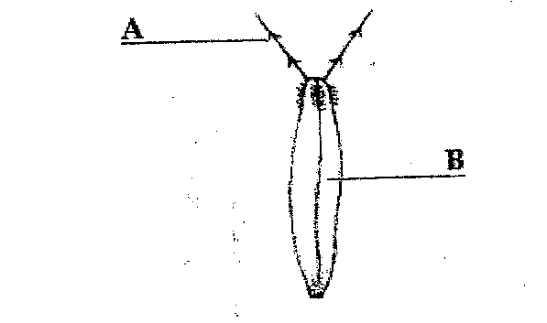

- What type of fruit is represented by the diagram above? (1 mark)
……………………………………………………………………………………………..
- Name each of the parts labeled A & B. (2 marks)
A………………………………………… B…………………………………………

- Name the agent of dispersal of the fruit.

……………………………………………………………………………………………..
- On the diagram of root tip below label each of the following. (2 marks)

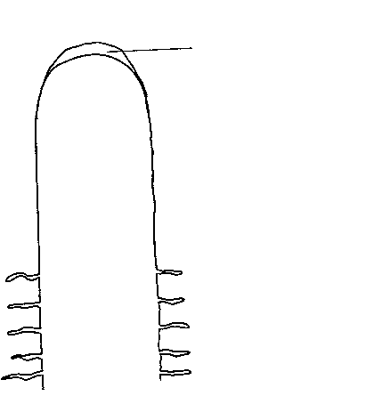
- Zone of cell elongation.

- Zone of cell differentiation.

