NAME: ………………………………………………………CLASS:………ADM NO:………

INDEX NO:………………………

312/1
GEOGRAPHY
PAPER 1

TIME: 2 ¾ HOURS

Geography
Paper 1

INSTRUCTIONS:

- The paper comprises of 2 sections A and B.
- Attempt all question in section A.
- Answer question 6 and any other two questions from section B.
- All answers must be written in separate answer sheets.

SCORE SHEET

SECTION A
QUESTIONS 6
QUESTION 7
QUESTION 8
QUESTION 9
QUESTION 10
TOTAL | %

SECTION A
Answer All Questions
1. (a) Define Geography (2 marks)
(b) Give two reasons to explain why the interior of the earth is hot (2 marks)
(c) Distinguish between meteors and meteorites (2 marks)
2. (a) Identify the types of folds shown (2 marks)
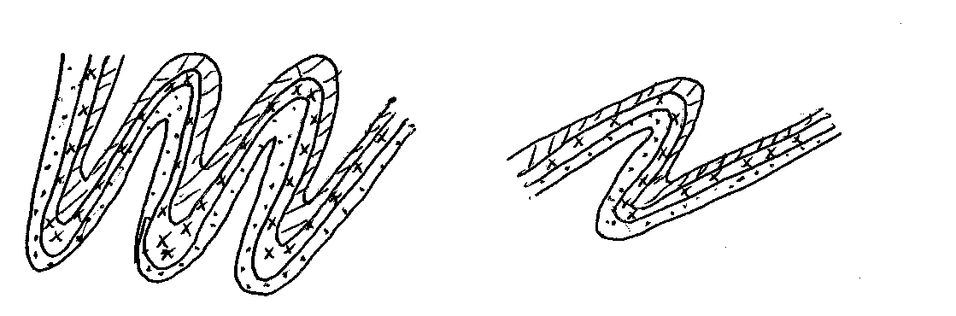
(b) State three negative effects of folding on human activities (3 marks)
3. (a) State two causes of soil creep (2 marks)
(b) The diagram below shows rock creep. Name the parts marked P,Q,R (3 marks)

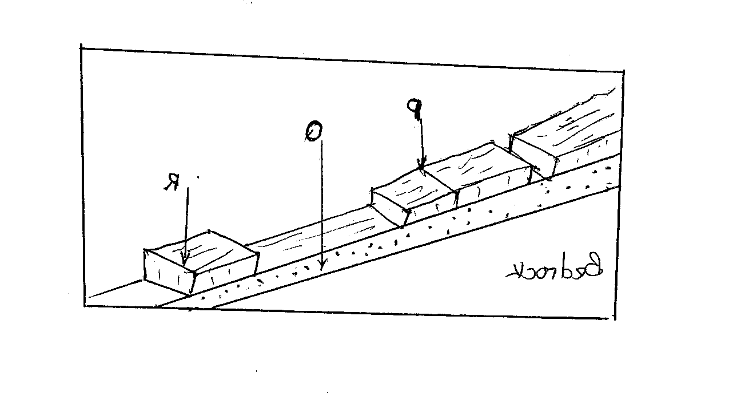

4. (a) Identify the features C, D, &E shown in the diagram (3 marks)

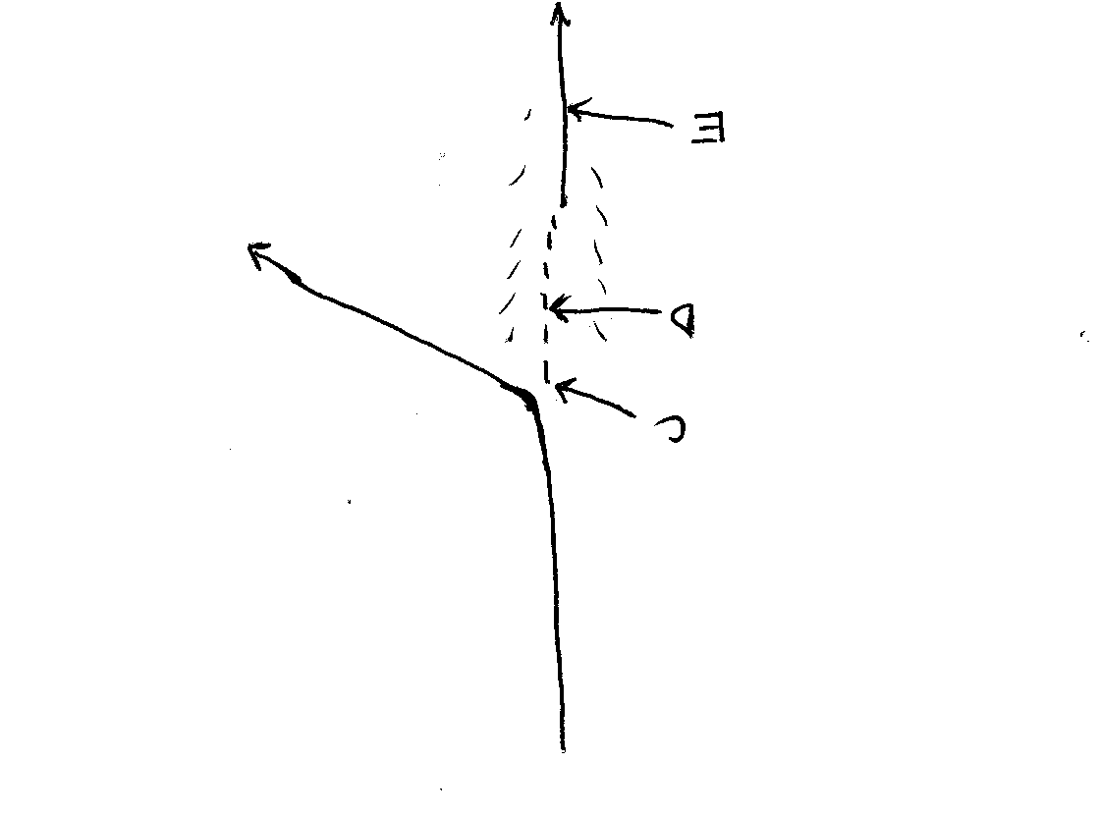
(b) State two causes of river rejuvenation (2 marks)
5. (a) State two physical factors that contribute to the development of Sahara Desert. (2 marks)
(b) Draw a well labeled diagram to show a Zeugen. (2 marks)

6. Study the map of Kitale scale 1:50,000(sheet 75/3) provided and answer the questions that
follow.

- (i) Give the bearing of the trigonometrical station secondary at grid 2823 from the water hole
at grid 3127 (2 marks)
(ii) Give the magnetic variation of the area covered by the map extract (1 mark)
- Name three types of settlement patterns found on the map extract (3 marks)

- (i) Draw a cross section from the grid reference 340280 to Kaipos trigonometrical station at
grid square 3932. (Use a scale of 1cm rep. 40 m) (2 marks)
On your cross section, mark and label the following:
(a) Dam (1 mark)
(b) River Saiwa (1 mark)
(c) Forest boundary (1 mark)
(ii) Calculate the gradient between the dam and the starting point (2 marks)
(d) (i) Explain 3 factors that favour the growing of wattle in the area covered by the map. (6 marks)
(ii) Give two evidences showing why the area has a wet climate (2 marks)
(e) Draw a rectangle 7.2 cm to 10 cm representing the a area West of Eastings 30 and South of
Northing 20 (1 mark)
On it mark and label the following
(a) Kitale municipality (1 mark)

(b) All weather roads loose surface (1 mark)

(c) Koitobos river (1 mark)

7. (a) (i) Differentiate between vulcanicity & volcanicity. (2 marks)

(ii) Draw the map of Kenya. (1 mark)
On it locate and name:
M-mau escarpment. (1 mark)
O-lake Magadi (1 mark)
Y – Yatta plateau (1 mark)

(b) With the aid of a well labeled diagram describe how the following features are formed:
(i) Lava plateau. (5 marks)
(ii) sill (3 marks)

(c) (i) Give two characteristics of the Gregory rift valley. (2 marks)

(ii) You have been asked to carry out a field study on faulting in the Rift Valley, design a
working schedule to use during the study. (3 marks)

(d) Explain three negative influences of vulcanicity and associated features on human
activities in Kenya. (6 marks)

8. (a) (i) Differentiate between a barrier reef and a fringing reef (2 marks)
(ii) Give three causes of oceans currents (3 marks)

(b) The diagram below shows Coastal features. Use it to answer questions b (i).
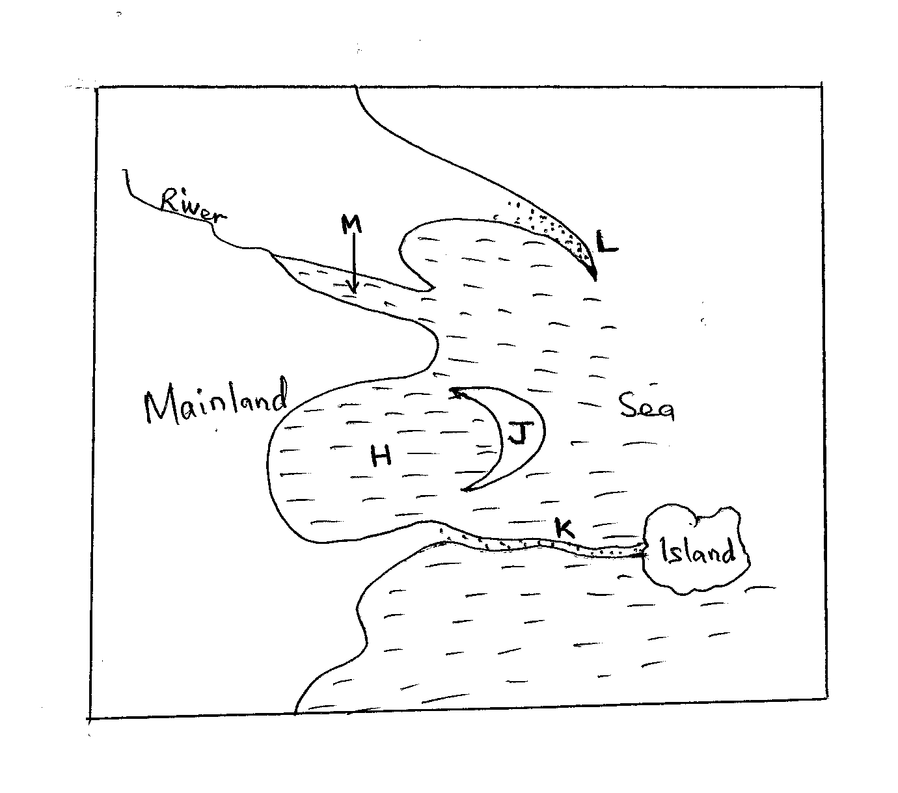
(i) Name the coastal features marked H,J,K,L (4 marks)
(c) With the aid of diagrams describe how a wave – cut platform is formed (6 marks)
(d) Explain how the following factors influence development of coasts
(i) Climate (2 marks)
(ii) Gradient of the Coast (2 marks)
(e) Your class intends to carry out a field study on the features along the coast of Kenya.
(i) Why would they need to carry out reconnaissance (3 marks)
(ii) Give three disadvantages of using observation to collect data (3 marks)

9. (a) Distinguish between glacial till and fluvio-glacial deposits (2 marks)
(b) Explain three factors that determine the rate at which ice moves. (6 marks)
(c) The diagram below shows depositional features in lowlands
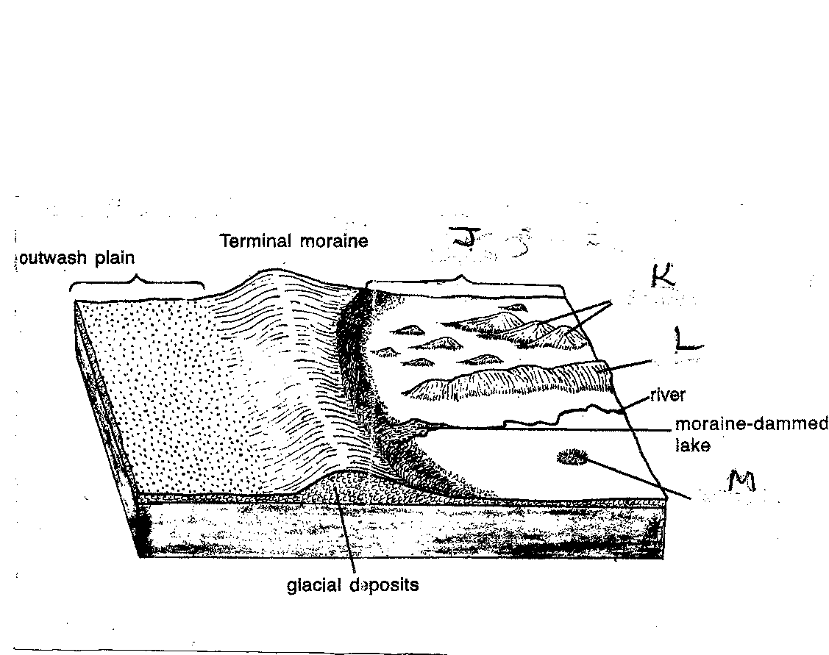
(i) Name the features marked J, K,L and M. (4 marks)

(ii) Describe how the following features are formed:
- moraine dammed lake (4 marks)

- outwash plain (4 marks)

(d) Students from Meru high school intend to carry out a field study on features of glaciations
on Mt Kenya
(i) Identify two methods they will use to collect data. (2 marks)

(ii) State one negative effect they are likely to identify (1 marks)

(iii) State two follow up activities they are likely to engage in (2 marks)
10. (a) (i) State three characteristics of ITCZ (3 marks)
(ii) Describe the following factors influence climate
- configuration of the coastline (2 marks)

- Distance from the sea (2 marks)
(b) Study the world map provided and use it the answer the questions below.
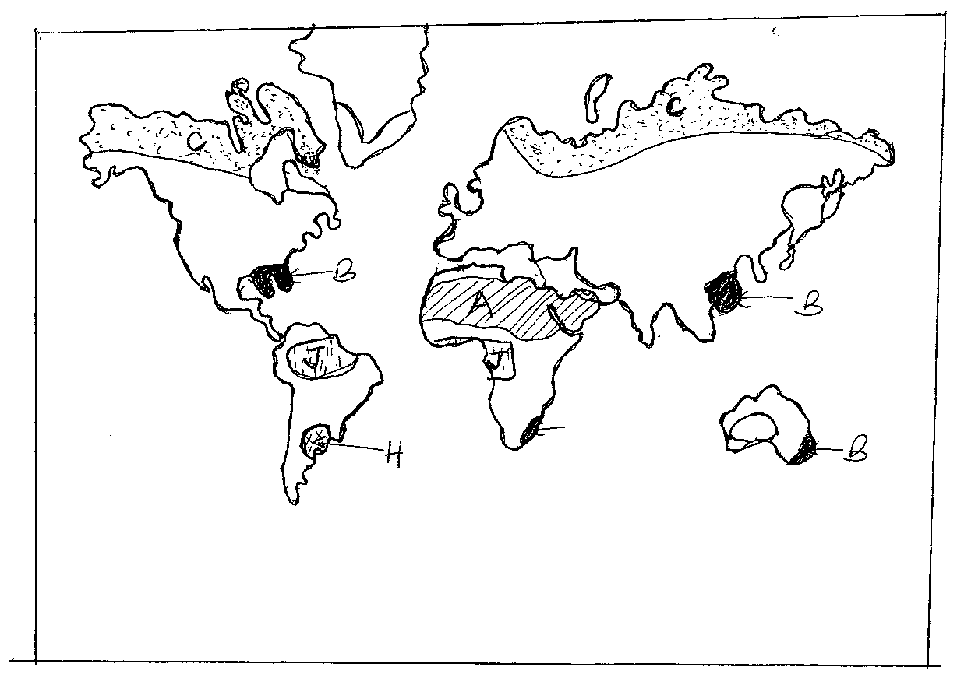
- Name the climatic regions A,B,C (3 marks)

- Name the vegetation type marked H&J (2 marks)

- Explain three ways in which coniferous forests have adapted to the climatic conditions (6 marks)
(c) You carried out a field study in an marginal area experiencing encroachment of desert conditions
(i) State two objectives for your study. (2 marks)
(ii) How would you record your findings during the study? (2 marks)
- Describe three findings on the causes of the encroachment (3 marks)

