NAME: ………………………………………,………....… ADMISSION NUMBER: ……………
232/2 SIGNATURE: …………………………..…….
FORM 3 PHYSICS DATE…………………………………….…….
Paper 2
JUNE 2017
2 Hours

HOLA SECONDARY SCHOOL

Mid Term Examinations 2017

INSTRUCTION TO CANDIDATES
- Write your name, index number in the spaces provided above.
- Sign and write the date of examination in the spaces provided above.
- This paper consists of two sections: A and B.
- Answer all the questions in sections A and B in the spaces provided.
- All working must be clearly shown.
- Silent non programmable electronic calculators may be used.
- Candidates should answer the questions in English.

For Examiners Use Only
Section | Question | Maximum  Score | Candidate’s  Score
A | 1 – 11 | 25
B | 12 | 15
 | 13 | 10
 | 14 | 12
 | 15 | 14
 | 16 | 4
Total Score |  | 80

This paper consists of 12 printed pages. Candidates should check the question paper to ascertain that all pages are printed as indicated and that no questions are missing
SECTION A (25 marks)
Answer all the questions in this section in the spaces provided
- The figure 1 below shows the image in front of a mirror M.
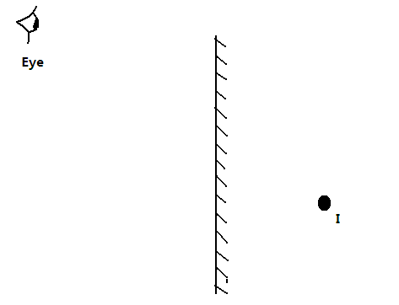
By ray diagram construction, locate the position of the object. (2 marks)

- Repulsion is the only sure way of testing polarity of magnets. Explain? (1 mark)
…………………………………………………………………………………………………………………………………………………………………………………………………………………………
- State the basic law of electrostatics. (1 mark)
…………………………………………………………………………………………………………………………………………………………………………………………………………………………
- The figure below shows two spheres in contact placed close to a positively charged rod.
+
+
+
+
+

Insulating stand
Show the distribution of charges in the two spheres. (1 mark)
- State two reasons why prism periscopes are preferred to mirror periscope. (2 marks)
…………………………………………………………………………………………………………………………………………………………………………………………………………………………
- A current carrying conductor AB is in a magnetic field as shown in figure 1 below.
Conductor
Direction of current
S
N

- Indicate the direction of the force F acting on the conductor. (1mark)
- State two factors that determine the direction of the force F. (2marks)
……………………………………………………………………………………………………………………………………………………………………………………………………………………
- Five successive wave fronts in a ripple tank are observed to spread over a distance of 6.4 cm. If the vibrator has a frequency of 8 Hz, determine the speed of the wave. (3 marks)

………………………………………………………………………………………………………………………………………………………………………………………………………………………………………………………………………………………………………………………………

- In a certain pinhole camera, the screen is 10 cm from the pinhole. When the camera is placed 6 m away from a tree, a sharp image of the tree 16 cm high is formed on the screen. Determine the height of the tree. (3 marks)

………………………………………………………………………………………………………………………………………………………………………………………………………………………………………………………………………………………………………………………………
- Draw a diagram to illustrate how dispersion of white light can be achieved using a prism by drawing only the red and violet rays (2 marks)

- A small object lies at the bottom of a water pond at a depth of 1.2m. given that the refractive index of water is 1.3, determine the apparent depth of the object.(Give your answer to one decimal place)
(3 marks)
………………………………………………………………………………………………………………………………………………………………………………………………………………………………………………………………………………………………………………………………………

- State two maintenance practices of a lead acid accumulator. (2 marks)
………………………………………………………………………………………………………………………………………………………………………………………………………………………………………………………………………………………………………………………………………

- A charge of magnitude 2.1 x 10³C flows through a point in 14 minutes. Calculate the amount of current that flows. (2 marks)
………………………………………………………………………………………………………………………………………………………………………………………………………………………………………………………………………………………………………………………………………

SECTION B (55 marks)
Answer all the questions in this section in the spaces provided
- (a) State Ohm’s law. (1 mark)
..........................................................................................................................................................................................................................................................................................................................................................................................................................................................................................

- The figure below shows part of the scale of a voltmeter, which is being used in an experiment to measure potential difference across a resistor.
0.6V
3.0V

1

2

0

3

0.2

0

0.4

0.6

V

- State the accuracy of the upper and the lower scales of the voltmeter. (2 marks)
…………………………………………………………………………………………………………………………………………………………………………………………….………………
- Record the reading shown by the lower scale of the voltmeter. (1 mark)
……………………………………………………………………………………………………………………………….……………..………………………..……………………………..………
- (i) Define electrical resistance. (1 mark)
……………………………………………………………………………………………………………………………….……………..………………………..……………………………..………

(ii) A current of 2.5mA flows through a conductor of resistance 1.2 kΩ. Calculate the voltage
across the conductor. (3 marks)
……………………………………………………………………………………………………………………………….……………..………………………..……………….…………………..………
(iii) State and explain two factors that affect the resistance of a given length of a conductor.
(4 marks)
……………………………………………………………………………………………………………………………….……………..………………………..…………………………………………………………………………………………………………………………………………………………………………………………………………………………………………………..……..………
- (i) Determine the current passing through L₁ in the figure shown below, given that 0.8A passes through the battery, 0.28A through L₂ and 0.15A through L₃.
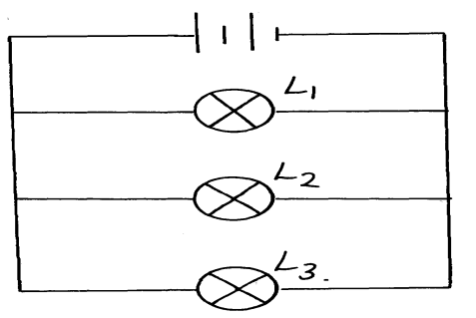

…………………….……………..………………………..…………………………………………………………………………………………………………………………………………………………………………………………………………………………………………………..……..………
(ii) Give a reason why the above method of bulb connection is preferred for domestic wiring than series connection. (1 mark)

…………………….……………..………………………..………………………………………………………………………………………………………………………………………………………

- (a) Define the terms. (2 marks)
- Wavelength.
……………………………………………………………………………………………………………………………………………………………………………………………………………………
- Speed as used in waves.
……………………………………………………………………………………………………………………………………………………………………………………………………………………
(b) Below is a wave traveling to the right side. Use it to answer the questions that follow.

Q

- Indicate the direction in which the particle at point Q is going to move. (1 mark)
- Show on the diagram a distance of one wavelength from particle Q. (1 mark)

(c) Differentiate between longitudinal waves and transverse waves. (2 marks)
………………………………………………………………………………………………………….……………………………………………………………………………………………………………………………………………………………………………………………………………………

(d) Sound waves are generated at point P. They hit a reflecting surface at Q and come back. A detector is put at point P. If it takes a time of 3 seconds to detect the echo,

Detector

Q P

- How far is Q from P.? Take speed of sound as 340m/s (3 marks)
………………………………………………………………………………………………………………………………………………………………………………………………………………………………………………………………………………………………………………………………

- What will be the effect of increased humidity of the surrounding air
- Decreasing the amplitude on loudness of sound? (1 mark)
…………………………………………………………………………………………………………
- Increasing the frequency? (1 mark)
…………………………………………………………………………………………………………
- (a) State two conditions which must be satisfied for total internal reflection to occur. (2 marks)
………………………………………………………………………………………………………………………………………………………………………………………………………………………………………………………………………………………………………………………………
(b) The diagram below shows two rays of light incident normally on face PQ of a glass prism, whose critical angle is 42⁰.
45⁰
P
R
Q

Complete the diagram to show the paths of the two rays as they pass through the prism. (3 marks)

(c) A pin is fixed horizontally at the centre of a rectangular container with thin transparent walls as shown below.
Pin
16 cm
Rectangular
container
A

A transparent liquid is then poured into the container. When viewed from side A, the distance of the pin is 6 cm from the surface of the liquid. Determine the refractive index of the liquid. (3 marks)
………………………………………………………………………………………………………………………………………………………………………………………………………………………………………………………………………………………………………………

(d) The figure below shows a coin placed in a large empty beaker. An observer looking into the beaker from the position shown is unable to see the coin.
Coin
Observer
Container

Sketch two rays from a point on the coin to show how the observer is able to see the image of the coin after the container if filled with water. (3 marks)

(e) A ray of light is incident on a water-glass interface as shown in the diagram below.
30⁰
r
Water

Glass

Calculate the value of angle, r, given that the refractive index of glass and water are 1.5 and 1.33 respectively. (3 marks)
………………………………………………………………………………………………………………………………………………………………………………………………………………………………………………………………………………………………………………………………

- (a) Define principal focus (1 mark)
…………………………………………………………………………………………………………………………………………………………………………………………………………………………………………………….…………………………………………………………………………
- The figure below shows an object,O, placed in front of a convex mirror.

F
O
- On the same diagram draw the appropriate rays and locate the image formed. (3marks)
- Determine the magnification of the image formed. (3 marks)
…………………………………………………………………………………………………………………………………………………………………………………………………………………………………………………….…………………………………………………………………………
(c) An object is placed 12cm from a convex mirror of radius of curvature 20cm. Calculate the position of the image. (3 marks)

…………………………………………………………………………………………………………………………………………………………………………………………………………………………………………………….…………………………………………………………………………

(d) (i) A lady holds a large concave mirror of focal length 1.8m from her face. State two characteristics of her image in the mirror. (2 marks)

……………………………………………………………………………………………………………………………………………………………………………………………………………………
(e) State two applications of convex mirrors. (2 marks)
……………………………………………………………………………………………………………………………………………………………………………………………………………………

