NAME______________________________________ ADM/NO___________

DATE_______________________________________ FORM______________

PHYSICS
TERM TWO 2017
FORM 1
TIME: 2 HOURS

HOLA SECONDARY SCHOOL
MID TERM EXAMINATIONS

SECTION A (25MKS)

1. Define pressure and state ist SI unit. (2mks)

2a) What is a physical quantity. (1mk)

b) State one basic and derived quantity. (2mks)

3a) When a certain quantity of mass was weighed on earth. Its weight was less than its weight on Jupiter where the gravitational acceleration is 26N/kg. Explain. (2mks)

b) The weight of a physical form one text book is 25N on earth. What could be its weight on moon where the gravitational acceleration is 16N/kg (the gravitational acceleration on earth is 10N/kg). (3mks)

c) Give any two differences between mass and weight. (2mks)

4. State any time types of forces. (2mks)

5. Explain how you can measure the circumference of a cylinder using a thread. (3mks)

6. How does temperature affect Brownian motion? (1mk)

7. A small potassium permanganate crystal is dropped into clean water. It dissolves and the colour eventually fills the whole beaker but this takes a long time. Explain. (2mks)

8. Describe the difference between solids. liquids and gases in term of arrangement of molecules. (3mks)

9. Define linear expansively. (1mk)

10. Show diagrammatically how forces of 7M and 9N can be combined to give a resultant force of 16N and 2N respectively. (2mks)

SECTION B (55 MARKS)

11A) Convert the following units to the SI units. (2mks)

i) 0.06km

ii) 27ºc

b(i) In the estimation of the height of the tree using the estimation method, the following were the results.
Height of the rod = 116cm
Length of the shadow of the tree = 840cm
Length of the shadow of the tree = 840cm

Use the information above to estimate the height of the tree. (3mks)

ii) State any limitation and possible error in carrying out the experiment. (1mk)

c) 100cm³ of fresh water of density 1000kgm⁻³ is mixed with 100cm³ of sea water of density 1030kg^{-3.} Calculate the density of the mixture. (4mks)

d) Describe how you can measure the density, of a liquid using density bottle. (4mks)

12a) State the difference between force and pressure. (1mk)

b) Explain how force applied at the brake pedal brings the car to a stop. (4mks)
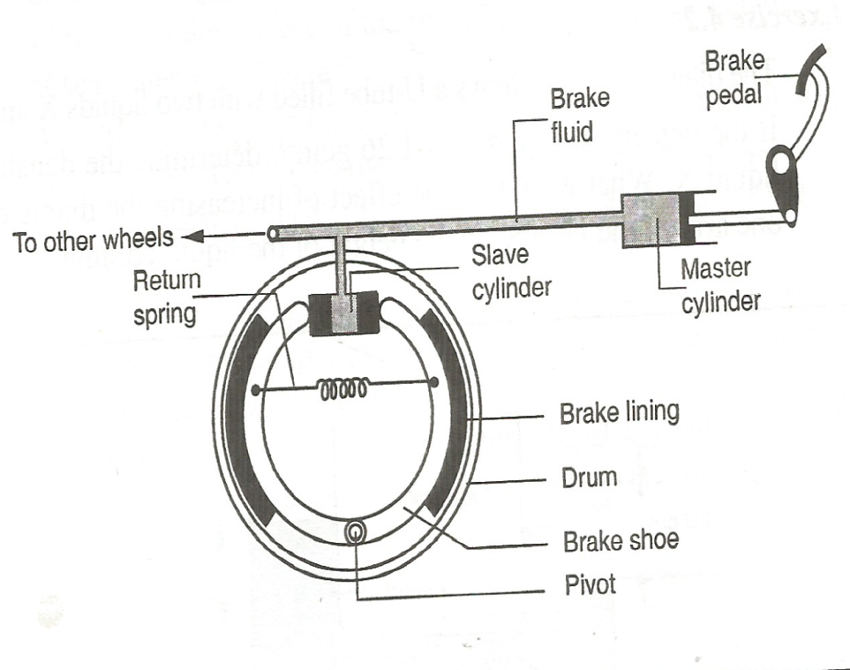

c) A sea diver is 35m below the surface of sea water. If the density of sea water is 1.03g/cm³ and g is 10Nkg⁻¹, determine the total pressure on him. (2mks)

d) State any three quantities that affect pressure in fluids. (3mks)

13a) Define temperature and state its SI unit. (1mk)

b) State any five differences between alcohol and mercury as thermometric liquids. (5mks)

c) State three properties of a liquid that is suitable for use in a thermometer. (3mks)

