HOLA SECONDARY SCHOOL

MID TERM EXAMINATION
AGRICULTURE
YEAR 2014
TERM ONE
FORM 3
PAPER 2
TIME: 2 HOURS

NAME_____________________________________CLASS_________ADM/NO.___________

INSTRUCTIONS: ANSWER ALL QUESTIONS IN THE SPACES PROVIDED

- State two feature of a good maize granary. (2mks)

- State implements used for secondary cultivation. (1 ½ mks)

- Name the tools used for the following management practices in livestock. (2mks)

- State four difference between ruminants and non-ruminants. (2mks)

- State four control measures of tsetse fly. (2mks)

- Give six symptoms of round work infection in sheep. (3mks)

- State four functions of protein in the body of an animal. (2mks)

- Name four tick borne disease. (2mks)

- State four factors that affect digestibility of feed. (2mks)

- State six method of controlling ticks. (3mks)

- Name four rabbit breeds. (2mks)

- Name one sleep breed which is resistant to foot rot disease. (1mk)

- Different between flushing and steaming up. (2mks)

- Name two disease that affect female animals only. (1mk)

- Give four disadvantages of in breeding in livestock production.

SECTION B (20MKS)

- The illustrations below represent the different stages of development of a three host tick. Stick it carefully and then answer the questions that follow.

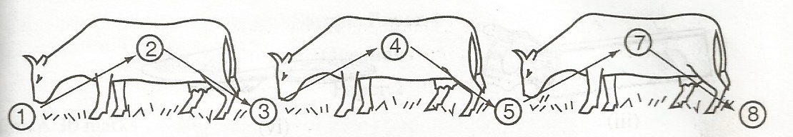
- Briefly explain what is happening in the following sages. (2mks)
1
4
5
7
- Why do you think that this tick is difficult to control using acaricide? (1mk)

- Name the most common sites the tick can be found on the body of an animal. (2mks)

- Give two examples of three – host tick. (2mks)

- A poultry farmer has maize containing 8% DCP and soya beans containing 43% DCP. If the farmer wants to make 100kg of a feed, using the pearson’s square method. Calculate the proportions in which the two ingredients would have to be mixed to make a feed stuff containing 15 % DCP (Show your working)

- Below is an illustrations of a sleep with parts marked E,F and G. Study it carefully and then answer the questions that follow.

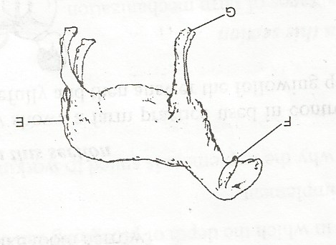
- State the operations that are carried out on the parts labeled E, F and G.

- State three reasons for carrying out the operations identified in E.

- At what age should the operation slated the operation named in E. 3mks)

SECTION C (40 MKS)

19a) Describe the digestion of grass in the rumen of a ruminant.
- With the aid of a well labeled diagram describe the formation of an egg.

20a) Discuss the advantage of artificial insemination. (10mks)

b) Explain the following terms

Close breeding (2mks)
Crossing breeding (2mks)
Lie breeding (2mks)
Out crossing (2mks)
Upgrading (2mk)

