**ELERAI MCK GIRL SECONDARY SCHOOL**

**BIOLOGY FORM 1**

**EXAM I TERM III 2014**

1. Examine the diagram below carefully and use it to answer the questions that follow.



(a) Name the parts X, Y and Z. (3 marks)

b) Why would Z be more on one side than the other (1mk)

(c) State the main substance which make-up the part labeled W.(1 mark)

1. A name of a certain garden plant is Duranta Repens
   * 1. i) What is the meaning of repens? (1mark)
     2. ii) Identify one mistake shown by the written name. (1 mark)
     3. Distinguish between a *genus* and a *Species* as Taxa used during classification of the Organism. (2marks )
2. A form one student observing Onion epidermal cells under the low power objective counted 5 cells on a field of view measuring 5mm

(a) Estimate the size of one cell. (1 mark)

(b) If the eye piece magnification used was × 10 and that of the objective lens was × 10. What was the magnification of the microscope? Show your working. (2 marks)

1. The diagrams below represent two plant cells A and B placed in two different solutions. Study the diagrams and answer questions that follow:

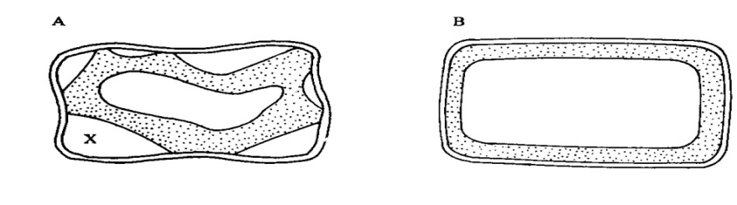

1. Identify the nature of solution into which each cell was placed. (2mark)
2. Name the physiological process responsible for the observed results. (1mark)

c) Give the correct biological term used to describe cell A. (1mark

1. Use the following figure to answer the questions that follow.

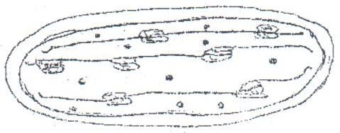

* + 1. Name the organelle (1mk)
    2. State the role of the organelle. (1mark)
    3. Give **two** ways in which the organelle is adapted to its functions. (1mark)

1. An animal has the following dental formula:

I = 0/2 C = 0/0 PM = 3/3 M = 2/3

* + 1. Suggest the type of diet for this animal. (1mark)
    2. Give two reason for your answer in (a) above. (2mark)
    3. How many teeth does the animal have in total? (1mark)

1. The equation below shows a chemical reaction that takes place in plants.

Carbon (IV) oxide + Water Glucose + A

* + - 1. Identify substance A. (1mark

1. Other than the reactants, state **two** conditions necessary for this reaction. (2marks)

b) Name the process represented by the equation above. (1mark)

8.. The diagram below shows a human tooth

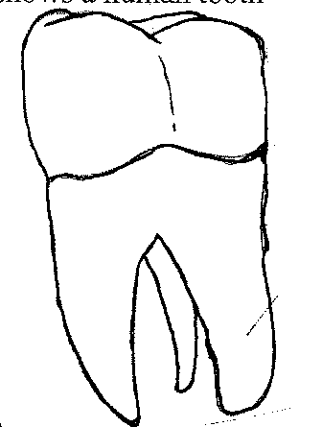

1. Identify the tooth (1mark)
2. How is the tooth adapted to its function (2marks)
3. Name two dental diseases (2mks)

9 The diagram below shows part of alimentary canal of a mammal.

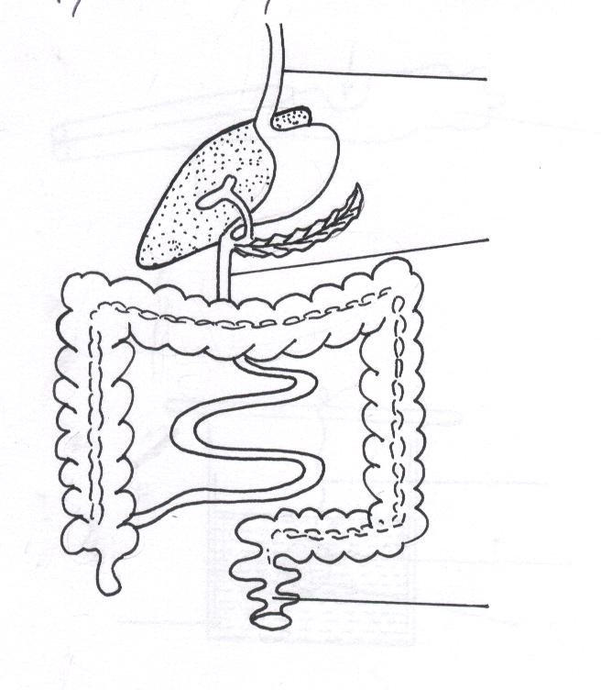

B

A

C

(i) Name the parts labeled. A and C. (2 marks)

(ii) State the function of the part labeled **B.** (1 mark)

10. State one use for each of the following apparatus in the study of living organisms.

(a) Pooter. (1mk)

(b) Pitfall. (1mk)

11. Write the role of the following parts of microscope. (3marks)

1. Mirror
2. Diaphragm
3. Coarse adjustment knob

12.(a) State the role of light in the process of photosynthesis. (2marks)

(b) Name two product of light stage of in photosynthesis. (2mark)

13. State two functions of

a) Bile juice in the digestion of food? (2marks)

b) Hydrochloric acid in the stomach (2mks)

14. a) Define an enzyme (2mks

b) How does substrate concentration affect the rate of enzyme reaction? (1mark)

c) Name one factor that denatures enzymes (1mk)

15.a) Define the term osmosis (2mks)

1. Describe 3 factors that affect diffusion (6mks)

16.a) List four properties of proteins (3mks)

1. Name two elements that make up carbohydrates (2mks)

17.a) what is the importance of chewing food (3mks)

1. Name 3 components of gastric juice (3mks)

18 Describe 5 ways in which a leaf is adapted for photosynthesis (10mks)