ELERAI MCK GIRLS SECONDARY SCHOOL
PHYSICS
FORM 3 PAPER 1
Answer ALL questions in this section in the spaces provided
1(a) Draw a diagram to represent a scale of a micrometer screw gauge of thimble scale 50 divisions and reading 0.379cm. (1mark)

- Determine the actual reading if the micrometer screwgauge has a zero error of -0.07mm. (1mark)

2. Explain why a wire gauze is used when heating water in a beaker in a laboratory instead of heating the water directly. (2marks)

3. What effect will the forces acting on the diagram below produce? Explain your answer. (2marks)

F₁ F₂

4. A boy stands inside a lift on the third floor of a 20 storey building. If the lift is ascending upwards at an acceleration of 4ms⁻² and he weighs 0.055 tonnes, determine the reaction of the lift at the boy’s feet. (3marks)

5.The figures (a) and (b) below show two identical pulleys A and B supporting equal loads.
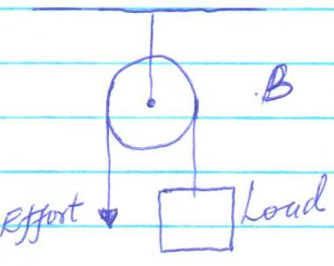
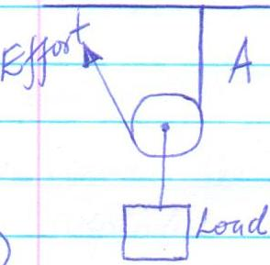

(a (b)
State with reasons which of the two pulleys is easier to operate. (3marks)
6. An elevator carries 50 people of average mass 60kg to a height of 5m in half a minute. Calculate the power needed to do so and give a possible reason as to why the actual power needed is greater than this. (3marks)

7. In a faulty mercury – in – glass thermometer, it was found that the mercury level stands at 3cm mark in the tube at 0C and 18cm when in steam above boiling water. Calculate the temperature the mercury stands at 12cm mark. (2marks)

SECTION B (55 MARKS)
Answer ALL questions in this section in the spaces provided
8. (a) State Newton’s first law of motion. (1mark)

- Distinguish between elastic collision and inelastic collision. (2marks)

- A minibus of mass 2000kg travelling at a constant velocity of 36km/h collides with a stationary car of mass 1000kg. The impact takes 2 seconds before the two move together at a constant velocity for 20 seconds.
Calculate:-
          - The common velocity. (2marks)

          - The impulse of force. (5marks)

          - The change in Kinetic energy. (3marks)

- The figure below shows a velocity-time graph describing the motion of a particle.
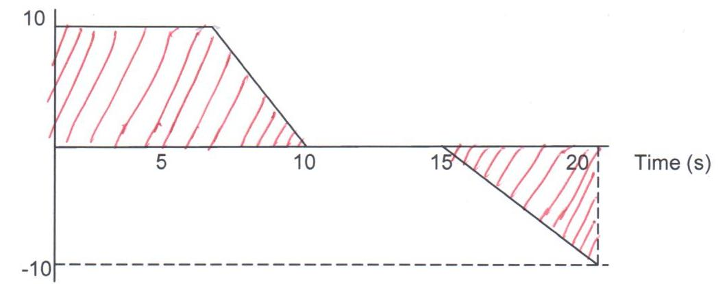

What does the shaded area represent? (1mark)

9.(a) State the principle of moments. (2marks)

(b) A solid body rests with it’s flat surface on horizontal ground. State two factors that determine the stability of the body. (2marks)

- The figure below shows a uniform bar of weight 3N and length 1.0m pivoted at a point and in equilibrium under the action of the forces shown.
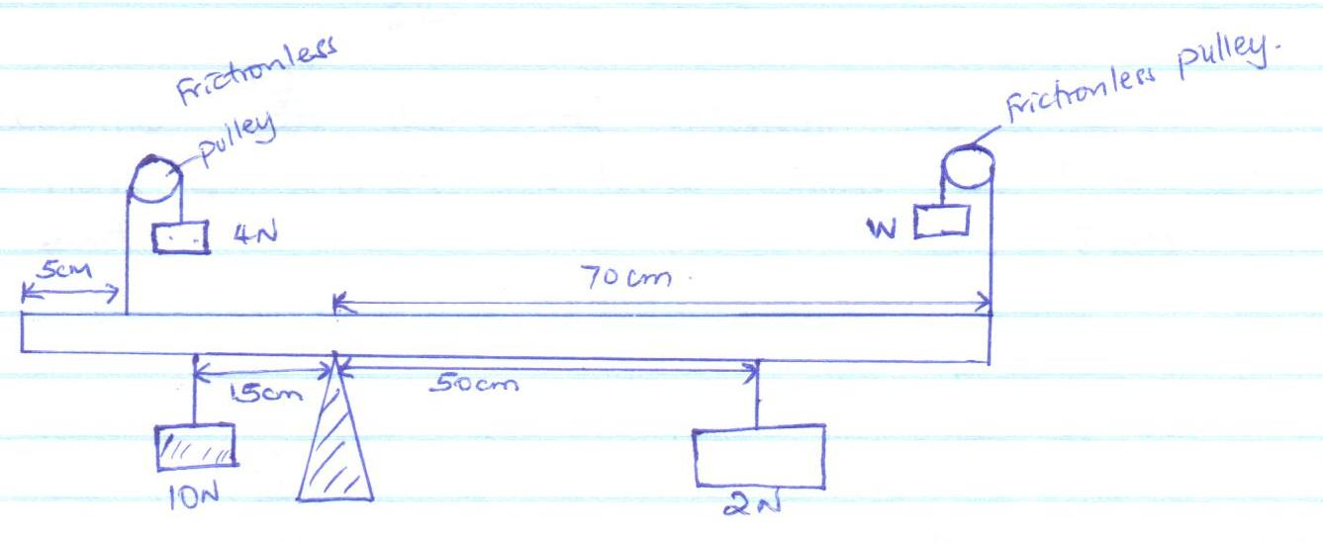

  - Write the expressions for the clockwise moments and the anti-clockwise moments about the pivot. (2marks

  - Determine the value of weight W. (3marks)

- (a) State Hookes law. (1mark)

(b) Two springs of negligible weight and of constants K₁ = 50Nm⁻¹ and K₂ = 100Nm⁻¹ respectively are connected end to end and suspended from a fixed point as shown below.
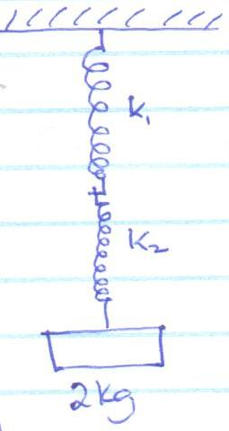

Determine:-
(i) The total extension when a mass of 2.0kg is hung from the lower end. (2marks)

(ii) The constant of the combination. (2marks)

- In an experiment, a spiral spring with its upper end fixed to a rigid support was hang vertically along a millimeter scale. A graph of force and extension was drawn as shown below.
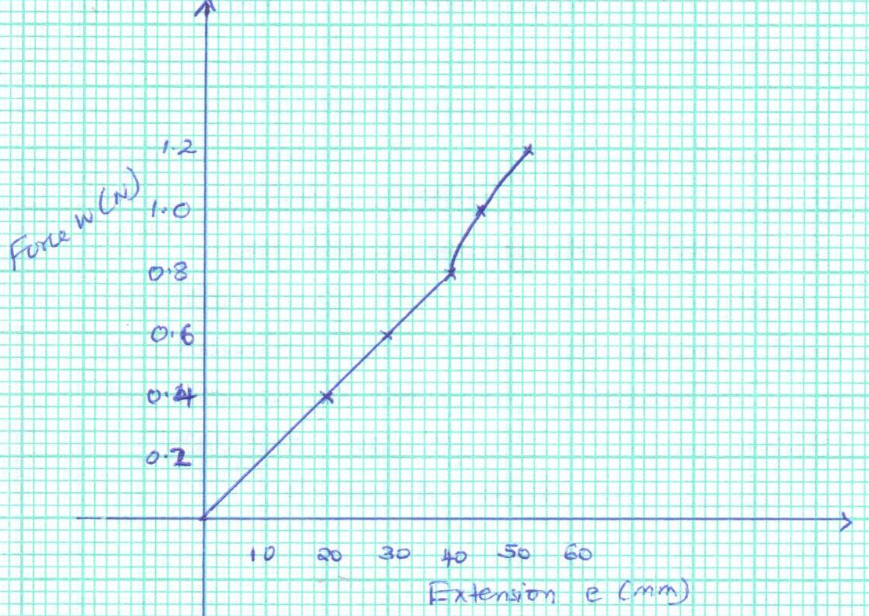

From the graph, determine:-
          - The elastic limit of the spring. (1mark)

          - The spring constant. (3marks)

10 (a) Explain what is meant by the terms streamline flow and turbulent flow. (2marks)

- The diagram below shows a syringe full of water. The area of the piston is 1.5cm² while the area of the outlet is 1.5mm².
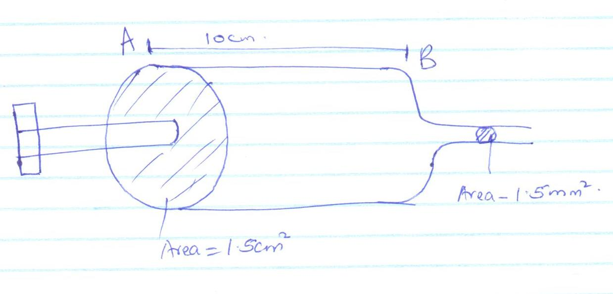
The piston is pushed such that it moves from point A to point B in 2s.

Determine:-
          - The velocity at which water travels between A and B. (1mark)

          - The velocity at the outlet. (3marks)

          - A nurse applies a force of 30N to a syringe. Given that the cross-sectional area of the tip of the needle is 1.0 x 10⁻⁷m², calculate the pressure produced at the tip of the needle. (3marks)

11. if a parallel beam of light pass through a very narrow opening at the roof of a dark room, the shadow obtained is broader than the opening. Explain this observation. (2mks).

12. Distinguish between destructive and constructive interference (1mk)

13. The figure below shows interference pattern produced using light waves.

- What is the role of slit S1 and S2. (1mk)

- Explain how a dark fringe is obtained at the point R. (1mk)

- Write the expression relating paths S1R and S2R and the wavelength (1mk)

- If S2R = 3.25 x 10⁻⁶m and S2R = 4.0 x 10⁻⁶m, find the wavelength of the light used (2mks)

- State the two necessary condition for the production of a stationary wave (2mks)

