

SCHOOL OF ENGINEERING
DEPARTMENT OF ELECTRICAL/ELECTRONICS
CRAFT CERTIFICATE IN ELECTRICAL AND ELECTRONICS ENGINEERING
MODULE I
END OF SERIES EXAMINATIONS
AUGUST/SEPTEMBER 2017
APPLIED SCIENCE

TIME: 2 HOURS

INSTRUCTIONS TO CANDIDATES:
- Attempt all the questions.
- Any examination IRREGULARITY will lead to DISQUALIFICATION.
- Indicate your FULL ADMISSION NUMBER in each Answer Sheet used.
- Cell phones are NOT allowed in the examination room
- Ensure you have both SCHOOL ID and EXAM CARDS in the examination room
- Scientific calculators and mathematical tables may be used where appropriate.
- Do not write your name anywhere on the answer booklet

Answer all questions in this section
QUESTION 1
- The grid below is part of periodic table. The letters do not represent the actual symbols. Use it to answer the questions that follow
C |  |  |  |  |  |  |  | T
 | K |  |  |  |  | U
X | Y |  | M |  |  | Q | W
J |  |  |  |  |  |  |  | Z
- How do the atomic radii of X and Y compare? (2marks)
- Write an equation for the reaction between M and W. (2mark)
- What is the name given to the elements which belong to the shaded region? (1mark)
- The ionic configuration of element G is 2.8 . G forms an ion of the form G⁻. indicate on the grid the position of element G. (1mark)
- To which chemical family does element G belong? (1mark)
- Using crosses (x) and dots (.), show the bonding between J and U. (2marks)
- Name the type of bonding drawn in (vi) above. (1mark)
- Which is the most reactive metal? Explain. (2mark)

- Differentiate between natural convection and forced convection (4marks)
- Outline FOUR factors which affect the rate of thermal conductivity in metals (4marks)

QUESTION 2
- Define the following terms as used in relation to heat quantity (8marks)
- Temperature
- Specific heat capacity
- Specific latent heat of fusion
- Melting point

- Using a chemical equation, explain the meaning of the term ‘NEUTRALIZATION’. (3marks)
- Differentiate between atomic number and mass number. (4marks)
- The critical angle of paraffin is 45⁰ what is the refractive index of paraffin (3marks)
- State the kinetic theory of matter (2marks)

QUESTION 3.
- Differentiate between condensation and sublimation (4marks)
- Differentiate between hygroscopy and deliquescence as used in salts. (4marks)
- Differentiate between covalent bonding and dative bonding. (4marks)
- Define the term magnification as applied to the formation of images by mirrors (2marks)
- An electrical heater consumes 3.6 MJ when connected to a 250 V supply for 40 minutes. Find :
- Power rating of the heater
- The current taken from the supply. ( 6marks)

QUESTION 4
- A student did an experiment to determine the specific latent heat of fusion of a block of ice. 0.05 kg of ice at 0⁰C melted up into 400g of water at 25⁰C in an alluminium can of mass 500g. If the final temperature of the mixture falls to 15⁰C, determine the specific latent heat of fusion of ice. (5marks)
Take: Specific heat capacity of water = 4200JKg⁻k⁻¹
Specific heat capacity of alluminium = 390 JKg⁻¹k⁻¹
- State the laws of reflection of light (2marks)
- Differentiate between the two types of reflection (4marks)
- What is the mass off 1.77x 10³⁰ molecules of CO₂? (C=12, O=16) (3marks)
- State THREE characteristics of Acids (3marks)
- The atomic notation of element P is represented as ²³ ₁₁P. Determine the number of protons, electrons and neutrons. (3marks)

QUESTION 5
- Define the following terms as used in reflection of light using a diagram (6marks)
- Normal
- Angle of reflection
- Incident ray
- (i) state two conditions necessary for total internal reflection to occur when light travels from one optical medium to another (2marks)
(ii)An object is placed on the principal axis of a convex lens of focal length 10cm so that it is 15cm from the lens. Determine the position of the image formed (4marks)
(iii) The path of a ray of light passing from water to a layer of liquid X on top of it. A coin is placed at the bottom of a tall gas jar. When the jar is filled with paraffin to a depth of 32.4cm, the coin is apparently seen displaced 9.9cm from the bottom. What is the refractive index of paraffin. (3marks)
(c) State snell’s law (2marks)
(d) (i) The critical angle for crown glass is 42⁰ . Using this information complete the figure below to show the passage of the ray shown through the glass block (3marks)
Air
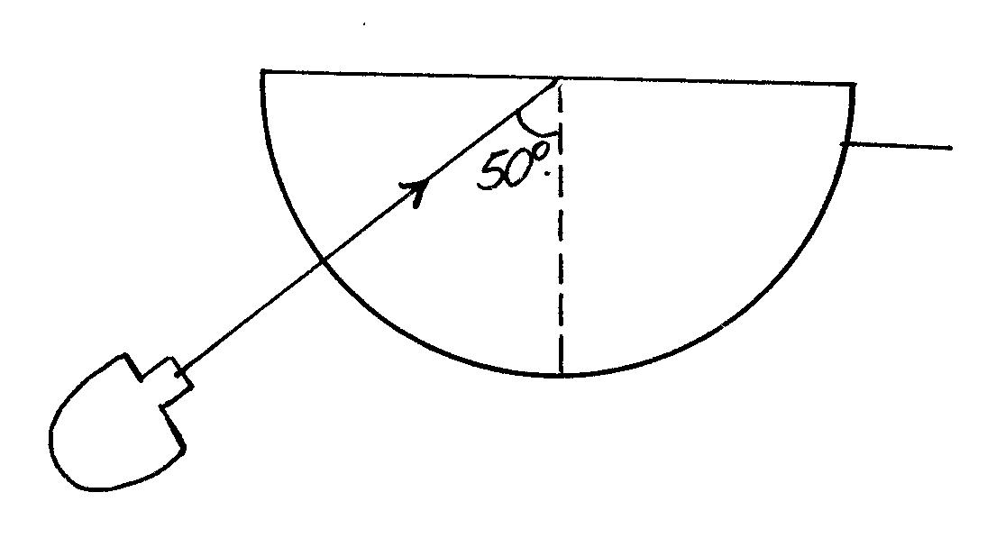
Glass block
Ray box

