

SCHOOL OF ENGINEERING
DEPARTMENT OF ELECTRICAL/ELECTRONICS
CRAFT CERTIFICATE IN ELECTRICAL AND ELECTRONICS ENGINEERING
MODULE I
END OF SERIES EXAMINATIONS
AUGUST/SEPTEMBER 2017
ELECTRONICS TECHNOLOGY

TIME: 2 HOURS

INSTRUCTIONS TO CANDIDATES:
- Answer ANY FIVE questions.
- Any examination IRREGULARITY will lead to DISQUALIFICATION.
- Indicate your FULL ADMISSION NUMBER in each Answer Sheet used.
- Cell phones are NOT allowed in the examination room
- Ensure you have both SCHOOL ID and EXAM CARDS in the examination room
- Scientific calculators and mathematical tables may be used where appropriate.
- Do not write your name anywhere on the answer booklet

Answer any FIVE questions
QUESTION 1
- Perform the following operations: (6 marks)
- 10110101₂ to decimal
- 326₈ to binary
- 2AF_{H} to octal by first converting to decimal
- With the aid of circuit and waveform diagrams, explain the operation of a full wave bridge rectifier ( 8marks)
- The figure below shows implementation of a logic gate (6marks)
Switch A

Switch B
Battery lamp

- State the logic gate
- With aid of its truth table, describe its operation

QUESTION 2
- Draw the symbols of the following logic gates (3marks)
- NAND gate
- EX-NOR gate
- OR gate
- Using karnaugh map, simplify the Boolean equation (5marks)

F(ABCD)=ABC D+ABC D+ABCD+ABCD+ABCD+AB CD
- Distinguish between Hartley oscillator and clap oscillator using diagrams (6marks)
- With the aid of a diagram explain the operation of full wave voltage doubler as used in power supplies (6marks)
QUESTION 3
- Define the term flip-flop as used in electronic design circuits (2mark)
- Differentiate between intrinsic and extrinsic semiconductors (4marks)
- Define the following terms as related to semicondutors (8marks)
- Doping
- Forward bias
- Insulator
- P-N junction
- Given that R_{S} = 3kΩ, V_{in} ranges from 40-70V, R_{L}= 2kΩ and zener voltage, V_{z} = 10V,
- Calculate the currents through R_{S} ,through the load and zener diode current I_{z}
- How will these values be affected if source voltage increases to 70V? (6marks)
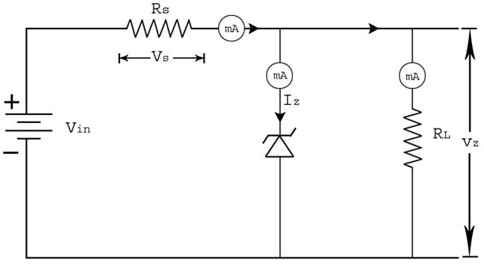
QUESTION 4
- Define the term transducer (2mark)
- Describe the operation of inductive transducers (6marks)
- The following bytes (shown in hexadecimal) represent a persons name as it would be stored in a computer’s memory. Each byte is a padded ASCII code. Determine the name of the person.
- 52 41 4E 43 49 53 (3marks)
- Outline FOUR method of coupling amplifiers (4marks)
- Using a diagram and waveforms, describe how a reservoir capacitor is used in smoothing dc output waveforms in power supplies (5marks)
QUESTION 5
- (i) Define the term parity bit (2mark)
(ii) State TWO types of parity bits (2marks)
- Using block diagrams differentiate between current series feedback and current shunt feedback connections (8marks)
- Outline THREE advantages of Negative feedback as applied in Feedback amplifiers(3marks)
- Define the term rectification as used in power supplies (2mark)
- The table below represents a truth table of a logic gate. (3marks)
A | B | A+B
0 | 0 | 1
0 | 1 | 0
1 | 0 | 0
1 | 1 | 0
- State the logic gate represented
- Show how two basic logic gates can be connected to form the gate in (I) above

QUESTION 6.
- using a diagram explain how a zener diode is applied in voltage regulation (5marks)
- State any THREE logic families used in design and construction of logic gates. (3marks)
- Explain the formation of N-type extrinsic semi-conductor material (5marks)
- Perform the following operations: (7marks)
- 1101₂ + 11011₂
- Binary 1111₂ to gray code
- $11001÷101$

*****END****

