a) (i) The diagram below is being used to demonstrate Boyle’s law. Use the diagram to answer the question that follow.
Gas

Pressure exerted
Piston
Sketch a possible graph of pressure volume (PV) against pressure (P). 1mk
P
PV

(ii) State Boyles law (2mk)

- Hydrogen of volume 2400cm³ at 54⁰C and pressure of 2.4N/m² is compressed until
Its volume is 300cm³ and its pressure is 6 Pascals. Determine the temperature of the gas after compression. 3mks*NDI*
(iv) Name one limitation of gas laws. 1mk*NDI*
b) With the aid of a well-labelled diagram, describe an experiment to determine the specific heat capacity of a metal by electrical method. (5mks)
A student did an experiment to determine the specific latent heat of fusion of a block of ice. 0.05 kg of ice at 0⁰C melted up into 400g of water at 25⁰C in an alluminium can of mass 500g. If the final temperature of the mixture falls to 15⁰C, determine the specific latent heat of fusion of ice. 3mks*NDI*
Take: Specific heat capacity of water = 4200JKg⁻k⁻¹
Specific heat capacity of aluminum = 390 JKg⁻¹k⁻¹

- (a) State Charles’ law bomet (1 mark)
…………………………………………………………………………………………………………………………………………………………………………………………………………

(b) A mass of gas occupies a volume of 150cm³ at a temperature of -73⁰C and a pressure of l
atmosphere. Determine volume when the pressure is 1.5 atmospheres and the temperature
227 ⁰C (3 marks)

- A heating element rated 2.5 KW is used to raise the temperature of 3.0 kg of water through
50⁰ C. calculate the time required to effect this. ( Specific heat capacity of water is 4200J/kgK). (3 marks
- State two factors that affect melting and boiling points of a substance. bungoma (2mks)
- What is the significance of absolute zero on the Kelvin scale? (1mk
- Bungoma p2
- (b) (i) Differentiate between soft x-rays and hard x-rays. (2mks
- (ii) State three properties of X-rays. (3mks)
Determine the wavelength of the wave. (2mks)
(ii) State five properties of stationary waves. (5mks)
- The following reaction is part of a radioactive series
210 210 C
Z
α
x
83 84 b
identify the radiation X and determine the values b and c (3mks) *Nrk*S
X
b

- (a) (i) What is ‘Background’ radiation in radio-activity? (1mk)
……………………………………………………………………………………………………
……………………………………………………………………………………………………

(ii) The following nuclear reaction is part of radio-active series. ksm
Identify the radiation q and determine the values of b and c (3mks)

q ……………………………………………………

b ……………………………………………………

c …………………………………………………….

) Cobalt 60 has a half life of 4 yrs. Its initial mass is 50g. After how many years will it
decay to 1.5625g? (2mks)
nand north
- A certain nuclide P decays by emission of a beta-particle to form a daughter nuclide Q. The daughter nuclide Q subsequently decays by alpha emission to form a nuclide R. The half-life of P is 20 seconds
(i) How long would it take for three quarters of a sample of P to decay? (2mks)
…………………………………………………………………………………………………………………………………………………………………………………………………………
(ii) How does the atomic number of nuclide R compare with that of nuclide P? (1mk)
…………………………………………………………………………………………………………………………………………………………………………………………………………
(iii) What effect would an increase of temperature have on the rate of decay? (1mk)
- …………………………………………………………………………………………………………………………………………………………………………………………………………(a) Americium-241, strontium -90 and cobalt-60 are known sources of alpha, beta particles and gamma rays respectively. All the three sources are placed in front of the obstacles shown below
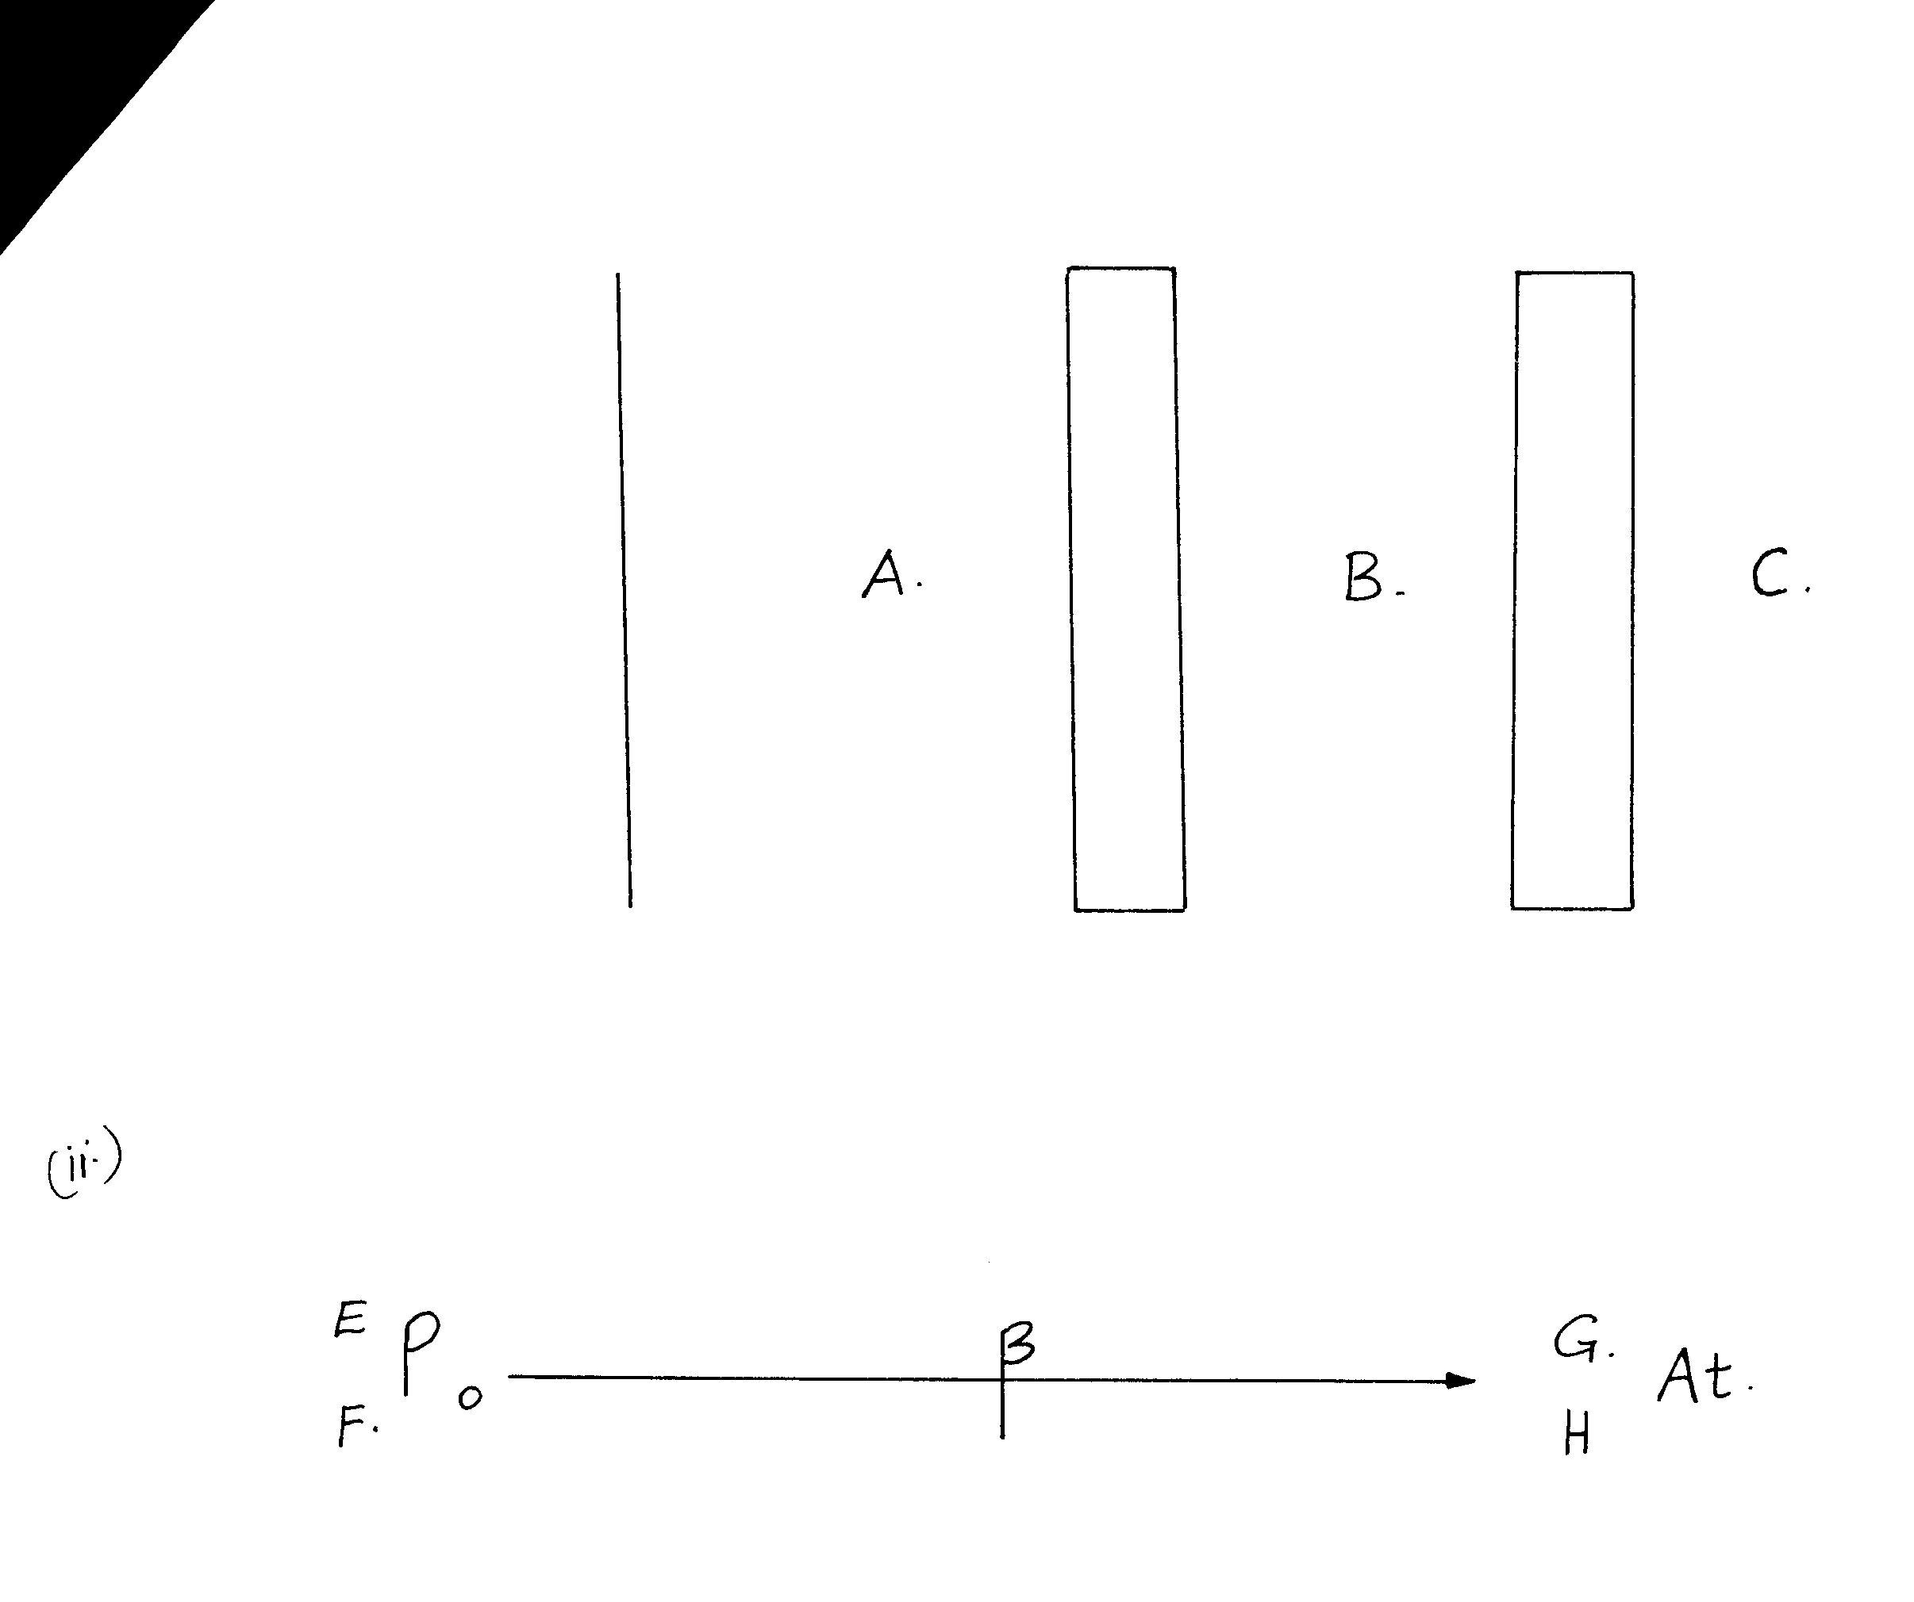

An attempt is then made to detect the particles/radiations at points A,B and C using a Geiger-Muller. Which particle(s)/radiations are detected at points (3mks) *Kyo*
(b) State two dangers of radioactive emissions (2mks) *Kyo*
(c) Radium (Ra) 226 decays by alpha emission to Radon (Rn). The atomic number of Ra is 88.
(i) Write down an equation to show this decay (2mks) *Kyo*
ii) Rn is itself radioactive and decays by alpha emission to polonium (po) while Po can
decay by beta emission according to the equation
E
F
determine the values of
E
F
G
H
Explain with the aid of a labeled diagram the production of x-rays in an x-ray tube (10mks) (2mks

