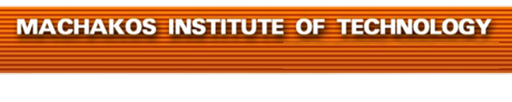


MACHAKOS TOWN CAMPUS
DIPLOMA IN COMMUNITY DEVELOPMENT
MODULE II
END OF TERM EXAMINATIONS: JANUARY -APRIL
2428/203: ADVOCACY AND LOBBYING
TIME ALLOWED: 2HOURS
INSTRUCTIONS
- Answer ANY FIVE of the following EIGHT questions.
- All questions carry equal marks.
- Any examination Irregularity will lead to Disqualification.
- Indicate your Admission No. in each Answer Sheet used.
- Cell phones ARE NOT allowed in the examination room.
© MIT2017

- a) Describe each of the following categories of legislators:
- Champions
- Allies
- Fence sitters
- Mellow opponents
- Hard core opponents (10mks)

b) Outline five strategies used in forming partnership for advocacy (10mks)

- a)Explain five importance advocacy (10mks)

b) Describe five circumstances that make lobbying unnecessary (10mks)
- a) Explain five emerging issues in lobbying and advocacy against corruption in Kenya (10mks)
b) Highlight five universal human rights according to the United Nations charter
(10mks)
- a) Evaluate the impact of policy research in lobbying and advocacy in the contemporary society (10mks)
b) Describe five preconditions necessary for a successful advocacy campaign.
(10mks)

- a) Define (i) advocacy
(ii) Lobbying
(iii) Legitimacy
(iv)Credibility
(v) Accountability (10mks)

b) Explain five roles of research in advocacy. (10mks)

- a) Explain five factors influencing advocacy. (10mks)

b) Briefly explain the process of advocacy. (10mks)

- a) Highlight five tools of advocacy. (10mks)

b) Explain five importance of advocacy. (10mks)

- a) Explain five forms of advocacy. (10mks)

b) Explain five factors influencing choice of media in advocacy.
(10mks)

