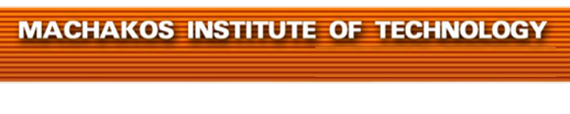


MACHAKOS TOWN CAMPUS
DIPLOMA IN SOCIAL WORK
MODULE III
SPECIAL EXAM: MAY -2017
DSW2428/302: COUNSELING
TIME ALLOWED: 2HOURS
INSTRUCTIONS
- Answer ANY FIVE of the following EIGHT questions.
- All questions carry equal marks.
- Any examination Irregularity will lead to Disqualification.
- Indicate your Admission No. in each Answer Sheet used.
- Cell phones ARE NOT allowed in the examination room.
© MIT2017

- a) Highlight four advantages of guidance and counseling to a counselee
(8mks)
b) Describe six form of counseling (12mks)
- a) Outline Four steps applied in behavior counseling. (8mks)

b) Explain six ethical issues of counseling. (12mks)

- a) Explain four differences between guidance and counseling. (8mks)

b) (i) Describe termination stage of counseling. (2mks)

(ii) Explain five reasons that may lead to termination of counseling. (10mks)

- a) (i) Describe each of the following forms of communication:

- written;
- oral. (4 marks)

(ii) Explain two advantages of using face-to-face communication in counseling.
(4mks)
(b) Explain six goals of counseling. (12mks)

- a) Explain five basic counseling skills. (10 marks)

b) Explain SOLER as one of the attending behavior in counseling. (10 marks)

- a) Suppose you have been working with ICAP and you have been charged with a responsibility of counseling people infected with HIV/AIDs. Explain the 5 C’s that you need to emphasis. (10 marks)

b) Explain five good qualities that you should have as a counselor. (10 marks)

- a) Explain five ways you can build rapport with clients when counseling. (10 marks)

b) You are working as a counselor in Machakos level five hospital. You have been told to plan for a counseling program that will be running throughout the year. Explain how you will prepare for the counseling session. (10 marks)

- a) Explain five advantages of oral communication. (10 marks)

b) Explain five disadvantages of oral communication. (10 marks)

