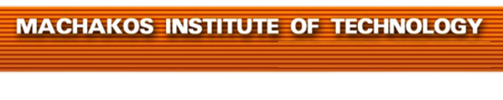


MACHAKOS TOWN CAMPUS
DIPLOMA IN SOCIAL WORK
MODULE III
SPECIAL EXAM: MAY -2017
DSW2428/302 SOCIAL REHABILITATION AND REINTEGRATION
TIME ALLOWED: 2HOURS
INSTRUCTIONS
- Answer ANY FIVE of the following EIGHT questions.
- All questions carry equal marks.
- Any examination Irregularity will lead to Disqualification.
- Indicate your Admission No. in each Answer Sheet used.
- Cell phones ARE NOT allowed in the examination room.
‘
© MIT2017

- a) Explain three cause of deviation (6 marks)

b) Explain seven impact of social deviation. (14 marks)

- a) Explain five beliefs towards social deviation. (10 marks)
b) Explain five impacts of culture on social deviation. (10 marks)
- a) Explain causes of physical challenges. (10 marks)

b) Explain five role of social work in rehabilitation and reintegration of physically disabled people. (10 marks)

- a) Explain five types of physically challenge disability. (10 marks)
b) Explain five impact of personality behavior on the society. (10 marks)
- a) Describe five causes of mental challenges. (10 marks)
b) Explain the categories of mental challenges (10 marks)

- a) Explain five strategies used in management of drug and substance abuse.
(10 marks)
b) Describe five causes of hearing impairment. (10 marks)
- a) Explain five forms of sexual deviation. (10 marks)

b) Explain the three levels of intervention. (6 marks)
c) Give two strengths and two weaknesses of any level of intervention (4 marks)
- a) Explain five emotional characteristics of adolescents. (10 marks)
b) Describe the following neurological impairments;
(i) Cerebral palsy
(ii) Epilepsy
(iii) Spinal bifida
(iv)Poliomyelitis;
(v) Multiple sclerosis. (10 marks)

