NAME:…………………………………………………………..…………………………………………...……. INDEX………….………..…
DATE………..………………….
SIGNATURE………………..…

232/ 3
PHYSICS
PAPER 3
(PRACTICAL)
JULY / AUGUST, 2013
2½ HOURS
SUBUKIA DISTRICT JOINT EXAMS- 2013
Kenya Certificate of Secondary Education (KCSE)
INSTRUCTIONS TO CANDIDATES
- You are advised to spend the first 15 minutes of the hours given reading through the entire question paper
- Answer all the questions in the spaces provided
- Marks are given for clear record of observations actually made for their suitability and accuracy for the use of them.
- Candidates are advised to record their observations as soon as they are made.
- Mathematical tables and electronic calculators may be used.

For Examiner’s Use Only
Question | Maximum Score | Candidates’ Score
1 | 20
2 Part i  ii | 12  8
Total | 40

This paper consists of 9 printed pages

QUESTION 1
- You are provide with the following;
Two meter rules/ OR one meter rule and a wooden strip.
One half meter rule
A pair of vernier calipers (to be shared)
A stop /watch or stop clock
Two retort stand, two bosses and two clamps
Two pieces of thread
Some cello tape

Proceed as follows;
- Measure the thickness, W, of the half meter rule using the vernier calipers provided
W = ………………………………………………………… cm = …………………………………m (1mk)
- Set up the apparatus as shown in figure 1 such that D = 2p =20cm and q = 20cm
Ensure that D is kept constant throughout the experiment (use a piece of cello tape to fix the threads) Ensure also that the loops of thread on the half meter rule are made such that they can slide along the rule. This would enable the adjustment of small q later in the experiment.
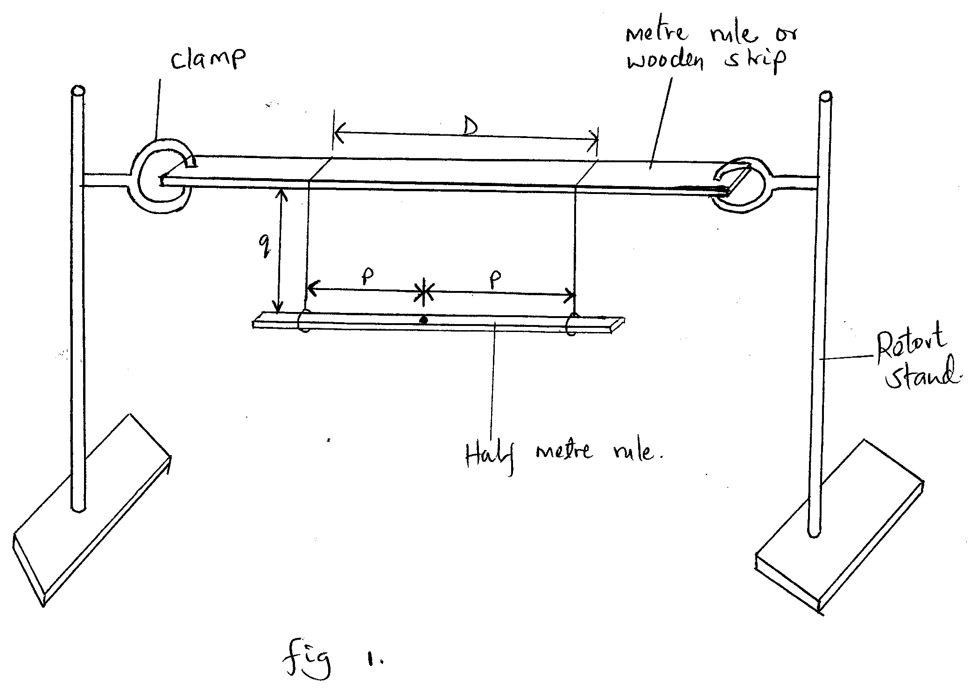

Note that the distance p is measured from the centre of the half meter rule.
- Adjust the position of the loops on the half meter rule so that p=21cm (i.e. 2p=42cm). You may use a piece of cello tape to keep the loop in position. Measure and record in table 1 the value of q.
N.B: q is the vertical distance between the half mater rule and the meter rule/wooden strip supporting it.
- Slightly displace one end of the half meter rule towards you and the other end away from you in a horizontal plane. Measure and record in table 1 the time t for 10 oscillations.
- Repeat the procedures in (c) and (d) for other values of p shown in table 1
Complete the table (7mks)
P(cm) | 21.0 | 19.0 | 17.0 | 15.0 | 13.0 | 10.0 | 8.0 | 6.0 | 4.0 | 2.0
Q(cm)
Time t for 10 oscillations (s)
Periodic time T for 1oscillations (s)
$$\frac{q}{p}$$

- i) Plot the graph of T (y-axis) against $\frac{p}{q}$ (5mks)

ii) Determine the slope s of the graph when $\frac{p}{q}$ = 2.0
s= (3mks)
……………………………………………………………………………………………………………………………………………………………………………………………………………………………………………………………………………………………………………………………………………………………………………………………………………………………………………………………………………….
g) Determine the constant k for the half meter rule given that k = $\frac{s}{π}$ $\sqrt{Dg}$
Where g = 10m/s (2mks)
………………………………………………………………………………………………………………………………………………………………………………………………………………………………………………………………………………………………………………………………………………………………………………………………………………………………

h) Determine the constant k given k = $\sqrt{L^{2}+W^{2}}$ Where L = 0.5m (2mks)
12
………………………………………………………………………………………………………………………………………………………………………………………………………………………………………………………………………………………………………………………………………………………………………………………………………………………………………………………………………………

QUESTION 2
- This question is in two parts. Answer both parts.
PART I
You are provided with the following:
- Two dry cells and a cell holder
- One ammeter
- One voltmeter
- A variable resistor
- A switch
- Connecting wires
Proceed as follows:
- Set up the circuit as shown in fig 2.
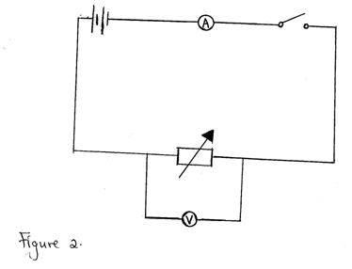
- Close switch S and adjust the variables resistor until the voltmeter reads 2.9 volts.
(If 2.9V is not obtainable, take the maximum possible value and insert it in the table in place of 2.9V)
Read and record the value of V and the corresponding value of I in table 2. Open the switch.

- Repeat the procedures in (b) above for other values of V shown in table 2. Complete the table. (3mks)
V(volts) | 2.9 | 2.7 | 2.5 | 2.3 | 2.0 | 1.8 | 1.6
I(A)
Table 2
- i) Plot the graph of V ( y-axis) against I. (4mks)
- From the graph, determine the e.m.f E, and the internal resistance r, of the battery given that
E = V + rI.
E …………………………………………………………………………………………………………………………………………………………………………………………………………………………………………………………………………………………………………
r …………………………………………………………………………………………………………………………………………………………………………………………………………………………………………………………………………………………………………

Part II
You are provided with the following:
- A voltmeter
- Two dry cells and a cell holder
- A switch
- A resistor labeled R ( 4)Ω)
- A wire mounted on a mm scale and labeled G
- A micrometer screw gauge ( to be shared)
- Six connecting wires with six crocodile clips
Proceed as follows:
- Record the length L₀ of the wire labeled G.
L₀ = ………………………………………………………………………………………………………. (1mk)
Use the micrometer screw gauge provided to measure the diameter of the wire labeled G at two different points and determine the average diameter, d.
The diameter d1 = ………………… mm, d2 = …………………..mm (1mk)
The average diameter d1 = …………………mm (1mk)
Determine the radius r of the wire in meters.
Radius r = …………….m
- Set up the apparatus as shown in the circuit diagram in figure 3
- Use the voltmeter provided to measure the p.d, V_{R} across R and the p.d, V_{G} across G when the switch is closed.
V_{R} = …………………………. Volts (1mk)
V_{G} = …………………………..volts
Open the switch.
- Use the value of R provided and the value of VR in b(i) above. Calculate the current I flowing through R when the switch was closed.
I = ……………………………………….. Amperes (1mk)
iii) Determine the constant H given that
H = 100V_{G}
I X L_{O}

H = ……………………………. ΩM⁻¹ (1mk)

