Name:……………………………………………………………….. Index No. ……………………………..
Date: …………………….. Sign……………………
232/1
PHYSICS
PAPER 1
JULY /AUGUST 2013
TIME: 2 HOURS

SUBUKIA DISTRICT JOINT EXAMINATIONS
Kenya Certificate of Secondary Education 2013

232/1
PHYSICS
PAPER1
JULY /AUGUST 2013
Instructions to candidates;
- Write your name, index number and name of your school in the spaces provided.
- This paper consists of two parts A and B.
- Answer all questions in sections A and B in the spaces provided.
- All working MUST be shown in the spaces provided after questions.
- Mathematical tables and electronic calculators may be used.
For examiners use only
Section | Question | Maximum score | Candidates score
A  B | 1-14 | 25
 | 15 | 11
 | 16 | 13
 | 17 | 11
 | 18 | 10
 | 19 | 10
 | Total score | 80

SECTION A (25 MARKS)
Answer ALL the questions in the spaces provided.
- The figure below shows a measuring cylinder which contains water initially at a level A. A spherical solid of mass 11g is immersed in the water, the level rises to B.
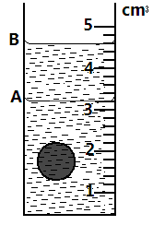
Determine the diameter of the spherical ball (2 marks)
....................................................................................................................................................
....................................................................................................................................................
....................................................................................................................................................
- Explain the reason why a dropping dust particle in a still room does not trace a straight vertical path (1 mark)
....................................................................................................................................................
....................................................................................................................................................
- The figure 2 below shows a beaker containing water placed on a flat bench.
Fig. 2
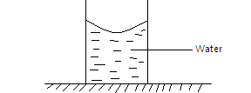
State and explain the changes in stability of the beaker when the water freezes to ice
(2 marks)
..............................................................................................................................................................................................................................................................................................................
- Figure 3 below shows a solid sphere moving on a platform 5cm above the ground. It rolls down a curved frictionless path in a point 0.5m above the ground.
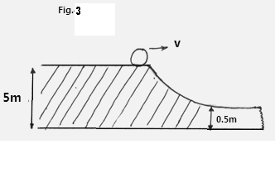
Calculate its velocity at the lower point (3 marks)
................................................................................................................................................................................
........................................................................................................................................................................................................................................................................................................................................................................................................................................................................................................................................................................................................................................................................................
- Two table tennis balls hang at the same level suspended from a thread a short distance apart. A stream of air is blown between the balls. Explain what happens to the balls. (2 marks)
....................................................................................................................................................................................................................................................................................................................................................................................................................................................................................

- Figure 4 shows a bubble of soap blown to the wider end of a funnel.
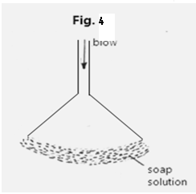
When the top is left open the bubbles flatten to a film which rises up the funnel. Explain observation. (1 mark)
....................................................................................................................................................................................................................................................................................................................................................................................................................................................................................
- State two advantages of a force pump over lift pump. (2 marks)
....................................................................................................................................................................................................................................................................................................................................................................................................................................................................................
- Using the kinetic theory of gases, explain why air inside a tyre exerts pressure on the walls of the tyre. (2 marks)
....................................................................................................................................................................................................................................................................................................................................................................................................................................................................................................................................................................................................................................................................
- When ice is heated, the temperature remains constant until all ice is melted. Explain this observation. (1 mark)
...................................................................................................................................................................................................................................................................................................................................................................................................................................................................................................
- A uniform half meter rule is supported by force of 3N and 2N as shown in figure 5 below.
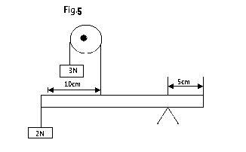
Determine the weight of the half meter rule (2mrks)
............................................................................................................................................................................................................................................................................................................................................................................................................................................................................................................................................................................................................................................................................................................................................................................................................
- A high jumper usually lands on thick soft mattress. Explain how the mattress helps in reducing the force of impact (1 mark)
...................................................................................................................................................................................................................................................................................................................................................................................................................................................................................

- A particle starts from rest and accelerates uniformly in a straight line. After 3 seconds, it is at a distance of 9m from the starting point. Determine the acceleration of the particle. (3 marks)
....................................................................................................................................................................................................................................................................................................................................................................................................................................................................................................................................................................................................................................................................
- A turntable of radius 8 cm is rotating at 30 revolutions per second. Determine the linear speed of a point on the circumference of the turntable. (3 marks)
…………………………………………………………………………………………………………………………………………………………………………………………………………………………………………………………………………………………………………………………………………………………………………………………………………………………………………………………………………………………………………………….

SECTION B (55 MARKS)
Answer ALL questions in this section
14. a) The figure below shows the length of a wooden block being measured.
State two errors made while taking the measurement above. (2marks)
………………………………………………………………………………………………………………………………………………………………………………………………………………………………………………………………………………………………………………………………………………………………………
b) In determining the size of 1molecule of oil a single drop of the oil was dropped from a burette on a tray and it is spread to form a circular patch of diameter 20cm. If 1 molecule of oil is assumed to be 1.67 x 10⁻⁸m thick, determine -;
i) The area of the circular patch on the tray. (2 marks)
………………………………………………………………………………………………………………………………………………………………………………………………………………………………………………………………………………………………………………………………………………………………………
ii) The volume of 1 drop of the oil from the burette. (2 marks)
………………………………………………………………………………………………………………………………………………………………………………………………………………………………………………………………………………………………………………………………………………………………………
iii) The radius of the drop from the burette. (2 marks)
………………………………………………………………………………………………………………………………………………………………………………………………………………………………………………………………………………………………………………………………………………………………………

iv) If 10 similar drops from the burette weigh 4.984 x 10⁻⁵N, calculate the density of the oil. (2 marks)
………………………………………………………………………………………………………………………………………………………………………………………………………………………………………………………………………………………………………………………………………………………………………
15. a) State two factors that affect the efficiency of a pulley system. (2 marks)
………………………………………………………………………………………………………………………………………………………………………………………………………………………………………………………………………………………………………………………………………………………………………
b) Sketch a labeled diagram to show how arrangement of a single pulley may be used to provide a velocity ratio of 2. (2 marks)

c) The figure below shows a pulley system with the load rising at uniform speed.
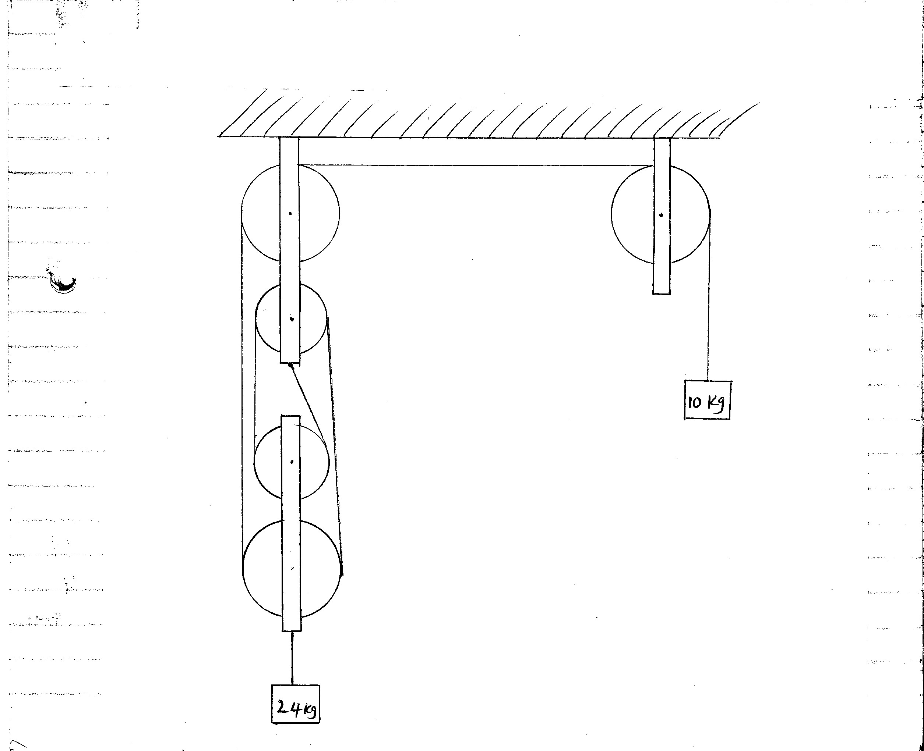
From the information given calculate;
i) Velocity ratio of the machine (1 mark)
………………………………………………………………………………………………………………………………………………………………………………………………………………………………………………………………………………………………………………………………………………………………………
ii) Mechanical advantage of the machine. (2 marks)
………………………………………………………………………………………………………………………………………………………………..……………………………………………………………………………………………………………………………………………………………………………………………………
iii) Efficiency of the machine. (2 marks)
………………………………………………………………………………………………………………………………………………………………………………………………………………………………………………………………………………………………………………………………………………………………………
d) The handle of the screw- jack in the figure below is 42cm long and the pitch of the screw is 0.5cm.
What force must be applied at the end of the handle when lifting a load of 1188N if the efficiency of the jack is 50%? (4 marks)
………………………………………………………………………………………………………………………………………………………………………………………………………………………………………………………………………………………………………………………………………………………………………………………………………………………………………………………………………………………………

16. a) Define the term ‘heat capacity’ (1 mark)
………………………………………………………………………………………………………………………………………………………………………………………………………………………………………………………………………………………………………………………………………………………………………
b) A block of metal of mass 150g at a 100⁰C is dropped into a well rugged calorimeter of mass 215g and heat capacity 400JKg⁻¹K⁻¹ containing 100g of water at 25⁰C. The temperature of the resulting mixture is 34⁰C. (Specific heat capacity of water = 4200JKg⁻¹ K⁻¹). Determine;
i) Heat gained by calorimeter. (2 marks)
………………………………………………………………………………………………………………………………………………………………………………………………………………………………………………………………………………………………………………………………………………………………………
ii) Heat gained by water. (2 marks)
……………………………………………………………………………………………………………………………………………………………………………………………………………………………………………………………………………………………………………………………………………………………………..
iii) Heat lost by the metal block. (2 marks)
………………………………………………………………………………………………………………………………………………………………………………………………………………………………………………………………………………………………………………………………………………………………………
iv) Specific heat capacity of the metal block. (3 marks)
………………………………………………………………………………………………………………………………………………………………………………………………………………………………………………………………………………………………………………………………………………………………………
c) State two factors that affect the rate of cooling of a liquid. (2 marks)
………………………………………………………………………………………………………………………………………………………………………………………………………………………………………………

17. a) Explain the following observation:-
Ice cubes float on water and solid benzene sinks in liquid benzene. (2 marks)
………………………………………………………………………………………………………………………………………………………………………………………………………………………………………………………………………………………………………………………………………………………………………
b) i) You are provided with the following:-
An overflow can
A beaker
A spring balance
A metal block
Water and
A String
Describe an experiment to verify Archimedes principle. (5 marks)
………………………………………………………………………………………………………………………………………………………………………………………………………………………………………………………………………………………………………………………………………………………………………………………………………………………………………………………………………………………………………………………………………………………………………………………………………………………………………………………………………………………………………………………………………………
ii) A block of wood weighing 2.0N is held under water by a string attached to the bottom of a container. The tension on the string is 0.5N. Determine the density of the wood. (3 marks)
………………………………………………………………………………………………………………………………………………………………………………………………………………………………………………………………………………………………………………………………………………………………………
18. a) Define angular velocity. (1 mark)
………………………………………………………………………………………………………………………………………………………………………………………………………………………………………………

b) A turn table of radius25cm is rotating at a speed of 0.875m/s. Calculate the angular velocity of a point on its circumference. (2 marks)
………………………………………………………………………………………………………………………………………………………………………………………………………………………………………………………………………………………………………………………………………………………………………
c) The figure below shows a graph that was plotted by a student investigating the variation of centripetal force with radius, r of the circular path in which a body rotates.
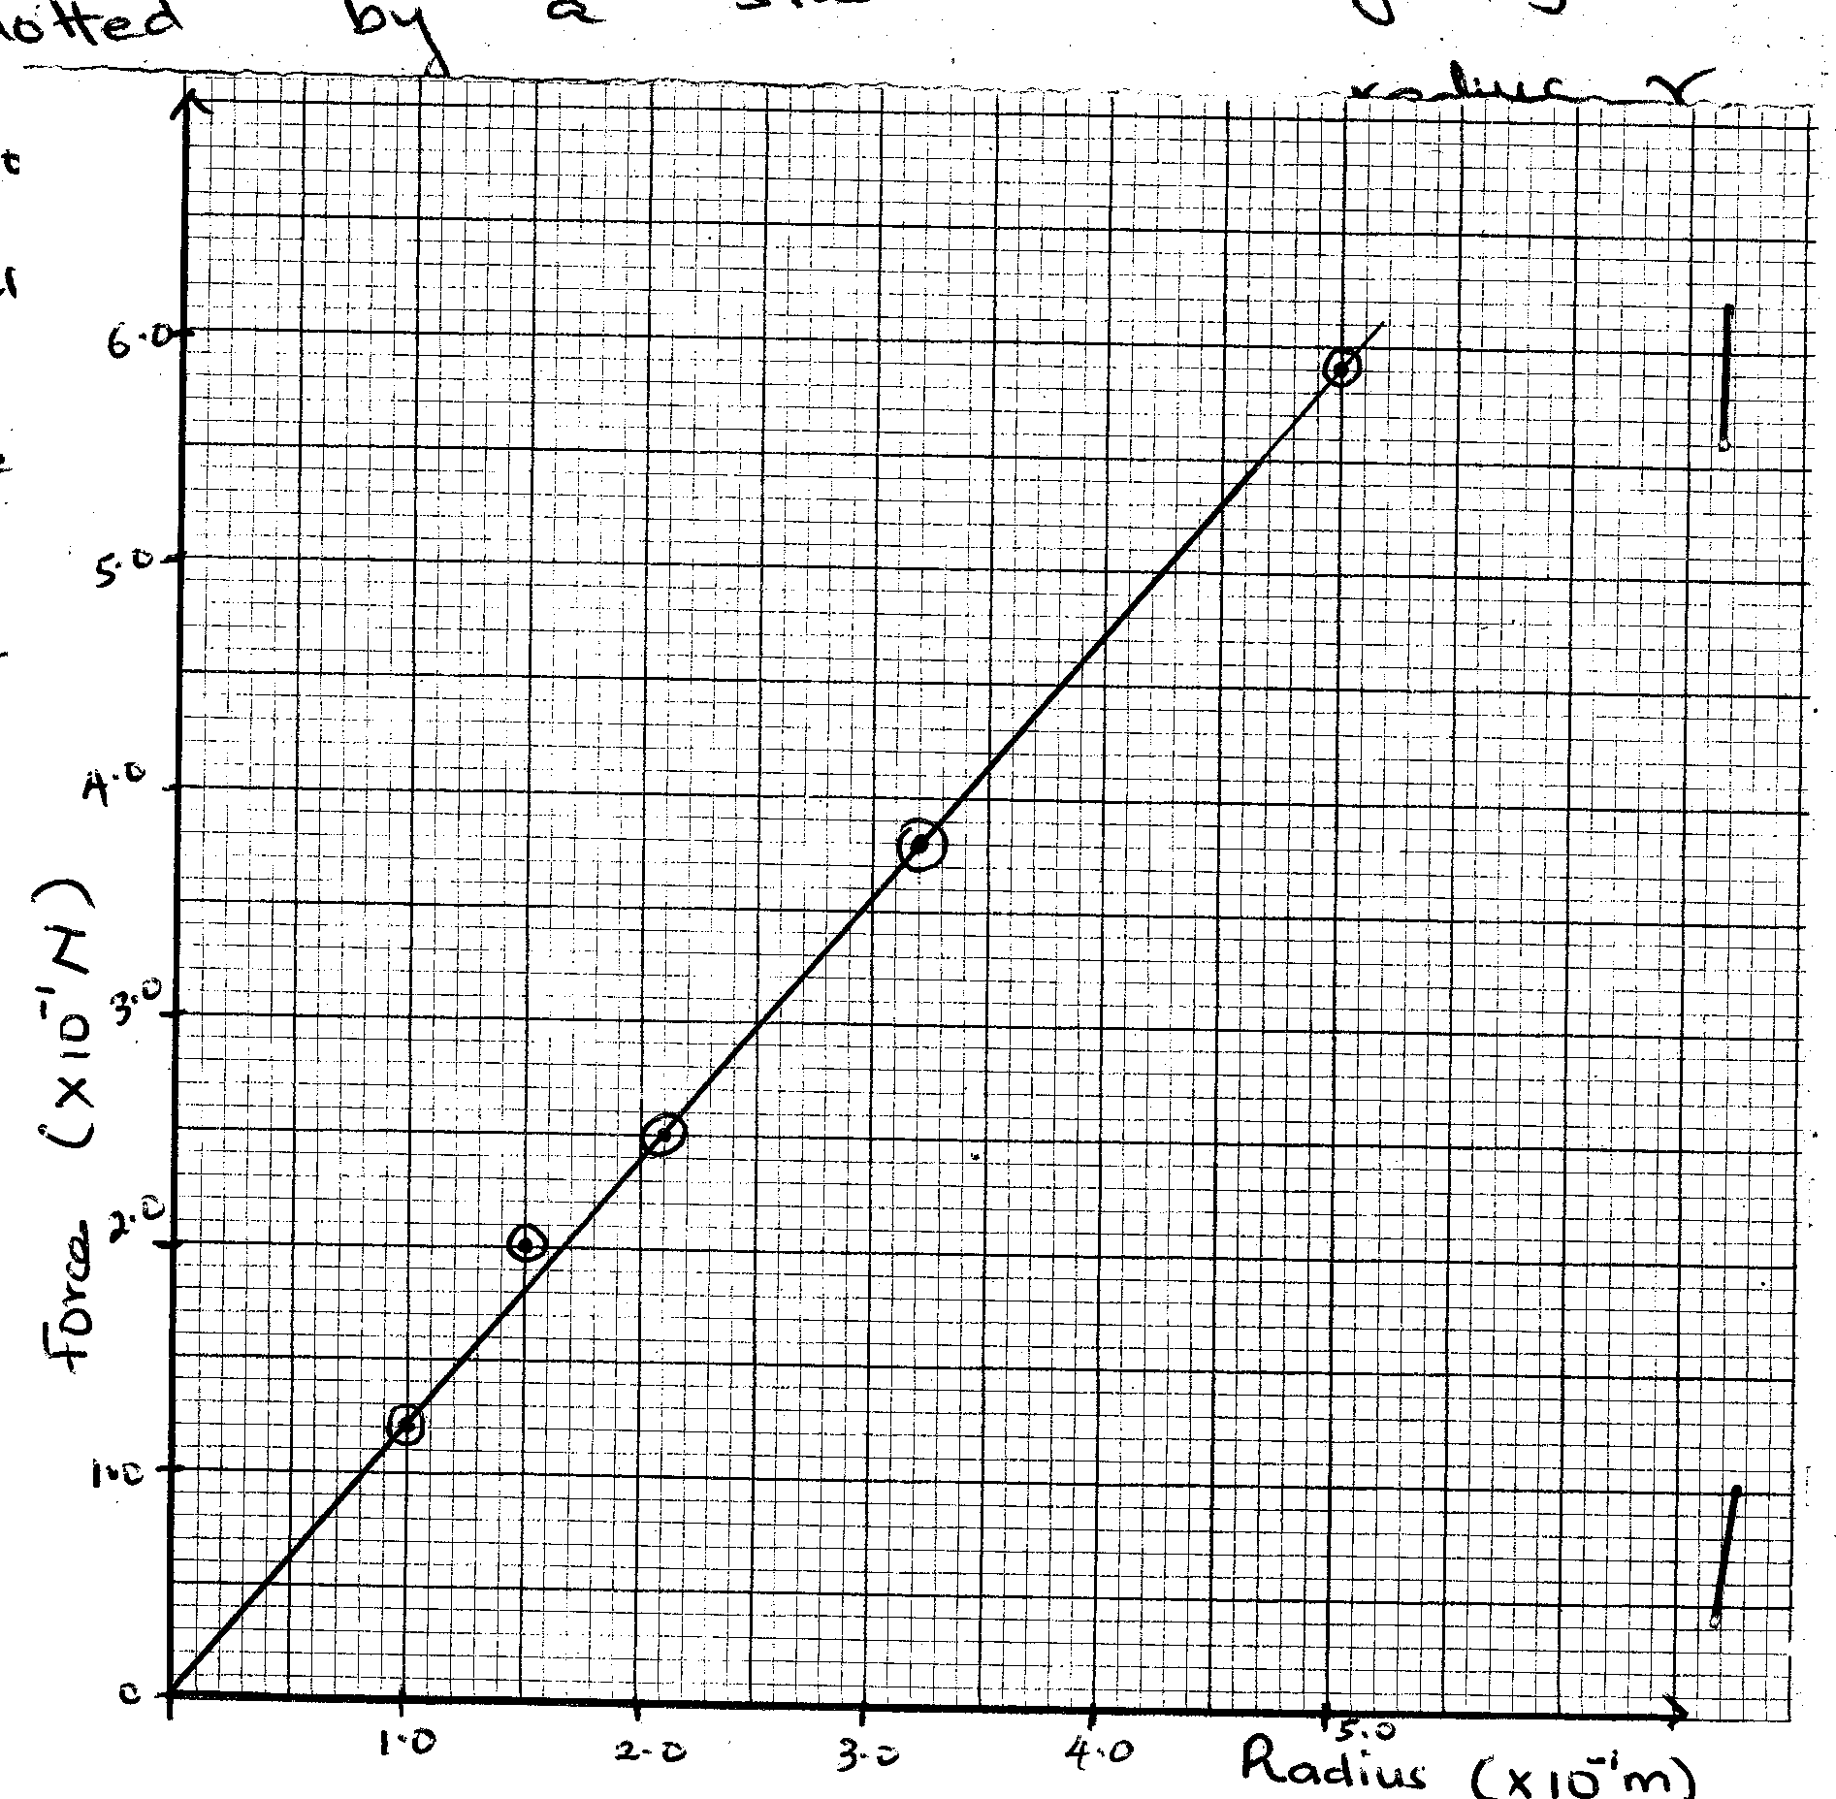
Given the mass of the body is a 100g, use the graph to determine the angular velocity, w of the body. (4 marks)
………………………………………………………………………………………………………………………………………………………………………………………………………………………………………………………………………………………………………………………………………………………………………
d) The graph below shows a displacement time graph of the motion of a body.
State the nature of the motion between;
i) A and B (1 mark)
………………………………………………………………………………………………………………………………………………………………………………………………………………………………………………………………………………………………………………………………………………………………………
ii) B and C (1 mark)
………………………………………………………………………………………………………………………………………………………………………………………………………………………………………………………………………………………………………………………………………………………………………
iii) C and D (1 mark)
………………………………………………………………………………………………………………………………………………………………………………………………………………………………………………………………………………………………………………………………………………………………………

