Name:…………………………………………………………………….. Index No. ……………………….
Date: …………………….. Sign……………………
232/2
PHYSICS
PAPER 2
JULY /AUGUST 2013
TIME: 2 HOURS

SUBUKIA DISTRICT JOINT EXAMINATION
Kenya Certificate of Secondary Education 2013
232/2
PHYSICS
PAPER 2
JULY /AUGUST 2013

Instructions to candidates
- Write your name, index number and name of your school in the spaces provided.
- This paper consists of two parts A and B.
- Answer all questions in section A and B in the spaces provided.
- All working MUST be shown in the spaces provided after questions.
- Mathematical tables and electronic calculators may be used.
- Candidates should check the question paper to ascertain that ascertain that all the pages are printed as indicated and that no questions are missing.
For examiners use only
Section | Question | Maximum score | Candidates score
A | 1-13 | 25
B | 14 | 14
 | 15 | 12
 | 16 | 12
 | 17 | 11
 | 18 | 07
 | Total score | 80

This paper consists of 13 printed pages
SECTION A (25 MARKS)
Answer ALL the questions in this section
- The figure 1 below shows the image in front of a mirror M.
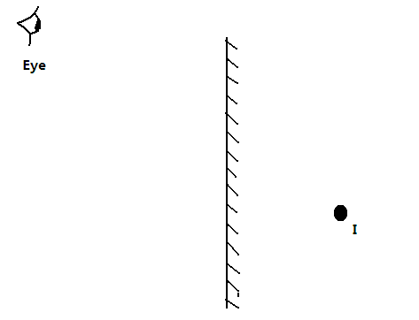
By ray diagram construction, locate the position of the object. (2 marks)
- A negatively charged rod is brought rear the cap of a leaf electroscope. The cap is then earthed momentarily by touching with the finger. Finally the rod is withdrawn. State and explain the observation made. (2 marks)
..........................................................................................................................................................................................................................................................................................................................................................................................................................................................................................................................................
- A boy observes his face in a concave mirror of focal length 100cm. If the mirror is 80cm away, state one characteristics of the image observed. (1 mark)
............................................................................................................................................................................................................................................................................................................................................................
- The coil of an electric motor is usually wound on a soft iron armature. State two purposes by this armature. (2 marks)
............................................................................................................................................................................................................................................................................................................................................................
- A student stands at a distance 400m from a wall and claps two pieces of wood. After the first clap the student claps whenever an echo is heard from the wall. Another student starts a stopwatch at the first clap and stops it after the twentieth clap. The stopwatch records a time of 50 seconds. Find the speed of sound. (3 marks)
..........................................................................................................................................................................................................................................................................................................................................................................................................................................................................................................................................
- The figure 2 below shows a displacement-time graph for a wave motion
Figure 2
What is the frequency of the wave? (2 marks)
............................................................................................................................................................................................................................................................................................................................................................
- Figure 3 below shows an incomplete circuit diagram for a half-wave rectification of an AC voltage.
~
+
-
Out put
x
Figure 3

ac v

- Complete diagram by inserting a diode at X so that the output terminals are positive and negative as shown (1mark)
- On the axes provided below sketch a graph showing how the output voltage varies with time (1mark)
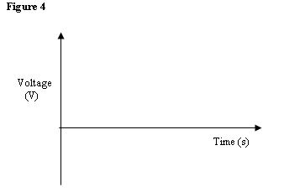
- The figure 5 below shows a series of wave fronts one wavelength apart approaching a gap between barriers in ripple tank.

Figure 5

On the same diagram, show what happens when the waves pass through the gap. (1 mark)
- In figure 6 shown below (not drawn to scale), sketch the path of a ray till it emerges from the prism.

- Explain briefly how free electrons are produced in an X-ray tube. (1 mark)
..........................................................................................................................................................................................................................................................................................................................................................................................................................................................................................................................................
- A bulb is rated 100W, 240V. At what rate would it dissipate energy if it is connected to a 220V supply? (3 marks)
........................................................................................................................................................................................................................................................................................................................................................................................................................................................................................................................................................................................................................................................................................................................
- (a). One method of producing a weak magnet is to hold a steel rod in the North South direction and then hammer it continuously for some time. Using the domain theory of magnetism explain how this method works. (2 marks)
………………………………………………………………………………………………………………………………………………………………………………………………………………………………………………………………………………………………………………………………………………………………………………………………………………………………………………………………

- Figure 7 shows a motor connected to a magnetic switch called a relay operated by an ordinary switch S₁. Use the information in the figure to answer questions that follows:
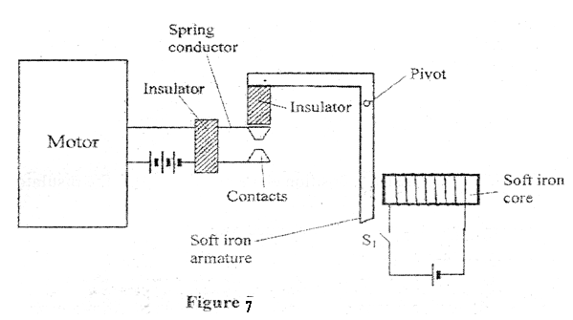
- Explain how the relay switches on the motor when S₁ is closed (3 marks)
…………………………………………………………………………………………………………………………………………………………………………………………………………………………………………………………………………………………………………………………………………………………………………………………………………………………………………………………………………
- State with a reason the effect on the motor if the iron core is replaced with a steel core and switch S₁ is put on and then off. (2 marks)
……………………………………………………………………………………………………………………………………………………………………………………………………………………………………………………………………………………………………………………………………………………...

SECTION B (55MARKS)
Answer ALL the questions in this section.
- a) State Lenz’s law of electromagnetic induction. (1mark)
..........................................................................................................................................................................................................................................................................................................................................................................................................................................................................................................................................
b) In the figure 9 below the bar magnet is moved into the coil.
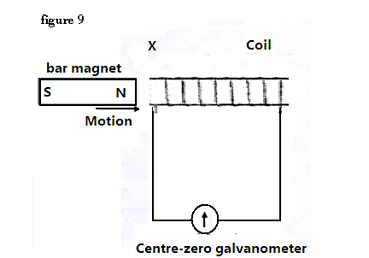
- State and explain what is observed in the galvanometer. (2 marks)
..........................................................................................................................................................................................................................................................................................................................................................................................................................................................................................................................................
- Explain briefly the source of an electrical energy in the circuit. (2marks)
..........................................................................................................................................................................................................................................................................................................................................................................................................................................................................................................................................
- State any two ways in which power is lost from the transformer and explain how each loss is minimized. (2 marks)
..........................................................................................................................................................................................................................................................................................................................................................................................................................................................................................................................................
- A transformer is used to provide a potential difference of 100KV to an X-ray tube from 250V a.c mains supply. A current of 100mA flows in the X-ray tube and the transformer is 100% efficient.
Calculate;
- The ratio of the number of turns of the secondary coil to the number of turns in the primary coil. (3 marks)
…………………………….........................................................................................................................................................................................................................................................................................................................................................................................................................................................................................
- The current in the primary coil (2 marks)
..........................................................................................................................................................................................................................................................................................................................................................................................................................................................................................................................................
- State giving reasons which of the coils of the transformer is thinner. (2 marks)
........................................................................................................................................................................................................................................................................................................................................................................................................................................................................................................................................................................................................................................................................................................................
15. a) The figure 1 below represent a cathode ray oscilloscope. (C.R.O)
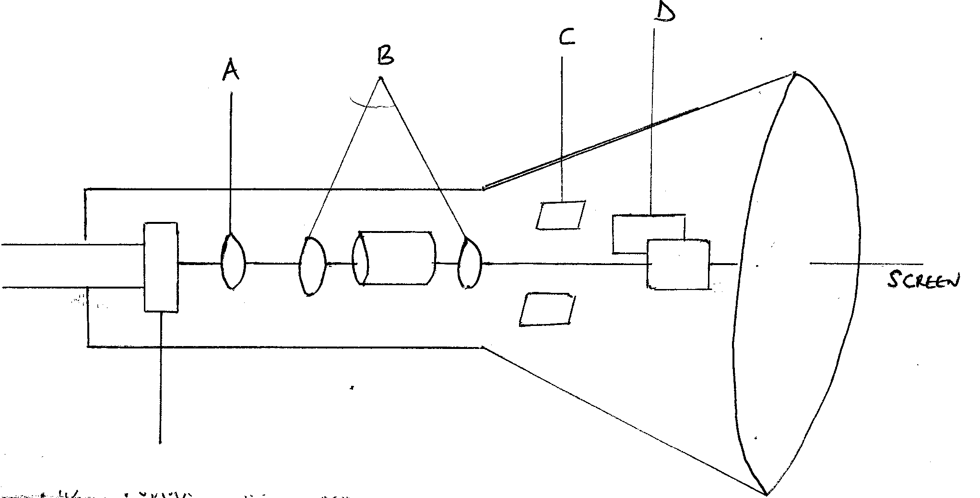
i) Name the parts labeled A and B (2 Marks)
…………………………………………………………………………………………………
…………………………………………………………………………………………………
…………………………………………………………………………………………………
ii) What are the functions of parts labeled C and D (2 Marks)
…………………………………………………………………………………………………
…………………………………………………………………………………………………
…………………………………………………………………………………………………

iii) Explain how electrons are produced. (1 Mark)
…………………………………………………………………………………………………
…………………………………………………………………………………………………
…………………………………………………………………………………………………

iv) Give a reason why the tube is evacuated (1Mark)
…………………………………………………………………………………………………
…………………………………………………………………………………………………
…………………………………………………………………………………………………

b) The potential between the anode and the cathode of an x- ray tube is 80kv. Calculate;
i) the energy of an electron accelerated in the tube (electronic charge e=1.6 x 10 ⁻¹⁹C) (3Marks)

ii) the velocity of electrons in the tube ( mass of an electron= 9.11 x 10⁻³¹kg) (3Marks)

16. a) The figure below shows ultra-violet light striking a polished zinc plate on a negatively charged gold leaf electroscope.
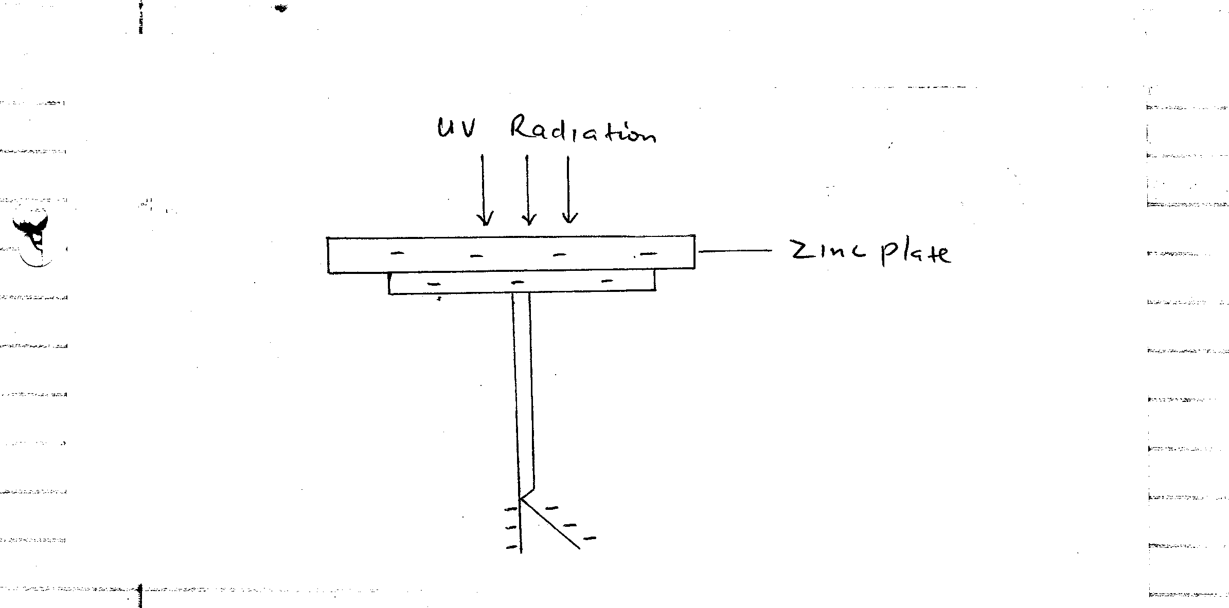
Explain the following observation;
i) The leaf of the electroscope falls. (2 Marks)
…………………………………………………………………………………………………
…………………………………………………………………………………………………
…………………………………………………………………………………………………
ii) When the same experiment was repeated with a positively charged electroscope the leaf did not fall. (2 Marks)
…………………………………………………………………………………………………
…………………………………………………………………………………………………
…………………………………………………………………………………………………
b) State one factor which determines the speed of photoelectrons emitted by a metal surface. (1Mark)
…………………………………………………………………………………………………
…………………………………………………………………………………………………
…………………………………………………………………………………………………

c) The graph below shows the plotting of stopping potential against frequency of radiation directed on a clean metal surface.
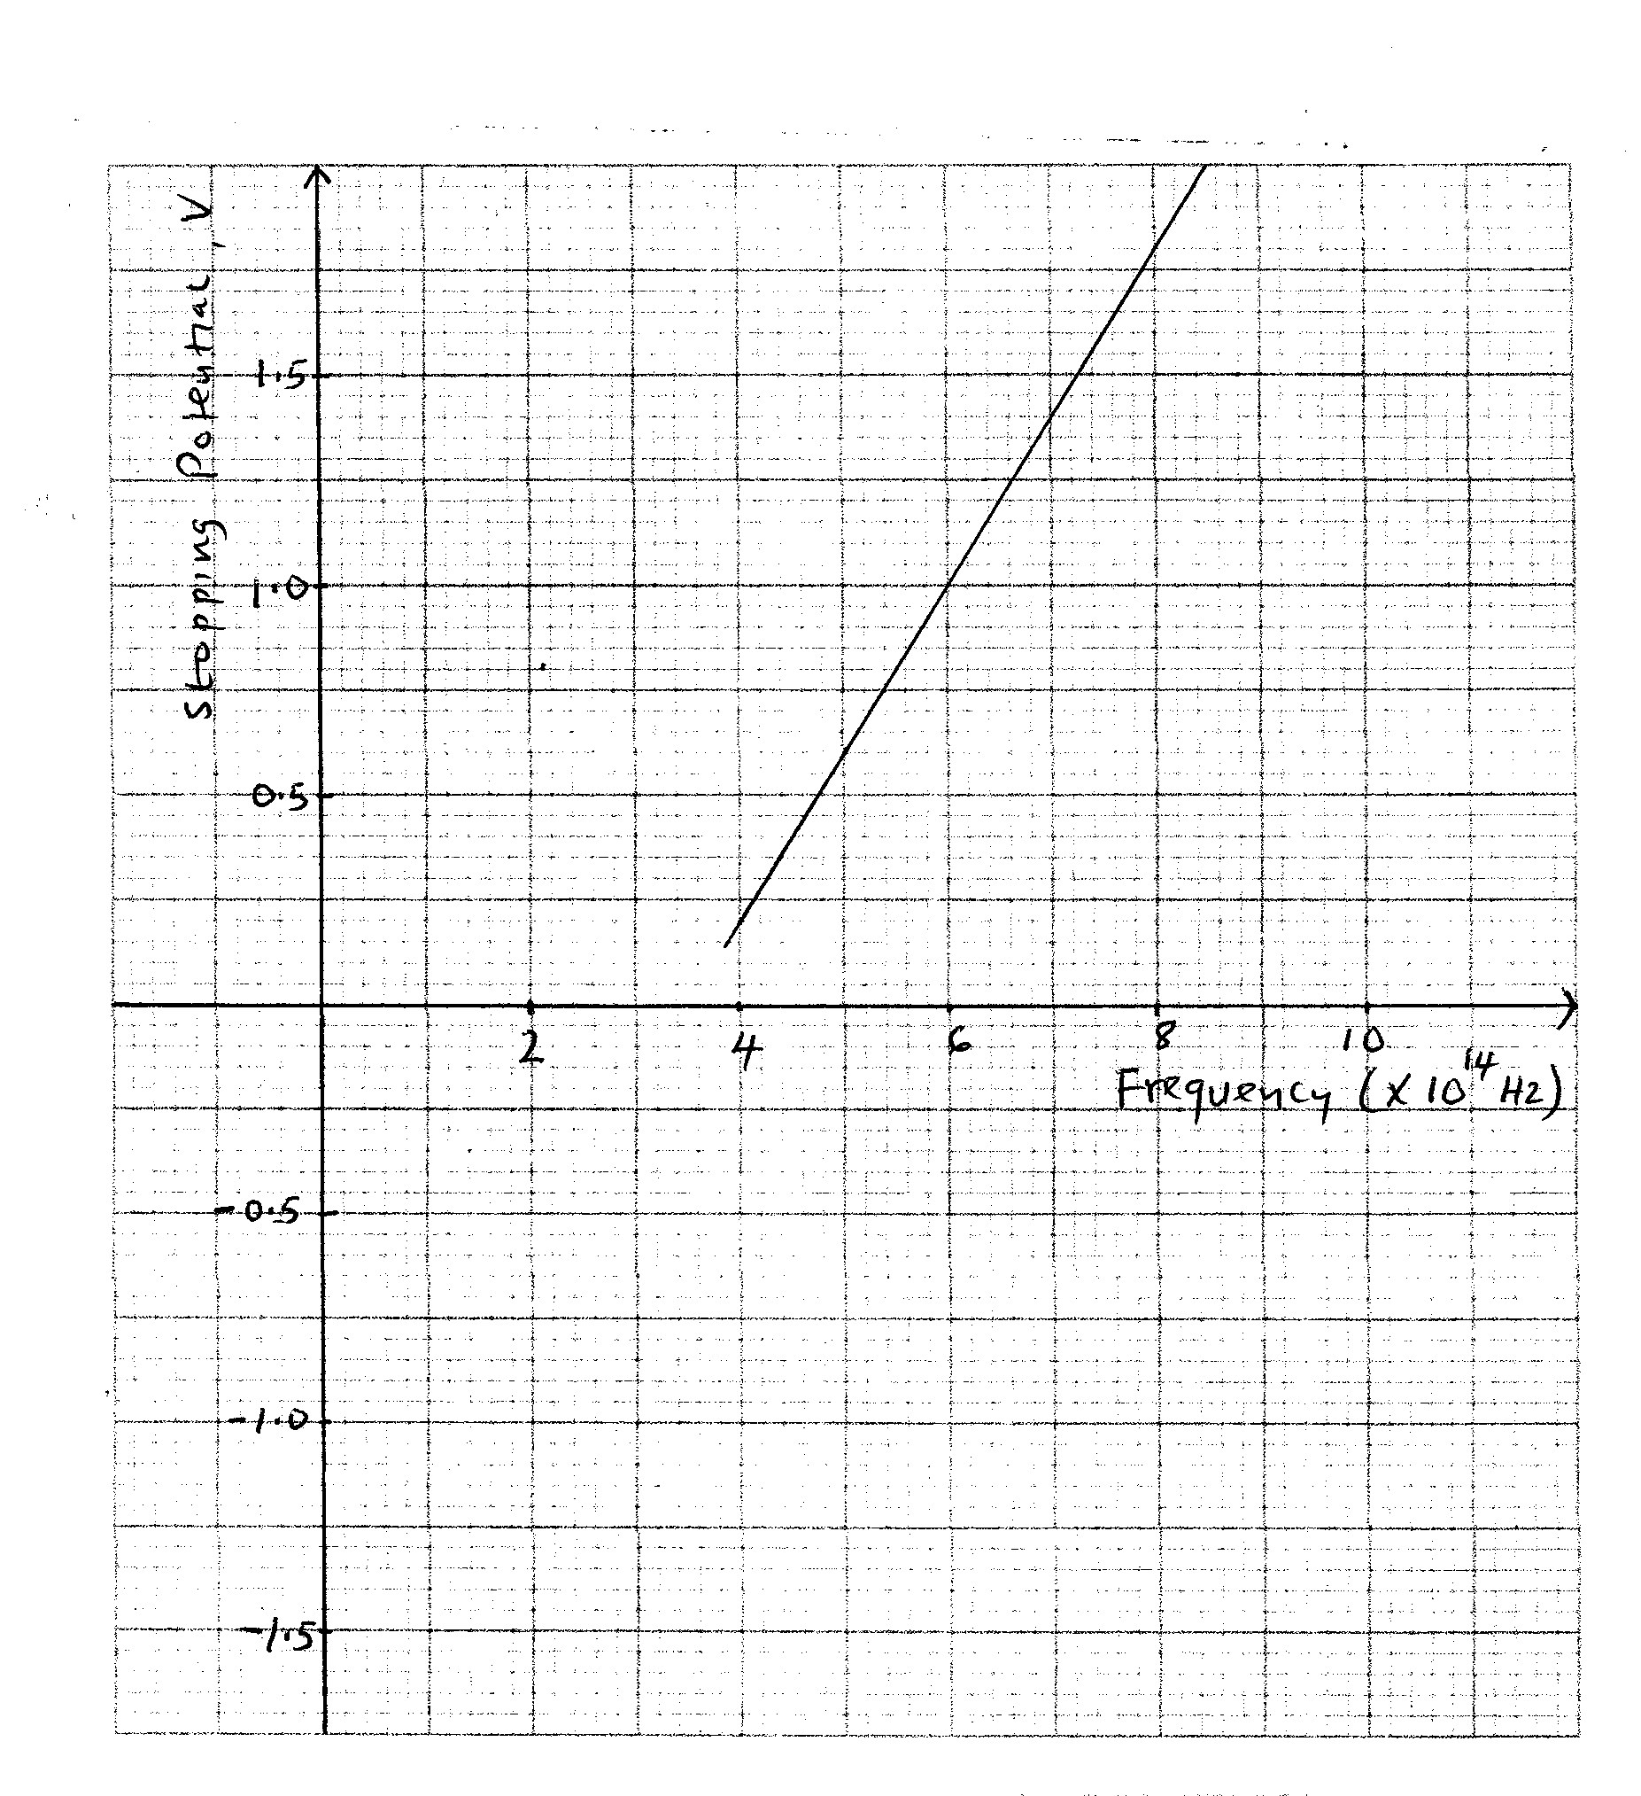
From the graph, determine;
i) Threshold frequency of the metal (2Marks)

ii) Planck’s constant (use charge of an electronic, e = 1.6 x 10⁻¹⁹ C) (3Marks)

iii) Work function of the metal in electron-volt. (2Marks)

17. a) Define the term ‘Ohms law’ (1Mark)
…………………………………………………………………………………………………
…………………………………………………………………………………………………
…………………………………………………………………………………………………
b) Three resistors 1 Ω, 3Ω and 5Ω are connected together in a circuit. Draw a circuit diagram to show an arrangement that would give minimum resistance and determine that resistance. (3Marks)

c) The cell in the figure below has an e.m.f of 1.8V and negligible internal resistance
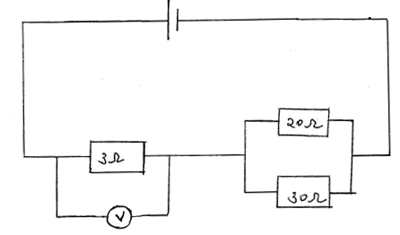
Determine ;
i) Total resistance in the circuit (2 Marks)

ii) The current in the circuit. (1 Mark)

iii) Reading of the voltmeter. (2 Marks)

d) Five identical cells each of e.m.f 1.5v and internal resistance Ω are connected in series. Determine;
i) Their overall e.m.f (1 Mark)
…………………………………………………………………………………………………………………
ii) Their total internal resistance. (1 Mark)
………………………………………………………………………………………………………………….
18. a) State the conditions necessary for total internal reflection to occur. (2 Marks)
………………………………………………………………………………………………………………………………………………………………………………………………………………………………………………………………………………………………………………………………………………………..
b) Figure below shows a ray of light incident on the boundary between two media 1 and 2 at an angle ѳ
Show that the refractive index for a ray of light travelling from medium 1 and medium 2 is given by η = $\frac{1}{sin ѳ}$
…………………………………………………………………………………………………………………………………………………………………………………………………………………………………………………………………………………………………………………………………………………………………………………………………………………………………………………………………………………………………………………………………………………………………………………………….

c) Figure shows a ray of light incidence on one face of a block of ice of refractive index 1.31 and totally reflected at the adjacent face.
Determine;
i) Angle ѳ (2 Marks)

ii) Angle x (1 Mark)

iii) Angle ѳ, the greatest angle for which the total internal reflection is possible. (2 Marks)

