Name ………………………………..…… Index No. …….……………/…… Class ……….…...

Candidate’s Signature …….…….…………

Date ………..…………..

Kenya Certificate of Secondary Education
Mock Examinations, 2013

443/2
Agriculture
(Paper 2)
July, 2013
2 hours

Write your name, index number and class in the spaces provided above.
Sign and write the date of examination in the spaces provided above.
This paper consists of three sections: A, B and C.
Answer ALL the questions in sections A and B, in the spaces provided.
Answer ANY TWO questions in section C in the foolscaps provided.

For Examiner’s Use Only

Section | Question | Maximum Score | Candidate’s  Score
A | 1 - 19 | 30
B | 20 - 24 | 20
C |  | 20
 |  | 20
Total Score |  | 90

This paper consists of 14 printed pages.
Candidates should check the question paper to ascertain that all
the pages are printed as indicated and no questions are missing.

© 2013

Section A (30 marks)
Answer ALL questions in this section in the spaces provided

- Give the gestation and lactation periods in camels (1 mark)

Gestation ………………………………………………………………………….…………

Lactation ………………………………………………………………………….…………

- Name one species of fresh, warm water fish reared in Kenya (½ marks)

……………………………………………………………………………………………………

- What is meant by lambing percentage? (1 mark)

…………………………………………………………………………………………………………………….
…………………………………………………………………………………………………………………….

- (a) How long is the oestrous cycle in cattle? (½ mark)

…………………………………………………………………………………………………………………….

(b) How long is oestrous in cattle? (½ mark)

…………………………………………………………………………………………………………………….

- State three indicators of respiratory tract infection in livestock (1½ mark)

…………………………………………………………………………………………………………………….

…………………………………………………………………………………………………………………….

…………………………………………………………………………………………………………………….

- List four non-chemical tick control measures (2 marks)

…………………………………………………………………………………………………………………….

…………………………………………………………………………………………………………………….

…………………………………………………………………………………………………………………….

…………………………………………………………………………………………………………………….

…………………………………………………………………………………………………………………….

- Name one poisonous / anti-nutritional chemical compound found in each of the following livestock feedstuffs (1½ marks)

- Cassava roots …………………………………………………………………………………….

- Groundnut seeds …………………………………………………………………………………….

- Cotton seed cake …………………………………………………………………………………….

- State four reasons for constructing a fish pond on gently-sloping land (2 marks)

…………………………………………………………………………………………………………………….

…………………………………………………………………………………………………………………….

…………………………………………………………………………………………………………………….

…………………………………………………………………………………………………………………….

- Give one functional difference between a tape measure and a garden line (1 mark)

…………………………………………………………………………………………………………………….

…………………………………………………………………………………………………………………….

- Name three livestock diseases associated with deficiency of calcium (1½ marks)

………………………………………………………, ……………………………………………………….

……………………………………………………….

- Differentiate between mothering ability and prolificacy as used in livestock breeding
(1 mark)
Mothering ability …………………………………………………………………………………………..

…………………………………………………………………………………………………………………….

Prolificacy ……………………………………………………………………………………………….…..

…………………………………………………………………………………………………………………….

- State two reasons for applying oil and grease on a mower (1 mark)

…………………………………………………………………………………………………………………….

…………………………………………………………………………………………………………………….

- What is meant by providing a feedstuff, to an animal, ad libitum? (1 mark)

…………………………………………………………………………………………………………………….

…………………………………………………………………………………………………………………….

- State three limitations of embryo transfer technology (1½ marks)

…………………………………………………………………………………………………………………….

…………………………………………………………………………………………………………………….

…………………………………………………………………………………………………………………….

- Give three reasons why calves should be fed on colostrum (1½ marks)

…………………………………………………………………………………………………………………….

…………………………………………………………………………………………………………………….

…………………………………………………………………………………………………………………….

- Define each of the following, as used with reference to livestock

- Quarantine (1 mark)

…………………………………………………………………………………………………………………….

…………………………………………………………………………………………………………………….

- Predisposing factor (1 mark)

…………………………………………………………………………………………………………………….

…………………………………………………………………………………………………………………….

- How can a farmer improve each of the following?

- Hardness of egg shells (½ mark)

…………………………………………………………………………………………………………………….

- Yellowness of the egg yolk (½ mark)

…………………………………………………………………………………………………………………….

- State four disadvantages of natural mating as a method of breeding in dairy cattle
(2 marks)
…………………………………………………………………………………………………………………….

…………………………………………………………………………………………………………………….

…………………………………………………………………………………………………………………….

…………………………………………………………………………………………………………………….

- Shown below are diagrams of livestock parasites. Study the diagrams carefully an answer the questions that follow

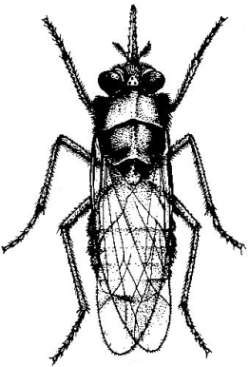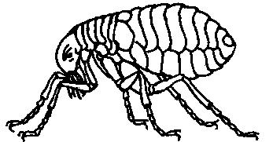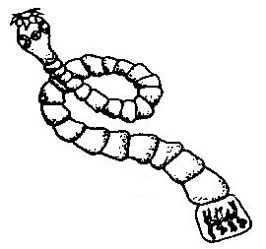
P1 P2 P3

- Identify each of the parasites shown (1½ marks)

P1 …………………………………………………………………

P2 …………………………………………………………………

P3 …………………………………………………………………

- (i) Name the disease transmitted by the parasite labelled P1 to (1 mark)

Man …………………………………………………………………………………………..
Livestock ……………………………………..………………………………………………

- Give three control measures of the parasite labelled P1 (1½ marks)

…………………………………………………………………………………………………………………….

…………………………………………………………………………………………………………………….

…………………………………………………………………………………………………………………….

- State three effects of the parasite labelled C on livestock infested by this parasite
(1½ marks)
…………………………………………………………………………………………………………………….

…………………………………………………………………………………………………………………….

…………………………………………………………………………………………………………………….

- What is the general name of the chemicals used to control the parasite labelled P3?
(½ mark)
…………………………………………………………………………………………………………………….

Section B (20 marks)
Answer ALL questions in this section in the spaces provided

- Shown below are diagrams of farm tools/ equipment. Study the diagrams carefully and then answer the questions that follow
T1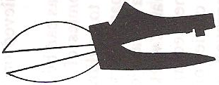 T2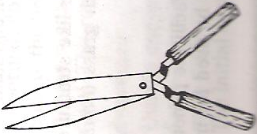

T3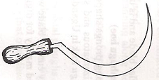 T4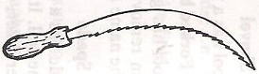

- Name each of the tools/ equipment labelled T1, T2, T3 and T4 above (2 marks)

T1 ……………………………………………….. T2 ………………………………………………..

T3 ……………………………………………….. T4 ………………………………………………..

- Distinguish between the uses of the tools labelled T3 and T4 (1 mark)

…………………………………………………………………………………………………………………….

…………………………………………………………………………………………………………………….

- (a) Name each of the parts labelled A, B, C and D on the image of a Zebu animal shown below
(on page 7) (2 marks)

A ……………………………………………….. B ………………………………………………..

C ……………………………………………….. D ………………………………………………..
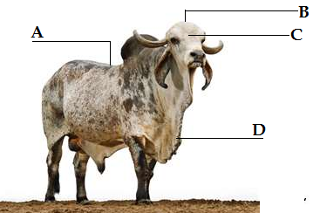

- (i) Using letter B, mark three areas most suitable for branding / inscribing marks,
numbers, letters on – the bull (1¹/₂ marks)

- Give one reason for your answer in (a) above (¹/₂ mark)

…………………………………………………………………………………………………………………….

- Name two equipment used for branding (1 mark)

…………………………………………………………………………………………………………………….

…………………………………………………………………………………………………………………….

- Illustrated below is the digestive system of a rabbit

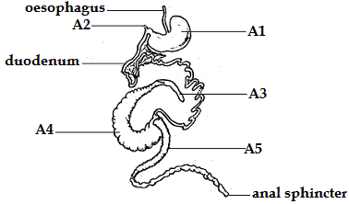

On the illustration, name each of the parts labelled A1, A2, A3, A4 and A5 (2¹/₂ marks)

- (a) Shown below (on page 8) is a section through the mammary gland of a cow. Study the
section carefully and then answer the questions that follow

- On the diagram, name each of the parts labelled K1, K2, K3, K4, K5, K6, K7 and K8
(4 marks)
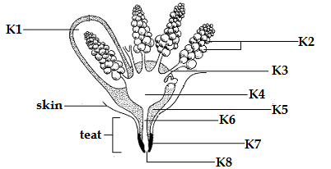

- Indicate one letter representing the part responsible for lactogenesis (½ mark)

…………………………………………………………………………………………………………………….

- Lactogenesis is controlled by a hormone called ………………………….……………… which is secreted by the pituitary gland (1 mark)

- Shown below is a diagram of a farm implement. Study the diagram carefully and answer the questions that follow
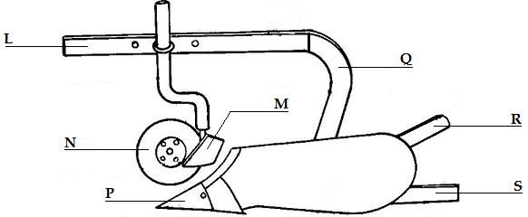

- Identify the farm implement above (½ mark)

…………………………………………………………………………………………………………………….

- Give one function of each of the parts labelled N and S (2 marks)

N …………………………………………………………………………………………………………

…………………………………………………………………………………………………………………….

S …………………………………………………………………………………………………………

…………………………………………………………………………………………………………………….
- State one function of the part labelled P (½ mark)

…………………………………………………………………………………………………………………….

- Name each of the parts labelled L, M, Q and R (2 marks)

L ……………………………………………….. M ………………………………………………..

Q ……………………………………………….. R ………………………………………………..

Section C (40 marks)
Answer ANY TWO questions in this section in the spaces provided after question

- (a) Outline the causes of stress in a flock of laying birds (10 marks)
(b) Discuss the maintenance requirements of the battery of a tractor (10 marks)

- (a) Outline the qualities of clean milk (8 marks)
(b) Outline the various practices carried out to produce milk with the qualities outlined in (a)(i)
above (12 marks)
- Describe the component parts of a plunge dip for cattle (20 marks)

…………………………………………………………………………………………………………………….

…………………………………………………………………………………………………………………….

…………………………………………………………………………………………………………………….

…………………………………………………………………………………………………………………….

…………………………………………………………………………………………………………………….

…………………………………………………………………………………………………………………….

…………………………………………………………………………………………………………………….

…………………………………………………………………………………………………………………….

…………………………………………………………………………………………………………………….

…………………………………………………………………………………………………………………….

…………………………………………………………………………………………………………………….

…………………………………………………………………………………………………………………….

…………………………………………………………………………………………………………………….
…………………………………………………………………………………………………………………….

…………………………………………………………………………………………………………………….

…………………………………………………………………………………………………………………….

…………………………………………………………………………………………………………………….

…………………………………………………………………………………………………………………….

…………………………………………………………………………………………………………………….

…………………………………………………………………………………………………………………….

…………………………………………………………………………………………………………………….

…………………………………………………………………………………………………………………….

…………………………………………………………………………………………………………………….

…………………………………………………………………………………………………………………….

…………………………………………………………………………………………………………………….

…………………………………………………………………………………………………………………….

…………………………………………………………………………………………………………………….

…………………………………………………………………………………………………………………….

…………………………………………………………………………………………………………………….

…………………………………………………………………………………………………………………….

…………………………………………………………………………………………………………………….

…………………………………………………………………………………………………………………….

…………………………………………………………………………………………………………………….

…………………………………………………………………………………………………………………….

…………………………………………………………………………………………………………………….

…………………………………………………………………………………………………………………….

…………………………………………………………………………………………………………………….
…………………………………………………………………………………………………………………….

…………………………………………………………………………………………………………………….

…………………………………………………………………………………………………………………….

…………………………………………………………………………………………………………………….

…………………………………………………………………………………………………………………….

…………………………………………………………………………………………………………………….

…………………………………………………………………………………………………………………….

…………………………………………………………………………………………………………………….

…………………………………………………………………………………………………………………….

…………………………………………………………………………………………………………………….

…………………………………………………………………………………………………………………….

…………………………………………………………………………………………………………………….

…………………………………………………………………………………………………………………….

…………………………………………………………………………………………………………………….

…………………………………………………………………………………………………………………….

…………………………………………………………………………………………………………………….

…………………………………………………………………………………………………………………….

…………………………………………………………………………………………………………………….

…………………………………………………………………………………………………………………….

…………………………………………………………………………………………………………………….

…………………………………………………………………………………………………………………….

…………………………………………………………………………………………………………………….

…………………………………………………………………………………………………………………….

…………………………………………………………………………………………………………………….
…………………………………………………………………………………………………………………….

…………………………………………………………………………………………………………………….

…………………………………………………………………………………………………………………….

…………………………………………………………………………………………………………………….

…………………………………………………………………………………………………………………….

…………………………………………………………………………………………………………………….

…………………………………………………………………………………………………………………….

…………………………………………………………………………………………………………………….

…………………………………………………………………………………………………………………….

…………………………………………………………………………………………………………………….

…………………………………………………………………………………………………………………….

…………………………………………………………………………………………………………………….

…………………………………………………………………………………………………………………….

…………………………………………………………………………………………………………………….

…………………………………………………………………………………………………………………….

…………………………………………………………………………………………………………………….

…………………………………………………………………………………………………………………….

…………………………………………………………………………………………………………………….

…………………………………………………………………………………………………………………….

…………………………………………………………………………………………………………………….

…………………………………………………………………………………………………………………….

…………………………………………………………………………………………………………………….

…………………………………………………………………………………………………………………….

…………………………………………………………………………………………………………………….
…………………………………………………………………………………………………………………….

…………………………………………………………………………………………………………………….

…………………………………………………………………………………………………………………….

…………………………………………………………………………………………………………………….

…………………………………………………………………………………………………………………….

…………………………………………………………………………………………………………………….

…………………………………………………………………………………………………………………….

…………………………………………………………………………………………………………………….

…………………………………………………………………………………………………………………….

…………………………………………………………………………………………………………………….

…………………………………………………………………………………………………………………….

…………………………………………………………………………………………………………………….

…………………………………………………………………………………………………………………….

…………………………………………………………………………………………………………………….

…………………………………………………………………………………………………………………….

…………………………………………………………………………………………………………………….

…………………………………………………………………………………………………………………….

…………………………………………………………………………………………………………………….

…………………………………………………………………………………………………………………….

…………………………………………………………………………………………………………………….

…………………………………………………………………………………………………………………….

…………………………………………………………………………………………………………………….

…………………………………………………………………………………………………………………….

…………………………………………………………………………………………………………………….
…………………………………………………………………………………………………………………….

…………………………………………………………………………………………………………………….

…………………………………………………………………………………………………………………….

…………………………………………………………………………………………………………………….

…………………………………………………………………………………………………………………….

…………………………………………………………………………………………………………………….

…………………………………………………………………………………………………………………….

…………………………………………………………………………………………………………………….

…………………………………………………………………………………………………………………….

…………………………………………………………………………………………………………………….

…………………………………………………………………………………………………………………….

…………………………………………………………………………………………………………………….

…………………………………………………………………………………………………………………….

…………………………………………………………………………………………………………………….

…………………………………………………………………………………………………………………….

…………………………………………………………………………………………………………………….

…………………………………………………………………………………………………………………….

…………………………………………………………………………………………………………………….

…………………………………………………………………………………………………………………….

…………………………………………………………………………………………………………………….

…………………………………………………………………………………………………………………….

…………………………………………………………………………………………………………………….

…………………………………………………………………………………………………………………….

This is the last printed page of this paper

