Name ………………………………………………… Class …….. Index No. …………..………/……..

231/1 Candidate’s Signature ……………...………..
BIOLOGY
Paper 1 Date …………………..
(Theory)
June/ July, 2013
2 hours

Kenya Certificate of Secondary Education

MOCK EXAMINATIONS, 2013

Instructions to candidates

Write your name, class and index number in the spaces provided above.
Append your signature and write the date of examination in the spaces provided above.
Spelling errors especially of Biological terms shall be penalized
Answer ALL questions in the spaces provided.

For Examiner’s Use Only

Question | Maximum Score | Candidate’s Score
1 – 29 | 80

This paper consists of 10 printed pages.
Candidates should check the question paper to ascertain that
all the pages are printed as indicated and no questions are missing.

- Name two metallic ions involved in transmission of nerve impulses (2 marks)

…………………………………………………………..………………………………...…………

…………………………………………………………..………………………………...…………

- Write out an equation summarizing the process of anaerobic respiration in plants (1 mark)

………………………………………………………………………………………………………………………

- Name one animal cell and one plant cell that has no nucleus when fully developed
(2 marks)
Animal cell ………………………………………………………………………………..

Plant cell ………………………………………………………………………………..

- State any two features of a homologous pair of chromosomes (2 marks)

………………………………………………………………………………………………………………………

………………………………………………………………………………………………………………………

- Name two respiratory surfaces in terrestrial plants (2 marks)

……………………………………………..........................................................................…………

……………………………………………..........................................................................…………

- Define Heterostyly (1 mark)

………………………………………………………………………………………………………………………

………………………………………………………………………………………………………………………

- The following statements are cellular short messages and represent gene mutations

Intended message Actual message

I Eat the meat Heat the meat
II This is my team This is my tea

Identify the type of mutation represented in each case (2 marks)

I ………………………………………………………………………………………….

II ………………………………………………………………………………………….
- (a) Name the most appropriate hand- held piece of apparatus used to pick a scorpion from a bait
Trap (1 mark)

………………………………………………………………………………………………………………………

(b) State one other precaution that should be taken before picking the scorpion (1 mark)

………………………………………………………………………………………………………………………

- During which phase of meiosis I does crossing over occur? (1 mark)

………………………………………………………………………………………………………………………

- Name the spore-producing structures in

- Bryophytes ……………………………………………………………………………. (1 mark)

- Pteridophytes ………………………………………………………………………….. (1 mark)

- State two factors within the seed, which would cause dormancy (2mark)

………………………………………………………………………………………………………………………

………………………………………………………………………………………………………………………

- (a) Name the membrane that surrounds the mammalian heart (1 mark)

………………………………………………………………………………………………………………………

(b) Give two functions of the membrane mentioned in (a) above (2marks)
………………………………………………………………………………………………………………………

………………………………………………………………………………………………………………………

- State three processes that take place during the interphase stage of cell division, in a plant cell (3 marks)
………………………………………………………………………………………………………………………

………………………………………………………………………………………………………………………

………………………………………………………………………………………………………………………

………………………………………………………………………………………………………………………

- Name the hormone responsible for

- Conversion of glycogen to glucose (1 mark)

………………………………………………………………………………………………………………………

- Regulation of the amount of water in mammalian blood (1 mark)

………………………………………………………………………………………………………………………

- (a) What is the function of co-factors in cell metabolism? (1mark)

………………………………………………………………………………………………………………………

(b) Give one example of a metallic co-factor (1 mark)

………………………………………………………………………………………………………………………

- (a) In which two ways are chloroplasts and mitochondria similar? (2 marks)

………………………………………………………………………………………………………………………

………………………………………………………………………………………………………………………

(b) Where in a chloroplast does each of the following processes occur? (2 marks)

- Photolysis ……………………………………………………………………………………………

- Carbon (iv) oxide fixation …………………………………………………………………………..

- Name two mineral elements necessary in the synthesis of chlorophyll (2 marks)

………………………………………………………., ……………………………………………………….

- What two ideas are proposed in Jean Baptiste Lamarck’s theory of evolution? (2 marks)

………………………………………………………………………………………………………………………

………………………………………………………………………………………………………………………

- State three sources of water for our bodies’ use (3 marks)

………………………………………………………………………………………………………………………

………………………………………………………………………………………………………………………

………………………………………………………………………………………………………………………
- Name two processes that bring about the translocation of manufactured food (2 marks)

………………………………………………………………………………………………………………………

………………………………………………………………………………………………………………………

- Outline two reasons why blood clotting does not ordinarily occur inside blood vessels
(2 marks)
………………………………………………………………………………………………………………………

………………………………………………………………………………………………………………………

………………………………………………………………………………………………………………………

- (a) Give the type of response shown by tendrils in plant stems (1 mark)

………………………………………………………………………………………………………………………

(b) State the function achieved by the response named in (a) above (1 mark)

………………………………………………………………………………………………………………………

- The body cells of an organism contain two copies of 24 000 genes i.e. 48 000 genes in total. Of these, how many genes would have been inherited from the mammal’s female parent?
(1 mark)
………………………………………………………………………………………………………………………

- Colchicine is a chemical substance which prevents the formation of spindle fibres during mitosis. The chromosomes replicate normally and chromatids separate. However, the cell then forms a nuclear membrane and encloses all the chromosomes. What will be the ploidy condition of the resultant cell? (1 mark)

………………………………………………………………………………………………………………………

- State one role of each of the following reagents in testing a given stock solution for the presence of non-reducing sugar

(a) 1% hydrochloric acid solution (1 mark)

………………………………………………………………………………………………………………………

(b) Sodium hydrogen carbonate powder (1 mark)

………………………………………………………………………………………………………………………

- Name, precisely, the structure described in each of the following statements (4 marks)

- The structure that transports deoxygenated blood from the mammalian heart

………………………………………………………………………………………………………………………

- The epithelial cell that secretes mucus in the mammalian trachea

………………………………………………………………………………………………………………………

- The structure that keeps the mammalian trachea open, preventing its collapse during inhalation and exhalation

………………………………………………………………………………………………………………………

- Blindly ending pouch (about 7cm long and 1.2cm diameter) leading from the caecum and which possesses no known function in the human digestive system

………………………………………………………………………………………………………………………

- To estimate the population size of Cancer pagurus, a species of a large edible crab of a red-brown colour, in a lagoon, 400 crabs were trapped, marked and released. After four days, 374 crabs were trapped and of these 87 had been previously marked. What was the estimated size of the population? (2 marks)

………………………………………………………………………………………………………………………

………………………………………………………………………………………………………………………

………………………………………………………………………………………………………………………

………………………………………………………………………………………………………………………

- Shown below is the time taken by cobalt chloride paper to turn pink on upper and lower leaf surfaces of two species of plants- X and Y

Species | Upper surface | Lower surface
X | 27 seconds | 42 seconds
Y | 35 seconds | 21 seconds

- What is the likely habitat of the plant species labeled X? (1 mark)

………………………………………………………………………………………………………………………

- Account for the results obtained for plant species Y (3 marks)

………………………………………………………………………………………………………………………

………………………………………………………………………………………………………………………

………………………………………………………………………………………………………………………

- Illustrated below are the dates of menstruation and ovulation in a human female, in a 31-day period of time
Menstruation ovulation

1 2 3 4 5 6 7 8 9 10 11 12 13 14 15 16 17 18 19 20 21 22 23 24 25 26 27 28 29 30 31

Indicate on the illustration, the dates during which the female would most likely conceive if sexual intercourse took place (1 mark)

- The diagram below shows a specialized plant cell

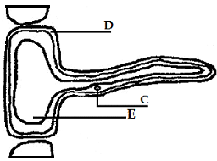

- Identify the cell ……………………………………………………………………… (1 mark)

- Name each of the parts labelled D and E (2 marks)

D ………………………………………………………………………………………..

E ………………………………………………………………………………………..

- State the function of the part labelled C (1 mark)

………………………………………………………………………………………………………………………

- Diagrams C1, C2, C3 and C4 below (on page 8) show a cell undergoing division

- The correct sequence of events is (1 mark)

………………………………………………………………………………………………………………………

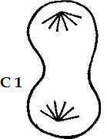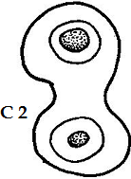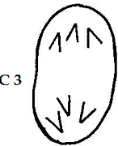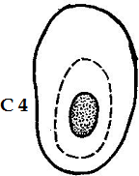

- (i) Is this a plant or an animal cell? (1 mark)

………………………………………………………………………………………………………………………

(ii) Give one reason for your answer in (b)(i) above (1 mark)

………………………………………………………………………………………………………………………

- The diagrams below are of two conducting structures in the xylem tissue

A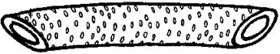

- Identify each of the structures shown above (2 marks)

A- ……………………………………………… B- …………………………………………………

- Give two differences between the structures shown above (2 marks)

………………………………………………………………………………………………………………………

………………………………………………………………………………………………………………………

- On diagram A, name two parts of the structure (2 marks)

- The diagram below (on page 9) shows a red blood cell and the concentration of ions (in mm dm⁻³) in the blood plasma and in the cell

Which ions are actively transported

- Into the red blood cell? ………………………………………………………………… (1 mark)
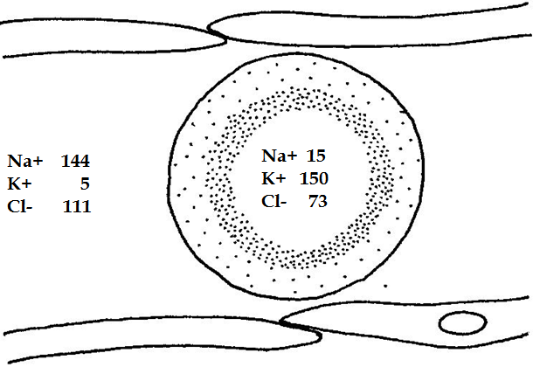

Which ions are actively transported.

- Into the blood plasma? …………………………………………………………. (1 mark)

- The equation for the oxidation of a certain chemical substance X is as shown below

2C₅₁H₉₈O₆ + 145O₂ 102CO₂ + 98H₂O
Substance X

- Work out the respiratory quotient for the oxidation of substance X (1 mark)

………………………………………………………………………………………………………………………

- What inference can be made from your answer in (a) above, about substance (1 mark)

………………………………………………………………………………………………………………………

- In an investigation carried out in a certain terrestrial ecosystem, the population sizes and biomass of four species were determined and recorded. The results were as shown below

Species Population Size Biomass (kg)
S1 1 x 10³ 1 x 10³
S2 1 x 10³ 1 x 10⁻¹
S3 1 x 10⁵ 1 x 10¹
S4 1 x 10¹ 1 x 10⁴
From the results above

- construct a food chain involving the organisms in the ecosystem (1 mark)

………………………………………………………………………………………………………………………

- construct a pyramid of numbers of the organisms in the ecosystem (2 marks)

This is the last printed page of this paper

