Name …………………………………………….…… Class ………. Index No. ………………/……..

231/2 Candidate’s Signature …….…….……..……...
BIOLOGY
Paper 2 Date ………...………..
(Theory)
June/ July, 2013
2 hours

Kenya Certificate of Secondary Education
MOCK EXAMINATIONS 2013

Instructions to candidates

- Write your name, class and index number in the spaces provided above.
- Sign and write the date of examination in the spaces provided above.
- This paper consists of two sections: A and B.
- Answer ALL the questions in section A in the spaces provided.
- In section B answer question 7 (compulsory) and either question 8 OR question 9 in the spaces
provided after question 9

For Examiner’s Use Only

Section | Question | Maximum  Score | Candidate’s  Score
A | 1 | 10
 | 2 | 9
 | 3 | 8
 | 4 | 6
 | 5 | 7
B | 6 | 20
 | 7/8 | 20
Total Score |  | 80

This paper consists of 10 printed pages.
Candidates should check the question paper to ascertain that
all the pages are printed as indicated and no questions are missing.
Section A (40 marks)
Answer ALL questions in this section in the spaces provided

- A rooster with grey feathers was mated with a hen of the same phenotype. Among their offspring, 15 chicks were grey, 6 were black and 8 were white

- Give an explanation for the appearance of the black and white feather colours in the offspring of the chicken (2 marks)

…………………………………………………………………………………………………………………….

…………………………………………………………………………………………………………………….

…………………………………………………………………………………………………………………….

- What feather colours would one predict from the mating of a grey rooster and a black hen? Show your workings (5 marks)

…………………………………………………………………………………………………………………….

…………………………………………………………………………………………………………………….

…………………………………………………………………………………………………………………….

…………………………………………………………………………………………………………………….

…………………………………………………………………………………………………………………….

…………………………………………………………………………………………………………………….

- The diagram below illustrates a part of the mammalian alimentary canal

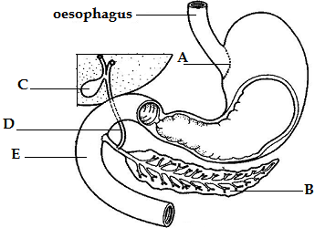

- (i) Identify the organ labelled B (1 mark)

…………………………………………………………………………………………………………………….

(ii) Name two secretions of the organ labelled B (2 marks)

…………………………………………………………………………………………………………………….

…………………………………………………………………………………………………………………….

- Name each of the parts labelled A and D (2 marks)

A …………………………………………………………………………………………….

D …………………………………………………………………………………………….

- State one function of the part labelled C (1 mark)

…………………………………………………………………………………………………………………….

- Explain why the part labelled E is curved (1 mark)

…………………………………………………………………………………………………………………….

…………………………………………………………………………………………………………………….

- The diagram below shows a transverse section of a certain part of an angiosperm. Study the diagram carefully and answer the questions that follow

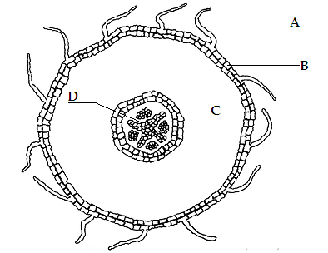

- With a reason, name the part of the plant from which the section was made (2 marks)

Part of plant ………………………………………………………………………………..

Reason …………………………………………………………………………………………………..

- Name each of the parts labelled C and D (2 marks)

C …………………………………………………………………………………………….

D …………………………………………………………………………………………….

- Name the tissue labelled B (1 mark)

…………………………………………………………………………………………………………………….

- (i) Name the class of angiospermae of the plant from which the specimen was obtained
(1 mark)
…………………………………………………………………………………………………………………….

(ii) Give one reason for your answer in (a) above (1 mark)

…………………………………………………………………………………………………………………….

- The diagrams below illustrate two types of neurones and associated structures. Study the diagrams carefully and answer the questions that follow

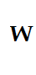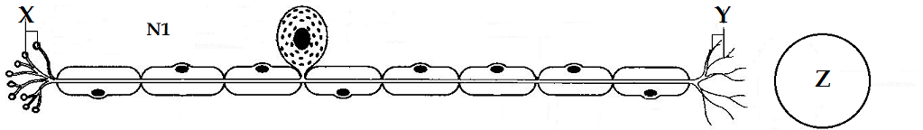

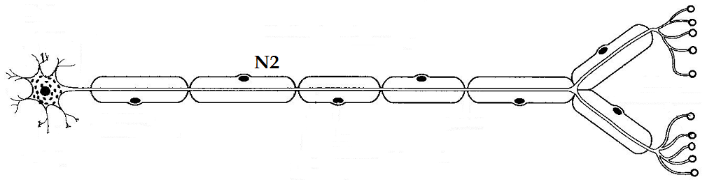
- (i) Identify the type of neurones illustrated in diagrams N1 and N2 (2 marks)

N1 …………………………………………………………………………………………….

N2 …………………………………………………………………………………………….
(ii) Provide two reasons for your identity of the neurone in diagram N1 (2 marks)

…………………………………………………………………………………………………………………….

…………………………………………………………………………………………………………………….

- Name each of the structures labelled X and Y in diagram N1 (2 marks)

N1 …………………………………………………………………………………………….

N2 …………………………………………………………………………………………….

- Give the general name of the type of cell at position Z in diagram N1 (1 mark)

…………………………………………………………………………………………………………………….

- Give the general name of the material in position W in diagram N1 (1 mark)

…………………………………………………………………………………………………………………….

- Alongside diagram N2 and by means of an arrow, indicate the direction of flow of the nerve impulse (1 mark)

- (a) State two merits of air as a respiratory medium, as compared with water (2 marks)

…………………………………………………………………………………………………………………….

…………………………………………………………………………………………………………………….

- Illustrated below is a part of the gas exchange structures in the grasshopper (Gastrimagus sp.). Study the illustration carefully and answer the questions that follow

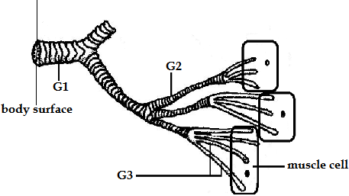

- Name each of the parts labelled G1 and G2 (2 marks)

G1 …………………………………………………………………………………………….

G2 …………………………………………………………………………………………….

- Describe four adaptive features of the structures labelled G3 to their function (4 marks)

…………………………………………………………………………………………………………………….

…………………………………………………………………………………………………………………….

…………………………………………………………………………………………………………………….

…………………………………………………………………………………………………………………….

…………………………………………………………………………………………………………………….

…………………………………………………………………………………………………………………….

- Illustrated below is germination in a certain plant raised from a seed. Study the illustrations carefully and answer the questions that follow
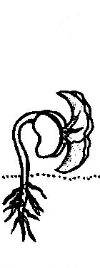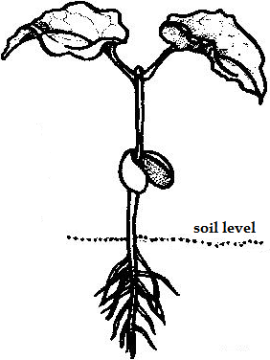
D1- Day 0 D2- Day 5 D3- Day 10 D4- Day 15

- Label the hypocotyl in diagram D3 (1 mark)

- Other than the position of the hypocotyl, give one other reason why this is an example of epigeal germination (1 mark)

…………………………………………………………………………………………………………………….

…………………………………………………………………………………………………………………….

Section B (40 marks)
Answer question 7 (COMPULSORY) in this section in the spaces provided and EITHER question 8 OR question 9 in the spaces provided after question 8

- (a) Distinguish between each of the following ecological phenomena

- Habitat and Niche (2 marks)

…………………………………………………………………………………………………………………….

…………………………………………………………………………………………………………………….

…………………………………………………………………………………………………………………….

- Grazer and Browser (2 marks)

…………………………………………………………………………………………………………………….

…………………………………………………………………………………………………………………….

…………………………………………………………………………………………………………………….

(b) In a study on interactions between populations, two protozoa- Paramecium caudatum and
Paramecium aurelia were grown in the same culture medium under laboratory conditions. The
results of the experiment were as shown in the table below

Time (hours) |  | 0 | 2 | 4 | 6 | 8 | 10 | 12 | 14 | 16
Relative  numbers | P. aurelia | 2 | 54 | 88 | 105 | 112 | 116 | 118 | 119 | 119
 | P. caudatum | 2 | 30 | 48 | 38 | 18 | 8 | 3 | 1 | 1

Display the results above suitably on the graph paper provided (8 marks)

- (i) Name the biological phenomenon illustrated by the results of this experiment
(1 mark)
…………………………………………………………………………………………………………………….

(ii) At what time did the phenomenon in (c)(i) above begin? Show this on the graph
(2 marks)
…………………………………………………………………………………………………………………….

(iii) Explain your answer in (c)(ii) above (3 marks)

…………………………………………………………………………………………………………………….

…………………………………………………………………………………………………………………….

…………………………………………………………………………………………………………………….

- What would have been the population of Paramecium caudatum at 17 hours? (2 marks)

…………………………………………………………………………………………………………………….

- (a) Describe the various evidence for organic evolution (10 marks)

(b) Using appropriate illustrations, outline the mode of action of auxins, with regard to each of
the following processes (10 marks)
- Phototropism
- Geotropism

- Describe how the human male reproductive system is adapted to its functions (20 marks)

…………………………………………………………………………………………………………………….

…………………………………………………………………………………………………………………….

…………………………………………………………………………………………………………………….

…………………………………………………………………………………………………………………….

…………………………………………………………………………………………………………………….

…………………………………………………………………………………………………………………….

…………………………………………………………………………………………………………………….

…………………………………………………………………………………………………………………….

…………………………………………………………………………………………………………………….

…………………………………………………………………………………………………………………….

…………………………………………………………………………………………………………………….

…………………………………………………………………………………………………………………….

…………………………………………………………………………………………………………………….
…………………………………………………………………………………………………………………….

…………………………………………………………………………………………………………………….

…………………………………………………………………………………………………………………….

…………………………………………………………………………………………………………………….

…………………………………………………………………………………………………………………….

…………………………………………………………………………………………………………………….

…………………………………………………………………………………………………………………….

…………………………………………………………………………………………………………………….

…………………………………………………………………………………………………………………….

…………………………………………………………………………………………………………………….

…………………………………………………………………………………………………………………….

…………………………………………………………………………………………………………………….

…………………………………………………………………………………………………………………….

…………………………………………………………………………………………………………………….

…………………………………………………………………………………………………………………….

…………………………………………………………………………………………………………………….

…………………………………………………………………………………………………………………….

…………………………………………………………………………………………………………………….

…………………………………………………………………………………………………………………….

…………………………………………………………………………………………………………………….

…………………………………………………………………………………………………………………….

…………………………………………………………………………………………………………………….

…………………………………………………………………………………………………………………….

…………………………………………………………………………………………………………………….

…………………………………………………………………………………………………………………….

…………………………………………………………………………………………………………………….

…………………………………………………………………………………………………………………….

…………………………………………………………………………………………………………………….

…………………………………………………………………………………………………………………….

…………………………………………………………………………………………………………………….

…………………………………………………………………………………………………………………….

…………………………………………………………………………………………………………………….

…………………………………………………………………………………………………………………….

…………………………………………………………………………………………………………………….

…………………………………………………………………………………………………………………….

…………………………………………………………………………………………………………………….

…………………………………………………………………………………………………………………….

…………………………………………………………………………………………………………………….

…………………………………………………………………………………………………………………….

…………………………………………………………………………………………………………………….

…………………………………………………………………………………………………………………….

…………………………………………………………………………………………………………………….

…………………………………………………………………………………………………………………….

…………………………………………………………………………………………………………………….

…………………………………………………………………………………………………………………….

…………………………………………………………………………………………………………………….
This is the last printed page of this paper

