1. Metal X has atoms with not more than four energy levels and reacts with cold water as shown below

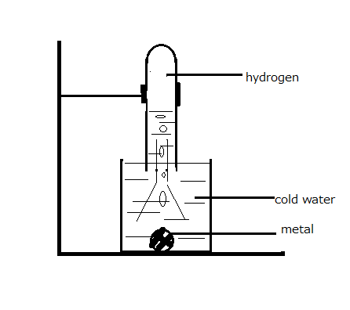

(a) A glass rod was dipped in the solution formed and then put in a non-luminous flame. A brick red colour was imparted to the flame. Which metal had reacted with the cold water. (1mrk)

………………………………………………………………………………………………………………………………………………………………………………………………………………………………………………………………………………………………………………………

(b) Write an equation for the reaction which took place between the metal and the cold water (1mrk) ………………………………………………………………………………………………………………………………………………………………………………………………………………

c) Sodium carbonate solution was added to the solution formed and a white precipitate formed. Write an ionic equation showing the formation of the white precipitate. (1mrk)

………………………………………………………………………………………………………………………………………………………………………………………………………………

2. The condensed structural formulae for the isomers of pentane are

(i) CH3 CH(CH3­)CH2CH3  (ii) CH3C(CH3)2CH3

1. Draw and name the open structural formulae for the isomers (2marks)

1. (ii)

(b)Write the molecular formula of pentane. (1 mark)

………………………………………………………………………………………………………………………………………………………………………………………………………………

3. (a) Name the solid raw material required in Solvay process for the manufacture of sodium carbonate. (1 mark)

………………………………………………………………………………………………………………………………………………………………………………………………………………

(b) Write an equation showing how one of the raw materials is regenerated.

(1mark)

………………………………………………………………………………………………………………………………………………………………………………………………………………

(c) Trona is a natural source for sodium carbonate. What type of a salt is trona

………………………………………………………………………………………………………………………………………………………………………………………………………………

(1mrk)

4. Ascending paper chromatogram for substances A, B, C and D is shown below

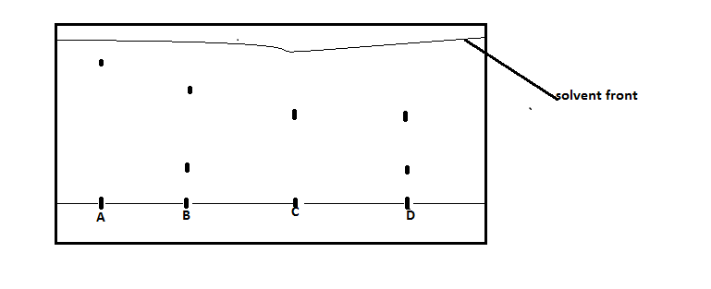

(a)Which substances are pure Give a reason. (1 mark)

……………………………………………………………………………………………………………………………………………………………………………………………………………

(b)Which mixture has the more soluble component in the solvent used (1mark)

………………………………………………………………………………………………………………………………………………………………………………………………………………

(c) Circle the spots which represent a component present in the two mixtures

(1mrk)

………………………………………………………………………………………………………………………………………………………………………………………………………………

5. (a) What is “rate of reaction”. (1 mark)

………………………………………………………………………………………………………………………………………………………………………………………………………………

(b)How does a rise in temperature affect the following.

(i) Rate of a reaction (1 mark)

………………………………………………………………………………………………………………………………………………………………………………………………………………

(ii) Position of a chemical equilibrium (1 mark)

………………………………………………………………………………………………………………………………………………………………………………………………………………

6. Oxygen was passed over heated sulphur as shown on the diagram below.

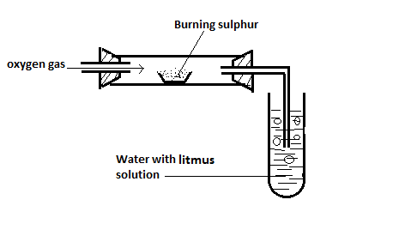

(a)State the observation made

(i) In the combustion tube. (1/2 mark)

………………………………………………………………………………………………………………………………………………………………………………………………………………

(ii) In test tube (1/2 mark)

………………………………………………………………………………………………………………………………………………………………………………………………………………

(b) Write an equation for the reaction which takes place in

(i) The combustion tube (1mark)

………………………………………………………………………………………………………………………………………………………………………………………………………………

(ii) the test tube (1 mark)

………………………………………………………………………………………………………………………………………………………………………………………………………………

7. (a) State grahams law of diffusion (1 mark)

………………………………………………………………………………………………………………………………………………………………………………………………………………

(b) 60 cm3 of hydrogen chloride gas diffuses through a porous barrier in 40 seconds. How long will it take an equal volume of chlorine gas to diffuse through the same barrier at the same temperature and pressure. (2mark)

………………………………………………………………………………………………………………………………………………………………………………………………………………………………………………………………………………………………………………………

8. )The set-up below was used to investigate the effect of an electric current on a molten

lead (II) bromide



(a)The bulb lit for a while then went off. Explain this observation. (1mrk)

………………………………………………………………………………………………………………………………………………………………………………………………………………

(b) A red gas was formed at electrode A while the bulb was still lit.

Using this observation label the terminals of the cell. (1mark)

………………………………………………………………………………………………………………………………………………………………………………………………………………

(c)Write an equation to show the formation of the product at the other electrode.

………………………………………………………………………………………………………………………………………………………………………………………………………………

(1mark)

9.) An element has three isotopes with abundances as shown below.

17A = 5% , 16A = 93% , 15A = 2%

(a) Calculate the relative atomic mass of the element. (2marks)

………………………………………………………………………………………………………………………………………………………………………………………………………………

………………………………………………………………………………………………………

(b) The atomic number for atom A is 8. What is the number of neutrons in 15A

(1mark)

………………………………………………………………………………………………………………………………………………………………………………………………………………

10.) The following methods can be used to soften hard water

|  |  |
| --- | --- |
| Method |  |
| Boiling | A |
| Distillation | B |
| Addition of washing soda | C |
| Addition of calcium hydroxide | D |
| Addition of ammonia solution | E |
| Use of ion exchange resin | F |

Select;

(a) Three methods that can be used to remove permanent water hardness.

(11/2 marks)

………………………………………………………………………………………………………………………………………………………………………………………………………………

(b) State one disadvantage of water hardness (1/2 mark)

………………………………………………………………………………………………………………………………………………………………………………………………………………

(c) Write the formulae of two ions which cause water hardness (1mrk)

………………………………………………………………………………………………………………………………………………………………………………………………………………

11.) Methane burns in oxygen as shown by the equation below

CH4 (g) + O2(g) 🡪 CO2(g) + H2O (g)

(a) Balance the equation (1 mark)

|  |  |
| --- | --- |
| Bond | Bond energy (kJ/mole) |
| C-H | 413 |
| O=O | 497 |
| C=O | 740 |
| O-H | 463 |

(b) Calculate the heat change for the reaction using the bond energies given

(2marks)

………………………………………………………………………………………………………………………………………………………………………………………………………………

………………………………………………………………………………………………………

12.) Ethanoic acid is a weak acid

(a) What is a weak acid (1mark)

………………………………………………………………………………………………………………………………………………………………………………………………………………

(b)The formula for ethanoic acid is CH3COOH. What is the basicity of the acid.

(1mark)

………………………………………………………………………………………………………………………………………………………………………………………………………………

(c)Write an equation to show how the acid forms ions in water.

(1 mark)

………………………………………………………………………………………………………………………………………………………………………………………………………………

13.) Iron (II) sulphate is prepared by adding excess iron filings into a dilute acid . The unreacted filings are then filtered off. The filtrate is evaporated to dryness

(a) Write the systematic name of the acid used (1mark)

………………………………………………………………………………………………………………………………………………………………………………………………………………

(b) What indicates that the reaction is over (1 mark)

………………………………………………………………………………………………………………………………………………………………………………………………………………

(c) What is the colour of the filtrate (1 mark)

………………………………………………………………………………………………………………………………………………………………………………………………………………

14) (a) Dissolving ammonium nitrate in water is an endothermic process. Complete the energy level diagram below to show the energy change during the process

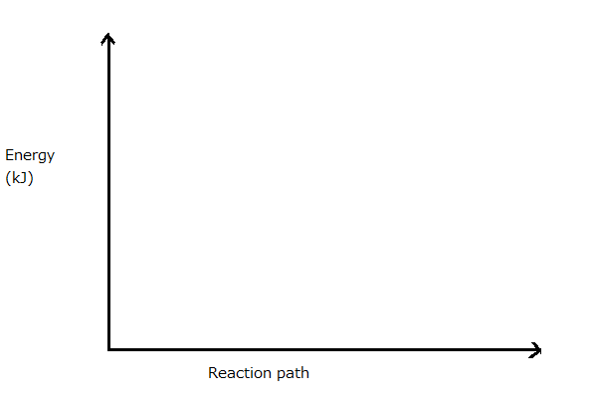

(b)How does the temperature of the mixture change during the process .

(1mark)

………………………………………………………………………………………………………………………………………………………………………………………………………………

15.) Chlorine gas can be prepared using the apparatus shown below

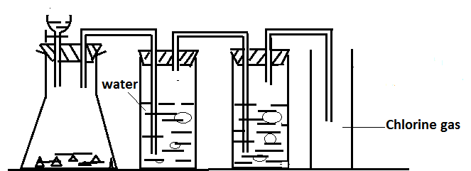

1. Name the reagent in the dropping funnel (1 mark)

……………………………………………………………………………………………………………………………………………………………………………………………………

1. What is the function of the water in the wash bottle ( 1 mark)

……………………………………………………………………………………………………………………………………………………………………………………………………

1. (i) Name the method of gas collection used (1/2 mark)

………………………………………………………………………………………………………………………………………………………………………………………………………………

1. What physical property of the gas is suggested by the method of gas collection used (1/2mark)

………………………………………………………………………………………………………………………………………………………………………………………………………………

1. k) 16. Draw a dot (.) and cross(x) diagram to show the bonding in a molecule of chlorine. The atomic number for chlorine is 17. (1mrk)

………………………………………………………………………………………………………………………………………………………………………………………………………………

(b) Describe a chemical test that can be used to show that an aqueous solution contains chloride ions (2mrks)

………………………………………………………………………………………………………………………………………………………………………………………………………………

17.) (a) Lattice energy for magnesium chloride - 2493kJ/mol. Hydration energies for Mg2+  and Cl‑  ions are -1891 and - 840 kJ /mol respectively. Calculate the heat of solution for MgCl2. (3mrks)

………………………………………………………………………………………………………………………………………………………………………………………………………………

………………………………………………………………………………………………………………………………………………………………………………………………………………

18.) (a) Find the oxidation state of Cr in Cr2O72- ( 1mark)

………………………………………………………………………………………………………………………………………………………………………………………………………………

(b) Write a cell representation for the cell diagram shown below

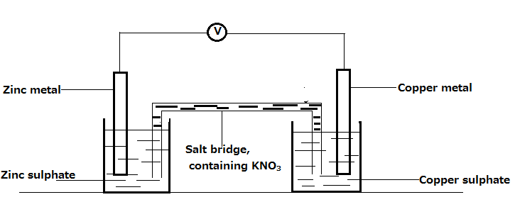

………………………………………………………………………………………………………………………………………………………………………………………………………………

(1mark)

(c)Calculate the e. m. f. of a cell made by combining half cells with E0 values shown below

A2+ (aq) + 2e 🡪 A(s) , E0 = -0.80 V

B+ (aq) + e 🡪B (s) , E0 = - 0.63 V ( 1mark)

………………………………………………………………………………………………………………………………………………………………………………………………………………

19.) Name the four types of reactions alcohols undergo as represented by ethanol in the flow chart below

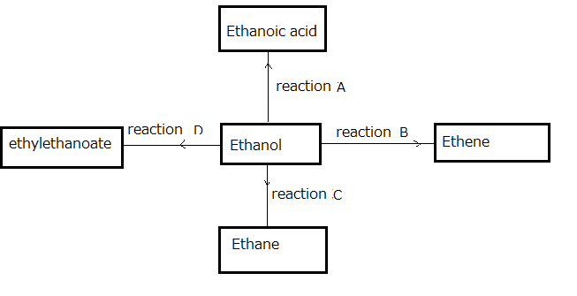

|  |  |
| --- | --- |
| Reaction | Type of reaction |
| A |  |
| B |  |
| C |  |
| D |  |

(2 marks)

(b) Write the general formula for the alkanols (1 mark)

………………………………………………………………………………………………………………………………………………………………………………………………………………

20). (a) 30cm3 of 1M hydrochloric acid solution was mixed with 40cm3 of 1M sodium hydroxide solution. Calculate the number of moles of sodium hydroxide that did not react (1 1/2marks)

………………………………………………………………………………………………………………………………………………………………………………………………………………

(b) 200cm3 of distilled water was added to 400cm3 of 1M sodium hydroxide solution. What is the molarity of the solution formed? (11/2 marks)

………………………………………………………………………………………………………………………………………………………………………………………………………………

21 ).(a) During electrolysis, an current of 4A was passed through an electrolyte for 70 minutes. Calculate the charge the charge that passed through the electrolyte in faradays ( 1 F = 96500C) (1mark)

……………………………………………………………………………………………………………………………………………………………………………………………………………

(b) If the charge was passed through molten aluminium oxide, calculate the mass of aluminium formed ( Al = 27) ( 2marks)

………………………………………………………………………………………………………………………………………………………………………………………………………………

………………………………………………………………………………………………………

22). 250 cm3 of 0.1 M copper (II) sulphate solution was put in a plastic beaker 3g of magnesium powder added. The temperature of the mixture rose by 100C. Calculate the molar heat of displacement ( Mg = 24) (3 marks)

………………………………………………………………………………………………………………………………………………………………………………………………………………

………………………………………………………………………………………………………………………………………………………………………………………………………………

24. Excess zinc powder was added to 40 cm3 of 2M Hydrochloric acid and 40cm3 of 2M ethanoic acid in beakers A and B respectively. Equal volumes of hydrogen gas were collected from the two beakers

(a) Calculate the volume of hydrogen gas collected from one beaker.

( 1 mole of hydrogen gas = 24 dm3) (2marks)

………………………………………………………………………………………………………………………………………………………………………………………………………………

………………………………………………………………………………………………………………………………………………………………………………………………………………

(b) In which beaker did effervescence take a longer time. (1 mark)

………………………………………………………………………………………………………………………………………………………………………………………………………………

25. Chloroethene forms a useful polymer.

(a) Write structural formula for the polymer formed. Show two monomer units

(1 mark)

………………………………………………………………………………………………………………………………………………………………………………………………………………

(b) State one use for the polymer (1 mark)

………………………………………………………………………………………………………………………………………………………………………………………………………………

(c) Name one natural fibre (1mark)

………………………………………………………………………………………………………………………………………………………………………………………………………………

26. (a) Substances with giant atomic structures have high melting points. Name two other types of giant structures (1mark)

………………………………………………………………………………………………………………………………………………………………………………………………………………

(b) Iodine and water molecules are each held by intermolecular forces of attraction.

(i) Name the intermolecular forces which exist between iodine molecule (1 mark)

………………………………………………………………………………………………………………………………………………………………………………………………………………

(ii) Draw the structural formulae for two water molecules and show the intermolecular force of attraction between the two water molecules (1mrk)

……………………………………………………………………………………………………………………………………………………………………………………………………………

27. (a) Name the ester formed when propanoic acid reacts with butanol (1 mark)

……………………………………………………………………………………………………………………………………………………………………………………………………………

(b) State one advantage soapless detergents have over soapy detergents

………………………………………………………………………………………………………………………………………………………………………………………………………………

(1mrk)