Name:___________________________________________Class__________

INDEX NUMBER: __________________________________

COMPUTER STUDIES
2013 MOCK EXAMINATIONS

COMPUTER STUDIES PRACTICAL PAER 1

FORM FOUR Examination
2¹/₂hours

INSTRUCTIONS TO CANDIDATES
- Answer BOTH the questions
- All answers should be SAVED in the storage device provided
- Create a folder at the desktop of your computer and rename it as your name and class
- Marks will be given for correct steps and expressions

This paper consists of 4 printed pages
Candidates should check the question paper to ensure that all the
Printed pages are printed as indicated and no questions are missing.

© 2013 The Computer Department

Question One

Table 1 Membership table
Membership no | Category no | Last name | First name | Title | Street
1 | 1 | Walker | Mwangi | Mr | Waruingi
2 | 2 | Jane | Morris | Mrs | Koinange
3 | 3 | Moses | Othiambo | Mr | Mboya
4 | 4 | Taby | Tett | Miss | Avenue

Table 2 Booking table
Booking | Room/Hall | Member class | Member class no | Date
1 | Fitness suit | Class 1 | 1 | 13/5/96
2 | Fitness suit | Class 2 | 2 | 13/5//02
3 | Sport hall 2 | Class 1 | 3 | 14/06/00
4 | Sport hall 1 | Class 2 | 4 | 19/02/02

Table 3 Membership category table
Category no | Category type | Membership number
1 | Senior | Ksh 200000
2 | Senior | Ksh 10000
3 | Junior | Ksh 5000
4 | Junior | Ksh 3000

Table 4 Class list table
Class No | Member Number
1 | 1
4 | 2
1 | 3
1 | 4

- Create a data base file called BMEMBERS to hold the data files and format as required (16marks)
- Create the relationship between your tables. (4marks)
- Create a select query with the following Membership first name, Last name, title street, Member no Membership fee & date save as membership query (7marks)
- Redesign the membership query by adding the computed fields: names that combines the first name & last name Don’t show the first and last name fields, Bday that extracts the booking day from the date save as new query (5marks)
e) Create a form with its object data from the new query; add all the fields (2marks)
f) Insert a form header & footer in the header add a title BOOKERS LEISURE CLUB, date and time created bold italics the title and change its fonts size to 14 . (8marks)
- In the footer display the total membership fee (2mk)
- Create a report with object day from the new query and include the field s : Names Bday ,street, & membership fee format membership fee in currency save as Leisure report (6mk)

Question Two
Green Company is a company dealing with the collection and payment of tea farmers. Assuming you are working for the Company and you have been given the following data
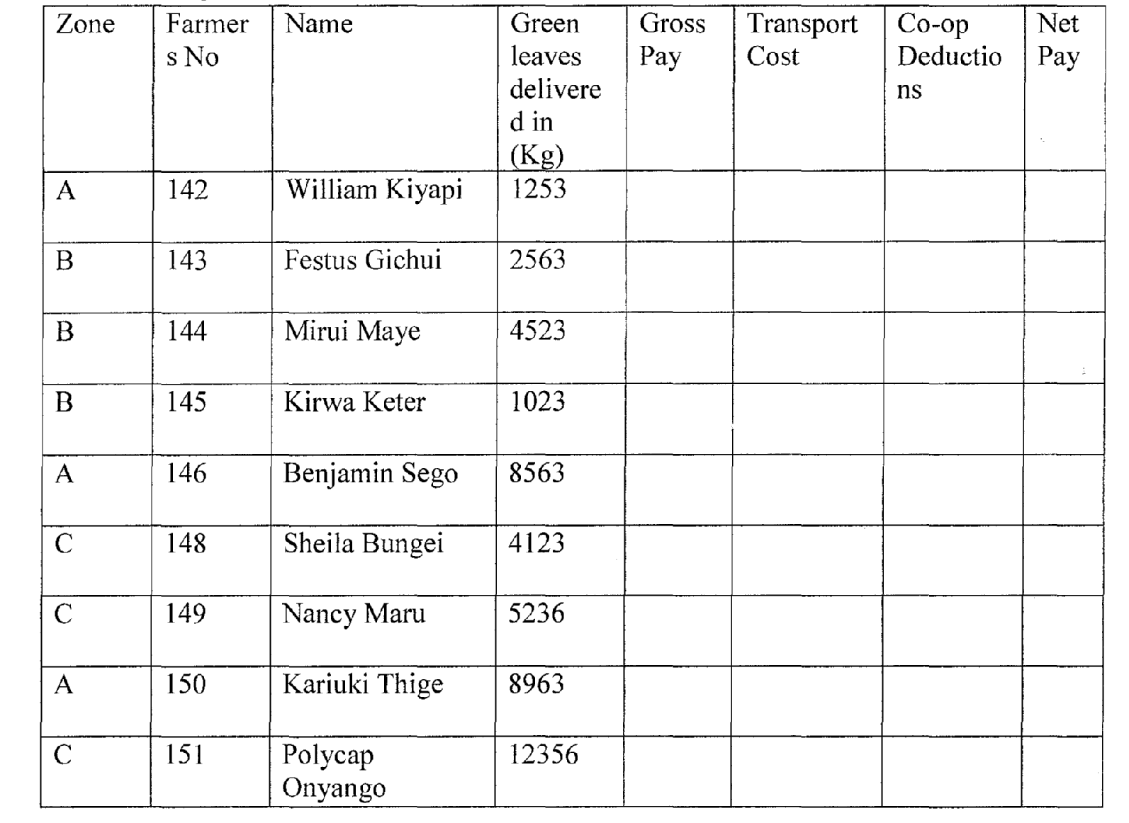

a) Enter the data shown above into a spreadsheet giving it an appropriate title (centered) and save the workbook as Mock 1. And rename the worksheet as Entries (l0mks)
b) Copy the data to a new worksheet and enter details of farmer Mike Rua of Zone A No 147 with green leaf 4, 5632 Kg was left out insert the details in the appropriate row.(2mk)
c) Insert borders after every cell and every row. (2mks)
d) Use a function to calculate the gross pay for Farmer No 142 given that the price of green leaves is Sh.14.00 per kg (3mks)
e) Apply the formula for gross pay across the column to calculate the gross pay for all the farmers (2mks)
f) Use a function to Calculate transport cost for all farmers given that transport is charged per Kg as follows (6mks)
Zone | Price per Kg
A | 1.00
B | 1.50
C | 2.00
g) Insert the value 20% in cell E14. Using absolute cell referencing calculate co-op
deductions given that the co-op deduction is 20% of the cost. (5mks)
h) Using a formula or function calculate the net pay given that: Net pay is Gross pay — Transport cost and co-op deductions. (4msk)
i) Format the columns containing currency values to currency with 2 decimal places and
prefixKsh. Rename the worksheet net pay and save it as Mock 2 (4 mks)
j) Arrange the records are ascending order of the zone (2mks)
k) Use subtotals function to calculate subtotals for green leaves delivered, gross pay and net payfro each zone. (3mks)
l) Create an embedded pie chart showing the total Green leaf for each zone the chart should have the following details in addition to other key details save it as Mock 3 (6mks)
a. Chart title Zone Total Green leaf for zones
b. Legend Position Right
m) Print the following work sheets:- Entries, mock2 and mock3. (3 marks)

