FORM 4 MOCK EXAMINATIONS 2013
GEOGRAPHY
PAPER 2
2³/₄ hrs.
INSTRUCTIONS.
- This paper has two sections A and B.
- Answer all questions in section A
- In section B, answer question 6 and any other two questions.
- Answer section A and each question attempted in section B on a separate answer sheet.
- Failure to follow instructions shall be penalized.

This paper consists of 4 printed pages.
Candidates should check the question paper to ensure that all the pages are printed as indicated and no questions are missing.

SECTION A
1(a) Give two types of forests in Kenya. (2mks)
b) State three differences between natural forests and man-made forests. (3mks)

2(a) Define plantation agriculture. (2mks)
b) State three characteristics of shifting cultivation. (3mks)

3(a) Define the term over-population. (2mks)
b) State three advantages of Nucleated settlements. (3mks)

4(a) List two benefits of land reclamation in Netherlands. (2mks)
b) State three physical conditions which made Mwea a suitable location for irrigation.
(3mks)
5(a) Define the term urban morphology. (1mk)
b) i) Give two characteristics of the Central Business District (CBD) of an Urban
Centre. (2mks)
ii) State two characteristic featured of slums in Nairobi. (2mks)

SECTION B
6. The table below shows Kenya’s mineral production from 1980 to 1983 in thousand tones

YEAR | Soda Ash | Salt | Limestone | Fluorspar
1980 | 160 | 50 | 29 | 11
1981 | 167 | 53 | 59 | 13
1982 | 172 | 38 | 15 | 15
1983 | 220 | 29 | 22 | 22

- Draw a compound bar graph to represent the above data. Use the vertical scale 1cm represents 50,000 tones. (6mks)
- Explain four measures that Kenya has taken to reduce the unfavorable balance of trade.
(8mks)
- Explain four benefits that of Kenya derives from International trade. (8mks)
- Give three reasons why there is trade Imbalance between Kenya and other countries.
(3mks)
7(a) i) Name three countries in West Africa where cocoa is grown on a large scale apart
from Ghana. (3mks)
ii) State five factors that have favoured cocoa growing in Ghana. (5mks)
b) Use the map to answer the questions that follow.
Major Cocoa growing areas in Ghana.
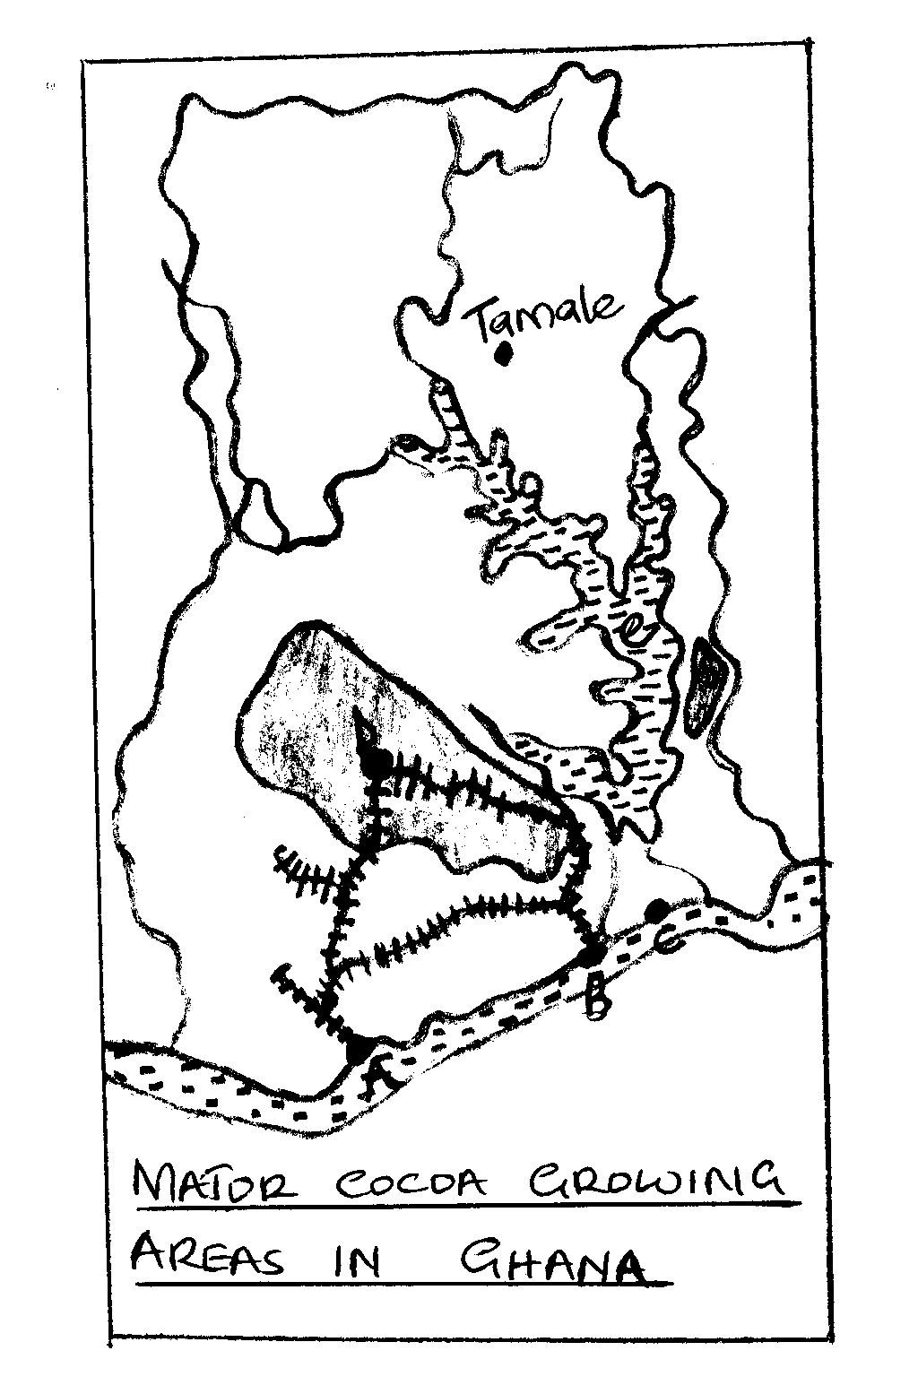
i) Name the towns marked A to D associated with Cocoa growing in Ghana. (4mks)
ii) Name the lake marked e. (1mk)
c) Discuss the growing of Cocoa under the following headings.
- Cultivation. (2mks)
- Harvesting and processing. (5mks)
d) Give five problems facing Cocoa growing. (5mks)

8(a) i) Name Four agricultural non-food manufacturing industries in Kenya. (4mks)
ii) Name three towns in Kenya where motor vehicles are assembled. (2mks)
b) Explain three causes of the decline in the tile industry in Kenya. (6mks)
c) Describe the measures that should be taken to control the following effects of industrialization
i) Rural to urban migration (3mks)
ii) Water pollution (2mks)
d) Explain four factors which have favoured the development of electronics industry in Japan. (8mks)

9(a) i) What is a game Sanctuary. (1mk)
ii) Name two game Sanctuaries in Kenya. (1mk)
b) i) Explain three problems experienced by governments of East Africa in their effort
to conserve wild life. (6mks)
ii) Explain three efforts the East African countries are making to conserve their wild life. (6mks)
c) i) What is ecotourism? (1mk)
ii) Give two reasons why many Kenyans do not visit other places in Kenya as tourists. (2mks)
iii) Explain two ways in which Kenya is planning to expand her tourism Industry.
(4mks)
d) You attend to visit the Kenyan Coast to study the major tourist sites
i) Formulate two hypotheses of your study. (2mks)
ii) State two significances of a working schedule. (2mks)

10(a) i) Differentiate between land reclamation and land rehabilitation. (2mks)
ii) State three benefits of irrigation over natural water supply. (3mks)
iii) Give four ways of reclaiming land apart from Irrigation. (2mks)
b) i) State four factors that have influenced the location of Mwea Tabere Irrigation
Scheme. (4mks)
ii) Outline the role of the National Irrigation board in Mwea Tabere Irrigation Scheme. (4mks)
iii) Give four problems resulting from Irrigation farming in Kenya. (4mks)
c) i) Name four polders created by reclamation of land from the sea in Netherlands.
(2mks)
ii) State four differences between land reclamation methods in Kenya and Netherlands.
(4mks)

