Name …………………………………………………. ………………….. Class…………………

Index Number: …………………………….

121/1 Candidate’s Signature …………………….
MATHEMATICS
Paper 1 Date: …………………………
2013

Kenya Certificate of Secondary Education.
Mock Examination 2013
Paper 1
2 ½ hours

Instructions to candidates
- Write your name, index number, admission and class in the spaces provided above.
- Sign and write the date of examination in the spaces provided above.
- You are reminded of the necessity for good English and orderly presentation in your answers.
- The paper contains TWO sections: Section I and Section II.
- Answer ALL the questions in Section I and any five questions from Section II
- All answers and working must be written on the question paper in the spaces provided below each question.
- Show all the steps in your calculations, giving your answers at each stage in the
spaces below each question.
- Marks may be given for correct working even if the answer is wrong.
- Non – programmable silent electronic calculators and KNEC Mathematical tables may be used, except where stated otherwise.

For Examiner’s use only.

Section I
1 | 2 | 3 | 4 | 5 | 6 | 7 | 8 | 9 | 10 | 11 | 12 | 13 | 14 | 15 | 16 | Total

Section II
17 | 18 | 19 | 20 | 21 | 22 | 23 | 24 | Total

Grand
Total

This paper consists of 17 printed pages
Candidates should check the question paper to ascertain
that all the pages are printed as indicated and no questions are missing.

SECTION I (50 MARKS)
Answer ALL questions in this section

1. Use logarithm tables to evaluate {4 marks}

2(a) A surveyor finds that she needs 28 beacons placed 40 m apart when she surveys a length of road. If she were to place the beacons 30 m apart, how many beacons would she need?
{2 marks}

b) What is the shortest school day that can be divided into exact periods of 25, 30 or 40 minutes.
{2 marks}

3. Solve the following inequalities and represent the solution on a single number line.
{3 marks}
x – 2 < 3x + 4
5x – 3 < x + 5

4. The volumes of two similar solid cylinders are 4752 cm³ and 1408 cm³. If the area of the curved surface of the smaller cylinder is 352 cm². Find the area of the curved surface of the larger cylinder. {3 marks}

5. Simplify the expression {3 marks}

6. The sum of interior angles of two polygons is 1620º. Given that one polygon is one side less than the other, find the number of sides in each polygon. {3 marks}

7. Form the three inequalities that satisfy the given region R. {3 marks}
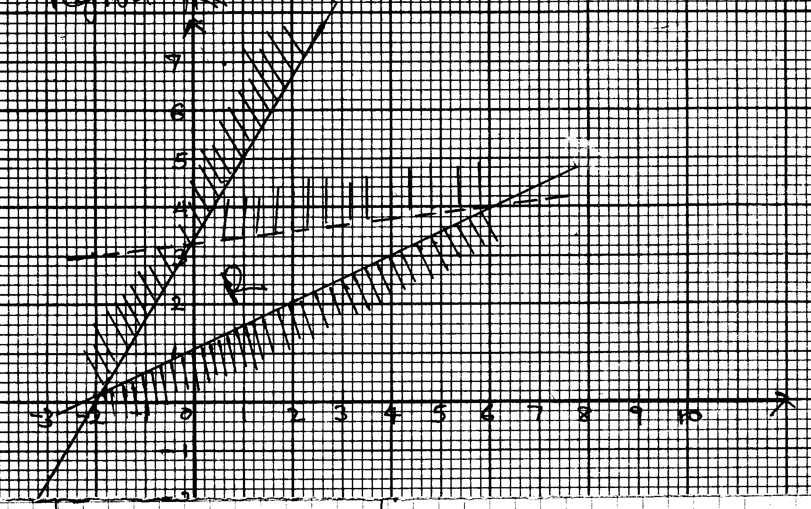

8. A train moving at an average speed of 72 km/h takes 15 seconds to complete cross a bridge that is 80 metres long. Find the length of the train. {2 marks}

9. The frequency distribution table below shows the weekly salary (K₤) paid to workers in a factory.

Salary | 50 < x < 100 | 100 < x < 150 | 150 < x < 250 | 250 < x < 350 | 350 < x < 500
Number of workers | 13 | 16 | 38 | 24 | 9

On the grid provided below, draw a histogram to represent the information shown above.
{3 marks}

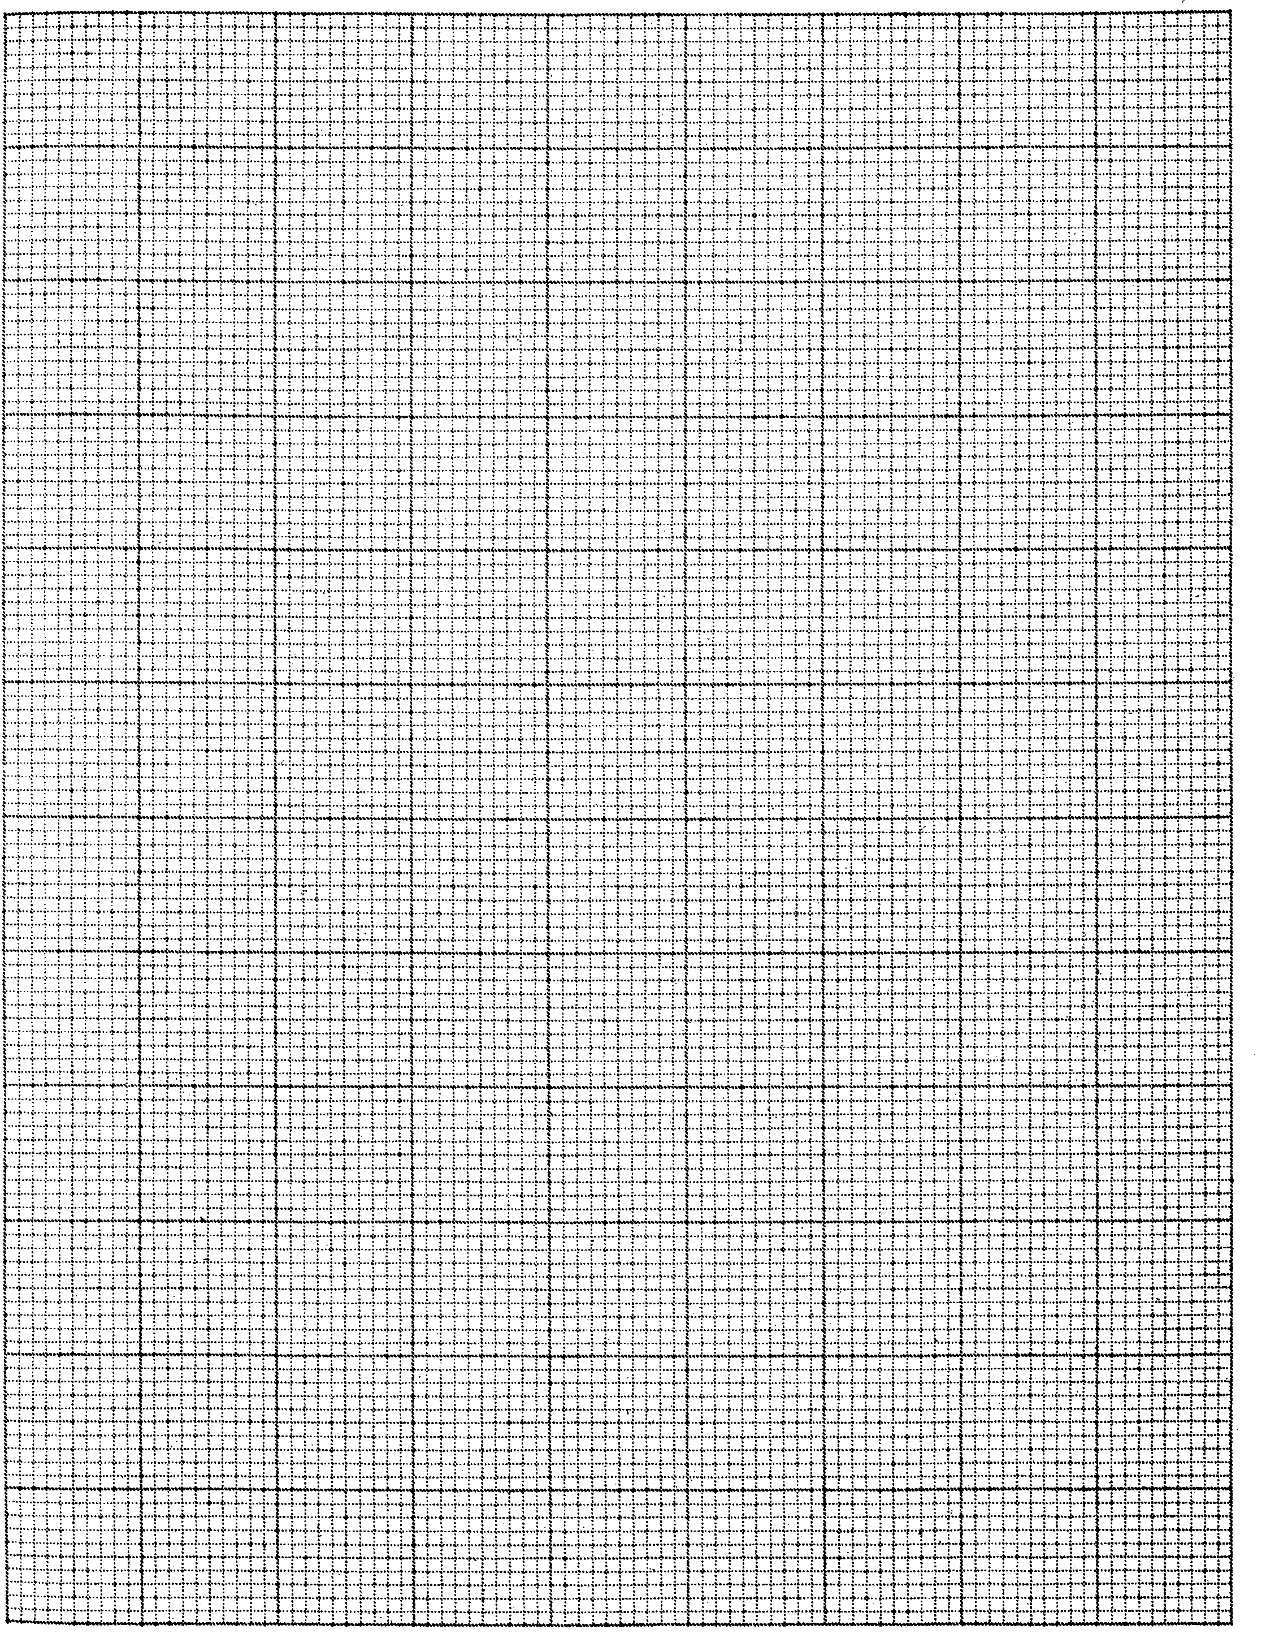

10. A tetrahedral die has front faces numbered 1, 2, 3 and 4. When the die is thrown the score is biased so that the probability of scoring a 1 is x, of scoring a 2 is 2x and of scoring a 3 is 3x and scoring a 4 is 4x.
a) Find x. {2 marks}

b) If the die is thrown twice, find the probability that the total score is atleast 7. {2 marks}

11. Two lines x + 2y = -1 and 2x + 3y = 3 intersect at the point R. Find the equation of a circle Centre R and radius 5 units giving your answer in the form x² + y² + gx + fy + c = 0 {3 marks}

12. The absolute errors of the radius and height of a cylinder are 3 mm and 2 mm respectively. If the actual radius and height are 5 cm and 5.5 cm respectively. Calculate the percentage error in the volume of the cylinder. {3 marks}

13. A group of 10 soldiers set off with enough food to last 7 days. After 4 days 4 soldiers were killed. How many days will the food last for the remaining soldiers? {3 marks}

14. A straight line L passes through the point (2, -5) and is perpendicular to a line whose equation is 2y – 4x = 1. Find the equation of L in the form y = mx + c {3 marks}

15. The figure below shows a line AB.

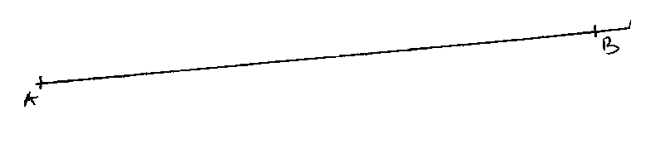

a) Without using a protractor, construct a line AC such that ∠BAC = 67.5^{O}.
{2 marks}
b) Using line AC divide line AB into 6 equal portions. {1 mark}

16. Musa obtained a loan in which the rate of interest was charged at 3.5% quarterly. He cleared this loan by paying Ksh. 24,805 at the end of 1½ years.
a) How much was the loan if the rate was on:
i) Simple interest. {1 mark}

ii) Compound interest. {2 marks}

SECTION II (50 MARKS)
Answer FIVE questions in this section

17(a) A solution whose volume is 80 litres is made up of 40% water and 60% alcohol. When x litres of water are added the percentage of alcohol drops to 40%. Find the value of x. {4 marks}

b) Thirty litres of water is added to the new solution. Calculate the percentage of alcohol in the resulting solution. {2 marks}

c) If 5 litres of the solution in (b) above is added to 2 litres of the original solution, calculate in the simplest form, the ratio of water to alcohol in the resulting solution. {4 marks}

18. Water flows through a cylindrical pipe of diameter 4.2 cm at a speed of 50m/min.
a) Calculate the volume of the water delivered by the pipe per minute in litres. {3 marks}

b) A cylindrical storage tank of depth 3m is filled by water from this pipe and at the same rate of flow. Water begins flowing into the empty storage tank at 8.30 a.m. and is full by 3.10 p.m. Calculate the area of the cross-section of this tank in m². {4 marks}

c) A family consumes the capacity of this tank in one month. The cost of water is sh. 40 per thousand litres plus a fixed basic charge of sh. 1650. Calculate the cost of this family’s water bill for the month. {3 marks}

19. Four points B, C, Q and D lie on the same plane, point B is 42 km South West of point Q, point C is 50 km on a bearing of S60ºE from Q point D is equidistant from B, Q and C.
a) Using a suitable scale, construct a diagram showing the positions of B, C, Q and D.
{6 marks}

b) Determine the
i) distance between B and C. {1 mark}

ii) bearing of D from B. {1 mark}

iii) distance between D and Q. {1 mark}

iv) bearing of B from C. {1 mark}

20. The table below shows the income tax rates for the year 2006.

Taxable income per annum in K₤ | Tax rates Kshs. per K₤
1 - 5808 | 2
5809 - 11280 | 3
11281 - 16752 | 4
16753 - 22224 | 5
22225 and above | 6

In the year 2006, Ali’s monthly earnings were as follows:
Kshs.
Basic salary 22600
House allowance 12000
Medical allowance 2880
Transport allowance 340

Ali was entitled to a monthly personal relief of Shs. 1162 and in insurance relief of Shs. 450. Every month the following deductions were made:

Kshs.
National Health Insurance Fund 320
Insurance premium 3000
Sacco Loan repayment 6000
Sacco share contribution 1500
Workers’ Union dues 200

Calculate
a) Ali’s taxable income in K₤ p.a. {1 mark}

b) Ali’s monthly tax paid in Kshs. {4 marks}

c) Ali’s monthly net income from his employment in Kshs. {2 marks}

d) If Ali received a 10% increase in his basic salary, calculate the corresponding percentage increase on the income tax. {3 marks}
21. A triangular plot ABC is such that AB = 72 m, BC = 80 m and AC = 84 m.
a) Calculate the
i) area of the plot in squares metres. {3 marks}

ii) acute angle between the edges AB and BC. {3 marks}

iii) the perpendicular height from A to the side BC. {2 marks}

b) A water tap is to be installed inside the plot such that the tap is equidistant from each of the vertices A, B and C. Calculate the distance of the tap from the vertex A. {3 marks}

22(a) Two quantities p and r are connected by the equation P = ar^{n}, where a and n are constants. The values of p and r are given in the following table. Determine the values of a and n. {7 marks}

p | 1.2 | 1.5 | 2.0 | 2.5 | 3.5 | 4.5
r | 1.58 | 2.25 | 3.39 | 4.74 | 7.86 | 11.5

b) A quantity A varies directly as B and inversely as the square root of C. Find the percentage change in A when B is decreased by 10% and C increased by 21%. {3 marks}

23(a) In the figure below, PQR is the tangent to the circle at Q. TS is a diameter and TSR and QUV are straight lines. QS is parallel to TV. Angle SQR = 40º and angle TQV = 55º. Find the following angles, giving reasons for each answer:
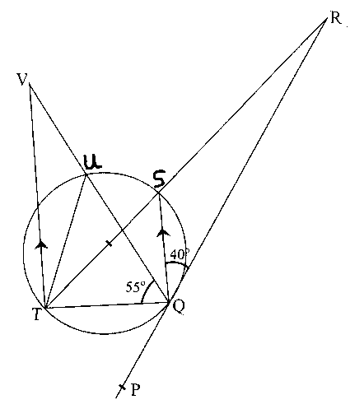

i) QTS {2 marks}

ii) QRS {2 marks}

iii) QVT {2 marks}

iv) UTV {2 marks}

b) Given that QR = 9 cm and RS = 7 cm, calculate the length of TS. {2 marks}

24. In this question, use a ruler and a pair of compasses only for all constructions.
a) Draw a triangle ABC such that AB = 10 cm, CB = 9.3 cm and angle CAB = 67½^{O} and angle ACB is obtuse. {3 marks}

b) By drawing a line AX such that angle BAX is acute, use the line AX to subdivide line AB into 7 equal parts, hence mark points Q and K on AB such that AQ:QB = 6:1 and AK:KQ = 1:5.
{3 marks}
c) Draw the locus of P such that angle KPQ = 60º and that locus of P lies on the same side of AB as C.
d) A school is located along BC and on the locus of P. Mark the position of the school with letter H.

