
SCHOOL OF HEALTH AND APPLIED SCIENCES
2015 MAY-AUGUST EXAMINATION
CERTIFICATE IN FOOD AND BEVERAGE PRODUCTION
FOOD SCIENCE AND NUTRITION
CFBP 1802
Instructions
- Write your admission number/index number on the answer booklet
- Answer ALL questions.
Time 2 Hours
- Highlight six methods of food preservation (6 marks)
- Mention any six ways through which HIV/AIDS is transmitted (6 marks)
- State five symptoms for HIV/AIDS (5 marks)
- Highlight any six food additives (6 marks)
- State the major food laws (4 marks)
- Give the name of the following macronutrients: (4 marks)
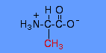

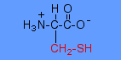

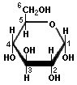
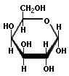
- Give any three types of microorganisms that cause food spoilage (3 marks)
- State five principles applied in food preservation (5 marks)
- State the significance of food preservation (6 marks)
- Name any three sources for each of the following nutrients:
    - Carbohydrates; (3 marks)
    - Proteins; (3 marks)
    - Lipids; (3 marks)
    - Calcium. (1 mark)
- Highlight the properties for each of the following:
    - Acids; (3 marks)
    - Bases. (3 marks)
- Explain the traditional methods of food preservation (10 marks)
- Explain the management measures for HIV/AIDS (10 mark)
- Explain the importance of any five food additives (10 marks)
- Discuss the three major classification of carbohydrates, giving examples in each
(10 marks)

