NAME ...................................................................................INDEX NO................................
SCHOOL.................................................................................DATES......................................
CANDIDATES’ SIGN...................
231/2
BIOLOGY
PAPER 2
(THEORY)
July / August -2014
Time: 2 Hours
Time: 2 Hours
KISII SOUTH DISTRICT JOINT EVALUATION TEST
Kenya Certificate of Secondary Education (K.C.S.E)

INSTRUCTIONS TO CANDIDATES
a) Write your name and index number in spaces provided above
b) This paper consists of two sections A and B.
c) Answer ALL the questions In section A in the space provided.
d) In section B answer question 6 (compulsory) and either question 7 or 8 in the spaces provided after question 8.

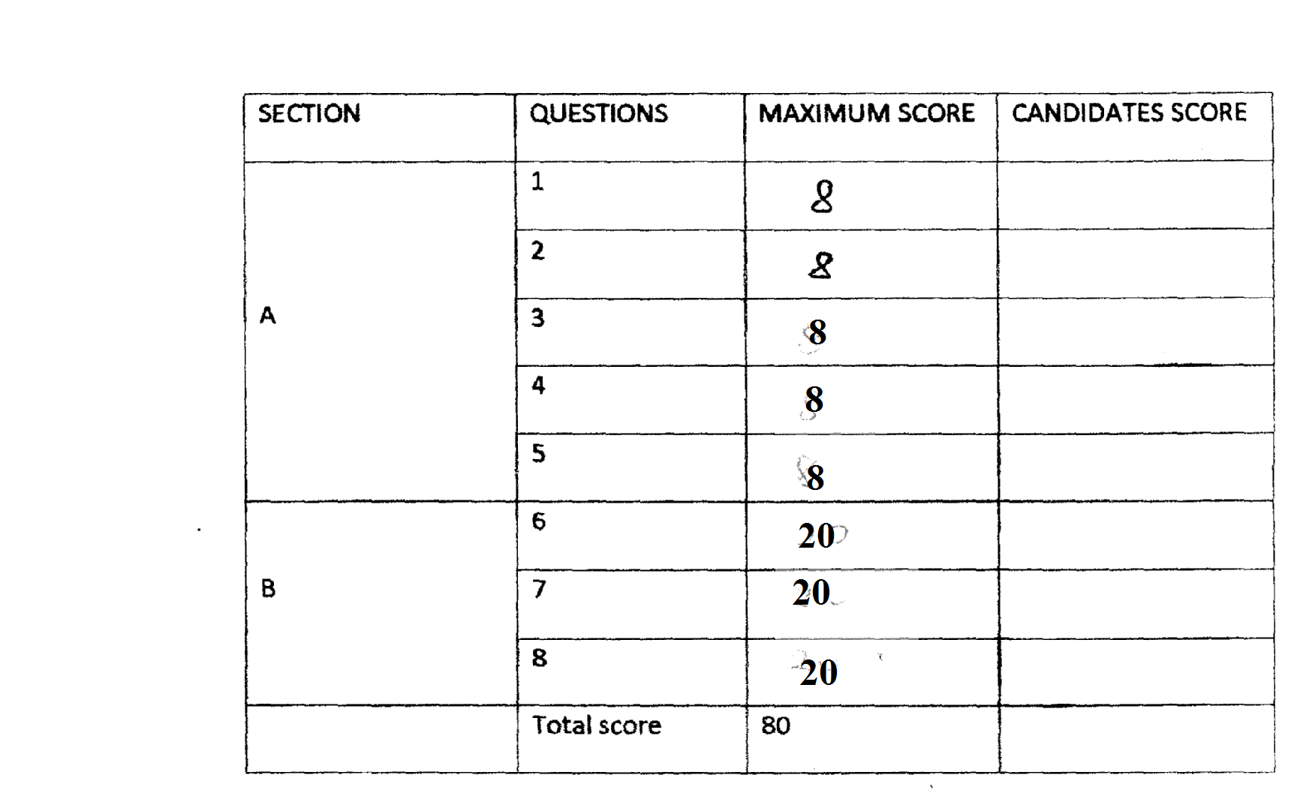

This paper consists of 12 printed pages.
Candidates should check the question paper to ensure that all pages are printed as indicated and no questions are missing.

- The diagram below shows the exchange site between circulatory system and body cells.
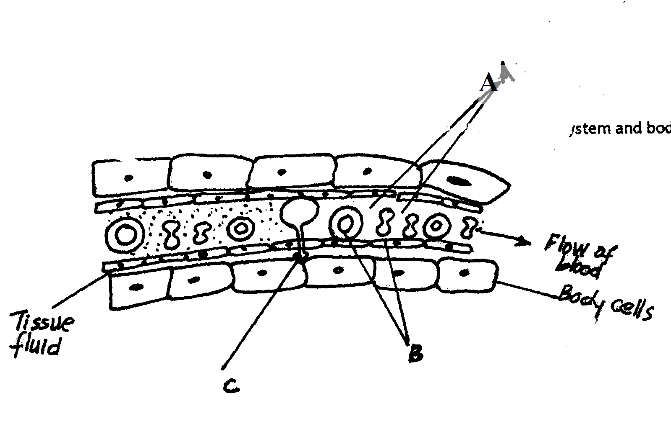
a) State two adaptations of the capillaries. (2mks)
...............................................................................................................................................................................................................................................................................................................................................................................................................................................................................................................................................................................................................................................................................................
b) (i) Name the blood cells labeled B. (1mk)
...............................................................................................................................................................................................................................................................................................................................................................................................................................................................................................................................................................................................................................................................................................
(ii) State the gas that diffuses from B to the tissue cells. (1mk)
...............................................................................................................................................................................................................................................................................................................................................................................................................................................................................................................................................................................................................................................................................................
c) State two functions of the part labeled A. (2mks)
...............................................................................................................................................................................................................................................................................................................................................................................................................................................................................................................................................................................................................................................................................................
d) Name the blood vessel with the highest concentration of;
Oxygen. (1mk)
...............................................................................................................................................................................................................................................................................................................................................................................................................................................................................................................................................................................................................................................................................................
Urea. (1mk)
...............................................................................................................................................................................................................................................................................................................................................................................................................................................................................................................................................................................................................................................................................................
- The table below gives information about an aquarium community which is ecologically balanced.
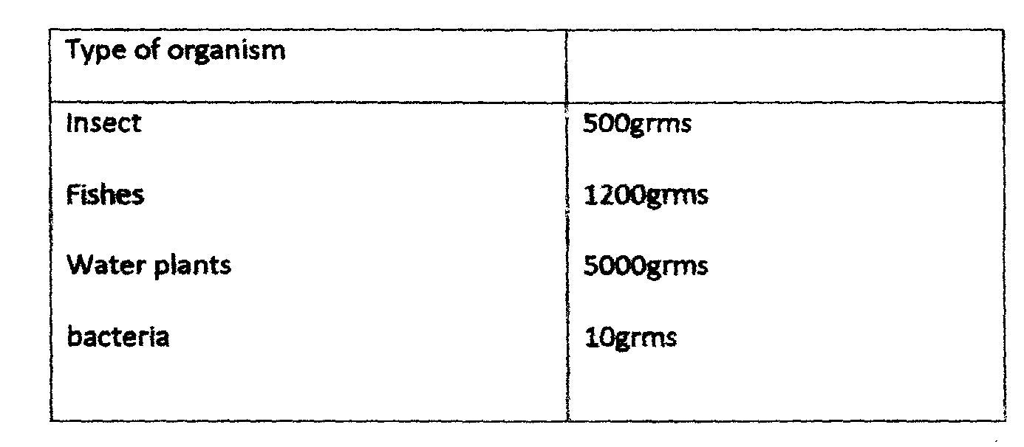

a) What do you understand by the term ecological balance? (1mk)
...............................................................................................................................................................................................................................................................................................................................................................................................................................................................................................................................................................................................................................................................................................

a) What do you understand by the term ecological balance? (1mk)
...............................................................................................................................................................................................................................................................................................................................................................................................................................................................................................................................................................................................................................................................................................

b) Calculate the total biomass of the aquarium. (2mks)
...............................................................................................................................................................................................................................................................................................................................................................................................................................................................................................................................................................................................................................................................................................
c) Which organism in the table is? (2mks)
...............................................................................................................................................................................................................................................................................................................................................................................................................................................................................................................................................................................................................................................................................................

i) Primary producer (2mks)
...............................................................................................................................................................................................................................................................................................................................................................................................................................................................................................................................................................................................................................................................................................

ii) Secondary consumer
...............................................................................................................................................................................................................................................................................................................................................................................................................................................................................................................................................................................................................................................................................................

d) Construct a food web of the aquarium. (3mks)
...............................................................................................................................................................................................................................................................................................................................................................................................................................................................................................................................................................................................................................................................................................
...............................................................................................................................................................................................................................................................................................................................................................................................................................................................................................................................................................................................................................................................................................
...............................................................................................................................................................................................................................................................................................................................................................................................................................................................................................................................................................................................................................................................................................
...............................................................................................................................................................................................................................................................................................................................................................................................................................................................................................................................................................................................................................................................................................

3. In human beings, a downward pointed frontal hairline (“windows peak”) is a heritable trait. A person with windows peak always has at least one parent who has his trait; whereas persons with frontal hairline may occur in families in which one or even both parents have windows peak. Using B and b to symbolize genes for this trait.

a) Determination the f1 generation if a homozygous windows peak male parent is married to a
Homozygous frontal hairline female parent. (4mks)
...............................................................................................................................................................................................................................................................................................................................................................................................................................................................................................................................................................................................................................................................................................
...............................................................................................................................................................................................................................................................................................................................................................................................................................................................................................................................................................................................................................................................................................

b) State two causes of variations. 2mk)
...............................................................................................................................................................................................................................................................................................................................................................................................................................................................................................................................................................................................................................................................................................

c) Name two examples of discontinuous variation. (2mks)
...............................................................................................................................................................................................................................................................................................................................................................................................................................................................................................................................................................................................................................................................................................

- The drawing below represents a mature bread mould (rhizopus).Study it and answer the questions which follow.

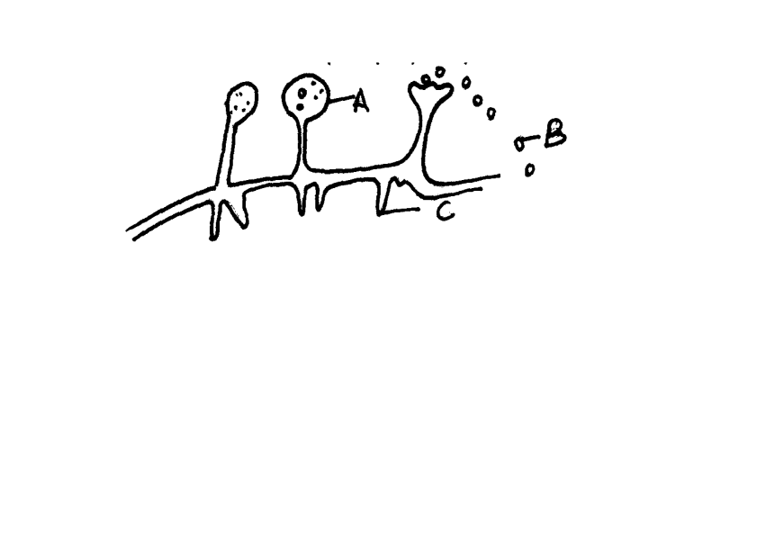

a) Name the structures labeled A, B and B. (3mks)
A...................................................................................................................................................
C.......................................................................................................................................................
b) Identify the type of asexual reproduction represented in the diagram (1mk)
...............................................................................................................................................................................................................................................................................................................................................................................................................................................................................................................................................................................................................................................................................................

c) Give one function of structure C. (1mk)
...............................................................................................................................................................................................................................................................................................................................................................................................................................................................................................................................................................................................................................................................................................

d) Define the term fertilization. (1mk)
...............................................................................................................................................................................................................................................................................................................................................................................................................................................................................................................................................................................................................................................................................................
i) Compare an ovum cell and a zygote. (2mks)
...............................................................................................................................................................................................................................................................................................................................................................................................................................................................................................................................................................................................................................................................................................

5. The diagram below shows three different types of neurons along a reflex.
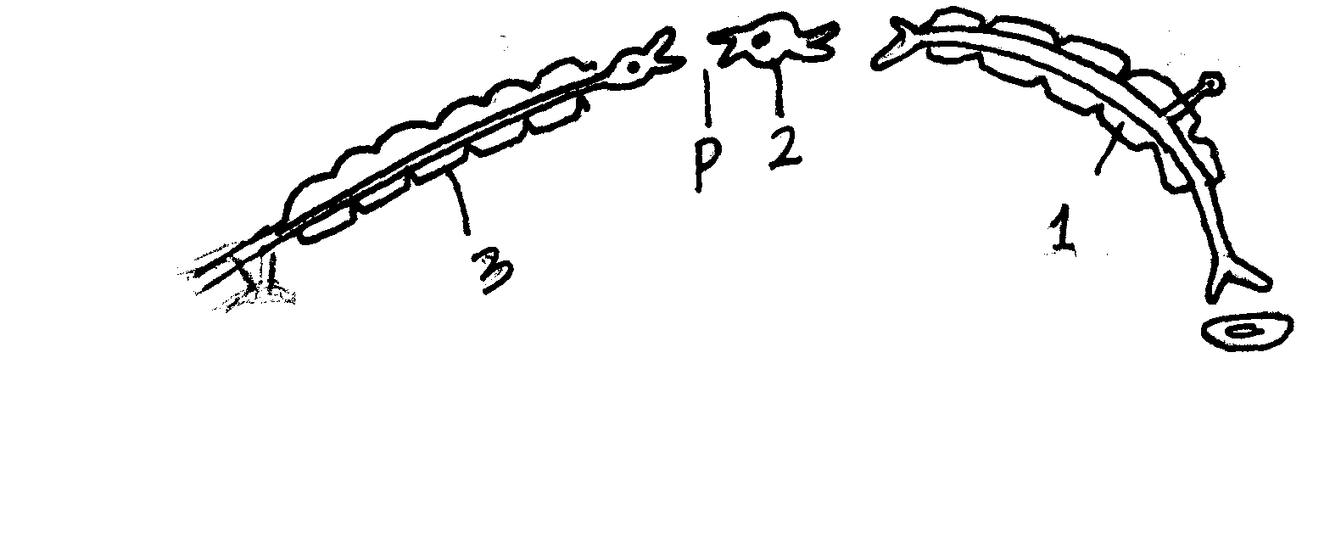

a) Identify the neuron labeled 1, 2 and 3 (3mks)
1..............................................................................................................................................
2..............................................................................................................................................
3............................................................................................................................................
b) Using arrow show the direction of impulse transmission on the diagram. (1mks)
..............................................................................................................................................................................................................................................................................................................................................................................................................................................................................................................................................................................................................................................................................................
c) Name the part of the spinal cord where the cell bodies of neuron 2 and 3 are located.
(1mk)
..............................................................................................................................................................................................................................................................................................................................................................................................................................................................................................................................................................................................................................................................................................

d) Describe the transmission impulses across the part labeled P. (3mks)
..............................................................................................................................................................................................................................................................................................................................................................................................................................................................................................................................................................................................................................................................................................
............................................................................................................................................................................................................................................................................................................................................................................................................................................................................................................................................................................................................................................................................................

6. Answer QUESTION 6(COMPULSARY) AND EITHER 7 OR 8 IN THE SPACES PROVIDED.
A man carried out an experiment to find out the effect of water and 0.9% salt solution on urine production.on the first day he drunk one liter of water(X).on the second day he repeated the experiment but instead of water,he drunk one litre of 0.9% salt solution(Y).
The experimental results are shown in the table below.

Time (hours) |  | 0.0 | 1.0 | 1.5 | 2.5 | 4.5 | 5.5 | 6.5 | 7.5
Amount of urine produced in cm³per hour | X | 80 | 60 | 360 | 520 | 60 | 100 | 40 | 60
Amount of urine produced in cm³per hour | Y | 40 | 40 | 40 | 45 | 100 | 60 | 80 | 100

a) Using a suitable scale draw graphs of urine produced in cm³per hour against time. (8mks)
Draw graph.
b) From the graph determine the:
(i) Amount of urine produced in the second hour when the man had drunk. (1mk)
(ii) The rate of urine production between the first and second hour after the man had drunk one liters of water. Show your working.
c) What does the shape of the curve representing column X tell us about the rate of urine production?
d) Explain the differences between the rate of production in graph X and Y. (2mks)
..............................................................................................................................................................................................................................................................................................................................................................................................................................................................................................................................................................................................................................................................................................

e) Why do you think drinking one liter of (0.9%) sodium chloride solution made little difference to the output? (2mks)
..............................................................................................................................................................................................................................................................................................................................................................................................................................................................................................................................................................................................................................................................................................

f. What does the comparisons of the results of the experiment indicate about the effect of the
Kidneys on the osmotic pressure of the blood plasma? (2mks)
.............................................................................................................................................................................................................................................................................................................................................................................................................................................................................................................................................................................................................................................................................................

g. What does the results of the experiment indicate about the effect of the kidneys on the
volume of blood plasma? (2mks)
................................................................................................................................................................................................................................................................................................................................................................................................................................................................................................................................................................................................................................................................................................
7. a) Describe how you will estimate the growth rate of a seedling? (6mk)
..............................................................................................................................................................................................................................................................................................................................................................................................................................................................................................................................................................................................................................................................................................
..............................................................................................................................................................................................................................................................................................................................................................................................................................................................................................................................................................................................................................................................................................
................................................................................................................................................................................................................................................................................................................................................

b) Explain the process of secondary thickening in flowering plants? (14mks)

..............................................................................................................................................................................................................................................................................................................................................................................................................................................................................................................................................................................................................................................................................................
..............................................................................................................................................................................................................................................................................................................................................................................................................................................................................................................................................................................................................................................................................................
..............................................................................................................................................................................................................................................................................................................................................................................................................................................................................................................................................................................................................................................................................................
..............................................................................................................................................................................................................................................................................................................................................................................................................................................................................................................................................................................................................................................................................................
..............................................................................................................................................................................................................................................................................................................................................................................................................................................................................................................................................................................................................................................................................................
..............................................................................................................................................................................................................................................................................................................................................................................................................................................................................................................................................................................................................................................................................................
..............................................................................................................................................................................................................................................................................................................................................................................................................................................................................................................................................................................................................................................................................................
..............................................................................................................................................................................................................................................................................................................................................................................................................................................................................................................................................................................................................................................................................................
..............................................................................................................................................................................................................................................................................................................................................................................................................................................................................................................................................................................................................................................................................................
..............................................................................................................................................................................................................................................................................................................................................................................................................................................................................................................................................................................................................................................................................................
..........................................................................................................................................................................................................................................................................................................................................................................................................................................................................................................................................................................................................................................................................................

8. Describe the following stages of photosynthesis. (14mks)
a. Light stage (10mks)

..............................................................................................................................................................................................................................................................................................................................................................................................................................................................................................................................................................................................................................................................................................
..............................................................................................................................................................................................................................................................................................................................................................................................................................................................................................................................................................................................................................................................................................
..............................................................................................................................................................................................................................................................................................................................................................................................................................................................................................................................................................................................................................................................................................
..............................................................................................................................................................................................................................................................................................................................................................................................................................................................................................................................................................................................................................................................................................
................................................................................................................................................................................................................................................................................................................................................
..............................................................................................................................................................................................................................................................................................................................................................................................................................................................................................................................................................................................................................................................................................
..............................................................................................................................................................................................................................................................................................................................................................................................................................................................................................................................................................................................................................................................................................
..............................................................................................................................................................................................................................................................................................................................................................................................................................................................................................................................................................................................................................................................................................
..............................................................................................................................................................................................................................................................................................................................................................................................................................................................................................................................................................................................................................................................................................
..............................................................................................................................................................................................................................................................................................................................................................................................................................................................................................................................................................................................................................................................................................
..............................................................................................................................................................................................................................................................................................................................................................................................................................................................................................................................................................................................................................................................................................

b. Dark stage (10mks)
..............................................................................................................................................................................................................................................................................................................................................................................................................................................................................................................................................................................................................................................................................................
..............................................................................................................................................................................................................................................................................................................................................................................................................................................................................................................................................................................................................................................................................................
..............................................................................................................................................................................................................................................................................................................................................................................................................................................................................................................................................................................................................................................................................................
..............................................................................................................................................................................................................................................................................................................................................................................................................................................................................................................................................................................................................................................................................................
..............................................................................................................................................................................................................................................................................................................................................................................................................................................................................................................................................................................................................................................................................................
..............................................................................................................................................................................................................................................................................................................................................................................................................................................................................................................................................................................................................................................................................................
..............................................................................................................................................................................................................................................................................................................................................................................................................................................................................................................................................................................................................................................................................................
..............................................................................................................................................................................................................................................................................................................................................................................................................................................................................................................................................................................................................................................................................................
..............................................................................................................................................................................................................................................................................................................................................................................................................................................................................................................................................................................................................................................................................................

End

