NAME:.....................................................................INDEX NO:...........................................

SCHOOL:.................................................................CANDIDATES SIGNATURE:...........

DATE:..................................................

233/1

**CHEMISTRY**

PAPER 1

JUNE/JULY-2014

TIME: 2 HOURS

**KISII SOUTH DISTRICT JOINT EVALUATION EXAMS-2014**

*Kenya certificate of secondary education (K.C.S.E)*

233/1

**CHEMISTRY**

PAPER 1

JUNE/JULY-2014

TIME: 2 HOURS

**INSTRUCTIONS TO CANDIDATES**

1. Write your name and Index number in the spaces provided.

2. Answer ALL the questions.

3. Answers must be written in the spaces provided in the question paper.

4. Additional pages must not be inserted.

5. Candidates should check the question paper to ascertain that all the pages are printed.

6. This paper consists of 12 printed pages

**FOR EXAMINER’S USE ONLY**

|  |  |  |
| --- | --- | --- |
| **QUESTION** | **MAXIMUM SCORE** | **CANDIDATE’S SCORE** |
| **1 - 29** | **80** |  |

*This paper consists of 12 printed pages.*

*Candidates should check the question paper to ensure that all pages are printed as indicated*

*and no questions are missing.*

1. In a motoring magazine, a journalist wrote “On a busy road the proportion of carbon (II) oxide has varied from 6 parts per million to 180 parts per million.”

a) Explain why the proportion of carbon (II) oxide varies as above. (1mk)

..................................................................................................................................................................................................................................................................................................

b) By what reaction is carbon (II) oxide above formed. (1mk)

..................................................................................................................................................................................................................................................................................................

c) What is the effect of carbon (II) oxide on blood and why does it make the gas poisonous. (1mk)

..................................................................................................................................................................................................................................................................................................

2. Compound K reacts with sodium hydroxide as shown.

H O

H-C-O-C-C17H35  H

O H-C-OH

H-C-O-C-C17H35 + 3 NaOH →H-C-OH + 3C17H35COO- Na+ (M)

* O H-C-OH



H-C-O-C-C17H35 H

H

a) What type of reaction is represented by the equation. (1mk)

..................................................................................................................................................................................................................................................................................................

b) To what class of organic compounds does K belong. (1mk)

..................................................................................................................................................................................................................................................................................................

c) How is M separated from aqueous mixture of L and M. (1mk)

..................................................................................................................................................................................................................................................................................................

3. A mixture of ammonium chloride and sodium nitrite was heated as shown in the set up below.

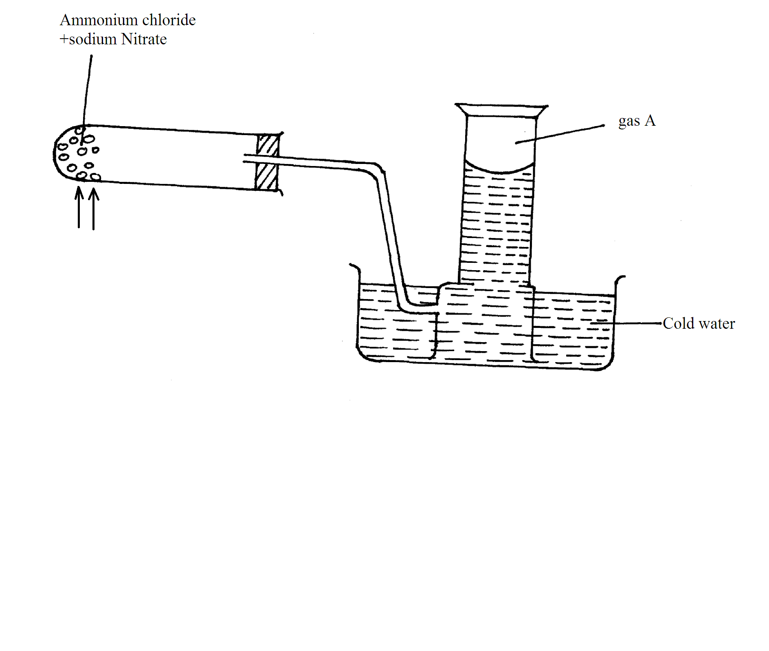

Heat

a) Identify gas A. (1mk)

..................................................................................................................................................................................................................................................................................................

b) State and explain the precaution that should be taken before heating is stopped. (2mks)

..................................................................................................................................................................................................................................................................................................

4. Study the reaction below and answer the questions that follow.

Reaction Equation

J Ba(aq)2+ + SO3(aq)2-  BaSO3(s)

heat

K Br2(g) + 2I(aq)- 2Br(aq)- + I2(g)

L 2Fe2+(aq) + Br2(g) 2Fe(aq)3+ + 2Br(aq)-

M HSO-4(aq)  + OH(aq)- SO2-4(aq) + H2O

heat

N Fe(s) + S(s)  FeS(s)

a) Which of these reactions indicate;

i) A precipitate reaction (1mk)

..................................................................................................................................................................................................................................................................................................

ii) Displacement noction (1mk)

..................................................................................................................................................................................................................................................................................................

iii) Neutralisation reaction (1mk)

..................................................................................................................................................................................................................................................................................................

5. Given the following half cells

Pb2+(aq) / Pb(s) Eθ = -0.13v

Cu2+(aq) / Cu(s) Eθ = +0.34v

a) Write the ionic equations for the half-cell that undergoes (2mks)

i) Oxidation

..................................................................................................................................................................................................................................................................................................

ii) Reduction

..................................................................................................................................................................................................................................................................................................

b) Calculate the e.m.f of the resulting electrochemical cell. (1mk)

..................................................................................................................................................................................................................................................................................................

6. The formation of carbon (II) oxide and hydrogen from methane and steam at 7500C, is represented by the equation below.

CH4(g) + H2O ⇌ CO(g) + 3H2(g) ∆H = 206kJ

a) Calculate the mass of methane that reacts to produce 556kJ of heat. (C=12 O=16 H=1) (2mks)

b) What effect does increase in pressure have on the yield of carbon (II) oxide gas? (1mk)

..................................................................................................................................................................................................................................................................................................

7. 5.34g of a salt of formula M2SO4 was dissolved in water. The sulphate was precipitated by adding excess banum chloride solution. The mass of the precipitate formed was 4.66g.

(Ba = 56, S = 32, O = 16)

a) Determine the moles of sulphate ion present. (1mk)

b) Calculate the relative atomic mass of M in M2SO4  (2mks)

8. Study the information in the table below and answer the questions that follow. A mixture contains three solids; aluminium sulphate sugar, and camphor. The solubility of these solids in different liquids is shown in the table below.

Liquid

|  |  |  |  |
| --- | --- | --- | --- |
| Solid | Water | Alcohol | Ether |
| Al2(SO4)3 | Soluble | Insoluble | Insoluble |
| Sugar | Soluble | Soluble | Insoluble |
| Camphor | Insoluble | Soluble | Very soluble |

Explain how you would obtain a solid sample of sugar from the mixture. (3mks)

..................................................................................................................................................................................................................................................................................................

..................................................................................................................................................................................................................................................................................................

9. The equation below represents changes in physical states of iron metal.

Fe(s)  Fe(s) ∆H = +15.4kJ/mol

Fe(l) Fe(g) ∆H = +354 kJ/mol

Calculate the amount of heat required to change 11.2g of solid iron to gaseous iron. (Fe = 56.0)

(2mks)

..................................................................................................................................................................................................................................................................................................

..................................................................................................................................................................................................................................................................................................

10. The set up below was used to prepare a gas X. study it and answer the question that follow.

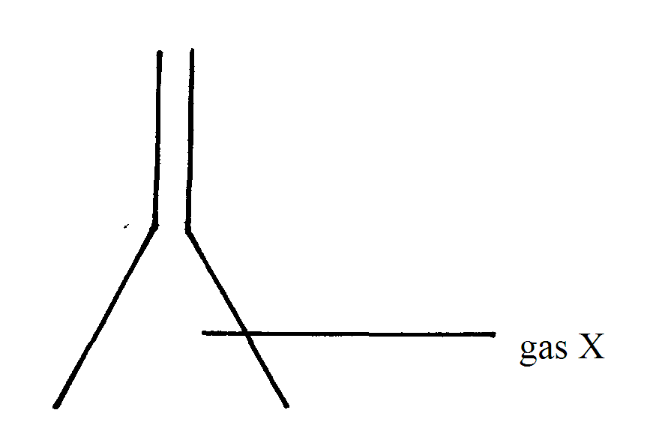

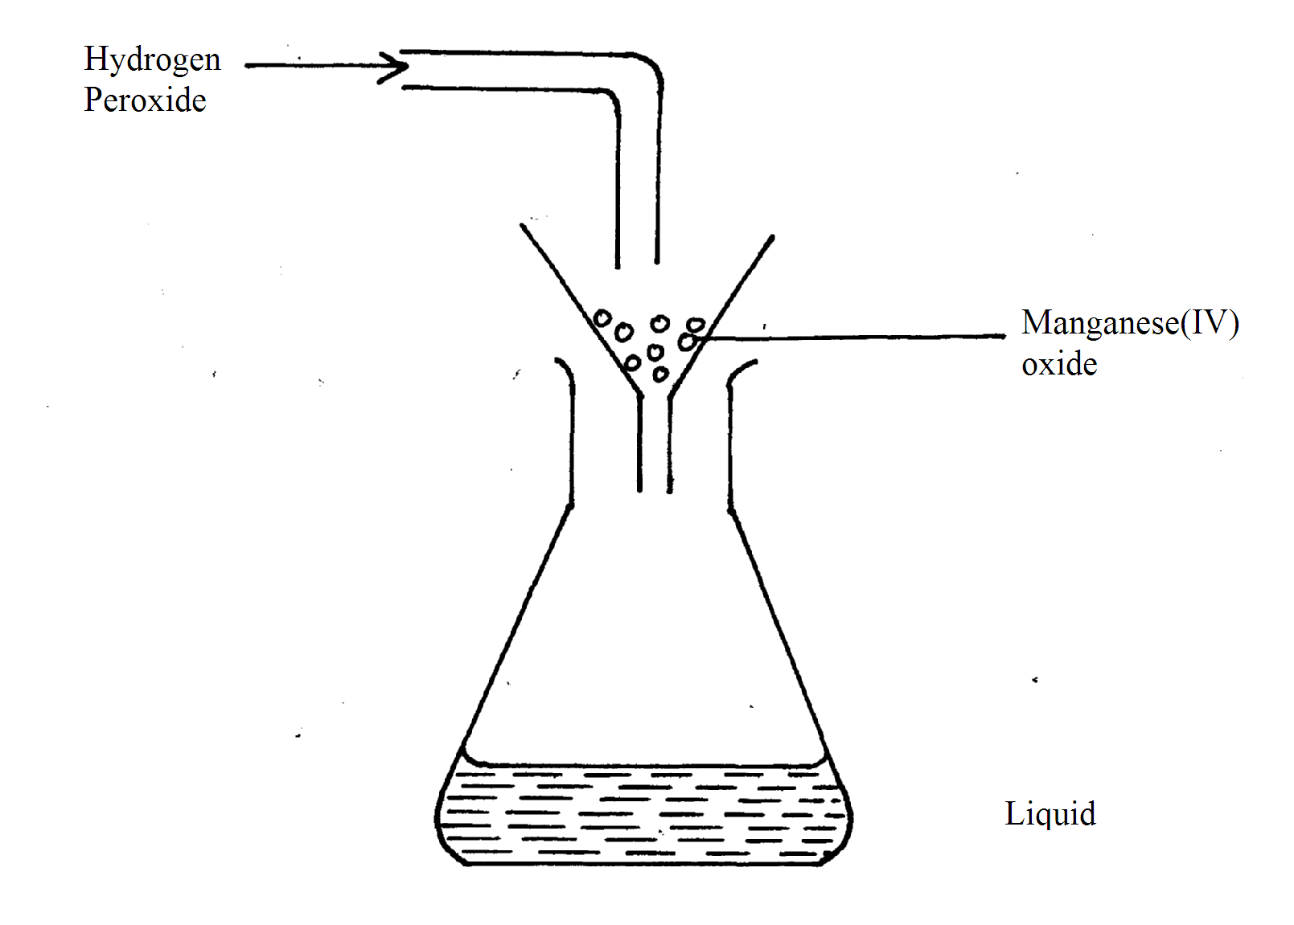

Name;

i) Gas X (1mk)

..................................................................................................................................................................................................................................................................................................

ii) Liquid P. (1mk)

..................................................................................................................................................................................................................................................................................................

11. The following are standard electrode potential for some elements.

Eθ(Volts)

A2+(aq)  + 2e- ⇌ A (s) -0.28

B+(aq) + e- ⇌ B(s) +1.68

C2+(aq)  + 2e- ⇌ C (s) -0.40

D2+(aq)  + 2e- ⇌ D(s) +0.85

E2+(aq)  + 2e- ⇌ E(s) -2.38

F+(aq)  + e- ⇌ F (s) +0.80

a) An aqueous solution containing F+ ions is placed in a container made of C. determine whether a reaction occurs or not, showing how you arrive at your answer. (2mks)

b) Identify two half-cells which if combined give the highest e.m.f. (1mk)

..................................................................................................................................................................................................................................................................................................

12. Complete the table to show how the factor given below affect the rate of reaction between acid and magnesium and give an explanation for each effect.

|  |  |  |
| --- | --- | --- |
| Factor | Effect on rate of reaction | Explanation |
| Using magnesium powder instead of ribbon | (1mk) | (2mks) |

13. The diagram below represent two iron nails with some parts wrapped tightly with zinc and copper stripes respectively.

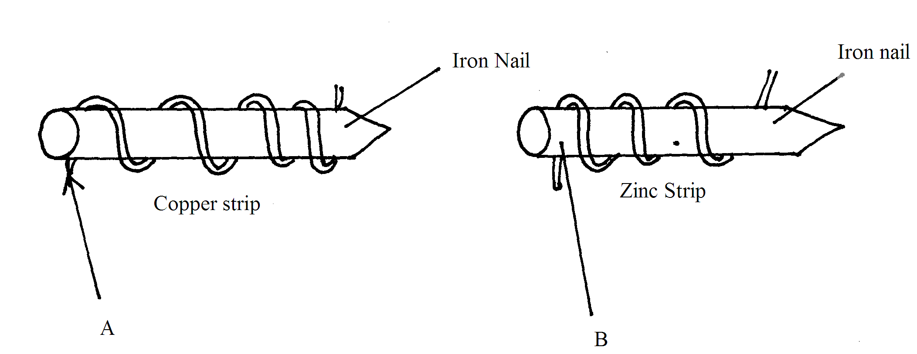

State the observations that would be made at the exposed points A and B if the wrapped nails are left in the open for several months. Explain (3mks)

..................................................................................................................................................................................................................................................................................................

..................................................................................................................................................................................................................................................................................................

14. 5.04g of a mixture of anhydrous sodium carbonate and sodium hydrogen carbonate when heated to a costant mass, gare 4.11g of residue. Calculate the percentage of anhydrous sodium carbonate in the mixture. (Na=23 O=16 H=1) (3mks)

..................................................................................................................................................................................................................................................................................................

..................................................................................................................................................................................................................................................................................................

15. State, giving reasons, the observations that would be made when concentrated sulphuric(VI) acid is added to powdered sulphur and the mixture heated. (3mks)

..................................................................................................................................................................................................................................................................................................

..................................................................................................................................................................................................................................................................................................

16. The curve below represent the changes in the concentrations of substance E and F with time in the reaction. E(g) ⇌ F(g)

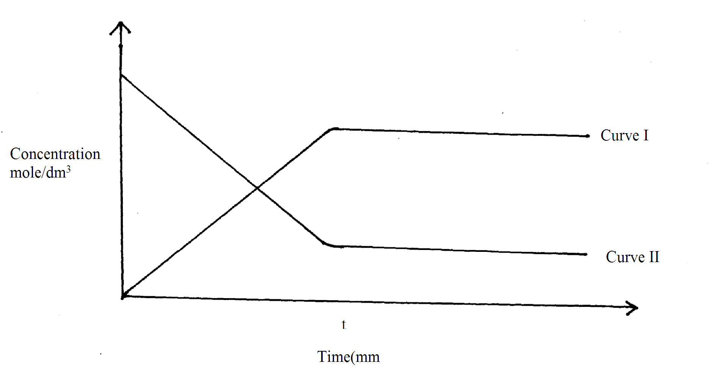

a) Which curve represents the changes in the concentration of substance F? Give a reason (2mks)

..................................................................................................................................................................................................................................................................................................

b) Give a reason for the shapes of the curves after time (t) minutes. (1mk)

..................................................................................................................................................................................................................................................................................................

17. State and explain the change in mass that occur when the following substances are separately heated in open crumbles. (3mks)

i) Copper metal

..................................................................................................................................................................................................................................................................................................

ii) Copper (II) Nitrate

..................................................................................................................................................................................................................................................................................................

iii) Anhydrous copper (II) sulphate

..................................................................................................................................................................................................................................................................................................

18. State Charles’ law for gases and explain it using kinetic theory of matter. (3mks)

..................................................................................................................................................................................................................................................................................................

..................................................................................................................................................................................................................................................................................................

19. Below is a diagram for the ‘fountain experiment’ using ammonia gas.

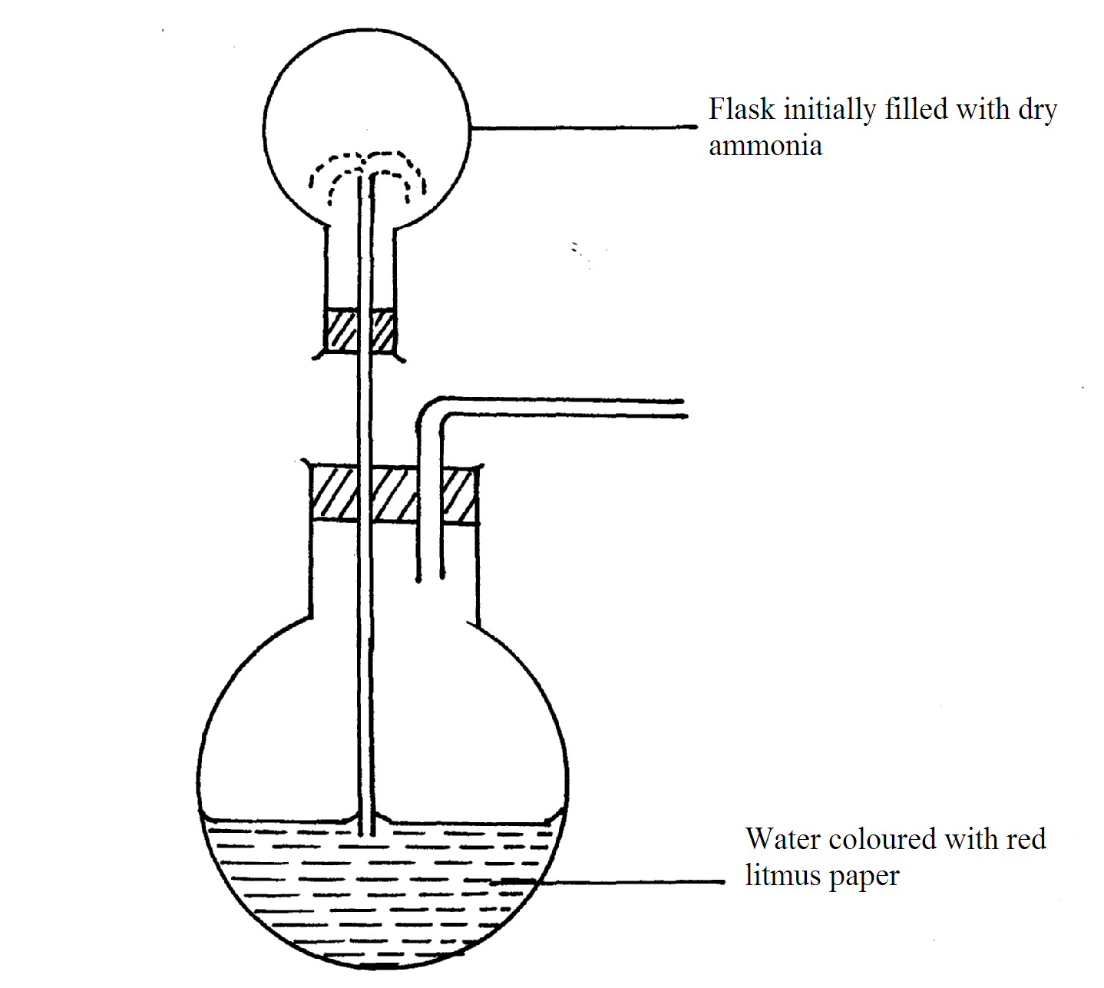

Red coloured water begins to rise up the tube from lower flask to upper flask and a “fountain” is observed in the upper flask. Red colour changes to blue.

i) Why does the colour change to blue? (1mk)

..................................................................................................................................................................................................................................................................................................

ii) Explain why the fountain effect occurs. (1mk)

..................................................................................................................................................................................................................................................................................................

iii) Why is it necessary to have two tubes in the lower flask? (1mk)

..................................................................................................................................................................................................................................................................................................

20. A student set-up the apparatus below in order to determine the percentage by volume of oxygen in air.

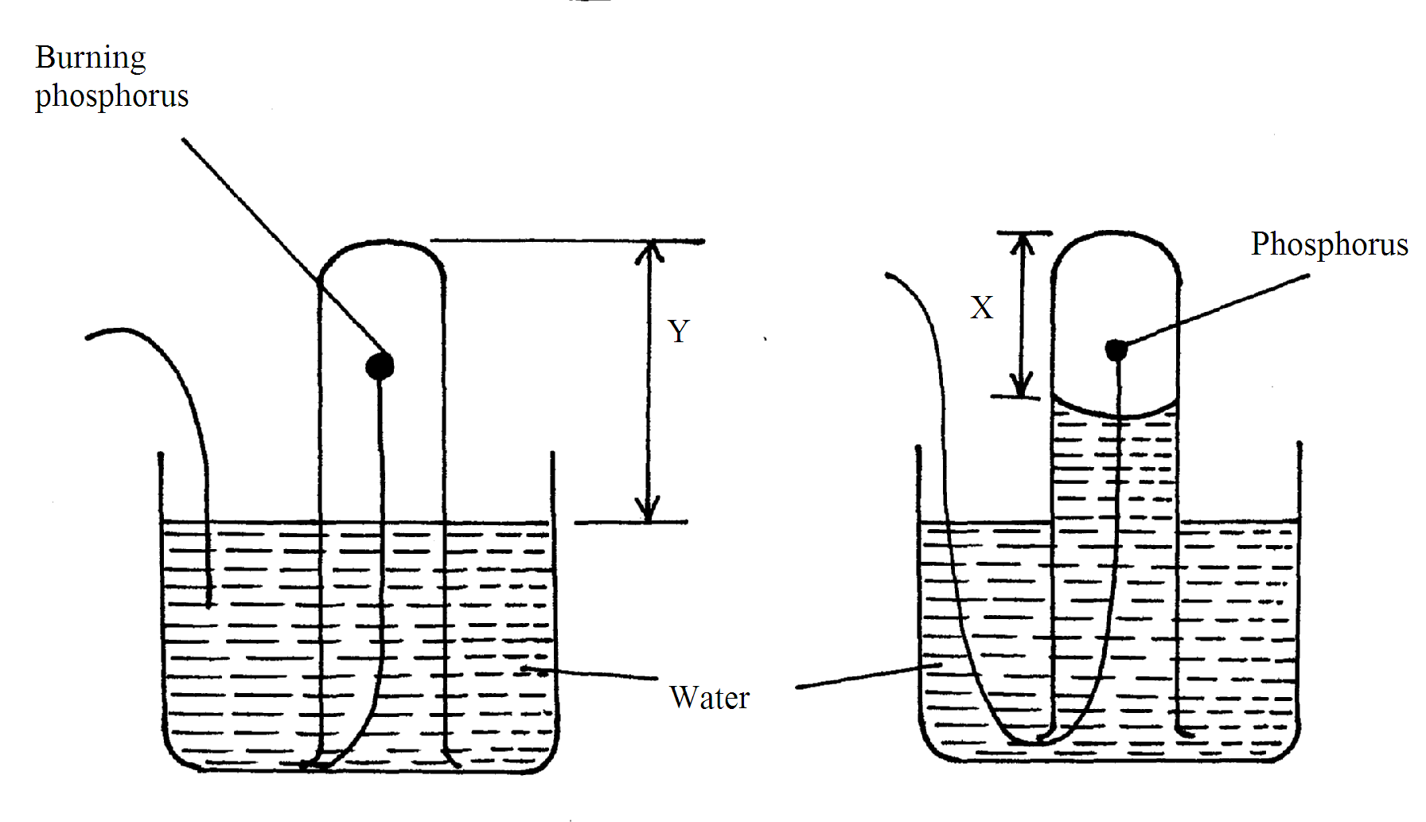

AT END

AT BEGINING

a) Why did water rise when the reaction had stopped? (1mk)

..................................................................................................................................................................................................................................................................................................

b) The student wrote the expression for the percentage by volume of oxygen in air as



Why was the volume of oxygen calculated using the above expression incorrect? (1mk)

..................................................................................................................................................................................................................................................................................................

c) What should have been done after the reaction had stopped in order to get a correct volume.

(1mk)

..................................................................................................................................................................................................................................................................................................

21. The table below shows the two allotropes of sulphur. Using the guidelines given, state the differences between the two allotropes. (3mks)

|  |  |  |
| --- | --- | --- |
| Property | Rhombic | Monoclinic |
| Appearance |  |  |
| Density |  |  |
| Melting point (0C) |  |  |

22. An element X, forms an ion ion X2- with the electronic configuration 2.8.8

a) Write the electronic configuration of element X. (1mk)

..................................................................................................................................................................................................................................................................................................

b) An element Y is found in the 4th group of the periodic table. Draw a dot (.) and (x) diagram to show bonding in compound formed when X and Y react. (1mk)

..................................................................................................................................................................................................................................................................................................

23. State and explain two main factors considered in determining the position of an element in the periodic table. (2mks)

..................................................................................................................................................................................................................................................................................................

..................................................................................................................................................................................................................................................................................................

24. Explain what would be the pH of the final solution obtained after mixing equal volumes of 2M Sodium hydroxide and 2M Ethanol acid. (2mks)

..................................................................................................................................................................................................................................................................................................

..................................................................................................................................................................................................................................................................................................

25. The graph below shows the solubility curves for salt X and Y.

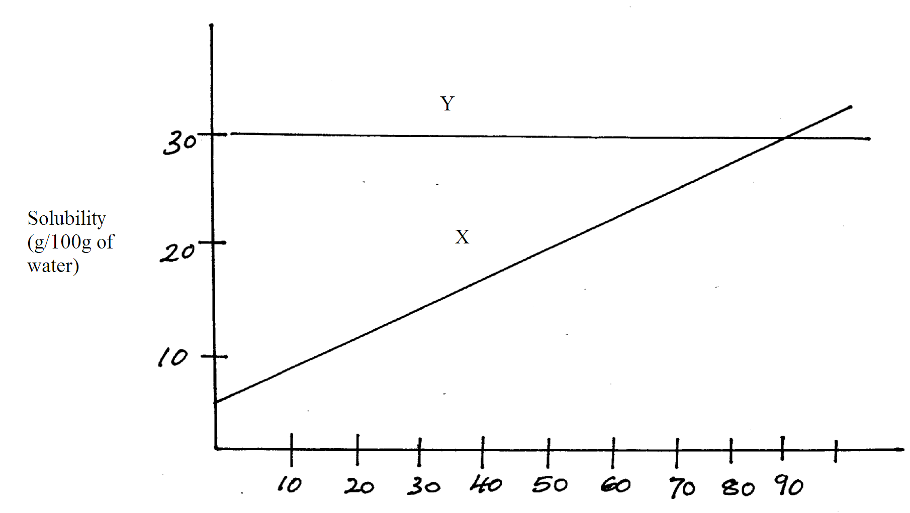

a) Which of the two salts is more soluble in water? Explain (1mk)

..................................................................................................................................................................................................................................................................................................

b) State and explain what happens when 100g of solution containing 20g of salt X and 20g of salt Y is cooled from 900C to 200C (2mks)

..................................................................................................................................................................................................................................................................................................

..................................................................................................................................................................................................................................................................................................

26. In an experiment to separate a mixture of two liquids A and B, a student set up the apparatus as shown below.

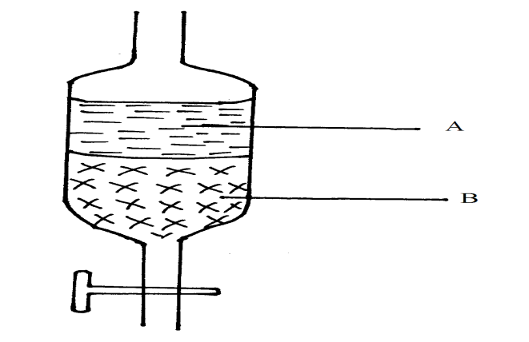

a) Name the apparatus (1mk)

..................................................................................................................................................................................................................................................................................................

.................................................................................................................................................

b) Which liquid is denser (1mk)

..................................................................................................................................................................................................................................................................................................

c) Which other method can be used to separate the two liquids. (1mk)

..................................................................................................................................................................................................................................................................................................

27. Study the information given below and use it to answer the questions that follow.

|  |  |  |
| --- | --- | --- |
| Substance (oxide) | Reaction with acids | Melting point (0C) |
| J  K  L  M | No reaction  Reacts explosively  No reaction  Reacts readily | -30  1190  1728  3075 |

Select

i) An oxide with giant atomic structure. (1mk)

..................................................................................................................................................................................................................................................................................................

ii) An oxide which dissolves in water to form an acidic solution. (1mk)

..................................................................................................................................................................................................................................................................................................

28. When 94.5g of hydrated barium hydroxide Ba(OH)2.nH2O were heated to constant mass, 51.3g of anhydrous barium hydroxide were obtained. Determine empirical formula of the hydrated barium hydroxide. (Ba = 137 O = 16 H = 1) (3mks)

..................................................................................................................................................................................................................................................................................................

..................................................................................................................................................................................................................................................................................................

..................................................................................................................................................................................................................................................................................................

29. Reagent bottles labelled H2SO4, K2CO3 and NaCl had labels accidentally removed. A packet of blue litmus paper is lying near a long with a rack of test-tubes, without using any other material explain how you would go about labeling the bottles correctly. (3mk)

..................................................................................................................................................................................................................................................................................................

..................................................................................................................................................................................................................................................................................................

..................................................................................................................................................................................................................................................................................................