NAME: ………………………………….. INDEX NO: …………………………………...
SCHOOL: ………………………………. CANDIDATE SIGN: …………………
DATE: ……………………………

451/1
COMPUTER STUDIES
PAPER 1
(Theory)
JULY/ AUGUST-2014

TIME: 2 ½ HOURS

KISII SOUTH SUB DISTRICT JOINT EVALUATION TEST 2014
Kenya Certificate of Secondary Education (KCSE)

451/1
COMPUTER STUDIES
PAPER 1
(Theory)
JULY/ AUGUST-2014

TIME: 2 ½ HOURS

INSTRUCTIONS TO CANDIDATE:
- Write your name, index number and school in the spaces provided.
- This paper consist of two sections A and B.
- Answer ALL the questions in section A.
- Answer question 16 (compulsory) and any other three questions from section B.
- All answer MUST be written in the spaces provided in this question paper.

SECTION | QUESTION | ACTUAL SCORE
A | 1 – 15
B | 16
B | 17
B | 18
B | 19
B | 20
TOTAL SCORE

1. a Define a system unit. (1 mk)
b) State two functions of the control unit. (2 mks)
2. a) Define a computer laboratories. (1 mk)
b) State two functions of the ups. (2 mks)
3. Discuss the following types of computers. (2 mks)
i) Dedicate purpose computers
ii) Embedded computers
4. State two advantages of using biometric devices in voting. (2 mks)
5. Discuss one are computers can be used in science and research. (2 mks)
6. State two types of database models. (2 mks)
7. State two types of database models. (2 mks)
b) By use of examples, differentate between a function and a formula in spread sheets. (2 mks)
8. With the of a diagram, explain amplitute and periodic time. (3 mks)
9. a) Explain industrial espioriage. (1 mk)
b) Describe data encryption. (2 mks)
10. What are data terminal equipment? (1 mk)
11. a) Explain open learning. (1 mk)
b) Computers are used to enhance marketing in a variety of ways, one of which is E-business. Explain how computers are used in E-business. (2 mks)
12. Discuss two computational errors giving example in each case. (4 mks)
13. Differentiate between warm and a virus. (2 mks)
14. Differentiate sequential file organization from indexed sequential file organization. (2 mks)
15. With the aid of a diagram, differentiate between analog and digital data signals. (2 mks)
SECTION B
Answer question 16 and any other three questions in this section.
16. a) State two types of selection controls used in high level programming language. (2 mks)
b) Give two characteristics of a good program. (2 mks)
c) Use the flow chart below to answer the questions that follow:

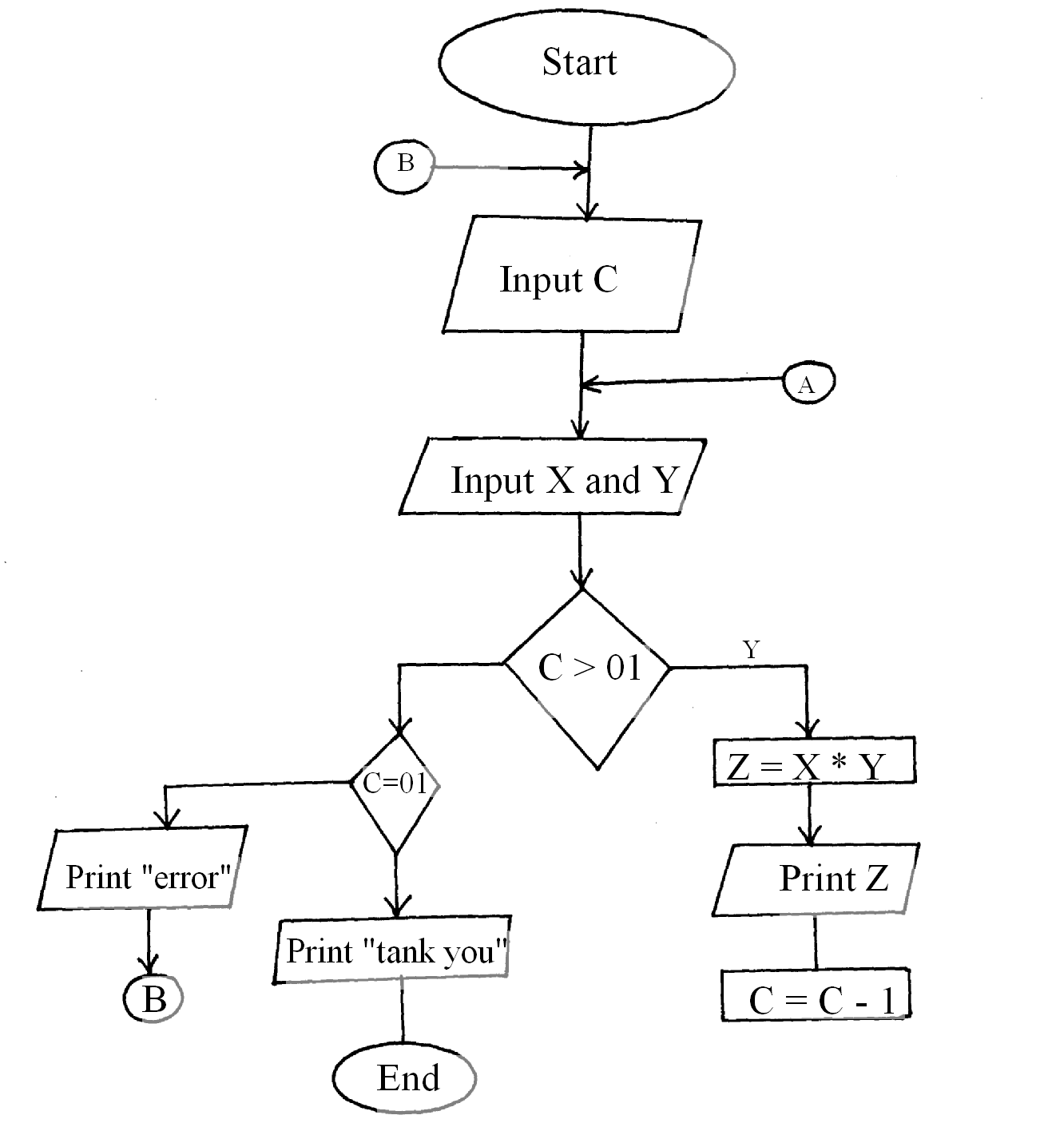

i) Write a pseudocode for the above flow chart. (6 mks)
ii) Write the expected output if c = 2, x = 2 and y = 3
iii) Modify the flow chart so that the program does not accept any negative inputs. (3 mks)
17. a) State and explain two disadvantages that will come about if a network was to be installed in your school. (4 mks)
b) Discuss two disadvantages of wireless networks. ( 4 mks)
c) Write the following abbreviations in full. (4 mks)
i) F.T.P
ii) H.T.T.P
d) With the aid of a diagram, discuss Hybrid topology. (3 mks)
e) Discuss one advantage of a client/ server network. (2 mks)
18. a) Explain why a computer is able to display the correct time and date when it has just be switched on. (2 mks)
b) Discuss two types of special memories found I computer system. (4 mks)
c) i) Define a Bus with reference to a computer system. (1 mk)
ii) List to examples of buses. (2 mks)
d) Distinguish between a power cable and interface cable. (2 mks)
e) Differentiate between the different types of RAM. (4 mks)
19. a) i) Define a system. (1 mk)
ii) Explain system entropy. (1 mk)
b) State three circumstances that can lead to development of information systems. (3 mks)
c) Distinguish parallel changes over from straight change over as used in system implementation. (2 mks)
d) Discuss two fact finding methods. (4 mks)
e) Differentiate an open system from a closed system. (2 mks)
f) List two responsibilities of a system analyst. (2 mks)
20. a) State two ways of representing a signed number. (2 mks)
b) Write the following abbreviations in full. (2 mks)
i) ASCII
ii) EBCDIC
c) Convert 110011.0110 to Decimal
d) Differentiate between absolute value and base value. (2 mks)
e) Outline two reasons for using binary system in computers. (2 mks)
f) Perform 111o11001000₂ – 11011011001₂ using ones compliment convert your answer to Hexadecimal. (4 mks)

